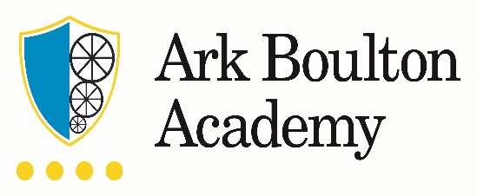

Job Description: Pastoral Administrator

The Role
As the pastoral team administrator you will play a vital role in ensuring that children are safe, well cared for and have the best chances to make excellent progress so that they can be successful at school and later life. The role focusses on providing administrative support for a cohesive pastoral team and working closely with the Safeguarding Officer and Vice Principal.

Key Responsibilities
- Manage diaries for pastoral leaders as well as liaise and manage visitors for the pastoral team , ensuring that visitors are welcomed into a friendly, professional environment and recorded in line with procedures
- Ensure that all communications are correctly logged and routed to their intended recipients, or an appropriate member of staff, to ensure a quick and effective communication system
- Deal effectively with pastoral team post and maintain electronic mail systems ensuring that information is passed to relevant staff in a timely manner
- Ensure that queries are dealt with effectively, taking the initiative to identify and handle issues that arise on behalf of the Leadership team and others
- Use of BromCom*, Outlook*, CCR* and other systems to enable effective communication
- Complete, update or maintain specific records or reports* in line with the needs of the academy
- Liaise with colleagues and external contacts at all levels of seniority with confidence, tact and diplomacy
- Liaise with parents and carers as necessary
- Take notes at meetings, record them according to the appropriate format and share appropriately with specific staff while maintaining confidentiality
- Provide administrative support for dealing with students' requests for leave during term-time and persistent absence
- Provide administrative support for dealing with referrals to outside agencies and requests for support from external agencies for students in need
- Ensure that internal and external perceptions of the school are managed and protected within favourable boundaries, maintaining confidentiality, both internally and externally, when appropriate
- Ensure safeguarding procedures are followed at all times, with particular regard to visitors and incoming calls
- Update student records as and when required
- Deputise for the attendance officer when needed*.
* Relevant training will be provided.
Other
- Following training, to undertake a proactive role in maintaining the culture and ethos of the academy – including the direct supervision of students
- To undertake training and development relevant to the post and in line with the academies priorities
- To undertake any task as directed by the Senior Leadership Team as and when required.

Person Specification: Pastoral Administrator

Qualification Criteria
- Right to work in the UK
- Maths and English GCSE at grade C or above
Knowledge, Skills and Experience
- Previous experience of working as a receptionist, desirable
- Professional telephone manner
- Excellent communication skills
- Excellent organisation and time-management skills
- Excellent IT skills and a high level of proficiency with Microsoft Office
- Ability to deal with minor incidents, First Aid, and the personal health and hygiene of the students
Personal Characteristics
- Genuine passion for and belief in the potential of every student
- Deep commitment to Ark’s mission of providing an excellent education to every student regardless of background
- Displays emotional resilience and is helpful, positive, calm with a caring nature
- Ability to work as part of a team
- Works productively in a high pressure environment with a positive attitude
- Adaptable and a fast learner
- Excellent interpersonal skills with children and adults
- Able to take direction but also take initiative when required
- Exercises sound judgment, especially relating to confidentiality and discretion

Other
- Commitment to equality of opportunity and the safeguarding and welfare of all pupils
- Willingness to undertake training
- The post holder will be subject to an enhanced Disclosure and Barring Service check.

Ark is committed to safeguarding and promoting the welfare of children and young people in our academies. In order to meet this responsibility, we follow a rigorous selection process. This process is outlined here, but can be provided in more detail if requested. All successful candidates will be subject to an enhanced Disclosure and Barring Service check.

