27 February 2018

Dear Applicant

Teacher of Drama

Thank you for showing interest in the post of Teacher of Drama at St Mary Magdalene Academy. Information about the Academy and an application form can be found on our website www.smmacademy.org. I hope that this will give you enough information to encourage you to apply for the above post.

Please apply by downloading the application form from our website, do not send CVs. In completing your personal statement please ensure that it is no more than two sides of A4 paper and explain why you believe you meet the requirements for the post. We are committed to providing equal opportunities to all sections of the community, we would therefore ask you to complete and return the enclosed equal opportunities monitoring survey form to enable us to review and improve our recruitment and selection procedures.

The Academy specialises in Humanities and Global Citizenship and as part of this we are committed to a sustainable future for the planet. In conjunction with Islington’s own Green Transport policy the Governors will encourage and support those who use public transport. Although the Academy has no on-site parking facilities the Academy is five minutes’ walk from Highbury and Islington Station (Victoria, London Overground and First Capital Connect Lines) and seven minutes’ walk from Holloway Road Station (Piccadilly Line).

The closing date for applications will be 9am on Monday 19 March and interviews will take place before the Easter break.

If we have not contacted you by 29 March you should assume your application has been unsuccessful on this occasion.

If you require any more information about the post or the Academy please do not hesitate to contact me.

Yours sincerely
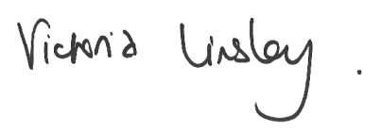
Victoria Linsley
Headteacher

