Isca Academy
Head of Design and Technology

Table of Contents

Contextual Information
Copy of advertisement
Job description
Person Specification

To start: 1st January 2019 (although a later start could be agreed for the right candidate)
Closing date: 9am on Thursday 18th October 2018

Contextual Information

Welcome to Isca Academy
Our school has been located on its very impressive and attractive site with a freshly designed campus and entirely new buildings since 2006. This was part of major re-organisation in Exeter with a PFI scheme that re-built all 5 Exeter secondary schools and one primary school. The Academy was built with a capacity for 950 students and the current roll is 830. We expect this number to rise and have an ambitious collaborative strategy to improve and strengthen relations with our feeder primary schools and community.
Students come to the Academy from a large number of primary schools that span the city and beyond, although 4 primary schools account for over 70% of the intake, these are Wynstream, St Leonards, Countess Wear and Topsham, all within close proximity to the Academy. In total the 2018 intake will come from 32 primary schools.

About Our Students
The Academy maintains a tradition of being an inclusive community school that serves the variety of family contexts in its immediate neighbourhood. The most distinctive feature of the academy is the very broad range of student abilities and aspirations on entry. We are a true comprehensive school. All students achieve well academically, in the activities beyond the formal curriculum and in their progression to further education, employment and training. We have large numbers participating in the Reach Academy Programme run by Exeter College for able, gifted and talented students and a high number of students going to the Maths School. Our intake also presents the challenge of a number of students who join us with low literacy and social skills. At present 32% of students in the academy are ‘disadvantaged students’. 7% of students have English as an additional language and many of these have their families linked to the University.

Our Curriculum
We regularly review our curriculum and endeavour to construct one which meets the needs of our diverse student body whilst ensuring that it is broad and balanced along with a high level of challenge. Our offer is both inclusive and demand led. Enriching students learning experiences beyond the classroom is also an integral part of our curriculum offer and life at Isca Academy. We have a rich tradition of providing outdoor education opportunities, after school activities as well as educational trips, visits and events.

In every aspect of learning we provide wider opportunities for personal and social development, designed to improve student confidence, resilience and teamwork, as well as to enthuse and inspire our students.

Significant examples of our wider curriculum offer are:
- Student Leadership Opportunities
- Ten Tors
- The Duke of Edinburgh for All Scheme
- Royal Marine Cadets – CCF Unit
- A week long Year 7 residential trip
- Book & Film Clubs
- Writing workshops
- Wildlife Champions
- Exe Valley Challenge
- Exe Valley Extreme
- Isca Underground – Performing Arts Showcase
- Theatre visits and workshops
- Sports teams and development opportunities
- Musical tuition, clubs and workshops

These opportunities, coupled with an inspirational and relevant curriculum, build the skills and attributes necessary to become resilient, successful learners and highly effective citizens. All of our students study Religious Education and PSHE as well as enhanced topical themes that link to our tutorial and assembly programme.

Beyond the Classroom
Whilst important, success at school is not just about examination credentials and we believe in the immeasurable value of activities beyond the classroom to promote self- belief and confidence. Our extensive extra-curricular programme offers a huge range of activities. If you look on our web site you will see there is a daily programme of activities offering a Breakfast Club for those who need a bit of calm and time to organise themselves (staff included!) and then lunchtime and after school activities including a regular After School Study Club, range of sports clubs, choir, samba band, community work and much much more!

There is also a calendar of Outdoor Education Events, with activities such as Ten Tors, Exmoor Challenge, Exe Valley Challenge and Duke of Edinburgh for All scheme led by dedicated and long standing teachers. The Academy also prides itself on a thriving Combined Cadet Forces unit.
We strive to ensure these activities and opportunities are taken up by all students so they are not exclusive to those fortunate to have very supportive families. Where necessary we will assist students to enable them to participate.

Our Facilities
We are proud of our buildings and even though we all know that buildings alone do not make a good school, they do create the environment for learning. Wide corridors, spacious classrooms and a welcoming atrium greet our visitors.
As would be expected there are specialist rooms; science laboratories, ICT rooms, technology spaces, music rooms and practice facilities, drama studio, and an impressive hall with moveable seating. There are generous office spaces for support staff, subject staff and middle leaders.
Outside there is a floodlit all weather pitch and extensive grassed areas for sport and recreation (large enough for 2 full sized football pitches ) as well as hard court spaces and plenty of outside seating for students.

The Governing Body
The Local Governing Body operates with full delegated authority from the Ted Wragg Multi Academy Trust and is directly accountable to the Trust. The governors understand well their statutory duties to hold leaders to account as well as setting the strategic direction of the Academy, ensuring the Academy has a sound financial footing. Their commitment is absolute, believing in social justice, they bring a rich background of experience beyond education. They are led by a chair determined for the academy to be a first choice for parents and where every child is given the opportunity to fulfil their potential.

The Ted Wragg Multi Academy Trust is a values driven, rapidly growing 2 – 16 Trust with a relentless focus on transforming lives through learning by delivering outstanding outcomes for every student, regardless of background.
With a reputation for highly successful school improvement in very challenging circumstances, we are passionate about
driving up standards and raising the aspirations of all our students.

Isca Academy

Head of Design and Technology
Permanent, Full-time
Starting 1st January 2019 (although a later start date could be agreed for the right candidate)

Do you have a relentless drive to achieve outstanding progress and attainment with children regardless of their background and prior learning?

We are seeking to appoint an outstanding Team Leader for Design and Technology to further strengthen the achievement, progress and experience of students at Isca Academy, and to continue to raise the profile of the Design and Technology department. You will be a highly motivated, innovative and capable leader, with a proven commitment to inclusive and inspiring teaching where each and every child can succeed. The post represents an exciting opportunity to be part of a vibrant and ambitious Academy working within the Ted Wragg Multi-Academy Trust.

Our school is located on a recently designed campus with purpose-built accommodation, offering spacious and excellent teaching and learning facilities. We currently have a roll of 830 students, rapidly growing to a capacity of 950. Isca Academy prides itself on providing high quality comprehensive education. Our students have a broad range of abilities and aspirations on entry, from able, gifted and talented to students needing more support with literacy and social skills. Our focus remains on every student in our school exceeding expectations, whatever their starting point. Beyond academic credentials, we firmly believe in the value of a more rounded education which promotes creativity, self-belief and confidence, and as such, offer an exceptional extra-curricular and outdoor education programme.

The Technology Department operates a two-year Key Stage 3 curriculum, covering the disciplines of Graphic Products, Product Design (plastic and wood) and Food, delivered on a 20-lesson carousel. The three-year GCSE options currently offered are the reformed GCSEs covering the disciplines of Resistant Materials and Graphic Products, in addition to vocational Hospitality and Catering. As the Academy expands, the department is looking for an individual who combines excellent teaching with energy and innovation, and who can offer both inspirational classroom experiences and extra-curricular opportunities for our students within the field of Technology.

The Leadership Team at Isca Academy is welcoming, energetic and highly committed and has led the school successfully through a time of significant change to reach above national student outcomes and a ‘Good’ Ofsted judgement. As a school, we are committed to investing in leadership development at all levels and strongly believe that the experience of the children will ultimately benefit from this. If you are a leader who can inspire both staff and students, with a passion for teaching and learning, and an outward facing approach to the development of pedagogical practice, we would love to hear from you.

The Ted Wragg Multi Academy Trust is committed to safeguarding and promoting

the welfare of children and young people and expects all staff and volunteers to share this commitment. All applicants will be subject to a full Disclosure and Barring Service check

before appointment is confirmed.

Application forms and further information are available from our website:
www.iscaexeter.co.uk or by email to bharrad@iscaexeter.co.uk

Closing date for application: 9am on Thursday 18th October 2018
Please note the interviews will take place on Monday 29th October 2018

ISCA ACADEMY – JOB DESCRIPTION

Post: Head of Design and Technology
Line Manager: Deputy Headteacher (Teaching and Learning)

CONDITIONS
As defined in the School Teachers Conditions of Service Document and Academy policy documents. The post holder will lead a team of Design and Technology staff and will be supported by a designated member of the Leadership Group.
KEY PURPOSE
To provide professional and effective leadership and management for the Design and Technology teachers within the department, in order to secure high student achievement within the context of the Academy overall aims and priorities.

OBJECTIVES

- To promote and provide a clear direction for the Design and Technology team, within the context of the Academy vision in order to contribute to whole school improvement.
- To promote high standards in Design and Technology teaching in order to ensure all students achieve their potential in Design and Technology.
- To promote positive attitudes to learning in Design and Technology lessons and activities so that students are equipped and able to access all subjects across the Academy.
- To ensure there is a consistency of practice within the Design and Technology team with regards to Academy policies and procedures, maintaining high expectations of all students in terms of academic success and behaviour.
- To develop Design and Technology schemes of learning, assessment plans and pedagogy in line with national developments and explore new strategies so that Design and Technology teaching continues to develop and improve, maximising student outcomes.

MAIN AREAS OF RESPONSIBILITY

      - Improving the quality of teaching and learning
      - Leading and enhancing the teaching practice of others
      - Leading, developing and enhancing a subject or curriculum area

  - Monitoring the standards of teaching and learning and student achievement across all Design and Technology lessons, and plan for improvement.
  - Working with the Academy Leadership Team (line manager) to undertake regular self-evaluation of the work of the department and the impact on student outcomes, in line with the Academy self-evaluation policy.
  - Setting a clear direction for Design and Technology within the context of the Academy vision and goals, creating and implementing a subject development plan which involves all subject teachers.
  - Supporting and developing the Design and Technology staff, providing regular constructive feedback in a way which recognises good practice and supports progress against appraisal objectives.
  - acting as a positive role model for the Design and Technology team so that staff have a clear understanding of good professional conduct.
  - Maintaining an ethos of high achievement and positive attitudes towards Design and Technology amongst staff and students, to maximise achievement.
  - Actively engaging the Design and Technology team in effective planning, development and delivery of the Design and Technology curriculum.
  - Organisation and provision of resources and allocation of staff to groups, so that resources are used efficiently and effectively.
  - Overseeing and evaluating subject budget allocations to ensure spending is in line with learning priorities and best value principles.
  - Effective communication within the Academy and to key stakeholders with regards to Design and Technology, to ensure confidence in the Academy and the subject area.
  - Ensuring high standards of health and safety within the department demonstrating an understanding and a commitment to safeguarding students.
  - Promote equality of opportunity and aspiration so that all students achieve their potential.

KEY TASKS

- Design and Technology teaching across all years.
- Ensure schemes of learning /programmes of study are clear and effective, to ensure progression and to maximise achievement for all students.
- Ensure the quality of teaching across the team meets the needs of all students, and encompasses strategies to engage students in a range of learning styles.
- Monitor the quality and impact of teaching and learning within Design and Technology through lesson observations, learning walks, work scrutiny and other identified strategies. Plan and implement improvements as appropriate.
- Monitor student progress in Design and Technology against national and internal targets, planning support as appropriate for both students and staff.
- Plan and implement the developments required in Design and Technology within the context of the overall Academy improvement plan.
- Ensure a programme of educational enhancement is delivered by the department, as appropriate.
- Ensure effective and timely scheduled meetings with the Design and Technology staff, both as a group and on a 1:1 basis as required.
- Attend and contribute to Team Leaders’ meetings.
- Order and allocate Design and Technology resources and manage the Design and Technology budget.
- Oversee the deployment of staff in Design and Technology lessons and advise on the recruitment of Design and Technology staff when required.
- Support the professional development of Design and Technology staff through Academy Appraisal processes, and other support strategies.
- Ensure efficient management of technical staff support (where required).
- Ensure Academy policies are consistently adhered to by the Design and Technology team.
- Other general professional duties under the reasonable direction of the Headteacher.

THIS JOB DESCRIPTION IS SUBJECT TO REVIEW BY CONSULTATION

Isca Academy
Head of Design and Technology: Person Specification

ESSENTIAL | DESIRABLE | HOW  ASSESSED
 |  | App Form | References | Interview
Experience  - Minimum 3 years teaching experience in a state comprehensive school  - Experience in planning and teaching Design and Technology at KS3 and KS4  - Experience of contributing to and delivering strategies to raise achievement across Design and Technology, including Assessment for Learning and creative pedagogies | - Experience of analysing student data to inform lesson planning and departmental improvement.
Qualifications  and training  - Qualified teacher status  - Educated to degree level | - Further qualifications relevant to the role
Skills  - Outstanding classroom practitioner (teacher)  - A desire to teach Design and Technology in an exciting and engaging manner  - Excellent planning skills  - Excellent inter-personal skills  - Ability to sustain positive relationships with staff, students and parents  - Able to analyse data and use this effectively to improve student outcomes  - Excellent ICT skills to support teaching  - Excellent organisation and time management skills  - Meets all relevant national teaching standards  - Good understanding of the National Curriculum and GCSE assessment requirements in Design and Technology  - Ability to plan high achieving Schemes of Learning to challenge and inspire young people.  - The ability to fulfil all spoken aspects of the role with confidence and fluency in English | - A gifted leader and teacher
Qualities  - Very good communicator and team player  - Energetic and committed  - Ability to work under pressure  - High level of integrity  - Positive role model  - Able to demonstrate commitment to safe school culture | - Keen to develop further by full participation in our CPD offer, often leading CPD for others
- Must pass relevant  safeguarding of children  checks |  | DBS Checks and interview

Isca Academy
Contacts and information
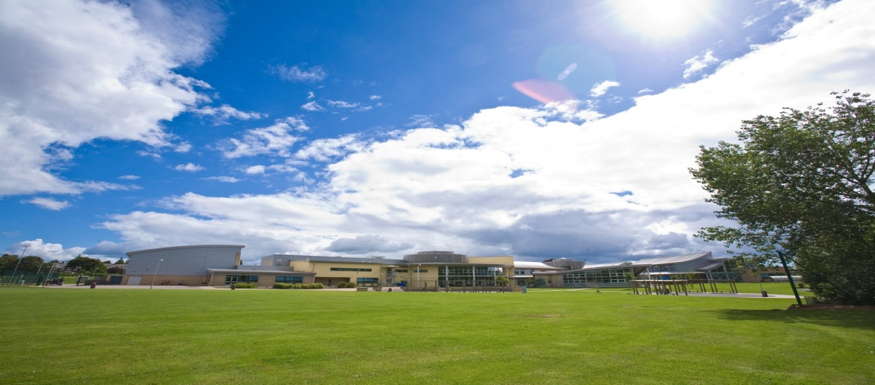
Contact Details: bharrad@iscaexeter.co.uk
Website: www.iscaexeter.co.uk
Isca Academy
Earl Richards Road South
Exeter EX2 6AP
Tel. 01392 204082
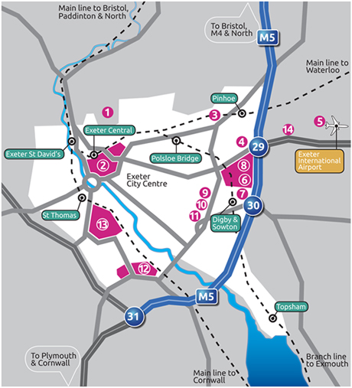
Isca

