Dear Applicant,

On behalf of the Our Lady of Lourdes Catholic Multi-Academy Trust, I extend to you a very warm welcome and thank you for expressing an interest in this vacancy with the Trust.

On 1st September 2018, the Our Lady of Lourdes Catholic Multi-Academy Trust will bring all of the 21 Catholic schools located in Nottingham City and Nottinghamshire together in a partnership, which will ensure the very best spiritual, social and academic experiences and outcomes for the young people in our schools. We will achieve this through working together to share what we do well and identify the areas where we can learn from each other. As a Catholic MAT, we will place the life, teachings and person of Jesus Christ at the centre of everything we do.
The Schools of the Our Lady of Lourdes CMAT:
Primary Schools
Blessed Robert Widmerpool, Clifton
Our Lady & St Edward’s, St Anne’s
St Patrick’s, Wilford
St Edmund Campion, West Bridgford
St Teresa’s, Aspley
Our Lady of Perpetual Succour, Bulwell
St Mary’s, Hyson Green
St Augustine’s, Mapperly

Holy Cross, Hucknall
The Good Shepherd, Arnold
Sacred Heart, Carlton
St Margaret Clitherow, Bestwood
Holy Trinity, Newark
St Patrick’s, Mansfield
St Joseph’s, Shirebrook
St Joseph’s, New Ollerton
St Philip Neri, Mansfield

Secondary Schools
All Saints’, Mansfield
The Becket School, West Bridgford
The Trinity School, Nottingham
Christ the King CVA, Arnold

The Trust has its own Teaching School, The Nottingham Catholic Teaching School Alliance, which is based at The Becket School. The Teaching School will support the work of the schools by providing high quality CPD for all staff, brokering school to school support, organising subject networks and co-ordinating ITT placements through the Schools Direct route.

Thank you again for your interest in this post. I wish you every success in your application.

Yours sincerely,
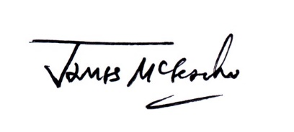
James McGeachie
CEO designate, Our Lady of Lourdes Catholic Multi-Academy Trust

