Robert Smyth Academy
Market Harborough

Head of Faculty for Science
Applicant Information Pack

Dear Applicant

Thank you for your interest in Robert Smyth Academy. I am very proud to lead the Academy and to have been part of the rapid improvements in recent years.

Our 2017 GCSE results build on the successes of previous years with results in English having vastly improved and mathematics remaining at its high standard. We are delighted that the efforts of students, parents and teachers alike has led us to these results, and that OFSTED recognised that we were a ’Good’ school in September 2017.

We are also very proud of our VI Form where over 400 students enjoy a dedicated VI Form area including a study area with computer stations and wireless capability.

The formal work area is complemented by excellent refreshment facilities and another study area in the William Bragg Hall.

Results in the VI Form remain very strong, and we are very pleased that VI Formers immerse themselves in the life of the school in such varied activities such as CAIRS (charity fundraising), mentoring younger students in Year 7 and leading their own Student Council and assemblies.

As an Academy we have a strong focus on traditional values, and in recent years we have raised standards of behaviour and expectations by introducing a new uniform for Key Stage Three and Key Stage Four students, and restricting mobile phone usage during the school day. We think if we “Dress Smart” that we are more likely to “Think Smart”.

We want to combine academic success in the traditional subjects with a commitment to all aspects of life and learning. This leads us to a strong commitment to the performing arts and sport, where you will see a plethora of extra-curricular clubs and events. Our teams and orchestras are regularly involved in county and national competitions with significant success.

We also have a rich heritage and practice of enriching learning, be it in or outside the classroom; with Business Enterprise Days, Most Able Stem conferences and a residential for our Year 7 students, being just a few examples of these. Duke of Edinburgh is very well established in the school with nearly 100 students participating in the scheme currently and our older students will shortly be travelling to Borneo on their Outlooks Expedition. This demonstrates the commitment of our staff to offering a rich array of learning opportunities in the most diverse of contexts.

We are a Good and Improving Academy and this is an exciting time to be joining us. We are working within Tudor Grange Academies Trust which is bringing rapid investment into the Academy, both in terms of infrastructure as well as acumen and inspiration in teaching and learning.

I wish you every success in your application and hope to meet you very soon.

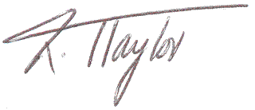
Yours sincerely

Richard Taylor
Acting Principal

ADVERTISEMENT

Head of Faculty for Science

Closing Date: Monday 26th February 2018 (noon)
Start date: | 23/08/2018 | Contract type: | Full Time
Salary: | MPS  TLR1B (£9,475) | Contract term: | Permanent
Suitable for NQTs: | Yes

Our staff are our most valued asset. The Academy has access to a wealth of support provided by outstanding practitioners, giving opportunities for staff to flourish and develop.

The Role
An outstanding Head of Faculty for Science is required for September 2018 to join a committed and hard-working department. Ideally we are seeking to appoint a Biologist or a Physicist however this is not essential as the right candidate for the post is more important. Applications are welcome from both experienced teachers and NQTs. The department has close links to other schools in the Tudor Grange family. A wide range of teaching and learning strategies are used in the delivery of Science including a focus on developing students’ independence and spontaneity.

Additionally, you will benefit from:
- Joining a department judged as ‘good’ in the school’s recent OfSTED inspection (September 2017).
- Teaching in a forward thinking department with excellent resources and facilities for teachers who are passionate about their subject.
- Working in a Faculty which achieves excellent results:
GCSE:
Science 50% A*-C
Additional science 67% A*-C
Biology 80.3% A*-C
Chemistry 89% A*-C
Physics 84% A*-C
A Level:
Biology 40% A*-A; 88% A* - C,
Chemistry 29.8% A*- A; 74.5% A*- C
Physics 36.4% A*-A; 72.7% A*-C

The Academy
The Robert Smyth Academy developed from Market Harborough’s oldest school and was founded in 1607. It is now a vibrant, fast growing 11 – 19 Academy with nearly a thousand students, including ‘new’ Year 7 students in 2016 and well over 400 students in the sixth form. The area around Market Harborough, which is an attractive and a growing market town, is increasing in its diversity and offering significant potential for the Academy to grow.

In 2016 and 2017 the Academy’s Key Stage 4 and 5 results were very pleasing and underpin the progress that has been made. The OfSTED inspection in September 2017 deemed the Academy as ‘good’. This, with other progress being made, is the foundation of the Academy’s journey to being ‘outstanding’. The Academy also enjoys a very positive reputation in its community and particularly for its considerable extra-curricular offer in many areas, most notably in art, music and sport.
If you join us, you will benefit from:

- Teaching pupils who are well motivated as the school enjoys strong parental support
- Working in a Trust with structured professional development opportunities
- A real chance to develop in a forward thinking, highly successful academy
- Developing yourself in our ‘can do’ culture and positive ‘want to’ climate

Informal visits and conversations about the post are most welcome.
The recruitment process is robust in seeking to establish the commitment of candidates to support the school’s measures to safeguard children and to identify, deter or reject people who might pose a risk of harm to children or are otherwise unsuited to work with them. The successful applicant will be required to undertake an Enhanced DBS check. All applications will be considered on their merit and the post will be offered subject to the usual health, criminal record and reference clearance. We are committed to safeguarding and promoting.
SCIENCE AT ROBERT SMYTH ACADEMY

The Faculty is an exciting and dynamic place to work with a strong culture of success and innovation. There are nine teachers and two technicians who work together to, continually, improve teaching and learning; support each other in an environment which is creative and inspiring. All new staff are mentored and it is important to our science faculty, and the Academy, that members of staff feel valued and supported both in their teaching and professional development.

The aim of the science teachers and technicians is to make students excited about science. In addition to this, we want students to find academic success and have the desire to study science further.

From September 2018 we will have a full cohort of students in Key Stage Three and have enjoyed developing, and teaching, the curriculum based on the Collins Activate programme. There has also been much work invested in preparing for and delivering the new GCSE and A Level specifications.

Being part of the Tudor Grange Academies Trust means that we are sharing support and expertise and enjoying working collaboratively with other schools within the Trust.

We offer GCSEs in combined science (trilogy), biology, chemistry and physics and teach the AQA syllabus at GCSE.

The current A Level specifications are:
- Biology OCR A H0420
- Chemistry OCR B (Salters) H435
- Physics OCR B

A levels in Science are proving extremely popular. A level teaching currently comprises more than one third of our curriculum. Our teaching materials support all GCSE lessons and help make planning effective lessons easy whilst freeing teachers up to be innovative and creative. These resources have recently been extended to the A level curriculum.

The Faculty has a suite of laboratories that were recently refurbished, a Space Education Centre, a pond, greenhouses and an arboretum of national significance.

The Robert Smyth Academy is one that is very positive about education and the opportunities that we are able to offer to all of our students. We have strong relationships with our feeder schools and have offered a Science conference to all primary key stage two over a number of years. Whatever the outcome of your application, we hope that you will have found this information useful. Should you require any further information, please do not hesitate to contact us.

General Information
The successful candidate will be expected to play a full and active part in developments in the subject area and a readiness to become involved in the extra-curricular life of the school would also be greatly valued.

HOW TO APPLY
If you would like to join our outstanding team and apply for this post, please complete the application form in full. Please note that incomplete applications may result in possible rejection from the shortlisting process.

Section 1: Letter of Application
Please attach a letter of application and use this opportunity to show your suitability for this post as outlined in the job description and person specification and tell us why you want to join us at Tudor Grange.

Sections 2, 3 and 4: Current/Most Recent Employment and Full Chronological History
Please ensure that this section is completed fully. If you have gaps in your employment please indicate the reasons for this. This may be explored further in an interview.

Section 5, 6 and 7: Education, Training and Qualifications
Please complete this fully and ensure that you have proof available of your qualifications. If you are not in possession of this proof, please be aware that we will require your permission to contact the relevant awarding bodies prior to a firm offer of appointment, should you be successful.

Section 8: Other Relevant Experience, Interests and Skills
Please add anything that is not already covered in your letter of application.

Section 9: References
Please provide two referees and their details. A telephone number or email address often makes this process easier and would be much appreciated. The references MUST include your current or most recent employer and will ask about your suitability to work with children. Open references or testimonials will not be considered. Please be aware that we may approach previous employers to verify particular experience or qualifications.

Section 10: Personal Information
Please ensure that all details are completed including your date of birth. This is to ensure that appropriate identity checks can be made. Ensure your NI number, email address and contact numbers are also included. For Teaching staff please make sure you include your Teacher Reference Number (TRN) number.

Section 15: Declaration
Please be aware that by signing the declaration you are declaring that you are not on List 99, disqualified from work with children or subject to sanctions imposed by a regulatory body e.g. the General Teaching Council (GTC) and that you either have no convictions, cautions or bind-overs or that you have attached details of these in a sealed envelope. You are also aware that you will be subject to a DBS Disclosure appropriate to the level of the post should you be successful.

Please be aware that providing false information is an offence and could result in the application being rejected or summary dismissal if you are appointed on the strength of this, with possible referral to the police.

ABOUT ROBERT SMYTH ACADEMY

When Robert Smyth founded the original Market Harborough Grammar School in 1607 he would not have known that, over 400 years later, his school would become the Robert Smyth Academy, a thriving and successful school at the heart of the local community. Today, the spirit of Robert Smyth lives on through the ambition, excellence and opportunity which are central to our ethos. We have a reputation for academic success, extensive curricular and extra-curricular provision and the personalised support and care that we offer to our students. We are proud to serve the young people of Market Harborough and look forward to working with you as you join our Academy.

You are joining us at an exciting time of change as we join Tudor Grange Academies Trust and, from September 2018, complete our transition to an 11 - 19 academy. This latter development will enhance continuity of the student experience and ensure maximum progression.

We are looking forward to working with all of our students during their secondary school experience and being able to follow, nurture and support them on their journey to adulthood. We have high expectations and set high standards. We will continue to inspire our students to reach their potential, achieve their goals and make a difference.

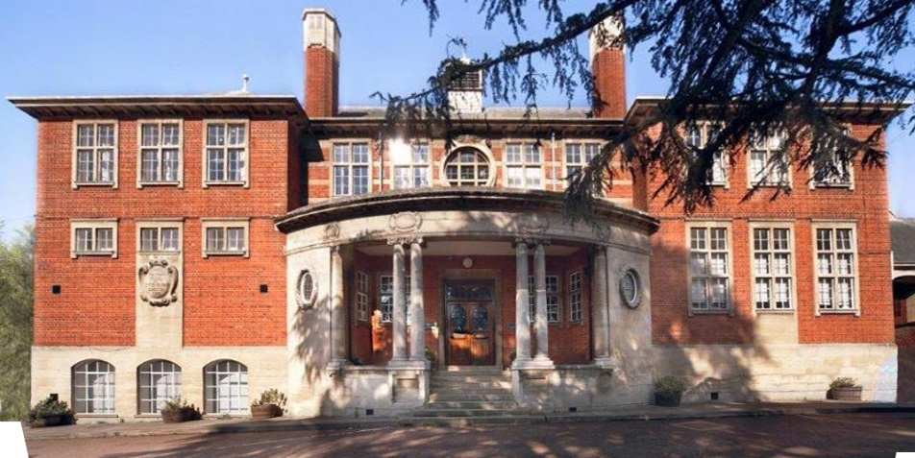

The Trust, as of September 2017, is a Trust of seven schools: four secondary, one all through academy and two primary academies. Restlessness characterises all our academies: we are not afraid to challenge complacency and weaknesses identified are seen as opportunities to improve, the energy and drive for the ceaseless journey comes from our key ambition: ‘Every child deserves an outstanding education.’
This movement as a Trust offers a huge opportunity for up to date training, cross curricular working, bespoke professional development pathways and allows all staff to be at the cutting edge of national and international educational movement. All staff are encouraged to better themselves and we collectively celebrate success in a vibrant and healthy working community.

2017 EXAM RESULTS
A Level Results 2017
A* - A = 24%
A* - B = 50%
A* - E = 98%

GCSE Results 2017
Progress 8 = -0.23
Attainment 8 = 46.6
English and Maths Grade 4 or above = 73%
English and Maths Grade 5 or above = 49%

LEADERSHIP TEAM AND GOVERNORS
Principal
Mr D Cleary

Acting Principal
Mr R Taylor

Senior Leadership Team
Mr M Payne
Ms L Kirk
Miss K Nicholson
Mrs V McNair

Associate SLT
Mr G Luhrs
Mr J Davies

Chair of Governors
Mr P Machon

MISSION STATEMENT
To prepare our young people for life in a modern society by excelling academically and across the whole range of subjects. To develop young people that are what the CBI calls “rounded and grounded” and who are able to significantly and positively contribute to the community of Market Harborough and beyond.

OUR FACILITIES
Robert Smyth Academy was opened in 1607 as a single classroom school in the centre of the town. It then moved up to its current site in 1909. It occupies a site just outside the centre of the market town. The Academy is made up of a variety of buildings including specialist buildings for Sport, Music, and Art & Design.

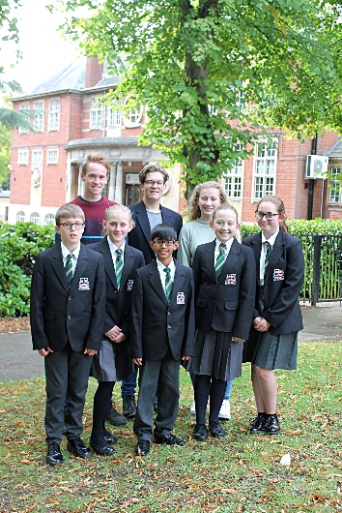
• Eight Science Laboratories
• Specialist building for Design & Technology and Art
• Specialist building for Music with rehearsal rooms
• Five ICT suites on the Windows platform
• Whole school network of over 200 PCs
• Media Studies suite
• Large Sports Centre with two Sports Halls and Changing Rooms
• Extensive sports fields surrounding the site
• Two cafeteria style dining areas with additional Food Bar in playground
• 6th Form Centre with 4 classrooms and study areas
• 6th Form only Café with study area
• 6th Form Quiet Study Area
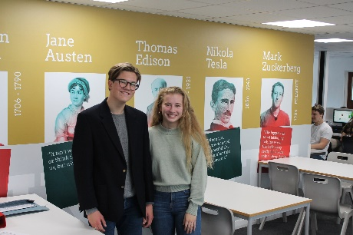
- 6th Form Wi-Fi

ACADEMIC ORGANISATION
At Robert Smyth we will be moving to a two week timetable in September 2018, with 25 one hour lessons in each week.
The philosophy of Robert Smyth is that each student is entitled to a curriculum that prepares him or her for life’s opportunities, responsibilities and experiences. Statutory requirements of the national curriculum are supplemented by the Academy’s broader curricular provision.
At Key Stage Three, students follow a common curriculum. In Years 9, 10 and 11 students are offered greater choice, enabling a more personalised curriculum that meets the needs of each individual learner; for example those needing extra help can do an additional studies course instead of one of the mainstream option choices.
Key Stage Three
All students in their first two years at the Academy study the core curriculum which includes English, mathematics, science, physical education, citizenship and guidance and religious studies. Their curriculum is enriched by studies in humanities, art, three design subjects, performing arts, digital literacy and a modern foreign language.
During Year 8, full consultation takes place between staff, students and parents to support curriculum choices at key stage four.
Key Stage Four
The Key Stage Four curriculum is designed to give students every opportunity to achieve their full potential and to maximise the choices available at Post-16.
All students in Years 9, 10 and 11 study English language, English literature, mathematics, science, physical education and citizenship and guidance. In Year 9 students engage in discrete religious studies lessons while in Years 10 and 11, the subject is taught as part of the citizenship and guidance programme.
Students are encouraged to comply with the EBacc subject list, so most are expected to study geography or history and a modern foreign language. There is a considerable amount of curriculum choice available for their remaining two options.
Key Stage Five
The curriculum in the Sixth Form is designed to prepare students for both university and the world of work. Each Sixth Form student has their own specific goal and ambition and we ensure that each student has a personalised curriculum that meets their individual requirements. Students choose from a diverse range of subjects so that they are able to participate in challenging and enjoyable courses. Extra qualifications such as the Extended Project are also available.
We provide a variety of opportunities within the Academy, and are proud that our students have been able to succeed as peer mentors, sports coaches, volunteer care workers and much, much more.

PASTORAL ORGANISATION
Students are looked after in one of four Colleges; Bragg, Hammond, Logan and Moseley. Each college is led by a College Leader, and are supported by a College Administrator.
In addition, we have two College champions whose role is to celebrate any good work with students across their Colleges in any arena of school life or indeed achievements outside of the community. When a student starts at Tudor Grange they are placed in vertical tutor groups; for 2018-19 these will be Years 7-8; 9-11; with Year 12 and Year 13 separate.

EXTRA CURRICULAR ACTIVITIES
As an Academy we feel strongly that the development of team and interpersonal skills is enhanced by the opportunities and experiences students have outside of the classroom. Hence, we provide a diverse breadth of activities that are part of a weekly timetable for students to opt into. These activities run before, during or after school and are delivered by willing and specialist staff who want to relay their knowledge and passion.
The list below shows just a small selection of the programme on offer:
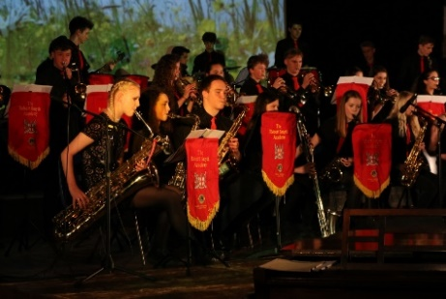
• Sports Teams including Football, Rugby, Netball, Hockey, Cricket, Basketball, Handball and Trampolining for both boys and girls
• Various Choirs
• Various Orchestras
• Drama
• Dance
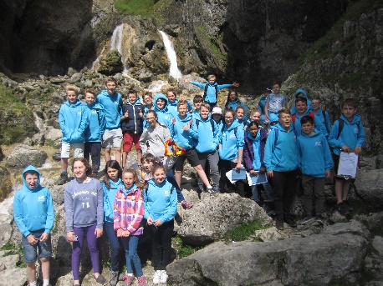
• STEM Club
• Chess Club
• Duke of Edinburgh
- Outlooks Expedition
