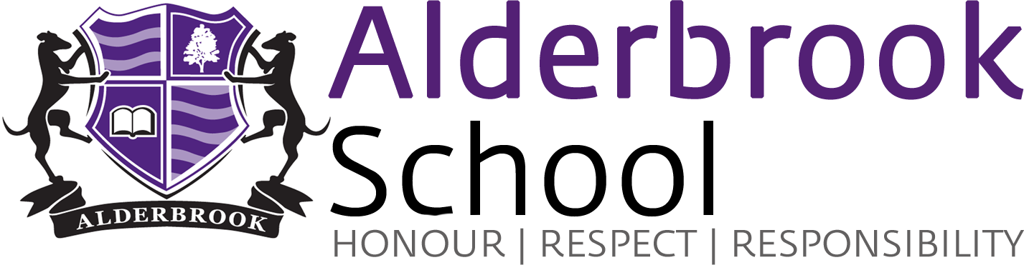

THE SCIENCE FACULTY, February 2018

The Science Faculty at Alderbrook currently has 11 full-time teachers, two part-time teachers and three lab technicians.

The team takes great pride in our students’ results. Our GCSE students have made good progress in Core and Additional Science and in Triple Science up till now, and we hope to maintain this with our first year group through the new Combined Science and Triple science courses. Results were encouraging for our first cohort of A level students and we hope to build on these with our current Year 13 students.

Our teaching staff range from NQTs to staff with over 20 years’ experience in teaching, all sharing a passion for science and a desire to use our expertise to inspire and enthuse our students. We ensure we keep up to date with our continually advancing subject knowledge and pedagogy by regular participation in both internal and external CPD in response to our own self-evaluation and the school’s priorities.

Teaching room accommodation for the Science department currently comprises ten fully equipped laboratories and an additional small A level teaching room. All of the laboratories, have been refurbished in recent years and they all have interactive whiteboard facilities.

At Key Stage 3 and 4 students are set according to potential and performance. Year 7 and 8 have 6 Science lessons per fortnight and year 9 have 8. We follow in-house Schemes of Work written for the KS3 Curriculum, which take into account the recent increased demand in maths and scientific enquiry skills required for GCSE and A level.

At Key Stage 4, for the revised GCSEs we currently offer 2 routes : AQA Triple Science and AQA Combined Science. All GCSE science groups in Key Stage 4 have 5 lessons each week. We follow the AQA Schemes of Work along with an online support package.

From September 2015 we have been pleased to offer AQA A level courses in Biology, Chemistry and Physics. We have high expectations for our Key Stage 5 students and are evaluating outcomes from our first results to build on our successes as we strive to offer the best possible results and overall experiences for those students who have committed to studying their Science A levels with us.

The Faculty is well resourced with practical equipment and text books in both key stages as well as online packages for students and staff. We run regular revision sessions and offer enrichment opportunities for students from all key stages, including gifted and talented groups, ranging from local and national competitions to visits and challenge days in school to stimulate their interest in science in the wider world.

We are very fortunate to have excellent technical support to facilitate lesson planning and delivery.

In summary, what we have to offer includes:

- A wide range of pupils – all of whom are valued and encouraged to achieve to their potential. They are consistently the best advertisement the school has and they are a credit to themselves and what we are trying to achieve here at Alderbrook;
- the opportunity to work with a friendly and welcoming team of committed staff, with a wide range of experience;
- the chance to teach a broad base of examination courses across the ability range;
- good opportunities for your own professional development.

Further information about courses, topics taught and assessment is available on the school website. We would also welcome you to visit the department to see the facilities and speak to staff who will be able to answer questions about the school, the faculty or the advertised position.

