Diocese of Westminster Education Service

Headteacher Recruitment Pack

for

St Lawrence Roman Catholic Primary School Feltham

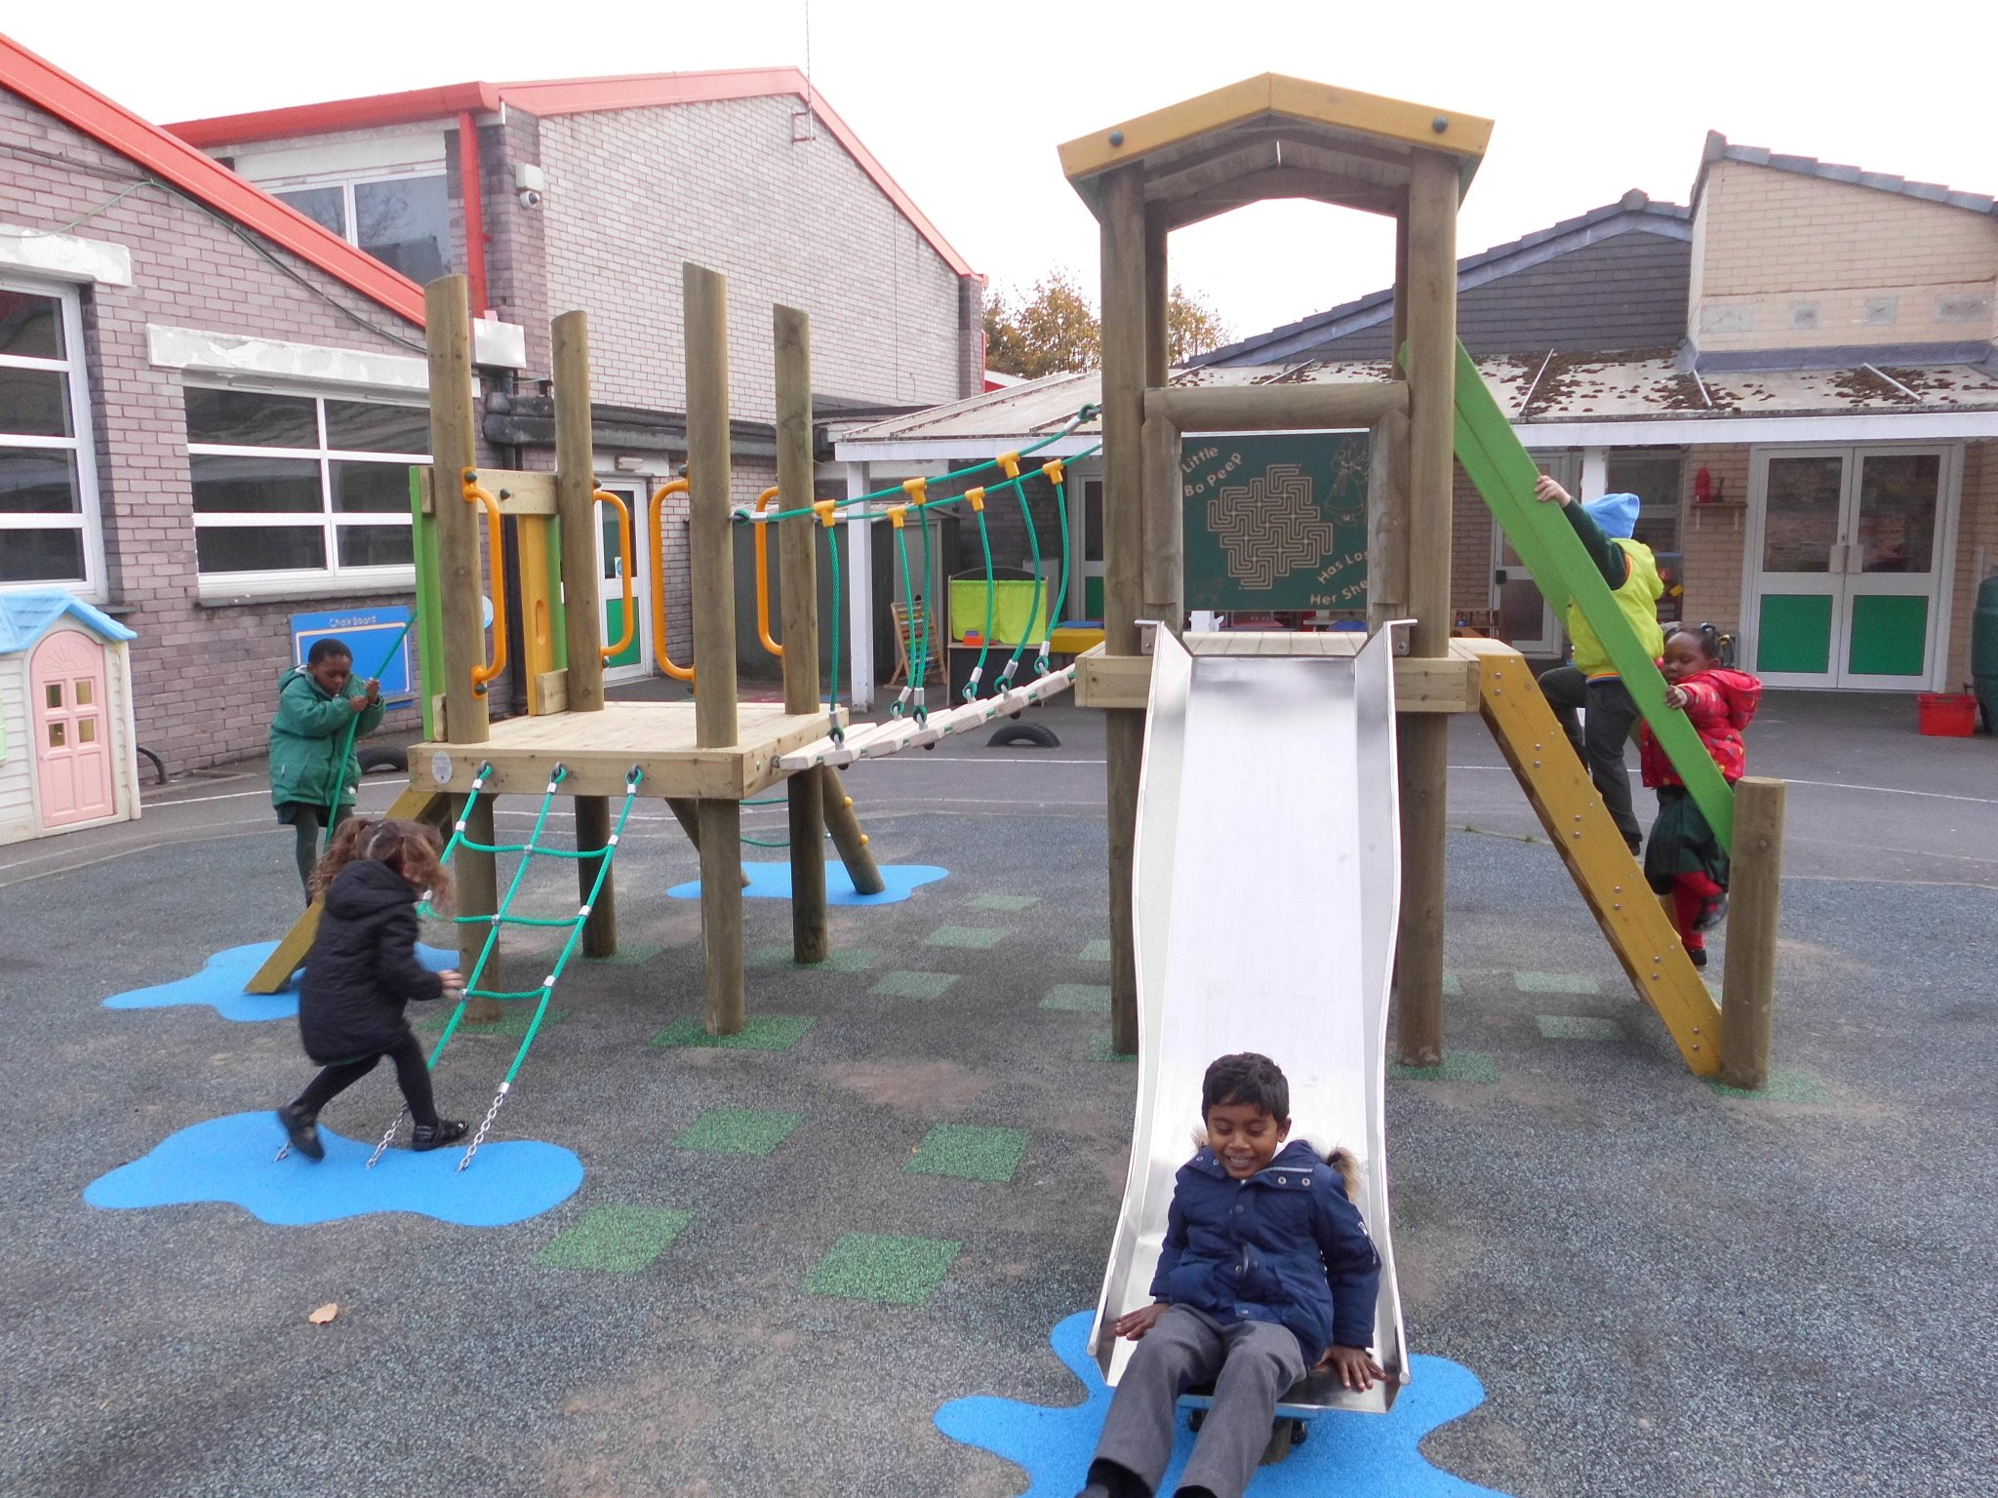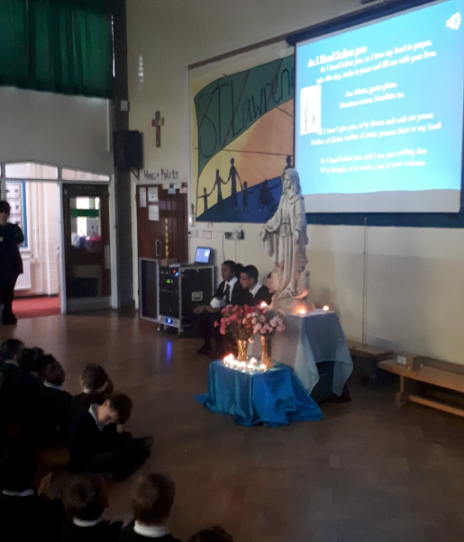

Contact Us

St Lawrence RC Primary School
Victoria Road, Feltham, TW13 4FF
Telephone: 020 8890 3878
Web: http://www.st-lawrencesprimary.co.uk/
Completed applications must be sent to schoolshr@hounslow.gov.uk

Role: Headteacher
Start Date: September 2018
Salary Pay range: Between L16- L27 Outer London (£60,202- £76,768)

Dear Applicant

Thank you for expressing an interest in the role of Headteacher of St. Lawrence Roman Catholic Primary School, Feltham. We are a two-form entry school with a happy, vibrant and friendly community that has a vision to continuously achieve ‘high standards through Christian values’.

The Governing Body would like to appoint someone who is ambitious, will uphold the Catholic faith, and take our school to the next level of educational excellence.

If you think you have the qualities, knowledge, skills and experience either as a current or aspiring headteacher to lead our school on the next stage of its journey, through the changing educational landscape, we look forward to receiving your application.

You are welcome to visit our school as part of the application process, when we will be happy to give you a tour. For further information, or to arrange a visit, please contact our school office on 020 8890 3878.

Leadership application forms can be accessed from TES.

Yours sincerely

Ade Marques
Chair of Governors

About St Lawrence RC Primary School

Our school is situated in Feltham in the London Borough of Hounslow, West London. We are at the heart of a diverse parish, which we are proud to have serviced since 1934.

We strive to maintain high standards for all children and staff by providing a conducive environment for teaching and learning. OFSTED judged our school as being ‘Good’ at our most recent inspection in February 2017, reporting that parents had an ‘overwhelmingly positive attitude about the school’s culture and all that it provides for the children’.

St. Lawrence was also rated ‘Outstanding’ at our last Section 48 inspection, which is due again during the current academic year.

Our school community is a core place in our parish where people come together to learn, grow and build friendships, all under God’s love and care. Consequently, the social, moral, spiritual and cultural development of every child is of great importance to us. We are Investors in People, and take pride in the support we give our staff to ensure their continuous professional development. This ethos supported by a very vibrant and committed Parents Teachers Association, has contributed to our pupils consistently making good progress across the school, which is why we have achieved ‘Good’ or its equivalent in every OFSTED inspection since 1997.

At St Lawrence we are committed to equality and diversity and the safeguarding of all children. As such, all appointments are subject to DBS checks.

Our Aim
Our aim is to embed and increase our ‘Good’ rating through continuous improvement in our children’s behavior, teaching, learning and our British and Catholic Values.
Our Mission Statement
Our school is a place, where we all come together as one community to learn, have fun and make lasting friendships, all under God’s love and Care.
About the role

The applicant must be a practicing Catholic, who will uphold the Catholic faith, school policies and practices, whilst ensuring a conducive environment for teaching and learning.
This role is open to anyone who has sufficient relevant experience of senior leadership and successful management in similar organisations, as the headteacher is responsible for deploying the school’s resources to promote educational excellence, and steer it through the changing educational landscape - both locally and nationally.
The successful candidate will be the ‘Designated Safeguarding Lead’ for the school.
This role benefits from a wide range of formal and informal support provided by peers within and around Hounslow, including the support of Hounslow Learning Partnership.
Important Dates

Application closing date: March 5th 2018
School Visits: Feb 19th - March 5th 2018
Shortlisting: March 12th 2018
Interviews: March 26th 2018
NB. To schedule a school visit please contact our school office on 020 8890 3878.
Key School Data
Type of school | Primary
Last OFSTED Inspection | 21st February 2017
Current OFSTED rating | Good
Section 48 Inspection | Outstanding
Age range | 4 - 11
Location | Feltham, Hounslow
Type of establishment | Voluntary Aided School
Co-ed. or single sex | Co-educational
Budget | Circa £2m
Number of children | 447 (children in Statutory school) +  45 (children in Nursery)
Average class size | 30
Average Termly Absence | 3.2%
Number of teaching staff (teachers & TAs) | 21 teachers + 18 TAs
% of children with FSM | 25 = 5.6%
% of children with SEND | 88 = 19.7%
% of children with EAL | 77%
Key Stage 1 attainment (2017) | EXS | GDS
Reading | 76.7% | 33.3%
Maths | 70.0% | 26.7%
Writing | 75.0% | 31.7%
Key Stage 2 attainment (2017) | EXS | GDS
Reading | 79.0% | 36.8%
Maths | 81.0% | 21.0%
Writing | 82.5% | 17.5%

Job Description
You understand the nature and purpose of Catholic education - and will be responsible for:
- Responsibility for Catholic Purpose and Identity of the School

- working with the Diocese of Westminster to sustain the Catholic identity of the school
- safeguarding the teaching of the Church
You will ensure that Catholic identity is reflected in every aspect of school life, particularly:
- Responsibility for Leadership in the School’s Catholic Education

- the curriculum, day-to-day organisation of the school
- staff development, staff and pupil relationships
- partnerships/relationships between school and its key stakeholders

This duty provides the context for the proper discharge of all other duties and responsibilities.
- Responsibility for Strategic Leadership
As the school’s strategic lead, you will work with, and be accountable to, the Governing Body:

- to maintain its relationship with the parish, staff and other stakeholders.
- to enable it to meet the specific requirements of governance in a Catholic school (e.g. the Trust Deed, admissions, personnel and financial matters).
- to draw on the person, life and teachings of Jesus Christ, to create and maintain a shared vision and strategic plan, which inspires and motivates pupils, staff and all other members of the community.
- to understand and communicate the mission of Catholic schools.
- to promote Gospel values in policy, practice and relationships.
- to ensure that the Religious Education programme is given full regard, not just in terms of the classroom, but the whole Catholic life of the school.

- Responsibility for Educational Excellence
As the leading professional in school, you will …

- determine and organise the curriculum linked to Catholic religious education, worship, liturgy and prayer, providing for pupils’ spiritual, moral, social & cultural development.

- identify excellence in teaching, and be able to demonstrate how it can be improved and sustained.

- ensure strategies for developing access to a diverse, inclusive, flexible and relevant curriculum, that are based on our equality as children of God.

- ensure that learning is at the heart of strategic planning and resource management.

- recognise the need to build partnerships locally, regionally and nationally, in order to achieve goals, and raise the standard of the school.

- be aware that you must use your influence on the Governing Body, local parishes and the local community, wisely to improve outcomes in the school.
- Responsibility for Managing the organisation
As the operational manager in school, you will …

- create an organisational structure that is affordable and maximises the chances of the school to deliver on its vision and Catholic ethos.
- establish and maintain a protocol of effective and on-going self-assessment and evaluation across the school.
- ensure due diligence in the school’s budget, and value for money with all expenditure.
- provide an efficient, effective and safe environment for learning and teaching.
- monitor, evaluate and review the work of the school to determine its effectiveness as a Catholic school.
- take responsibility for the school’s performance, and disseminating it appropriately to a range of audiences (e.g. governors, the Diocese, the LA, the local community, OFSTED etc.), enabling them to play their part effectively.
Person Specification
Qualification
 | QUALIFICATIONS
ESSENTIAL | - Practising Catholic  - First degree/teaching certificate or QTS  - Recent professional development relevant to senior management  - Have had, or are undertaking, further study relevant to headship (e.g. Diploma or Higher Degree)  - Hold the Catholic Certificate in Religious Studies or equivalent, or willing to undertake it.
CATHOLIC PURPOSE AND IDENTITY OF THE SCHOOL | - Be able to articulate the distinctive nature and purpose of Catholic education and be committed to developing the Catholic ethos of the school
DESIRABLE | - NPQH or comparable relevant experience in school leadership.

Leading Learning and Teaching
KEY AREAS OF HEADSHIP | EDUCATIONAL EXCELLENCE
Delivering continuous improvement | Can express clearly the importance of leading teaching and learning in terms of continuous improvement and raising standards
Modelling Excellence in Teaching | Can recognise where performance is poor, and has the confidence and proven ability to insist on and encourage higher standards
Learning Focus | Can demonstrate a passion for learning in all pupils and other members of the school community
Partnership and collaboration | Can demonstrate the ability to work with other agencies to bring about learning improvements
Organisation and community understanding | Can demonstrate an understanding of the power of relationships within the organisation and the wider community

Strategic Management
Key Areas | Requirement
Self-awareness and self-management | Can explain clearly their personal strengths and areas for improvement
Personal drive and accountability | Can understand the need to regularly account for their performance to governors and other stakeholders
Resilience and emotional maturity | Can understand the importance of maintaining personal and organisational values when faced with uncertainty and adversity
Conceptual thinking | Can show a wider understanding of educational issues based on their experience
Future focus | Can recognise opportunities for positive change, and the ability to negotiate with others to bring it about
Impact and influence | Can demonstrate an understanding of other points of view, but can also persuade others to their perspective by articulating a compelling vision

Operational Management
Key Areas | Requirement
Efficient and effective | Can understand how the school’s human, financial and environmental resources can best be deployed to achieve the school’s goals and secure value for money
Analytical thinking | Can collect, manipulate and interrogate data systematically in order to identify trends, evaluate performance and deliver continuous improvements.
Holding others to account | Can understand the importance of making interventions, even when this involves making unpopular decisions in order to achieve the agreed goals
Relationship Management | Can understand the critical importance of interpersonal skills and perception when managing others in order to achieve the school’s goals
Developing others | Can demonstrate a genuine commitment to improving others in the organisation, and the value of a learning environment for all

Senior leadership application forms can be accessed at TES Online.

Completed applications must be sent to: schoolshr@hounslow.gov.uk

St. Lawrence RC primary school is committed to safeguarding and children’s welfare. This appointment will be subject to various checks including receipt of a satisfactory enhanced Disclosure and Barring Service check.

