Eynsham Partnership Academy Trust

Chief Financial Officer

Recruitment Pack

Witney Road, Eynsham, Oxon, OX29 4AP
epa-mat.org

Eynsham Partnership Academy Trust
Chief Financial Officer
Recruitment Pack

Thank you for expressing interest in this exciting and vital role within our multi-academy trust. Eynsham Partnership Academy is at an exciting and challenging point in its development and we hope that this pack provides you with the information you need to apply for the position of Chief Financial Officer. This vacancy has come about as a result of our current Chief Operating Officer, Mike Lawes, retiring after six successful years within the Eynsham Partnership Academy Trust.

The Eynsham Partnership Academy (comprising Bartholomew School, Eynsham Community Primary School, Standlake CE Primary School, Stanton Harcourt CE Primary School, Hanborough Manor CE School, Freeland CE Primary School and St Peter’s CE Primary, Cassington) was formed on 1st May 2014 and it was the first multi-academy trust nationally that comprised of a community secondary and primary school, and voluntary aided and voluntary controlled church schools. This left us with a unique set of Articles of Association.

As the number of academies, young people and members of staff increase within the Trust, so do our responsibilities and accountabilities, and no more so than those relating to Trust finances. We are now a medium sized business and dealing with everything that this entails. The Eynsham Partnership Academy was founded to build a family of schools dedicated to high academic achievement and developing well-rounded children, providing the best possible learning environment for all young people. The post of the Chief Financial Officer is vital in making sure that resources are available for the Board and the Headteachers to be able to carry out their duties to enable our young people to have outstanding educational opportunities. Ultimately, our aim is that each young person will be able to leave our academies having experienced an outstanding education, whether the next phase of their lives is to move on to university, high quality work placements or work within our community.

An important part of the role of the Chief Financial Officer is to ensure that the Trust is compliant in all financial matters; these issues are covered within the job description and will be covered in further detail during the interviews.

Currently within the Trust we have a small group of senior staff who work closely together ensuring that the professional services we offer to our academies is outstanding. This group is known as the Strategic Academy Leadership Team and currently includes:

- Chief Executive Officer/ Primary Executive Lead
- Chief Operating Officer
- School Improvement Officer
- HR Manager
- Trust admin officer
- Company Secretary

From September 2018 a central services support team for Finance, HR, Health and Safety and Facilities management will become operational and the Chief Financial Officer will lead and develop that team to support the day-to day activities of the trust and secure the delivery of the Trust’s aims.

The aim of the Eynsham Partnership Academy is for all schools to have the maximum level of autonomy in all aspects of its functioning. However, it is recognised that the areas of financial autonomy and standards autonomy are those of highest risk to the overall efficient and effective functioning of the Trust as a whole. The new Chief Financial Officer will be instrumental in maintaining the highest financial standards across the Academy.

The new Chief Financial Officer must be able to communicate with a wide variety of audiences, from presenting to the Board, to working at a highly technical level when answering questions from auditors or the Educational and Skills Funding Agency. More crucially, they will also be dealing with non-specialist finance staff including academy Headteachers.

Our successes are built upon the efforts of a hard-working and enthusiastic staff, well-motivated students and supportive parents. Our Academy Board has a strong connection with the local communities it serves and benefits from the expertise that the Oxford Diocesan Board of Education brings as a corporate member.

To find out more about this exceptional opportunity or for a confidential discussion about the role, please contact Catherine Barker, Administrative Officer on EPAAdmin@bartholomew.oxon.sch.uk or phone 01865 881430 ext 279. Applications can be made using the EPA application form available on the website or by request.

We look forward to hearing from you.

Sarah Kerswell
Interim CEO

Eynsham Partnership Academy Trust
Chief Financial Officer
Recruitment Pack
Vision

The Eynsham Partnership Academy (EPA) was founded to provide the best possible education for all young people in our communities and for those outside of our communities who choose to attend our member academies. The essence of this is that all the academies in the EPA have committed to working together to generate excellence in their educational provision so that all students within all academies receive the best possible educational opportunities and experiences available to them.

Our belief is that all young people can succeed if they have access to exceptional education in an empathetic, supportive education environment. It is our ambition to provide this for all the students in all of our academies.

The primary aim of the EPA is to ensure that all member academies develop in their students a deep and sustained passion for learning, alongside the academic and character skills necessary to achieve their ambitions, preparing them for the opportunities, responsibilities and experiences of life as global citizens.

Values

We expect every member of the EPA community to take responsibility for shaping their future and be instrumental in shaping the futures of their communities. At its inception, the EPA academies collaboratively developed a set of core values which need to be embedded in all of the academies whilst allowing each academy to develop a distinctive identity, appropriate to the academy’s designation and relevant to its local community.

The starting point for the creation of the EPA was the development of these agreed, overarching generic aims for the EPA that all the academies subscribe to and will work to deliver.

These aims can be summarised as:

• Raising aspirations
• Promoting thinking
• Developing leaders
• Building community
• Ensuring well-being
• Celebrating diversity
• Embracing the future

These overarching aims are being used to develop a common ethos and approach to providing the kind of education that we aspire to for all our young people and that strives to deliver excellence across all areas of that education. These aims are broadened out to give us our objectives, the outcomes that we are aiming for, the impacts that we are trying to achieve, and the PIP and EPA development plans that will enable us to reach these ambitious goals.

Strategic priorities

We have identified the following key priorities arising from our vision and values. They are:

Teaching, Learning and Assessment:
- To ensure that our Schools provide the very best teaching in order to promote and provide high quality learning for our children and that there is support in place for teachers to achieve this and make a difference to our students.
- To develop and implement an academy-wide CPD programme to ensure that staff have the right skills to raise standards further.
- To ensure that the EPA Standards Committee have a rigorous and robust programme of Quality Assurance and self-assessment that helps to support teachers, build expertise and capacity and continually raise standards in our Schools to deliver positive outcomes for students.

Finance and Central Services:
- Ensure financial security, stability and probity across the Trust in order to deliver value for money across all of our operations.
- To build a strong central services infrastructure at Trust level.

Leadership and Governance:
- Through creation of a MAT handbook to have Governance arrangements that demonstrate effective oversight in order to achieve the greatest possible economies and pupil outcomes.
- To ensure that the Trust is well prepared for any external monitoring and inspection.
- To provide support and resources to our VA and VC schools so that SIAMS outcomes are at least ‘good’.
- Ensure all schools within the academy continue to put students’ welfare first.

Local Impact:
- Develop key local relationships, particularly between our primary schools and feeder secondary schools with regards to smooth student transition.
- To respond to emerging local priorities for example, Oxfordshire LEP.

MAT Expansion:
- Ensure long-term sustainability of the MAT through appropriate expansion opportunities.
- Increase our presence in the south of England, selecting growth on the basis of a firm commitment to co-operation and a good match for our existing academies.

Eynsham Partnership Academy Trust
Chief Financial Officer
Recruitment Pack

Organisational Structure

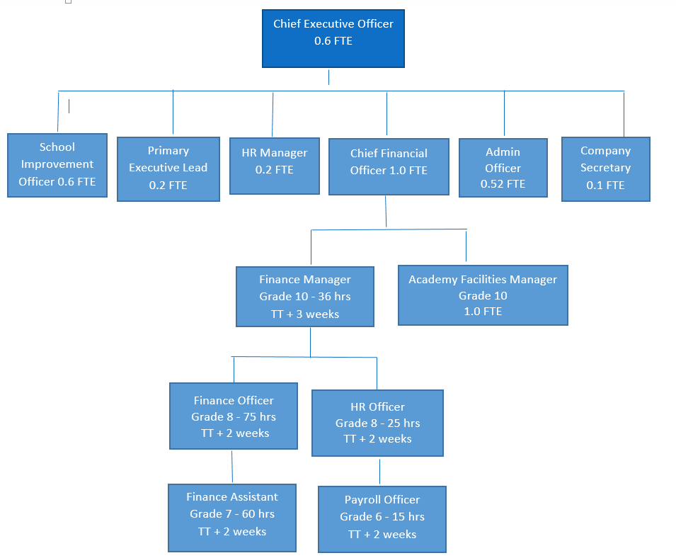

Eynsham Partnership Academy Trust
Chief Financial Officer
Recruitment Pack
Job Description

Post Title | Eynsham Partnership Academy Chief Financial Officer | Department | Senior Academy Leadership Team
Reports to | Chief Executive Officer | Salary Package | Grade 18 on the NJC Green Book Pay Rates plus a top allowance of up to £3,013  Plus Local Government Pension Scheme
Liaises with - internal | EPA member academy Headteachers, EPA finance and payroll officers, EPA Facilities Manager and EPA Company Secretary.
Liaises with - external | Chair of the EPA Directing Board, Chair of the EPA Resources & Financial Management Committee; Chair of the EPA Audit Committee; Chairs of Local Governing Bodies; Chairs of Local Governing Bodies Finance & Resources Committees; external auditors; external accountants; external solicitors; Peer Reviewer; ESFA Assurance Team; DfE Academy Converter Team; Regional Schools Commissioner, HMRC; insurers; independent actuaries; accounting systems provider, payroll provider, and other key suppliers and stakeholders.
Line manages | EPA central support services team
Working Hours | This is a senior post within the Trust carrying significant responsibility and as such is a full time, full-year post with flexible working
Holiday entitlement | 29 days, increasing to 32 days after 10 years continuous service

Job Purpose:

To be the Trust’s Chief Financial Officer and provide strategic vision and leadership in all business-related aspects of work in the Trust, in support of the overarching aim of raising achievement and providing an outstanding education to the students in the Trust and specifically to:
- Lead the financial management of the trust, identify opportunities to improve the financial strength of the Trust and ensure effective procedures and systems are in place
- Develop a business approach to the Trust’s financial management and development
- Lead and develop a central support services team of associate staff to support the day-to day activities of the Trust and secure the delivery of the Trust’s aims
- Be accountable for the development of the Trust’s estate

Key areas of responsibility:

1. Leadership
Be the Trust’s Chief Financial Officer, providing a key leadership role across the Trust in all financial, operational and governance matters and be accountable to the Chief Executive Officer and the Trustees for all aspects of financial management in the trust.

2. Financial planning
Deliver comprehensive financial planning information across all member academies and the Trust, including budgeting, detailed forecasting information and other planning information as required.

Work with the Chief Executive Officer, Trustees, Headteachers and Governors to offer advice and support on all financial issues and to establish priorities for expenditure and monitor the effectiveness of spending and usage of resources through benchmarking to ensure value for money.

Oversee the management of all strands of the Trust’s funds, managing the cash flow effectively, managing and monitoring the investment of the Trust’s reserves and funds to ensure efficient use, working with our bankers to ensure zero risk scenarios and tight investment controls.

Be familiar with all the different funding streams which make up each school’s budget and be aware of who has direct responsibility for each one.

Seek opportunities for generating revenue for the Trust.

Ensure that a consolidated budget (including individual academies within the trust) is submitted annually to the ESFA by the notified deadline.

3. Reporting
Ensure the deliver timely and accurate financial reporting across all member academies and the Trust, including budget monitoring, management accounts, detailed benchmarking information, clear narrative commentaries, information for year-end accounts, financial reports to the EPA Directing Board Finance & Resources Committee and the EPA Audit Committee and any other financial reports required.

Attend all meetings of the EPA Directing Board, the EPA Resources & Financial Management Committee, the EPA Audit Committee, the EPA Senior Leadership Group and the Bartholomew School Resources & Financial Management Committee and other local governing body finance and resources committees across the EPA as necessary.

Ensure all financial returns and reports are submitted to the ESFA and other agencies within published deadlines.

4. MAT strategy and projects
Perform a key role in the development and implementation of the Trust’s strategy and projects, including supporting the growth of the Trust, project managing academy conversions, embedding new academies in the Trust, developing central support services, establishing priorities for developing the premises and facilities within the trust, develop a Trust capital development and risk management plans, co-ordinating capital project and other projects as required.

Seeking opportunities for generating revenue for the Trust, including through the provision of financial services and support to other schools and academies.

5. Compliance
Ensure full and timely compliance with all external regulatory bodies in respect of financial and governance matters, including ESFA, HMRC and auditor requirements.

Work as the Trust’s liaison with the auditors and respond to audit reports, implementing actions where necessary.

Liaise and support the Trust’s Data Protection Officer in relation to all requirements of the General Data Protection Guidelines.

6. Systems and controls
Construct and review annually agreed policies and procedures on financial systems and controls and ensure that these meet the essential principles of financial management and governance and the financial framework for academy trusts as set out in the Academies Financial Handbook issued annually by the ESFA.

Ensure robust financial systems and controls are in place across all member academies and the Trust, including procedures to safeguard finances and to ensure efficiency and value for money.

Manage the Trust’s asset management/inventory system.

Ensure the monitoring of financial issues relating to all internal businesses: school meals and lettings.

7. Human Resources
Oversee all HR matters including staff contracts, safeguarding and clearance checks, single central record, staff salaries, expenses, maternity and sickness procedures and the maintenance of confidential staff records.

Have responsibility and accountability for three yearly automatic enrolment to pension schemes.

Have accountability for the performance management of the Trust’s central support services team.

Liaise directly with the Trust’s payroll and payroll administration service provider.

Ensure that the Trust complies with the public sector apprenticeship targets of 2.3% of the Trust’s headcount between April 2017 and March 2021.

8. Site, Facilities, ICT and Health and Safety
Work with the Chief Executive Officer, Trustees, Headteachers, Governors and the Academy Facilities Manager to offer advice and support on all premises issues and ensure that priorities for developing the premises and facilities across the Trust are documented in Capital Development and Asset Management plans.

Work with the Chief Executive Officer, Trustees, Headteachers, Governors and the Academy Facilities Manager to ensure compliance with Health and Safety and staff and pupil wellbeing across the Trust.

Develop priorities for ICT infrastructure, facilities and support across the Trust to ensure value for money.

9. Marketing and branding
Develop a wider brand and communication strategy for Trust growth and any future Trust expansion.

Establish and develop links with the Regional Schools Commissioner, the Local Authority, developers and housebuilders to further trust growth.

10. Networking
Fully engage with established networking groups to share and benefit from personal development and training opportunities, collaboration and joint procurement opportunities i.e. FD Forum, Oxfordshire Academies Business Managers Group, NWLSC RSC MAT Reference Group.

Person Specification
QUALIFICATIONS | Source of Evidence | Essential/  Desirable
- A recognised finance or accounting qualification (e.g. ACCA or CIMA) or evidence of qualification by experience | A, I | E
- Evidence of relevant and continuous prof. development | A, I | E
- A recognised human resources management qualification or evidence of qualification by experience | A, I | D
- A recognised premises and health & safety management qualification (e.g. CSBM or DSBM) | A, I | D
- Graduate in Business, Information or Public Admin | A, I | D
EXPERIENCE | Source of Evidence |  | Essential/  Desirable
- At least 3 years in a leadership and management role | A, I, R |  | E
- Experience of financial management, using financial data and setting budgets | A, I, R |  | E
- Experience of producing budgetary estimates and reports  - Experience of working with stakeholders to develop strong financial understanding across an organisation  - Excellent numeracy and literacy skills | A, I, R  A, I, R  A, I |  | E  E  E
- Experience of performance management responsibilities and operation | A, I |  | E
- Experience of managing projects | A, I, R |  | E
- Experience of people management and HR | A, I, R |  | E
- Experience of successfully managing change | A, I |  | E
- Experience of premises management | A, I, R |  | D
- Awareness of current education issues and developments | A, I |  | D
- Experience of working with a variety of external partners | A, I |  | D
- Experience of developing staff through quality Continuous Professional Development and coaching | A, I |  | D
SKILLS AND ABILITIES | Source of Evidence | Essential/  Desirable
- A highly motivated team leader who is approachable and promotes positive relationships | A, I, R | E
- A proven track record as a leader and manager | A, I, R | E
- Excellent organisational skills including ability to prioritise and meet deadlines | A, I, R | E
- Ability to cope with the pressures of a demanding leadership position | A, I, R | E
- Ability to communicate orally and in writing to a wide range of audiences | A, I, R | E
- Ability to set and maintain high standards | A, I | E
- Ability to lead and manage initiatives to a successful conclusion  - Resourceful, reflective and able to solve problems | I, R  A, I | E  E
OTHER | Source of Evidence | Essential/  Desirable
- Commitment to working in comprehensive education | A, I | E
- Commitment to develop partnerships between the Trust and the community  - Car owner, with ability to travel between sites as required | A, I  A, I | E  E
- Commitment to working with trustees, governors and parents | A, I | E
- Is honest, has integrity and a confidential approach  - Excellent ICT skills | A, I  A, I | E  E
- Sense of humour! | A, I | E
- High expectations of self, staff and students and the Trust | A, I | E
- Team player and an energy giver | A, I | E
- Risk taker | A, I | E
- A reflective professional who wants to improve | A, I | E

Key: A = Application, I = Interview, R = References, E = Essential, D = Desirable
Eynsham Partnership Academy Trust
Chief Financial Officer
Recruitment Pack

The Application Process

To find out more about this exceptional opportunity or for a confidential discussion about the role, please contact Catherine Barker, Administrative Officer on EPAAdmin@bartholomew.oxon.sch.uk or phone 01865 881430 ext 279.

Closing date: Midday 23 March 2018.

Interviews: 16-19 April 2018.

The Trust is committed to safeguarding and promoting the welfare of children and young people/vulnerable adults and expects all staff and volunteers to share this commitment. Successful candidates will be required to undertake and receive a satisfactory Disclosure & Barring Service check as well as attending safeguarding training as part of this role

