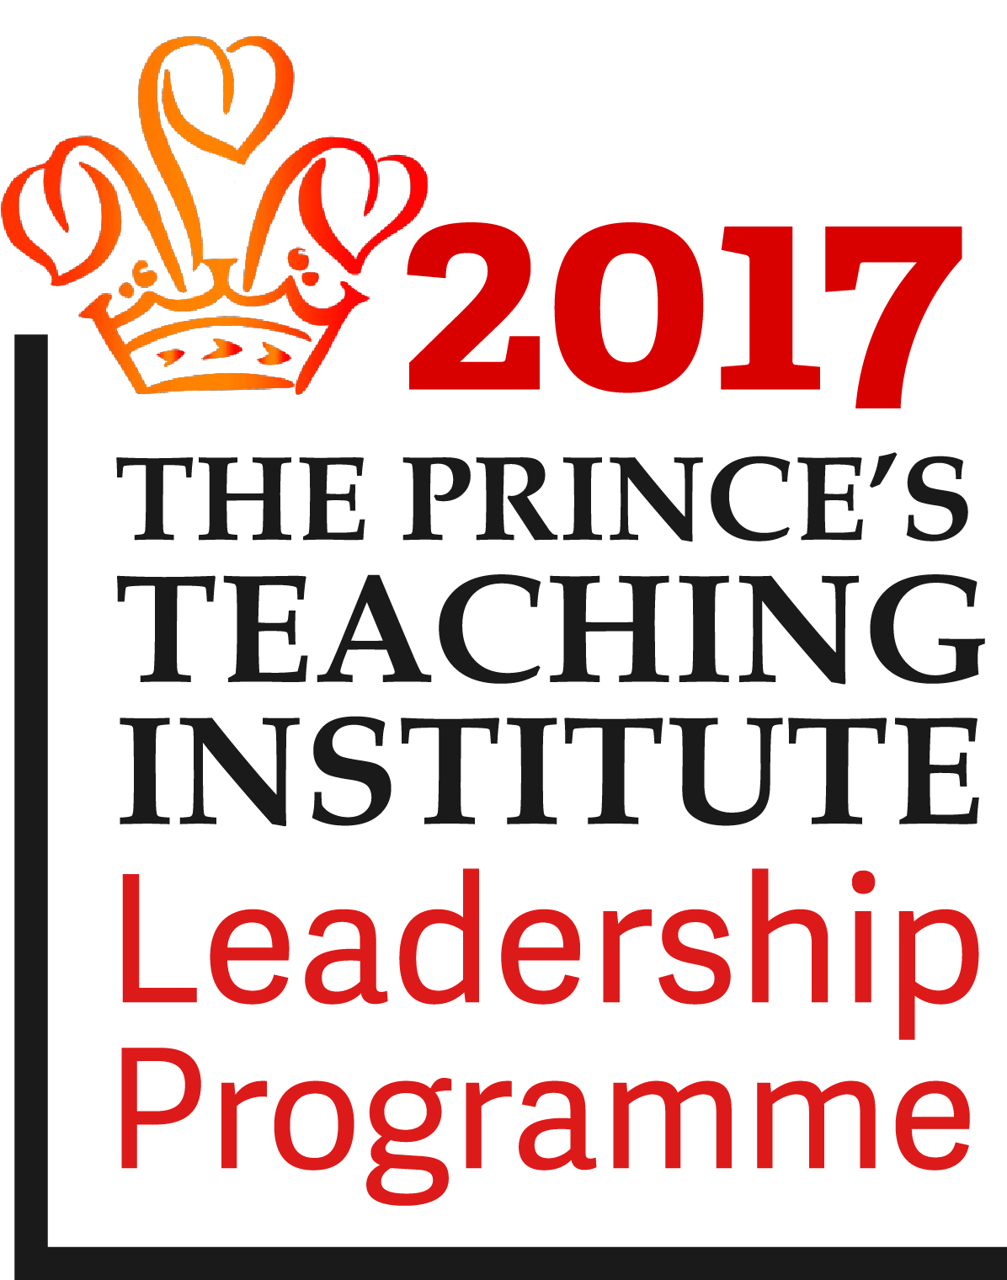 Bury Church of England High School





**Haslam Brow**

**Bury**

**BL9 0TS**

Tel: 0161 797 6236

Email:offman@burychurch.bury.sch.uk

www.burychurch.bury.sch.uk

**HEADTEACHER:** Revd Craig Watson MA BSc (Hons) NPQH

March 2018

Dear Applicant,

**Teacher of Design and Technology**

Thank you for your interest in Bury Church of England High School. I hope that the information provided here gives you what you require at this stage as you consider whether or not to apply for the post.

The school is full and annually oversubscribed with capacity for 826 pupils on roll. The attendance rate is 95.53% and unauthorised absence 0.6%. Parents tell us that they choose to send their children here mainly because of the school’s high academic standards, caring Christian ethos, orderly and work centred atmosphere, very good working relationships between staff and pupils and the emphasis we place on promoting the progress and achievement of the individual child. Parents are very supportive of the school.

We are proud of the school’s good practice and high standards of achievement. Like any school we also have our challenges, but through our collective efforts Governors, staff, parents and community partners are committed to improving the effectiveness of the school yet further. Our aim is to provide a high quality educational experience for our pupils as we help to prepare them for adulthood and lifelong learning.

We sustain high levels of attainment, which exceed national standards and expectations. Performance in the end of Key Stage 3 assessments is consistently good and GCSE results are well above local and national averages. We enjoy a very good local reputation and strong relationships with the Churches, LA, community organisations, business, primary schools and colleges.

The school's Christian foundation dates back to 1748 and the present buildings opened in 1964 with a Sports Hall added in 2004 and further adaptations more recently. We occupy an open site including extensive lawns, playing fields and tennis courts close to Bury town centre. The school is a Church of England voluntary aided school where the Governors are the employer and staff have National Society contracts of employment.

The Governors seek to appoint well qualified, innovative and committed individuals who will support the values, aims and ethos of the school and work hard with us to help realise our vision.

We place great emphasis on helping staff settle happily and purposefully with us. Careful attention is paid to their induction and subsequent professional development. The successful applicant can look forward to joining a strong and supportive team of dedicated and hard working colleagues.

The closing date for applications is noon on Monday 19th March 2018. We will inform shortlisted candidates by letter, or it may also be by telephone so please make sure that you include your contact telephone number in your form.

I look forward to receiving your application.

Yours in Christ,

Rev’d. C Watson

Head Teacher

****T:\Office Staff\Logos\Standard - Full Welcome Pack\IIP Standard Logos\IIP Standard Logos (Standard)\JPEG RGB Versions\IIP Award Brand Mark Standard (Standard) Black.jpg****