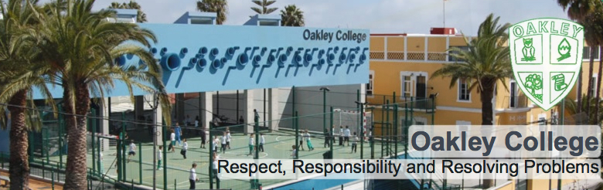

ICT TEACHER WITH PE

For the months of April, May and June 2018.

POST INFORMATION
We require a teacher to cover sickness absence, being able to teach ICT (CIE) up to IGCSE and PE across secondary. The post begins after our Easter break on 9.4.18 and finishes at the end of our summer term on 29.6.18.
It is recommended the successful candidate arrives the week before the post starts to organise accommodation and get the legal paperwork sorted (with the help of our admin team).

INFORMATION FOR CANDIDATES
Oakley College is situated on the outskirts of Las Palmas, capital of the beautiful island of Gran Canaria and of the wider Canary Islands. Since its foundation in September 1989, Oakley has grown to a co-educational British International School of 610 students, from 2-18 years of age (Pre-Nursery-Sixth Form). Our Early Years and Primary school (ages 2-11) deliver an adapted Early Years Foundation Stage and English National Curriculum, incorporating strong elements of thematic and enquiry-based learning. Our Secondary students (aged 12-18) study a minimum of five subjects in preparation for IGCSE and A-Level examinations, their learning journeys adapted according to their individual needs and in response to whether they are expatriates or Spanish nationals. Primary and Secondary pupils study Spanish language and the history and geography of Spain, throughout the duration of their studies at the school. The Oakley College family includes children, parents and staff from more than fifteen countries; therefore while levels of English proficiency are generally high, an awareness of how to adapt lessons for EAL learners, as well as a range of learning styles, is essential.

We pride ourselves on our strong academic programme, our family atmosphere and positive links with the local community and, above all, the committed team of staff who care for and educate our students. The school seeks self-motivated professionals who can achieve excellence by positively adapting to an international setting, whilst maintaining the very highest expectations of their students and themselves. The ideal candidate would be fully qualified (with QTS) and have a minimum of two years’ experience of teaching the National Curriculum.
We offer a teachers salary, a relocation allowance and administrative support with all core areas of establishing yourself as a resident of Gran Canaria.

Full details of how to apply for a position at our school are included at the end of this information pack.

OUR LOCATION

The school is on the outskirts of Las Palmas in the residential area of Tafira. It is easily accessible by public transport and staff often live in Las Palmas by the beach district of Las Canteras or nearer the school in the residential area of Tafira Alta, close to the university, national park and gateway to the mountains.

OUR PHILOSOPHY

We believe that a caring and stimulating environment is essential to the development of children. We aim to provide a high quality educational experience to our students, ensuring a passion for learning and life.

OUR VISION

A confident learning community

OUR MISSION

"To provide a high quality British education in a caring family environment"

OUR CORE VALUES

Respect, Responsibility and Resolving Problems
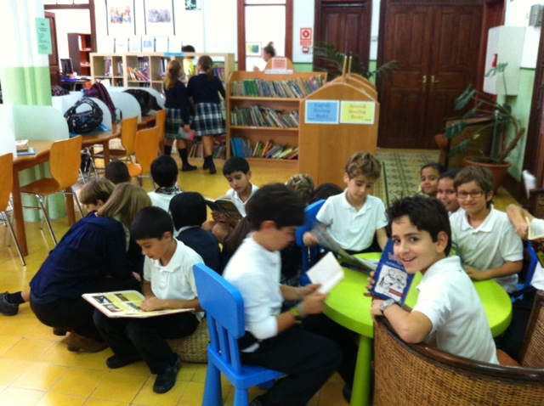

CAMPUS & FACILITIES

The school combines traditional Canarian buildings with 21st century architecture, on two sites a few minutes apart.

The Early Years site is housed in a spacious villa, situated in Calle San Quintín in Tafira Alta, near to the main school building. This accommodates children from 2 to 4 years of age and is equipped with age-appropriate outdoor play areas as well as a kitchen and dining facilities.

The main school building at Zuloaga combines a classical Canarian building, housing the Primary classes with the 21st Century architecture of the Secondary block. Visitors enter a main atrium that houses the school library and independent study areas for Secondary children; this site is equipped with science labs, an ICT suit and is the location for the main administrative offices. All classrooms and offices are linked by a powerful ICT infrastructure including IWB projectors, Internet in every classroom and a file server.

The recently completed modern building extension accommodates the sixth form classes and the new gymnasium. The school is equipped with a number of outdoor play spaces and a neighbouring sports ground.
The Teaching Day

SECONDARY
8.20 on Monday  8.30every other day  Required in school | 8.35 -8.50  Tutor period | 8.50 - 9.40  Lesson 1 | 9.40 – 10.30  Lesson 2 | 10.30 -11.20  Lesson 3 | 11.20-11.35  Break | 11.35- 12.25  Lesson 4 | 12.25- 13.15  Lesson 5 | 13.15- 14.05  Lunch | 14.05-14.55  Lesson 6 | 14.55-15.45  Lesson 7 | 15.45- 15.50  Required in school

* The above reflects the duration of the teaching day; as in all quality school settings, the length of the working day will vary.

The school also provides administrative support in meeting the legal requirements for foreigners wishing to live and work in Spain, including:

- support in obtaining the legal documentation necessary to work as a foreigner living in Spain
- support in registering with your local doctor
- assistance in opening a bank account and organising direct debits etc

SALARY/conditions

Salary is 1.600€ net for the month (pro rate for April).
Secondary teachers have 5 (50 min) periods non- contact a week.
One return flight will also be paid.
Accommodation is the responsibility of the candidate however assistance can be provided by our admin team.
All legal paperwork is organised by the school.

INTERVIEW PROCEDURES
Dhort listed candidates will be interviewed by skype.

See the following link for cost of living information in Las Palmas:
Las Palmas - cost of living information
http://www.numbeo.com/cost-of-living/city_result.jsp?country=Spain&city=Las+Palmas

Further information available at:
http://www.oakleycollege.com/index.php/en/staffing

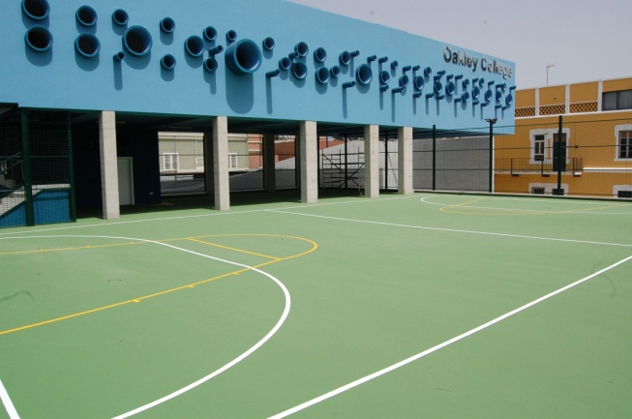

JOB DESCRIPTION FOR TEACHERS
Job Purpose | To teach students, creating an environment where they want to learn and where they can naturally discover their true passions, taking responsibility for their academic progress and pastoral care.
Line Managers | - Head of Secondary School
Learning and teaching | - To plan, prepare and deliver schemes of work in accordance with school policies.  - To maintain a working knowledge of National Curriculum & other DFE documents.  - To maintain records of pupils’ progress including all statutory documents required by the UK DFE or the Spanish Ministry of Education.  - To produce reports and grades for pupils as per the school calendar.  - To conduct termly meetings with parents to discuss and explain their child’s  performance and progress in school.  - To provide and maintain an attractive and stimulating environment in which to foster effective teaching and learning.  - To monitor progress and the effectiveness of class work and to evaluate and modify planning and teaching as necessary
Managing | - To understand and implement:  - Regulations and correct procedures relating to attendance registers  - Emergency and evacuation procedures  - Health and safety policies  - All curriculum polices  - Any other organisational policies or agreed procedures  - To conduct standardised or other tests when required and document pupils’ performance  - To attend and participate in weekly staff meetings and also on other occasions as required  - To attend and participate in all training sessions  - To supervise playtimes and lunchtimes when required  - To supervise pupils in assemblies when required  - To liaise with colleagues enabling satisfactory transfers of children within school between schools and hand over to new staff  - To promote the subject(s) within the school and provide enrichment opportunities  - To provide additional activities and opportunities for pupils outside the classroom
Pastoral | - To be aware of the physical and emotional well-being of pupils and the need to respond to particular situations.  - To carry out duties of care as a form tutor and also during non-class times.  - To understand and implement all welfare and safeguarding policies.  - To liaise with other staff as required e.g. educational psychologist.  - To promote and safeguard the welfare of all pupils at school.
Other information | - Teachers at Oakley College are required to adhere to DFE Teachers’ Standards (published September 21012)

Person Specification

Qualifications

Essential
Degree or equivalent in relevant subject
QTS with at least two years’ teaching experience
Fluent English speaker
Eligible to work in the EU
Desirable
British educational background
International experience

Knowledge and Experience

Essential
A clear philosophy on how and why the
subject should be taught
Sufficient knowledge to challenge more able
pupils
Strategies to deliver differentiated lessons
Up to date knowledge of current educational
developments.
Desirable
Experience or awareness of pastoral and
academic roles and responsibilities as a tutor
EAL experience

Skills and Abilities

Essential
An understanding of how to use assessment for learning strategies to improve learning. Ability to motivate pupils and instil a love of
learning
Good communication skills.
Desirable
Ability to adapt and react positively in any given situation
Willing and able to offer enrichment and/or
extra-curricular activities
Suitability to work with children and commitment to safeguarding promoting the welfare of children.

Personal Qualities

Essential
Flexible, positive approach when dealing with students
High moral and ethical values
Good interpersonal skills
Ability to work independently and collaboratively
Passion for teaching
Desirable
Willingness to engage in local culture and
learn basic Spanish
Creative when approaching challenges,
offering solutions rather than obstacles.

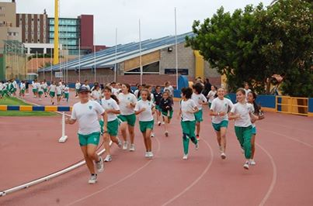

HOW DO I APPLY?

Please send your CV (with two professional referee) and letter of application, along with a recent photograph, to the Principal, Donat Morgan at jobs@oakleycollege.com
Successful applicants will be required to obtain a CRB (DBS) check and confirm they are medically fit to teach.

Oakley College
Calle Zuloaga 17,
Tafira Alta,
35017
Las Palmas de Gran Canaria
0034928354247
www.oakleycollege.com

Oakley College is committed to safeguarding and promoting the welfare of children. Applicants must be willing to undergo child protection screening, including reference checks with previous employers and an enhanced criminal record check.

Top 20 international schools in Spain link http://www.elmundo.es/mejores-colegios-internacionales.html

