HEAD OF MATHEMATICS
Applicant Information

VISION – “EXCELLENCE FOR ALL AND FROM ALL THROUGH CO-OPERATION”

As part of a co-operative society in operation since 1873 we place our ethical values at the very heart of everything we do.
Dear Applicant
I am delighted that you are interested in the position of Head of Mathematics at Lipson Co-operative Academy, to start in January 2018.
The Academy has secured its position as an established and highly valued inclusive school which has improved in terms of results and reputation over the last two decades. During this time we have been a Specialist Arts College, Co-operative Trust College and more recently converted to Co-operative Academy status in 2011.
We have consistently improved results and met the Governments floor targets within a selective authority; implemented a rolling programme of facility improvements, creating many flexible teaching and learning spaces, and provided a purpose built drama theatre used as a city wide resource.
One of our great strengths is the mature approach to their studies of the students and behaviour within the Academy, which was recognised by Ofsted to be outstanding. We believe that this must be maintained as it is one of the fundamentals for our success.
We are proud of our history and achievements having only had two principals since the school was built in 1983 but equally we are ambitious and excited looking forward to the next phase of our development and rising to the challenges of GCSE, AS and A Level reforms, life without levels and the Governments drive to create more formal structural partnership in the ever changing educational landscape.
Whilst we aim to achieve high standards in all the traditional academic subjects, we are proud of our broad curriculum, with an emphasis on the creative arts, which enables all students to have the opportunity to shine, and we value activities in areas such as music, drama and sport. We stage high quality drama productions, musical performances, art displays and offer a wide range of sports and trips in order to enhance the educational experience of our students. We are truly a comprehensive academy and we aim to provide many experiences for our students: The Co-operative Big Band, Jazz Band, orchestra, choirs and soloists perform at high profile events; Football, Rugby, Netball teams compete to the highest standard, winning leagues and tournaments, we encourage participation in the Duke of Edinburgh Award scheme and Ten Tors Teams annually compete in this challenging event on Dartmoor.
If you don’t know the area, then I would say that Plymouth is a wonderful place to live, work and raise a family. There are some very attractive parts of this coastal city, such as Plymouth Hoe and Barbican as well as being 15 minutes away from Dartmoor National Park and a bridge across the Tamar River to Cornwall, so if you like an active, outdoor life there are many opportunities and facilities both within the city and in the surrounding area.
Please contact us if you would like to make an informal visit to the school, or phone for any further information. I look forward to receiving your application.
Yours faithfully

Debbie Macleod
Chair of Governors

Introduction by the Principal

As the Principal of Lipson Co-operative Academy I am pleased by your interest in the role of Head of Mathematics.

Our Co-operative ethos strives for excellence for all and from all through Co-operation. The International Co-operative values of self-help, self responsiblity, democrary, equality, equity and solidarity are at the heart of all we do giving a voice to students, parents, staff and the community, not only on important issues, but in every part of the Academy’s life. We are particularly proud of our unique Guild structure and vertical tutoring system. The pastoral care and support of students is an enduring feature of the academy and cited by parents as the reason they choose to send their children to this school.

We want the best for our students and to be a school where teachers love teaching and children love learning. We make no apologies for asking you to reflect on what you believe and practice. We want teachers to join our team who genuinely care about children and who are prepared to work hard with colleagues to make a difference. It is very important that any applicants have very strong relationship management skills and that they are prepared to adopt our school values, pedagogy, cultural competencies, key competencies and developmental approach. Our vision and strategic goals are what drives us and you will need to be a positive and dynamic influence in our school. This position is an exciting opportunity to lead the school into the future. Our teachers are expert practitioners and totally committed to modern learning practice and deeper learning. They set the bar high for student achievement and model what we want from our students. We want our students to flourish. We are committed to raising student achievement and our core business is quality teaching and learning. We want to be the best that we can be for the children in our care.

Lynda Budd
Principal

LEADERSHIP AND GOVERNANCE

The Support and Leadership Team (SLT) consists of the Principal, two Vice Principals, five Assistant Principals and Business Manager. All members of the SLT are leading professionals in the Academy. They are the custodians of all Academy outcomes and standards. Working with the governing body and the Co-operative Academy Trust, the SLT provide vision, leadership and direction for the Academy and ensure that it is managed and organised to meet its values and principles. The SLT is responsible for the continuous improvement in the quality of education; for raising standards; for the development of policies and practices; and for ensuring that resources are efficiently and effectively used to achieve the Academy’s aims and objectives. The SLT also secure the commitment of the staff, students, parents and the wider community to the Academy.

All members of SLT have undertaken NPQH, Leadership Pathways or M-level CPD and one is currently working towards an EdD. SLT have also been trained through the Challenge Partners programme and have completed ECO training. The impact of their CPD is seen in their ability to evaluate learning, lead on new initiatives and help teachers develop their skills. Strong leaders have been developed at all levels at Lipson for the last two decades with eight SLT members moving on to headships and three moving to HMI and LA advisory service. We do not passively let suitable prospective candidates for key leadership posts simply emerge from the ether but take the long term development view and recruit candidates with potential and then hone that potential.

The governing body (supported by a Co-operative Trust) is effective, supportive of the needs of the school and provides regular challenge in order to hold senior leaders to account for all aspects of performance. It monitors standards through a committee structure and department link governors. Curriculum Committee works to a detailed data analysis calendar. Governors attend LA training and academy based CPD events which mean they are well informed to fulfil their statutory duties and challenge leaders effectively. The Chair of Governors holds each Committee Chair to account, evaluating progress and agreeing a calendar of action points for the year ahead. Governors have worked with HMI Pauline Robins as a SIP and to evaluate improvements since the last inspection. Governors evaluate the robust appraisal system, with exemplars of success criteria, objectives, CPD etc.

FINANCE
Financial management at the academy is sound. Annual Academy Accounts have always been unqualified and auditors' management letter detailed no further recommendations to be considered. Quarterly reviews undertaken by an internal auditor provides assurance that resources are managed in an efficient, economical and effective manner, that sound systems of financial control are being instigated and maintained and that financial considerations are fully employed in reaching decisions.
The sports and arts facilities of the academy are used by a wide range of community groups outside of school hours which also provides a valuable income stream.

The Campus

We are located on a beautiful site in a valley with plenty of playing fields on all sides. Since becoming an academy we have been fortunate to secure over £2 million of academy capital funding to improve our facilities which has enabled us to replace our boilers, all windows and roofs, refurbish toilets and address issues with our external concrete access routes. During this summer we have also replaced our 13 year old astro at the same time as being able to create a further MUGA facility on the site of unused hard courts.

CURRICULUM PROVISION
Principles of our Co-operative Curriculum

Learners are at the centre of our curriculum that aims to:

- Develop their meta-cognitive skills (the ability to think deeply);
- Acquire and use a good depth and breadth of knowledge;
- Inspire motivation to learn;
- Encourage study and a scholarly attitude;
- Raise the achievement of our young people to enable them to compete nationally and internationally;
- Enable students to progress to the most appropriate next step in their education.

Our Co-operative curriculum also acknowledges the socio-cultural nature of learning – and actively encourages well-organised co-operative learning (based on the latest OECD research).

Co-operative group work, appropriately organised and structured, has demonstrated very clear benefits for achievement as well as for behavioural and emotional outcomes. (See the Lipson Ofsted Sept 2012 ‘Best Practice in UK’ report.) Co-operative methods work for all types of students because, done well, they push learners of all abilities.

We recognise individual differences – Students differ in many ways fundamental to learning: prior knowledge, ability, conceptions of learning, learning styles and strategies, interest, motivation, self-efficacy beliefs and emotion; they differ also in socio-environmental terms such as linguistic, cultural and social backgrounds. The curriculum therefore is chunked into schemes of learning and rich authentic end point tasks. Lessons are then planned based on fine diagnosis from the teacher.

Job Description
Post: Head of Mathematics

To oversee and be responsible for the Mathematics curriculum area, promoting high expectations and securing high standards of teaching and learning and ensuring good student progress. To lead the strategic direction and development of the subject area.

Summary of the Role

The principal responsibilities are set out below. The list is not exhaustive, and aspects of the job description may be adjusted from time to time to take account of developments at Lipson Co-operative Academy.

Strategic Leadership | Take a leading role in:  - Raising Attainment and Progress within the Mathematics department and the whole school;  - The development of innovative teaching within the Mathematics department using methods that make full use of modern technology, cross-curricular teaching and performance, supporting personalised learning in an environment of mixed-ability teaching for all year groups;  - Attending Curriculum Meetings to develop and embed all aspects of the Mathematics programme in the whole school curriculum;  - Developing a culture of pride in achievement and progress with high expectations for all;  - Recognising the importance of all aspects of the philosophy behind the Mathematics programme to the curriculum and incorporating them into school life;  - Developing a rich and exciting extra-curricular programme for Mathematics.
Planning and Setting Expectations | - Establish a shared understanding of the characteristics of high quality tutoring and the main strategies for improving and sustaining high standards of achievement for all students.  - Set high expectations and targets for staff and students in relation to standards of student achievement within the Mathematics department.
Teaching and Learning | Take the lead in:  - Improving the Quality of Teaching and Learning in a mixed ability teaching environment within the Mathematics department;  - Using and demonstrating technology to best effect in the classroom and whole school environment where relevant;  - Keeping all teachers up to date with changes and developments in Mathematics;  - Lead staff training in areas of Teaching and Learning in Mathematics;  - Ensuring appropriate systems are in place to track and monitor student performance;  - By liaising with all staff including the SENCO, that regular monitoring of attitudes to learning across the school provides clear evidence to deploy support for staff and students in engaging more effectively with learning;  - Establishing a coherent programme of Mathematics using all resources in the school’s locality ensuring those children with particular interests and aptitude are encouraged and challenged through mentoring programmes, shadowing opportunities etc;  - Establish an outstanding department and be an outstanding teacher and role model.
Assessment and Evaluation | In collaboration with the Senior Leadership Team assess the impact of developments in Teaching and Learning on student attainment and progress within the Mathematics department.
Student Achievement | Work with all staff in establishing clear targets for students’ achievement outcomes and evaluate progress and achievement by all students
Liaising with Parents and the Wider Community | - Communicate effectively, orally and in writing, with parents, governors, external agencies and the wider community.  - Utilise expertise in the local community and beyond to enhance the Mathematics programme.  - Develop a working partnership with outside experts.  - Development of whole school partnerships for learning eg parental involvement and training.  - Share best practice with wider community.
Managing and Developing Staff | - Play a full part in staff review including peer mentoring and appraisal process.  - Nurture and coach colleagues, challenging current practice where relevant.  - Play a full part in recognising and organising relevant staff training.
Managing Own Performance and development | Prioritise and manage own time effectively, particularly in relation to balancing the demands made by teaching and leadership. Take responsibility for own professional development.

This Job Description will be reviewed annually

Person Specification
Head of Department
Attributes | Essential | Desirable
Qualifications | - Qualified Teacher Status  - Honours degree in relevant or related subject  - Evidence of a commitment to own professional development  - Recent relevant in-service training in the subject area  - Evidence of training with focus on current curriculum developments e.g. life after levels, Progress 8. | - Management qualification  - Masters level research
Work-related Experience and Associated Skills | - Excellent teacher  - Enthusiasm for teaching your subject  - Ability to teach KS3, 4 & 5  - Commitment to extra-curricular activities  - Wide-ranging subject knowledge  - Up-to-date with contemporary educational issues and development  - Experience with tracking student performance and calculating value added  - Experience with line management and performance management | - Management experience  - Track record of team leadership  - Experience of innovation
Experience | - Good/outstanding classroom teacher with high expectations and aspirations for our students’ achievement and behaviour  - Effective system leader with a clear understanding of process  - Proven track record in raising standards and supporting student achievement  - Proven leadership skills and ability to motivate and inspire others  - Clear commitment to continuous school improvement  - Experience of effective leadership of student behaviour for learning.  - High level of data literacy to analyse trends across school and initiate effective responses  - An excellent communicator with strong interpersonal skills  - Up-to-date knowledge of emerging issues in school leadership  - Experience of self-evaluation and action planning  - Experience of monitoring set targets in a specified action plan to evaluate and ensure progress  - Management of a team to ensure at least good student provision | - Training in areas complementary to job  - Ability to contribute to wider school activities
Shaping the future | - Strong driven leader – clear commitment to school improvement.  - Passion for teaching & lifelong learning.  - An understanding of the community context of Lipson Co-operative Academy.  - Have high expectations of student achievement and standards  - Raise standards still further to be above national indicators  - A vision for how outstanding Behaviour for Learning can contribute to student progress
Leading, Learning & Teaching | - Proven track record in leading creativity in teaching and learning  - Place learning at the heart of the school and further improve the quality of teaching and learning  - Be imaginative and innovative in leading teaching and learning  - Implement strategies to remove barriers to learning
Personal skills | - Ability to lead and motivate both colleagues and pupils  - Good team player  - Creative thinker  - High level of commitment  - Positive outlook  - Commitment to raising pupils’ standard of achievement  - Energy and enthusiasm  - Good communication skills  - Effective at delegating responsibilities  - An eye for detail  - Well-organised  - Imaginative  - A willingness to demonstrate commitment to Lipson’s co-operative values | Ability to think “outside of the box”
Safeguarding Children | - Commitment to safeguarding and promoting the welfare of children and young people  - Contributed significantly in the safeguarding of young people | Senior responsibility for Safeguarding

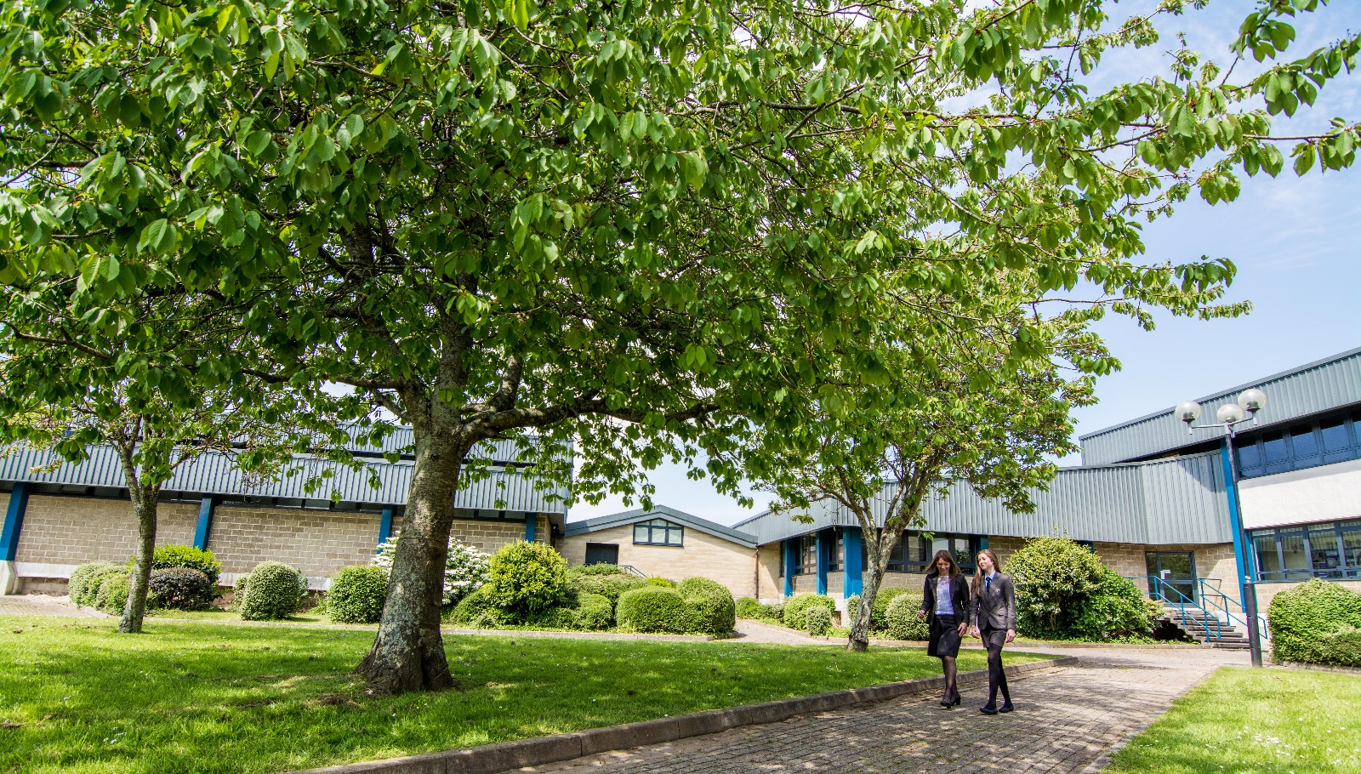

APPLICATION DETAILS
You must complete the application form fully and give details of all employment, training and gaps in employment since leaving secondary school to the present day. Any additional information, which you wish to bring to the notice of the school’s Governors, should be included in your supporting statement. Please ensure that you take each of the essential and desirable criteria found on the person specification and say why and how you meet these criteria in your letter of application.
For an informal discussion about the role please contact Lynda Budd, Principal on 01752 671318 or headspa@lipson.plymouth.sch.uk

References must cover the previous five years’ employment and please provide an email address for your referees so that we can contact them.
The closing date for applications is NOON on Friday 20th October 2017. Interviews will take place on Monday 30th October.
The application form is available at:
http://www.lipsonco-operativeacademy.coop/College-Vacancies/
Please submit your application and supporting statement [no longer than 2 sides of A4] to:
Amy Bates, PA to the Principal
Lipson Co-operative Academy
Bernice Terrace, Plymouth PL4 7PG
or email to:- headspa@lipson.plymouth.sch.uk

SAFEGUARDING
The safer recruitment of staff in schools is the first step to safeguarding and promoting the welfare of children in education. Lipson Co-operative Academy is committed to safeguarding and promoting the welfare of children and young people and expects all staff and volunteers to share this commitment. It is recognised that this can only be achieved through sound procedures, good inter-agency co-operation and the recruitment and of competent, motivated employees who are suited to and fulfilled in the roles they undertake. The academy implements robust recruitment procedures and checks for appointing staff and volunteers to ensure that reasonable steps are taken not to appoint a person who is unsuitable to work with children, or who is disqualified from working with children, or does not have the suitable skills and experience for the intended role.

