EYFS/ KEY STAGE 1 TEACHER (FULL TIME/0.8)
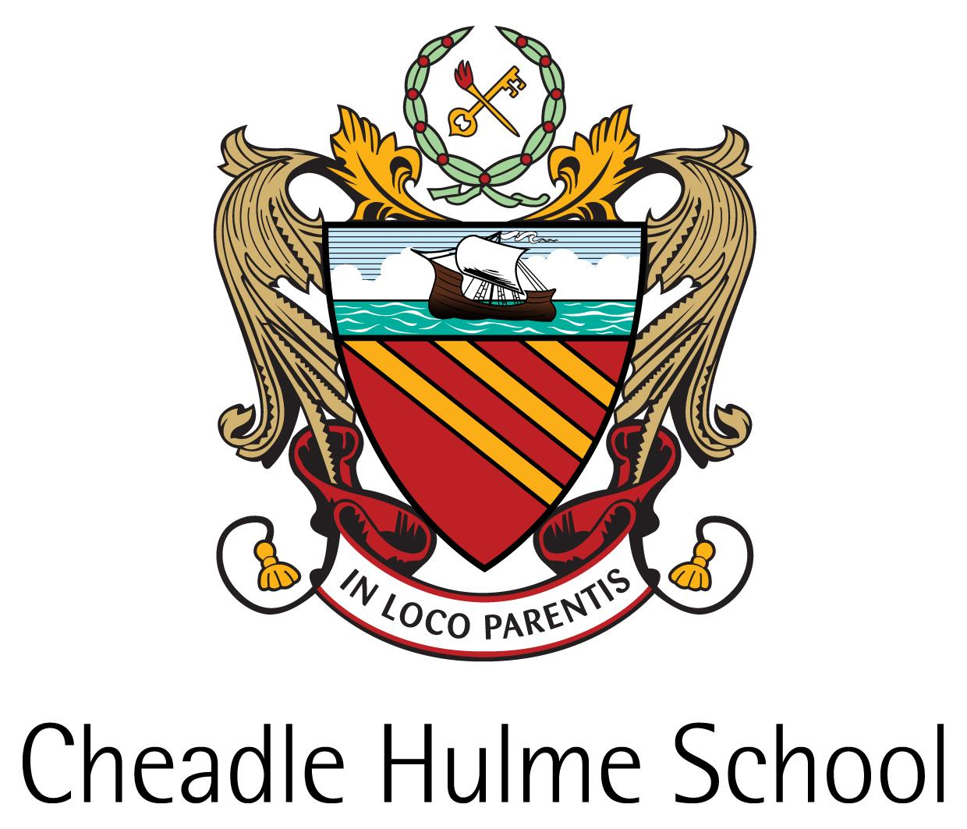
Teacher of Required for September 2018

The School - A Background

Founded in 1855 by a small group of Victorian philanthropists in Manchester, Cheadle Hulme School began its life educating the “orphans and necessitous children” of warehousemen and clerks during the Industrial Revolution.

Over the years since its inception, the School has grown in ways far beyond the imaginings of its Founders: the introduction of fee-paying day pupils was the first step towards the School becoming, as it is now, a very successful, independent, co-educational HMC day school, providing high quality education to boys and girls, aged 4 to 18, from all over the North West.
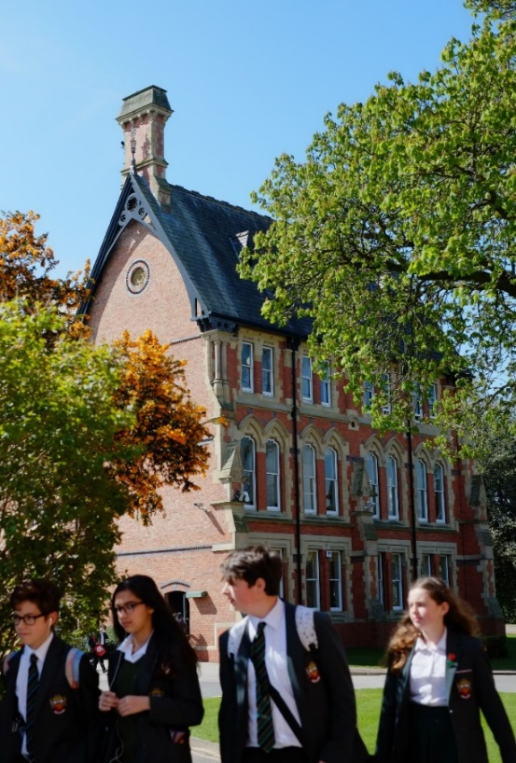
The School currently has 1414 students and is truly co-educational: there are 648 girls (46%) on the school roll and
766 boys (54%).

The School is committed to honouring the original intentions of the Founders by providing bursaries for students
whose financial background would otherwise preclude them from a CHS education.

The School has a Ten Year Strategic Plan (2011-2021) which informs its future aspirations and priorities.
Cheadle Hulme’s vision and aims
What it is like to work in Cheadle Hulme School.

The School’s Aims
- That each student experiences a challenging, dynamic and relevant education which enables them to reach
their full academic potential and flourish in a rapidly changing world;
- That each student develops a love of learning that extends beyond the confines of examination courses,
and is able to work effectively in a variety of settings;
- That each student develops a strong set of personal values and learns to value themselves and others,
appreciating difference and individuality and supporting those in need or less fortunate than themselves;
- That each student discovers and develops a broad and relevant set of skills and aptitudes, which enable them
to undertake useful and effective roles in their communities.
THE JUNIOR SCHOOL

The Junior School comprises fourteen classes of children from the age of 4 to 11. There are two parallel classes of around 20 children that run through from Reception onwards. By the final year of the Junior School there are usually 26 children in each class. The Junior School, like the Senior School, is co-educational.

Throughout the Junior School, the Form Teacher takes his or her form for most of the week, although there are specialist teachers for PE, Music and Languages.

The Junior School has always offered its pupils a broad curriculum. All pupils are taught English, Mathematics, Science, Humanities, Art, Music, ICT, Technology, Learning for Life, PE, Swimming and Games. All subjects follow a skills-based curriculum which takes account of national developments.

The Junior School Staff

The Junior School is led by the Head of Junior School. The leadership and management team which includes posts for curriculum, pastoral, staff and pupil performance management. There are over 40 staff in the school, including teaching and lunchtime assistants and some subjects such as Music and PE are taught by specialists.

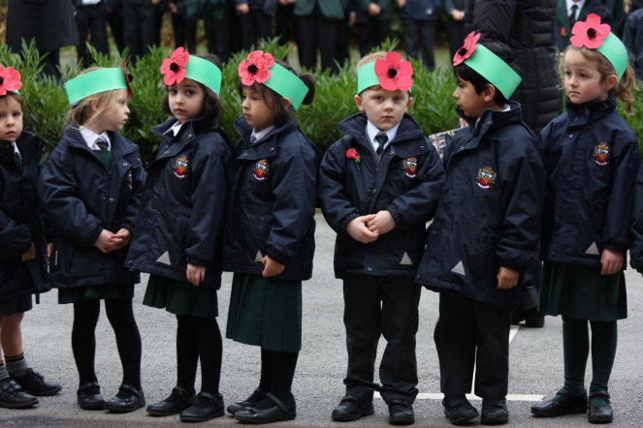
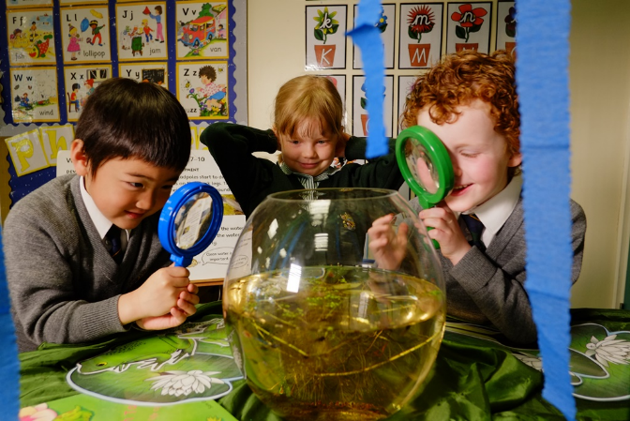

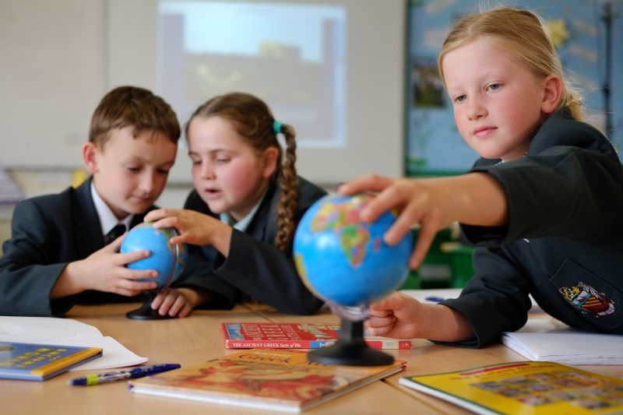
Curriculum in the Senior School
Cheadle Hulme School is an academically selective School that prides itself on providing a challenging academic curriculum, aiming to stretch and develop the intellectual capacities of each student.
The School offers a broad curriculum, which begins in the Junior School, where from Reception, children are gradually introduced to the study of particular subjects, with the emphasis on literacy and numeracy. From Year 3, students follow a subject-based curriculum, which includes ten subjects.
In the Senior School the curriculum is broader. In Year 7, all students gain experience in: Art & Design, Computing, Classical Civilization, Design Technology, Drama, English, Geography, History, Mathematics, Music, Religious Studies, Science and Spanish. In Year 8, they also begin to study Food & Nutrition, German and Latin. In Year 9, General Science is replaced by Physics, Chemistry and Biology and students have some discretion over which ‘option’ subjects they would like to continue to study, including the addition of French as a third Modern Language option.
All students take a minimum of nine subjects at GCSE/IGCSE, which include English Language, English Literature, Mathematics and a Modern Language. Students can take either separate sciences or Dual Award Science. They choose their other courses from a wide range of options. IGCSE is currently offered in Biology, Chemistry, Drama, English Language, English Literature, French, German, History, Mathematics, Physics, Science (Dual Award) and Spanish. In the last two years, both GCSE PE and Computer Science have been included in the range of other GCSE subjects available (Geography, Religious Studies, Latin, Art & Design, Music, Design Technology and Food & Nutrition). Further Mathematics and Greek are also available as additional subjects. Alongside the academic curriculum, students have lessons in Well Being, Physical Education and Games from Year 7 through to Year 11.
At post-16, CHS offers both Advanced Level and Cambridge Pre-U examination courses. Students in the Lower Sixth will most commonly take four subjects; reducing to three in the Upper Sixth. An increasing number of students complete an Extended Project Qualification in addition to their A Level and Pre-U courses.
At Advanced Level, the School offers: Art & Design, Biology, Chemistry, Classical Civilisation, Design Technology, Drama & Theatre, English Language, English Literature, Mathematics, Further Mathematics, Music, History, Latin, Politics, Physical Education, Physics and Psychology.
Pre-U courses are followed in Business Management, Economics, French, Spanish, German, Geography, and Philosophy & Theology. Alongside the academic curriculum, students take part in Sixth Form Enrichment and Games Programmes. In the Upper Sixth, students take a weekly Extension Class in the subject area that they will be applying for at university.
Pastoral Care
Pastoral Care at CHS falls into three areas:
Pastoral Curriculum - this includes both the 'hidden curriculum' that is the ethos and values of the School, the day to day relationships between staff and pupils, the opportunities for moral, spiritual, social and cultural development as well as the more formal and overt Well Being Curriculum and Pastoral Programme.

Pastoral Support- where individual pupils who are having problems be they of an academic, social, emotional or behavioural nature are effectively supported by the pastoral team.

Pastoral Control - a clear and consistently implemented discipline system that commends and rewards good conduct whilst acknowledging and challenging inappropriate behaviour. Through our clear expectations and focus on character and values, pupils are encouraged to exercise individual and social responsibility, a vital ingredient to pastoral care.

A Dedicated Pastoral Team

The Senior School is divided into three smaller Schools: The Lower School (Years 7 and 8), The Upper School (Years 9, 10 and 11) and The Sixth Form. These Schools allow pupils to feel part of a smaller community and ensure that every pupil is known and feels valued.

Each Year group is led by a Head of Year who coordinates the pastoral programme for their year group and is responsible for monitoring the progress of the cohort academically and making sure that the pupils are happy, supported, included and involved in the wider life of the School.

An enhanced tutor system, which places the Form Tutor as a mentor at the centre of the pupil’s school life, provides individuals with the guidance that they need to build on their skills and further develop their academic profile over the course of their education. The Form Tutor is a fundamental person in the life of each pupil and is the first point of contact for parents.

Three dedicated Student Managers support the Form Tutors closely and work with individuals and groups of pupils to promote the welfare and to provide the best outcomes for all within the relevant School. Responsibility is placed on the Student Manager for monitoring the attendance, punctuality, behaviour and attitudes of the pupils and the impact of these factors upon learning. Student Managers are non-teachers and are best placed to deal with day-to-day issues as they arise.
Co-Curricular Activities

Great emphasis is placed on co-curricular activities; we believe in the value that the students derive from learning beyond the classroom, of developing their talents and improving their social skills through diverse activities.

A House system has been recently re-introduced and there are numerous House activities encouraging participation in sport, music, drama, charitable events and academic competitions. The House structure also provides many opportunities for leadership.

All students participate in the Games programme as part of their curriculum, through which they sample all the major sports. Beyond this, pupils are able to engage with a wide range of further sporting opportunities through social and team practices.

The School has a justified reputation for the quality of its Music. Young musicians have a chance to play or sing in a range of choirs, the Big Band, the Concert Band, the Orchestra and numerous other ensembles.

We have a long and proud tradition of dramatic productions: two major productions are staged each year as well as there being GCSE and Advanced Level showcase evenings. There is a flourishing Musical Theatre Club pupils and an annual Sixth Form self-directed production.

Lunchtime and after-school clubs and societies exist to give every student the opportunity to broaden themselves and their education. A wide range of educational trips are also offered with some day trips taking place during curriculum time and many longer residential visits undertaken in the holidays. Comprehensive details of these can be found in the ‘CHS Life’ section of the School’s website.
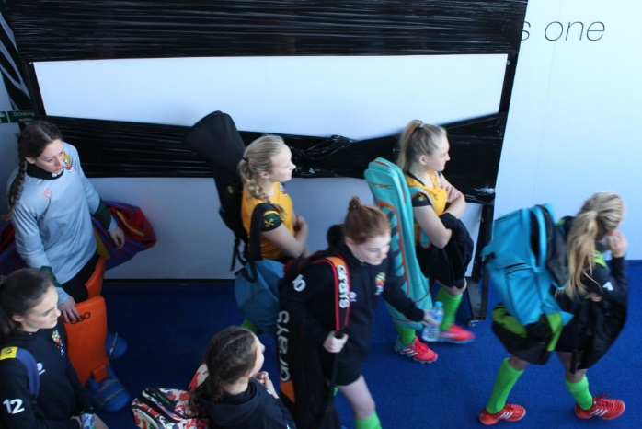
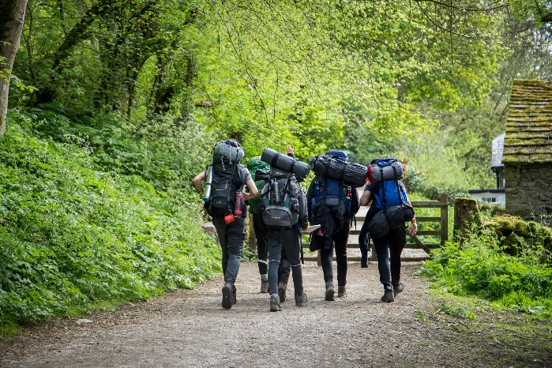
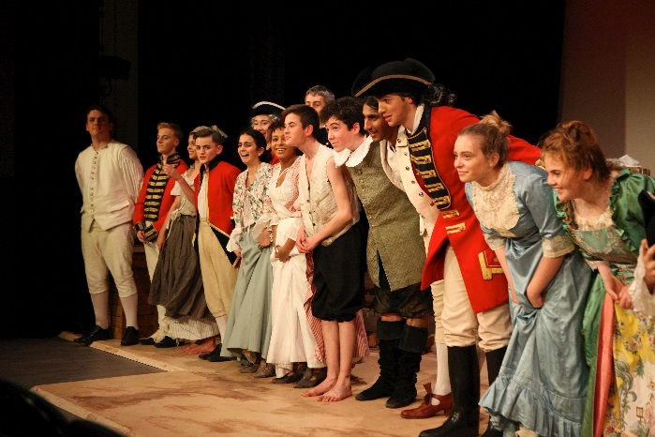

The Appointment

The School seeks to appoint a well-qualified and committed EYFS/Key Stage 1 Teacher, to join our highly professional team. The successful candidate will have the ability to understand, inspire and motivate children. A willingness to assist with co-curricular activities is essential.

We are willing to consider full-time or part-time applications (approximately 0.8). The Job Description is enclosed at the end of this document.

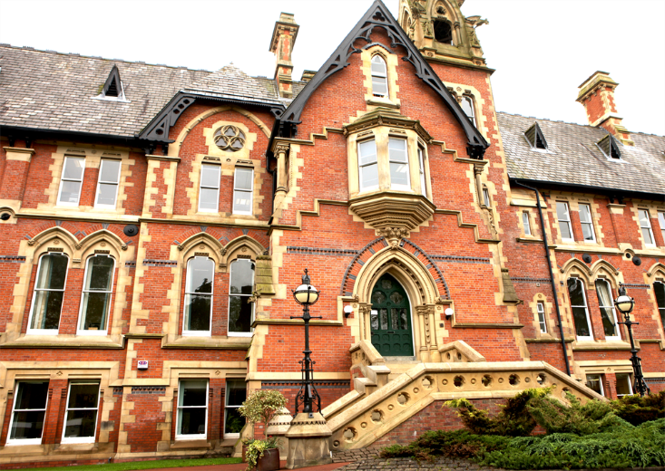

Remuneration package  The successful candidate will be offered an attractive salary package. Please see the full list of benefits on our website.  Application procedure  A completed Application Form is to be submitted by 9am on Friday 02 March 2018, to the Human Resources Department:  Phone Number: 0161 488 3330  Email: humanresources@chschool.co.uk  Postal Address: Cheadle Hulme School, Claremont Road, Cheadle Hulme, Cheshire, SK8 6EF  Interviews will take place on Monday 12 and Tuesday 13 March 2018. Unfortunately, if you have not heard from the School in response to your application by Friday 09 March 2018, you will not have been short-listed for interview.  (Cheadle Hulme School is committed to safeguarding and promoting the welfare of young people and expects all staff and volunteers to share this commitment. All appointments at Cheadle Hulme School are subject to clearance by the Disclosure & Barring Service and to identity and qualification checks).  Cheadle Hulme School is an equal opportunities employer and values a diverse workforce; we welcome applications from all sections of the community.  Registered Charity Number 1077017 for the education of children. | 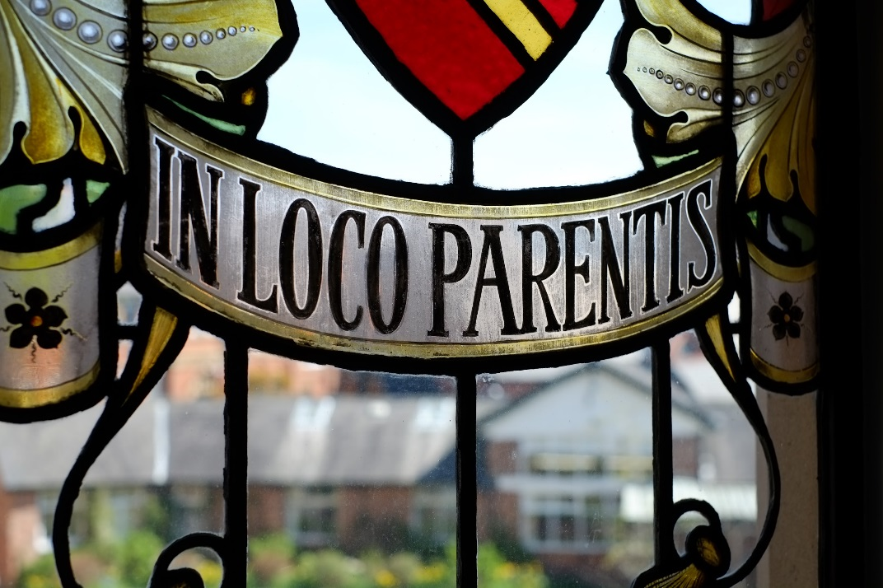

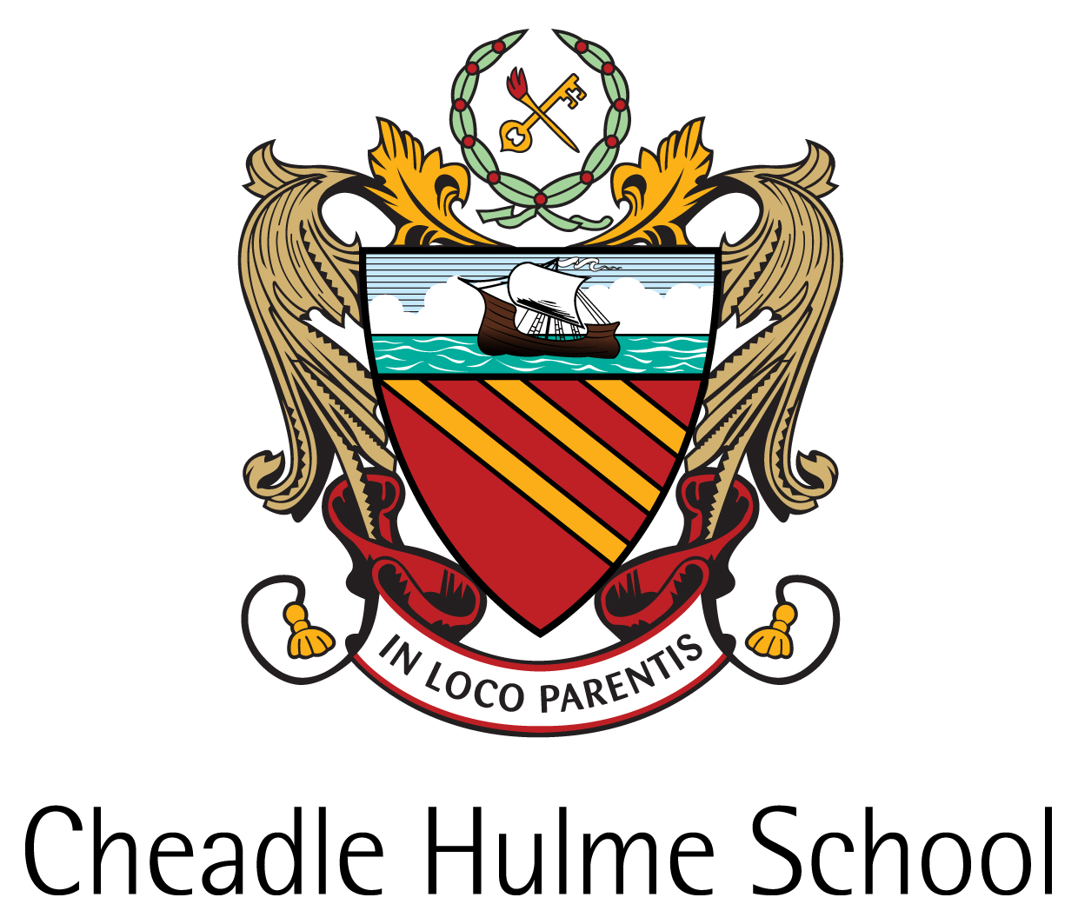

Job Description

Job Title: Teacher (Junior School)

Job Purpose:

To carry out the professional duties of a teacher in accordance with School policies under the direction of the Head of the Junior School.

Cheadle Hulme School is committed to safeguarding and promoting the welfare of young people and vulnerable adults and expects all staff and volunteers to share this commitment.

Key areas of responsibility:

- Teach all areas of the Primary Curriculum;
- Take responsibility for the progress of a class of Junior School children;
- Organise the classroom and learning resources to create a positive learning environment;
- Plan, prepare and present lessons that cater for the needs of the whole ability range within the class;
- Motivate pupils with enthusiastic, imaginative presentations;
- Prepare and mark work to facilitate positive pupil development;
- Maintain discipline and safeguard pupil health and safety;
- Take responsibility for pastoral welfare of pupils within the class on a day-to-day basis;
- Provide feedback to parents on a pupil’s progress at parents’ evenings and other meetings;
- Meet requirements for the assessment and recording of pupils’ development;
- Co-ordinate activities and resources within a specific area of the curriculum as requested;
- Work as part of a team, participating in meetings, curriculum reviews, or project work as required;
- Stay up-to-date with changes and developments in the structure of the curriculum;
- Take responsibility for personal training and development;
- Contribute fully to the co-curricular life of the Junior School;
- Attend School functions as required;
- Undertake any further additional responsibilities as requested by the Head of the Junior School.
This is not an exhaustive list, and will vary as the School’s requirements change. Flexibility regarding hours may be expected from time to time, in consultation with the job-holder.

