Lark Hill Road
Preston
Lancashire
PR1 4HD

Tel: 01772 460181
Fax: 01772 204671

Email: hr@cardinalnewman.ac.uk

Web: www.cardinalnewman.ac.uk
Dear Applicant

We are delighted that you are considering completing an application for the post of Casual Netball Coach to commence September 2018.

Cardinal Newman is a wonderful place to start (or to continue) your career and we welcome applications from people who are keen to make a contribution to our outstanding institution. We are a happy and thriving Catholic Sixth Form College and welcome colleagues and students into our community regardless of their religion or belief, ethnicity, gender, disability, sexual orientation, marital or pregnancy status.

At Cardinal Newman, we are committed to the development of the whole person and we value each student as an individual, with a unique mix of skills and talents. Our students achieve outstanding results, which consistently place Cardinal Newman amongst the top four Colleges nationally for Value Added. We were awarded Beacon Status in 2010 and the College was awarded an ‘outstanding’ Inspection in May 2009. However, we are as proud of our students’ social, cultural and spiritual achievements as we are of their outstanding exam results. We have a fabulous team of colleagues who give up an extraordinary amount of time to support their students and their fellow members of staff. The dedication and attention to quality they exhibit is what makes our College so successful.

If you meet the criteria of the post advertised and feel that you would enjoy working here, we hope you will make an application to join us. We welcome applications from suitably experienced and qualified persons for appointment to this post.

Completed application forms should be returned to the Human Resources Department (via email or post) by 8:00am on Tuesday 22nd May 2018. We do ask that you accept, in the interests of economy, that if you have not heard from us by the end of June 2018 that you will not have been selected for interview on this occasion.

We will confirm receipt of all applications by email within one working day of receipt. Please do telephone HR team if you have not received a confirmation email by the closing date. Should you have any questions which are not covered in the enclosed information please do not hesitate to contact the Human Resources Department

Yours faithfully
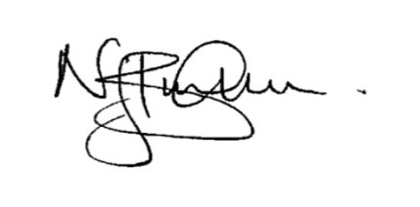
Nick Burnham
Principal

Mission Statement

As a Catholic Sixth Form College we strive to be a centre of educational excellence for the community built on faith, respect and trust. We celebrate diversity amongst all out students and staff and seek to nurture the gifts of each individual through high quality teaching and learning and dedicated pastoral care.

Values Statement

Cardinal Newman College is a community which aims to live out the gospel values of service and love. This means that:

- The individual student is central to all our endeavours
- The College values each individual as a unique person irrespective of gender, race, belief or ability and regards each person, made in the image and likeness of God, as worthy of the utmost respect
- The College strives to develop each person intellectually, socially and spiritually through an inclusive programme of study and enrichment
- The College values the spiritual journey of each individual and will offer opportunities for each to engage appropriately in their spiritual search
- The College is committed to creating a culture that is open and welcoming, free from fear and from violence of any kind, in which all individuals feel safe, happy and secure
- The College provides learning environments that are stimulating, enjoyable and challenging to students, fostering their creativity, imagination and search for truth
- The College encourages individuals to contribute positively to the world in which they live, to challenge injustice and to seek out more co-operative, just and peaceful forms of human existence.

Sport and Physical Education at Cardinal Newman College

The Sport and Physical Education Department at Cardinal Newman Catholic Sixth Form College offers a range of courses to suit the individual needs and preferences of a wide range of students with differing interests, abilities and career aspirations. Students on A-Level courses follow the AQA specification, students on a variety of BTEC Level 3 programmes follow the Edexcel Specifications.

The College also proudly offers Sports Academies in Boys’ Football, Netball and Basketball. The College is an AOC Sport affiliated member and the students represent the college in all sports at regional and national events. Traditional sports fixtures are an integral part of our extra-curricular provision; all teams play in regional leagues and National Competitions involving Wednesday afternoon fixtures.

The department is consistently graded Outstanding in Self-Assessment, all measures of success are significantly above National and Sixth Form Colleges’ benchmarks with Outstanding and Excellent ALPS grades for all level 3 courses. A culture of high expectations exists within the department, student progression rates onto course related Higher Education, training and employment is high.

The department celebrates diversity of its students and nurtures their gifts and talents through a high quality educational experience. We are committed to placing students at the centre of all our endeavours; we have a proactive student voice strategy and involve students in quality improvement.

The person appointed must embrace the ethos of the College and be willing to share in and promote the gospel values on which the College is founded. They will become part of an extremely hard working, supportive, generous and very positive team who are highly flexible, determined to support all students to achieve their full potential.

Job Description

Post Title: Casual Netball Coach

Responsible to: Head of Sport/Academies

Pay: £17.75 per hour (£15.84 per hour plus £1.91 holiday pay)

Working Hours: Hours as detailed in the current training/fixture schedule below. The netball season runs from September until end of May each year.

Responsibilities:

Your detailed responsibilities which might change from time to time are as follows:

- To coach Netball Academy and development teams
- To coach the teams for training and match fixtures (*see details below)
- To take teams to AOC competitions
- To arrange and confirm fixtures
- To book transport and referees for teams
- To organise payment for the referees
- To ensure that the playing kit for netball teams is laundered and fit for purpose
- To undertake departmental administration – for example to respond to phone calls, emails,
- To publicise team events at St Augustine’s to staff and students
- To maintain relevant equipment at St Augustine’s and other venues as appropriate
- To undertake the duties of a first aider (following appropriate training)
- To follow all College policies and procedures and work proactively in accordance with the college’s Health & Safety and Safeguarding Policies

Current Training /Fixture Schedule:

Netball Academy: (Compulsory)
- Training: 8.30-10.15 am Tuesdays and 2.15 – 3.30 on Thursdays
- Fixtures: AOC competitions every Wednesday afternoon 12.15 to 4.15
- 2 teams in the Blackpool league on a Tuesday night 7.00 -9.00 pm (or by fixtures)
Netball Development: (By Negotiation)

- Training: Monday or Tuesday 3.30-5.00pm

- Fixtures: 1 team in the UCLAN league on a Thursday night for 1 hour

PERSON SPECIFICATION
NETBALL COACH

All staff must make a positive contribution to:
- the Catholic ethos of the College and its distinctive nature;
- the College Equality and Diversity, Health and Safety and Safeguarding Policies and Procedures;
- the pursuit of excellence and the highest standards of quality in all aspects of College life;
their own professional development, in accordance with the needs of the College.
 | Essential | Desirable
Personal | - Medical Clearance*  - Enhanced Disclosure and Barring Service Clearance*  - Provision of two references which are deemed as satisfactory to the Principal*  - Ability to meet the requirements of the Asylum, Immigration and Nationality Act (in respect of eligibility to work in the UK) | - Full UK Driving Licence (preferably with 6 of less penalty points)  - Willingness to drive the college minibus
Qualifications | - Hold a First Aid qualification or be willing to undertake the qualification  - Netball Level 2 coaching Qualification | - Advanced Level 3 Coaching Qualification  - GCSE or equivalent in English, minimum grade C
Experience and knowledge | - A minimum of 2 years’ experience of Netball Coaching | - Experience of coaching National league level or above  - Previous experience of working in an educational setting  - Competent in the use of Microsoft Office Packages
Skills and qualities | - Enthusiasm for player development  - A passion for Sport, evidenced by performance, experience or higher study  - Possess self-direction and motivation  - Commitment to the ethos of the college.  - Effective organisational skills  - An excellent record of attendance and punctuality subject to the provision of the Equality Act 2010.  - Good communication skills  - Ability to relate well with staff and students  - Ability to work under pressure  - Good team working skills  - Commitment to Equal Opportunities and safeguarding of young people.  - Willingness to work flexible hours including evening/weekends where necessary  - Willingness to work flexibly within the college and its sport centres. | - Patience  - Persistence  - Enthusiastic  - A sense of humour

*Following an initial offer of appointment.
Cardinal Newman College has a commitment to safeguarding and promoting the welfare of students and expects all staff and volunteers to share this commitment. All posts are subject to Enhanced Disclosure Clearance through the Disclosure and Barring Service. Please note candidates’ suitability to work with children will be explored at interview and confirmed through references for the appointee.

About Cardinal Newman College

Based in the heart of Preston city centre, Cardinal Newman College is a Catholic Sixth Form College. Our core activity is to provide education for students aged 16-18, offering a range of A Level and BTEC courses, at both level 2 and 3. The College also offers a Foundation Learning course for young people with specific learning needs. In addition to the 16-18 provision, Cardinal Newman also offers a range of University courses, including Foundation Degrees in Teaching and Learning Support and Early Years, as well as the School Direct Programme, offering Initial Teacher Training for graduates looking to get into teaching.

Cardinal Newman College is the post-16 provider for the Newman Partnership, a working group consisting of the College and ten Catholic Partner High Schools. The location of these schools demonstrates the wide area from which the College draws a significant proportion of its full time 16–18 learners. Because of its distinctive ethos, its reputation, the levels of achievement, the support the College offers students and its provision of high quality courses, Cardinal Newman College is an attractive option for learners who attend other high schools in Preston and the surrounding area as well. Year-on-year applications from these schools have increased significantly.

An Outstanding College

The latest Ofsted Inspection in the summer of 2009 graded all areas of the College as ‘outstanding’. It confirmed that there is a culture of high expectations and rigorous quality improvement in all areas. Standards, expectations and processes have continued to improve since then. Students achieve well above their (high) target grades and make a positive contribution to the College and its wider community. Student attendance and behaviour are exemplary, illustrating that the Catholic mission and ethos of the College is lived out at all levels.

Every year, the vast majority of the College’s students, progress to Higher Education with almost 40% of those taking up places at Russell Group Universities.

Our Community

Links with the local and Catholic partner high schools are very strong. The Principal meets regularly with Head Teachers and the Newman Partnership Head Teachers meet to discuss and share a wide range of curriculum, pastoral and strategic issues. Relationships with College trustees, and with the Diocese of Lancaster are maintained through the foundation governors.

The College has outstanding links with both the local and wider community. Learners and staff fully contribute to this for example students at the College are continually seeking to engage in volunteer work within the community. Voluntary work is carried out in the local community by the CAFOD Group; Foundation Learning students; Health and Social Care students; the Medical Society and Chaplaincy. The curriculum departments also contribute widely to the links with local community groups, charities and local primary schools.

As a Catholic Sixth Form College we strive to be a centre of educational excellence for the community built on faith, respect and trust. We celebrate diversity amongst all our students and staff and seek to nurture the gifts of each individual through high quality teaching and learning and dedicated pastoral care.

Students study in a purposeful and diverse environment with a strong focus on respect in which every learner genuinely does matter. The team of specialist RE teachers live out the college’s commitment to ‘valuing the spiritual journey of each individual and offering opportunities for each to engage appropriately in their spiritual search’.

College Facilities

At Cardinal Newman College, we are blessed with wonderful surroundings for our students to work, learn and relax in. The College contains Lark Hill House, which was built in 1797 as a private house for Samuel Horrocks, a cotton manufacturer and later Mayor and Member of Parliament for Preston. In 1919 it became Lark Hill Convent Grammar school, which began taking sixth form students in 1967 from other local Catholic Secondary Schools. It finally became Cardinal Newman College in 1978, when it merged with Winckley Square Convent School and Preston Catholic College, taking its name from Cardinal John Henry Newman.

Over the past few years the College has embarked on an extensive redevelopment programme with approximately £16 million worth of investment in state-of-the-art facilities, which perfectly combine the old with the new.

In 2009 we saw the addition of the St Cecilia Building and the St Augustine’s Building in 2010, which was renovated and refurbished to house classrooms, drama/dance studios, as well as the original sports facilities. 2015 saw the addition of yet another new building in the form of St Francis, which is home to new classrooms for Sociology and Maths, as well as Open Learning Centres, Seminar rooms and a Mango Bean Coffee shop.

A further addition to the College’s already outstanding facilities, in the form of a brand new state-of-the-art gym in the St Augustine building, opened in October 2016. This was accompanied by a complete refurbishment of the social space and café area of the St Augustine’s is building. This site also added a new modular building within its grounds, where RE lessons are now delivered from the eight classrooms it has provided.

Staff at Cardinal Newman College

Cardinal Newman College has achieved all of its success through the hard work, skills and commitment of its 300 plus staff. We seek to work with an inclusive and transparent style of management, which is open, consultative and encourages all staff to participate in the leadership and management of the College. The development of staff skills is a priority for the College and teams are encouraged to innovate and continuously improve Cardinal Newman’s curricular and pastoral offer to its students.

What our staff say about working at Cardinal Newman College

Over the last five years staff have been asked to take part in an annual staff survey. The college’s score, as determined by staff, has improved year on year and we are pleased that the scores for all areas (culture, demands, control, relationships, change, role, support, personal wellbeing and work-life balance) places the college at or above the top 10% of employers who take part in the same survey.

What our students say about Cardinal Newman College

Name: David Corr
Previous School: Astley Park
Programme of Study: Foundation Learning
“I wanted to come to Newman because my brother came here and I had heard good things about the course from people I know who were already studying it. I like meeting old friends and making new ones as well as being challenged by my work. I have lots of fun making clubs at lunchtime so that me and my friends can do things that we enjoy like dancing!”

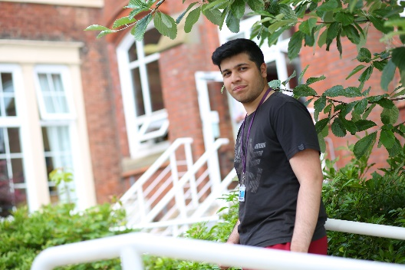
Name: Adil Lakha
Previous School: Archbishop Temple
Programme of Study: A Levels in Biology, Chemistry, Maths and Physics
“There are plenty of excellent enrichment opportunities available at Newman where you can stretch yourself beyond the standard course syllabus. All of my teachers have been enthusiastic and engaging and they are always willing to give me extra help outside of my lessons. I have really enjoyed my subjects and I have met some great friends here at Newman.”

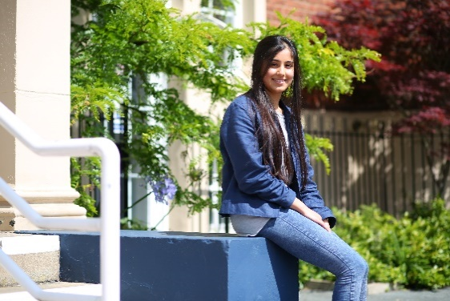
Name: Henna Reddy
Previous School: Westholme
Programme of Study: A Levels in Biology, Chemistry and Maths
“Newman has opened my eyes to lots of opportunities and has allowed me to grow so much as a person, both academically and socially. I’ve had the chance to meet so many different people and the teaching here is excellent.”

Name: Ella Shaw
Previous School: Leyland St Mary’s
Programme of Study: A Levels in French, Spanish, English Literature
“I have been able to develop my own interests and I have loved the independence that college has given me. Newman is definitely an amazing College and you feel part of something when you’re here. There hasn’t been a day where I have regretted coming to Newman, it’s everything I hoped College would be.”

Name: Abbie Lund
Previous School: Clitheroe Royal Grammar School
Programme of Study: A Levels in Maths, Physics and Further Maths
“I decided to come to Newman because I wanted a change of scene and the chance to meet new people. Throughout my two years here I have always been encouraged to excel. When choosing which college to attend, make sure to go somewhere you feel comfortable and choose subjects you enjoy, success comes a lot more easily when you’re happy!”

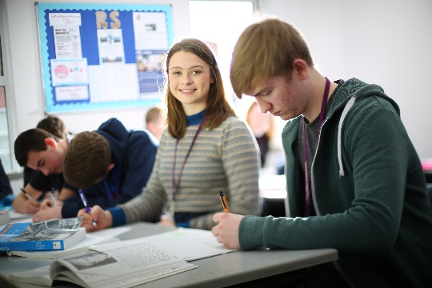
Isabella Raven
Previous School: Broughton
Programme of Study: Religious Studies, Philosophy, English Literature and EPQ
“I felt that coming to Newman would be a big step up from high school but Newman has made the transition much easier. You have a lot more independence when you come to College but the teachers are really supportive and welcoming. They will help you whenever you need it, but also push you to achieve your best. Newman has changed my life!”

Temiloluwa Onilogbo
Previous School: Lancaster Royal Grammar
Programme of Study: A Levels in Maths, Chemistry, Physics and French
“The most important thing is picking courses that interest you and if a College you like has these subjects; go for it! For me, Newman has been a great step up from High School. You can meet people from all over Lancashire, who are actually interested in the subjects that they take, creating a welcoming learning environment.”

Matthew Holden
Previous School: Holy Cross
Programme of Study: A Levels in Economics, Modern World History, English Literature & Business Studies
“After researching local colleges and attending several open days, I was impressed by Newman’s facilities and friendly atmosphere. Their reputation as a brilliant college and their position in Sixth Form College League Tables also helped me decide that Newman was the right college for me.”

