Rossett School
Success for everyone

February 2018

Dear Candidate

As Headteacher I would like to thank you for your interest in the post of Deputy Headteacher at Rossett School and I hope you find the information in this pack helpful.

Rossett School is a highly successful 11-18 mixed secondary school and we converted to academy status on 1 July 2011. In the summer term of 2010 the school was judged ‘Outstanding’ by Ofsted. Our key objective is ‘success for everyone’. Since joining Rossett in September 2014 I have been working with the Governors and staff to build on the strengths of this very successful school.

We wish to appoint an inspirational and strategic senior leader with presence and drive to the post of Deputy Headteacher to lead the development and improvement of student progress and achievement at the school. This post will give the applicant the opportunity to also lead the areas of specialist provision within the school that exist to eradicate barriers to learning: we have EMS (Enhanced Mainstream School) Practitioners onsite, a developing inclusion team and an enviable pastoral record. The staff and senior team are committed to supporting students and their families in the pursuit of excellent academic outcomes.

The successful candidate will be able to demonstrate a strong, dynamic and proven track record of strategic leadership with the ability to inspire and engage the whole school community. Applicants for this role should be passionate advocates for high quality teaching and learning within a caring and supportive community.

Rossett is recognised as a school that maintains strong academic focus. We believe it is important to provide an education for all, acknowledging that the society in which we live is enriched by diversity. We strive to recognise and celebrate the diversity within our school where everyone is equally valued and treated with respect and fairness.

Our students are encouraged to reach their full potential through both academic and social development and our team of staff is hard-working and dedicated.

The school achieves excellent value added results with an above average P8 score for the last two years, putting us in the top 30% of schools in the country.

Staff development is also important to us. The successful candidate will be able to identify and promote excellence in the classroom and have the ability to recognise and develop potential in teachers at all levels, encouraging them to develop skills which will result in excellent outcomes.

A positive ‘can-do’ attitude is necessary to ensure that potential obstacles to progression are quickly identified and removed for the individual student.

The appointment of a new Deputy Headteacher will significantly contribute to the school’s leadership development in order to address the challenges and opportunities provided by the ever-changing educational landscape, enabling us to provide a first class education for every student.

Thank you for considering Rossett School for the next phase in your career and I very much look forward to receiving an application from you.
Yours sincerely

Helen Woodcock
Headteacher
General Information

Rossett School is a successful 11-18 mixed secondary serving Harrogate/Ripon and North Leeds. Currently there are 1500+ students on roll, including 200+ in the Sixth Form. Rossett is a highly successful school whose achievements are driven by:
- success for everyone
- a focus on excellence in teaching and learning
- the 3Rs Culture of Learning
- putting students at the centre of everything it does
- a real sense of community among staff and students

We aim to provide a high quality, inspirational learning experience for young people from a wide variety of backgrounds to create a happy and vibrant community.

Academic excellence is important to us and we provide a first class education with a relevant and varied curriculum where the fundamental aim is to ensure success for everyone.

Central to this aim is a culture and ethos where students can develop into resilient, responsible and reflective learners with high self-esteem and high expectations.

Results have continued to be good year on year but Rossett offers much more, including an extensive range of extracurricular activities and learning opportunities outside the classroom.

In this inclusive school, we expect our students to have the highest standards of behaviour, to respect diversity and to understand global citizenship and equality of opportunity.

Rossett’s vision
- To further improve student progress across all groups
- To further improve the quality of teaching and learning
- To further improve the behaviour and safety of all learners
- To maximise the business activities of the academy to make an impact on teaching and learning

Red Kite Teaching School Alliance
Rossett is proud to be a founding member and key partner within the Red Kite Teaching School Alliance. This is a partnership of a variety of local schools (primary, secondary and special) who have joined together to share skills and experience to improve teaching and learning across Yorkshire.

Teaching
Teaching and learning is a key focus at Rossett; its leadership sets the highest expectations for both teachers and students.
- The majority of teaching is good or better
- Lessons are characterised by high levels of engagement, concentration, progress and
achievement by the majority of students
- Literacy and Numeracy strategies lead on the consistent approach to the teaching of key skills.
- The monitoring of teaching and learning is of prime importance – we undertake regular
departmental reviews and work scrutinies and regularly undertake a series of peer
observations to improve practice
- Members of staff are supported, valued and encouraged to maintain continuous professional development
- A significant number of staff have undertaken professional development through Red Kite Alliance courses over the last 2-3 years and all subject leaders belong to Curriculum Development groups who meet regularly in school time.

Curriculum Research Communities (CRCs)
These are groups of cross faculty colleagues who work together on lesson studies. They have been set up to promote and share good practice in teaching and learning across the school. The Teacher Development agency judged the school with a Silver Award in 2017.

They are led by younger staff who have a key developmental role to play in improving our teaching and learning.

Academic Performance
Rossett continues to deliver good results generally and outstanding results for individual students.

GCSE Results 2017
The school achieves excellent value added results with an above average P8 score for the last two years, putting us in the top 30% of schools in the country.

Full details are available from the DfE Performance Tables for Rossett School in due course, please follow the links below:
http://www.education.gov.uk/cgi-bin/schools/performance/school.pl?urn=136896

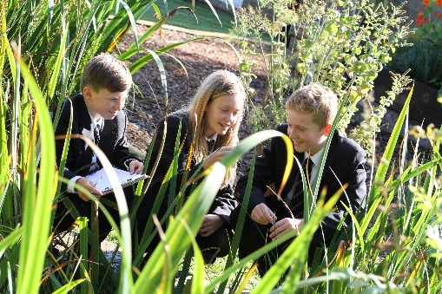
Students are Central
The key objective of the school is ‘success for everyone’. We believe in the development of the whole child. Student voice and student responsibility are extensive. The degree of student involvement in the management of the school includes:

Student Council: This is an elected body (with representatives from each year group) which meets regularly with the Assistant Headteacher and is routinely consulted on any significant change in the school. Its remit is wide and includes giving views on curriculum changes and developments and organising significant developmental initiatives (eg the 3Rs Culture of Learning and the introduction of iPads). The Student Council is an integral part of the school development process and its views are important in determining school policy.

Staff appointments: Students assist with staff interviews.

Peer Mentoring: Rossett’s ‘Listeners’ are a team of Key Stage 5 students who are selected and trained each year to give appropriate peer support to Year 7 students, providing additional support, helping to build confidence and increasing opportunities for personal and social development. The Peer Mentoring scheme has been nationally accredited and our ‘Listeners’ have won a number of awards.

Other student initiatives: Students are also involved in a wide range of other community and developmental activities including: the Healthy Schools programme, Sports Leaders, Amnesty International, LGBT+ support group, Sixth Form Ambassadors, Digital Leaders and in class support activities.

Fund raising: Students raised over £20,000 for charity during the last academic year. Events held included Sixth Form Rag Week, Christmas Jumper Day and other non-uniform days and we have supported a large number of charities including the Nepal Earthquake Disaster Fund, Children in Need/Red Nose day, Elliot’s Footprint, the Transplant Research Fund at Leeds Teaching Hospital Trust, MIND and Amnesty International in the past.

Pastoral and academic guidance: The other key objective is strong pastoral and academic guidance for students. Each year group has a Student Support Officer (SSO) who offer pastoral care to the students and contribute to raising attainment by delivering a robust but caring support system. The School also has a Director of Learning (DOLs) for each year group and a Director and Deputy Director of Sixth Form who are responsible for securing outstanding levels of progress and achievement whilst maximising student potential by setting high expectations and ensuring that they are met. There is also extensive support available throughout the Rossett community – both teaching and support staff.

Leadership and Management
In addition to the Headteacher the Senior Leadership Team currently comprises:
- Two Deputy Headteachers One post is Progress and Achievement: Learning and Teaching; the other, Progress and Achievement: Student Experience.
The post advertised is: Deputy Headteacher (Progress and Achievement: Student Experience).

Two Assistant Headteachers who each have a specific area of responsibility:
- Learning and Teaching with oversight of Quality Assurance, CPD and data and assessment.
- Learning Support with responsibility for Safeguarding, SEND and inclusion support strategy, to enable all learners to participate in the curriculum, maximising their progress through effective partnerships

- The Director of Finance who is responsible for the annual school budget of over 7 million and the financial and management disciplines required following academy conversion.

The Extended leadership Team comprises:
Three Associate Assistant Headteachers:
- Learning and Teaching with responsibility for coaching, S2S support and QA of ITT and NQT courses
- Curriculum Timetable, logistics and financial benchmarking with responsibility to ensure the quality of the curriculum – allowing all learners to develop the skills required for lifelong learning
- Transition, Admissions, Pupil Premium, CIAG (Careers Curriculum Development) (QA of alternative courses)

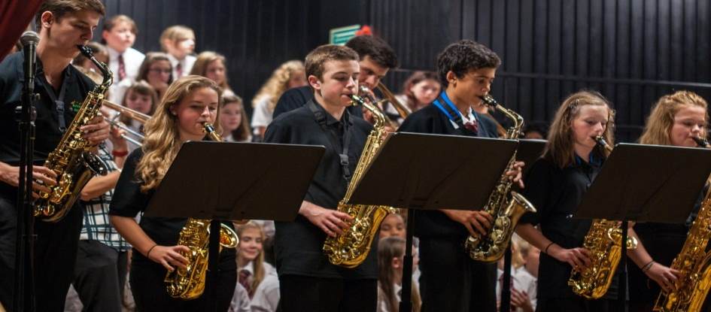

Job Description

Deputy Headteacher (Progress and Achievement: Student Experience)

Core Purpose
To provide a strategic lead for the pastoral systems at Rossett School.

Key Tasks

- To facilitate and maximise student progress in Years 7-13
- To lead and coordinate the DoL and Post-16 teams in maintaining and raising attainment and achievement at Key Stages 3, 4 and 5
- To lead the ‘marriage’ of DoL and DoS roles to focus on high quality interventions that result in targeted support for groups - identified by the analysis of data – and thus ‘closing any gaps’ in progress between groups
- To lead and manage the pastoral self-evaluation systems and reporting systems with accountability to the school’s Governing Body
- To line manage the Assistant Heads, Associate Assistant Heads and Pastoral teams, as appropriate:
- Learning Support with responsibility for our inclusion support strategy, to enable all learners to participate in the curriculum, maximising their progress through effective partnerships
- Transition, Admissions, Pupil Premium, CIAG (Career Curriculum Development) (QA of alternative courses).
- Directors of Learning for Years 7 – 11
- To play an active role in the celebration of high quality teaching, through actively supporting our CRC structure (Curriculum Research Communities).
- To work with the Assistant Headteacher responsible for the line-management of the Director of Inclusion, the Director of Behaviour and the school’s SENDCo to ensure that students are supported effectively to achieve their aspirational targets.
- To lead on the completion of the pastoral elements of all Self-Evaluation and school improvement documentation, liaising with the Headteacher and other members of the school management teams, as appropriate.
- To lead and coordinate, where appropriate, parent forums, PSHE events, and interaction and support with our local community, here at Rossett School.

Person Specification
It is expected that the Deputy Headteacher of Rossett School will demonstrate a range of qualities, skills and experience as outlined below.

Personal Qualities
- The ability to demonstrate a passion and vitality for teaching and learning and working with
young people – at the forefront of educational thinking and pedagogical practice
- The ability to inspire others with high quality interpersonal skills with a reputation for integrity and
high personal values which earns respect of staff, students and parents
- Strong leadership, underpinned with the skills to motivate effective team working whilst being
open to challenge
- Excellent communication through written and oral skills appropriate for a variety of audiences
- A strong visible presence in school and to the wider community
- A well-developed self-awareness to take on the role
- A confident, cheerful, approachable and open personality with a good sense of humour and
emotional resilience – a positive role model for students and staff
- An enthusiasm for creativity and the ability to promote freedom for others to be creative
- The ability to create and maintain an effective partnership with parents/guardians to support and improve students’ achievements and personal development (eg the ability to write reports demonstrating the impact of initiatives, supported by knowledge and understanding of what makes good evidence).
- The ability to think strategically, analytically and creatively

Qualifications and training
- Graduate qualification
- Qualified Teacher status
- Experience in post as Assistant Headteacher, or Deputy Headteacher in a secondary environment
- An impressive classroom teaching record showing impact in raising standards
- Evidence of significant continuing professional development eg NPQSL or NPQH

Leadership and Management
- The ability to plan collaboratively, prioritise and delegate effectively
- Understanding and experience of effective strategic change, successful financial and resource
management
- The ability and drive to develop an exciting pastoral vision for the school; to be able to articulate this and to work
collaboratively with the staff and governing body to realise it
- The ability to monitor and evaluate teaching and learning effectively within a framework
of performance appraisal, encouraging and celebrating excellence, and having the ability to
mentor and motivate others to produce outstanding results
- Firm but compassionate attitude to behaviour management
- Commitment to a student-centred approach; prepared to listen and respond to the student
voice
- Commitment to balancing educational outcomes with the ‘whole child’ approach to student
development
- Up to date knowledge and understanding of the national education agenda, especially as it pertains to Personal Development, Behaviour, Welfare and Safeguarding
- Knowledge of the statutory and legal framework governing an academy, a charity and a
company

Leading Teaching and Learning
- A track record of effective managing, monitoring and evaluating students resulting in improved
educational outcomes
- Capacity to inspire and motivate colleagues and students to enable all students and staff to
achieve their full potential
- Experience of successful teamwork focused on improving standards and outcomes for all
students across the curriculum

The appointment
Rossett School is committed to safeguarding and promoting the welfare of children and young people and expects all staff and volunteers to share in this commitment. Therefore, this position will be subject to the appropriate clearance checks including an Enhanced DBS check with the Disclosure & Barring Services (previously known as the Criminal Records Bureau). Rossett School is an equal opportunities employer.

Pay
Since becoming an Academy the Governors have generally adopted National Pay and Conditions for the school. The remuneration package for the Deputy Headteacher will reflect the spirit of those arrangements, but will acknowledge the experience and skills of the person appointed. Salary is L21-L25 (£64,417 - £71,052).

Application Process
You are welcome to visit the school in advance of your application (although this is not viewed as part of the application process) and we have made arrangements to welcome you on the mornings of Tuesday 20 February and Friday 23 February at 9am. Please book your visit with the Headteacher’s PA, Debbie Duncan by email: dduncan@rossettschool.co.uk.

If you feel you have the strategic vision, drive and commitment to join our team we would like to hear from you. Please complete the Deputy Headteacher Application Form and write a separate letter of application (maximum 3 sides of A4 type – no smaller than font 11 please) in which you:

- Explain your reasons for applying
- Address the following:

Your vision for how a fully inclusive school can meet, and exceed, the grade descriptors for personal development, behaviour and welfare.

Successful applications will show examples of leading and making a difference at whole-school level and give quantified evidence of impact.

Please return your application via email to recruitment@rossettschool.co.uk or by post marked for the attention of the Headteacher.

The closing date for applications is 9am on Monday 5 March 2018.

Key Dates
Tuesday 20 February School visit (9am)
Friday 23 February School visit (9am)
Monday 5 March Applications close at 9am
Tuesday 6 March Shortlisting process commences / References applied for
Thursday 8 March Candidates notified if selected for interview
Monday 12 March Interview Day 1. Candidates will undertake a series of interviews and tasks. The appointment panel will then draw up a final shortlist for Interview Day 2 and candidates will be informed by phone of the outcome
Tuesday 13 March Interview Day 2 for final short-listed candidates.

Feedback will be available for unsuccessful candidates.

To arrange a visit to the school, or if you have any queries, please contact: Debbie Duncan, the Headteacher’s PA by email: dduncan@rossettschool.co.uk or by telephone: 01423 700954.

More information

You can find out more about Rossett from:

School website: http://www.rossettschool.co.uk

Rossett School prospectus: http://www.rossettschool.co.uk/wp-content/uploads/2013/10/Rossett_prospectus_2017_v4.pdf

The Sixth Form prospectus: http://www.rossettschool.co.uk/wp-content/uploads/2014/02/Rossett_6th_form_2018_WEB.pdf

OFSTED Reports
- 2010 Ofsted Inspection Report http://www.rossettschool.co.uk/wp-content/uploads/2013/09/Ofsted-Report-July-20101.pdf
- Good practice report for PSHE Education and Citizenship http://www.rossettschool.co.uk/wp-content/uploads/2013/09/Rossett-School-Citizenship11.pdf

DfE Performance Table: http://www.education.gov.uk/performance/rossettschool

