# cid:image007.jpg@01D260DB.9BF896B0Ocklynge Junior School

# 

# Victoria Drive | Eastbourne | BN21 8XN

[www.ocklynge.co.uk](http://www.ocklynge.co.uk)

Tel: 01323 725839

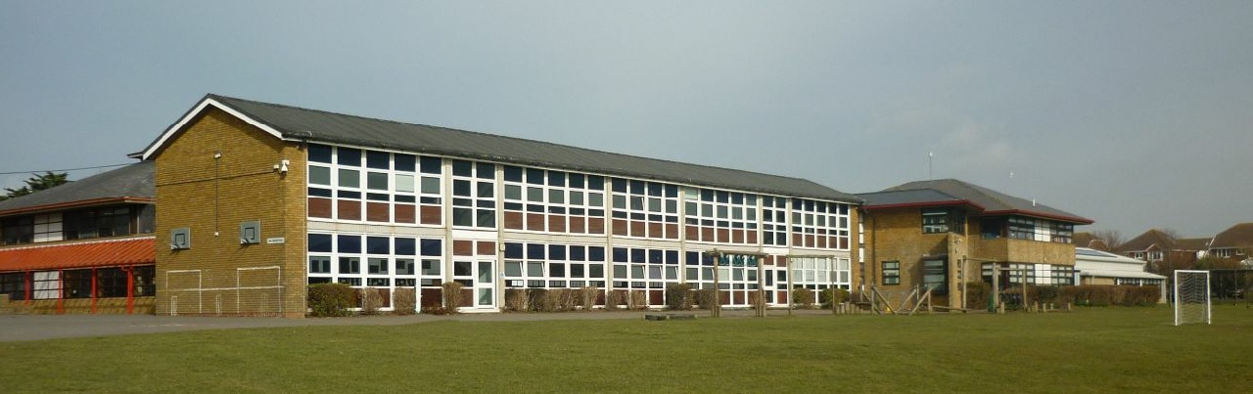

**UPPER JUNIORS TEACHER**

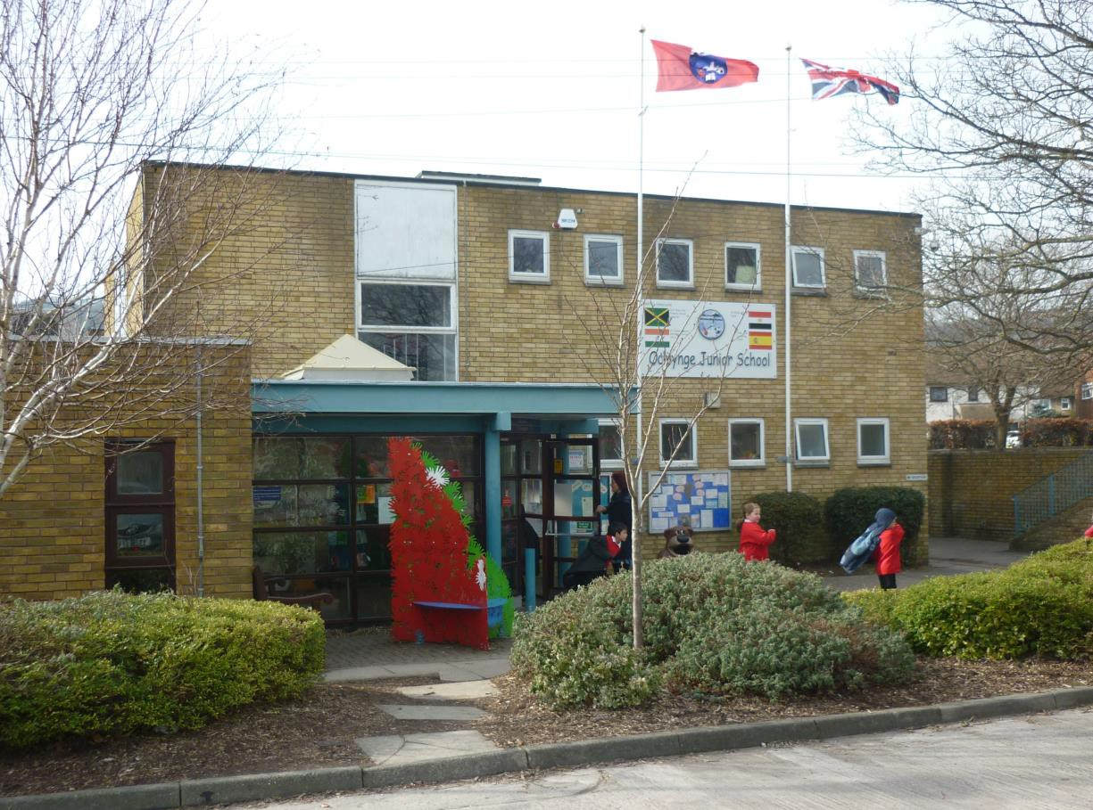

**CANDIDATE INFORMATION PACK**

|  |  |
| --- | --- |
| **Contents** | **Page** |
| Vacancy Details | 1 |
| Letter from the Headteacher | 2 |
| Information for Candidates | 3 |
| Additional Information for Candidates -   * Our Values * Application procedure * Appointment process * Pre-employment checks * Conditions of service * Policy on equal opportunities | 4-5 |
| Job Description and Person Specification | 6-8 |

|  |  |
| --- | --- |
| **Vacancy details** | 0.4 FTE |
| Permanent from September 2018 |
| **Salary** | TMS/UPS |
| **Closing Date for Receipt of Applications** | Midday on Monday 21st May |
| **Interview Date** | Wednesday 23rd May |

***“The school’s new curriculum is imaginative and interesting and is inspiring better attitudes to learning.”***

***“The school makes a strong contribution to most pupils’ well-being and their personal, spiritual, moral, social and cultural development.”***

OFSTED October 2016

Dear Applicant

We are very pleased that you are considering applying for the post of 0.4 FTE Teacher at Ocklynge School. I hope our application pack is clear and informative and gives you a sense of our high aspirations for all students.

This is a fantastic opportunity to join a successful and forward thinking school. We are looking for an imaginative and skilled teacher who is committed to our vision and values and driven by the desire to improve the life chances of young people. The job description and person specification in this pack describe what the post entails and the type of person we are looking for.

Ocklynge is at an exciting phase in its development. In December 2017, we joined a multi-academy trust (MAT), the South Downs Learning Trust. The vision for the new MAT is to develop outstanding provision for all children. In the longer term, there may be opportunities to work across both schools.

You will be joining an innovative and successful year team who are working enthusiastically to improve outcomes for all learners

You will be joining an ambitious and highly supportive organisation which offers:

* An excellent induction programme for teachers joining the school;
* A strong commitment to professional development which will improve your leadership skills, develop your understanding of whole school issues and prepare you for the next stage in your career;
* Motivated and enthusiastic learners who respond very well to active and engaging teaching and work well independently;
* A strong team ethos across the year group and whole school.

This is an exciting post with the potential for career development as part of an ambitious and innovative school. You will:

* be able to demonstrate/incorporate the school values in all aspects of your work;
* need to be an innovative teacher who is able to teach across KS2, but initially key stage 2, 0.4 in a job share situation.
* Be able to work collaboratively within a team, supported by Head of Phase and senior leadership team.

If you decide to apply for this post, please use the information provided and your own expertise to complete the application form, which can be downloaded from our website, and return to the school by the closing date. Please note that we do not accept CV’s.

For a discussion or any further information, please do not hesitate to contact me.

I look forward to receiving your application and hearing why you believe you have the passion, commitment and talent to join Ocklynge School.

Jon Reynard  
Headteacher

# INFORMATION FOR CANDIDATES

#### Eastbourne

Ocklynge School is to the north of Eastbourne, which is a seaside resort, set in enviable surroundings flanked by the South Downs and countryside of outstanding natural beauty. There is easy access to Brighton and London *(please see* [*www.eastbourne.gov.uk*](http://www.eastbourne.gov.uk/) *for further information).*

#### Ocklynge School

Ocklynge Junior School opened in September 1972 when the former St. Mary’s Boys School and Ocklynge Girls School were combined. The school caters for children aged 7 – 11 and currently has approximately 840 pupils on roll. We have recently converted to an academy and are now part of the South Downs learning Trust.

Since the opening of the school there have been a number of extensions and improvements to the buildings. As a school we also benefit from having a large multi-purpose hall with a stage; a theatre used for drama, dance, etc., a music room, a practical room for art and craft, a refurbished library, several rooms for small group or individual work, a swimming pool, a floodlit multi-use games area, a fully equipped computer room and a ‘pavilion’ where there is an extra classroom and spaces used for breakfast and after school clubs, individual music lessons and sports changing.

**School Aims**

In general terms this is what we are trying to achieve with the children in our care:

1. To help the children towards the realisation of their full potential.
2. To help the children to develop enquiring minds and the ability to listen, concentrate and apply themselves to tasks.
3. To develop children’s self-reliance, confidence, and the ability to work both independently and co-operatively.
4. To appreciate and value each child’s contribution and celebrate their achievements.
5. To instil respect and understanding for religious and moral values and tolerance of races, religions and ways of life.
6. To help the children learn courtesy, good manners, and consideration for others.

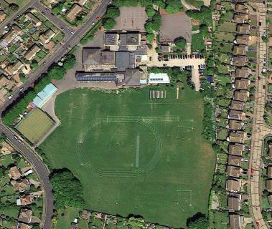**School Organisation**

The children are organised into 6 mixed ability classes in each year group with 35 pupils in each class. These classes are carefully put together when children join Ocklynge in Year 3 from the feeder infant schools.

The class teacher will plan the work for all the children in the class and has a trained assistant who will provide extra support for individuals or small groups. Each year group has a senior teacher who is Head of Year or phase and they co-ordinate the work of the whole year group. After the class teacher they provide useful advice or guidance for parents.

# ADDITIONAL INFORMATION FOR CANDIDATES

We follow the school values:

We are **Responsible** - we work hard, are helpful, reliable, look after property and co-operate with others.

We are **Respectful** – we are polite, well mannered, considerate, gentle and understanding of others.

We are **Reflective** – we are patient, honest, kind, good listeners, forgiving and admit when we have made a mistake.

We are **Resilient** – we do not give up, we try to sort our problems calmly and give things a go.

#### Application Procedure

1. Read carefully all the information about this post.
2. Complete the application form as fully as possible. You must use the school application form. If there is insufficient room on any section of the form, please provide the additional information on a separate sheet.
3. In section ‘details in support of your application’ please tell us:
   1. Why you are applying for this post.
   2. How your experience, skills, training and/or qualifications equip you for this position and specifically how you meet the person specification and requirements of the job description.

#### Appointment Process

1. Suitable applicants will be shortlisted for an interview.
2. If you are successful you will receive an email inviting you to attend an interview. It is therefore important that you give us an email address you access regularly.
3. Candidates called to an interview:
4. will be given a tour of the school.
5. may have a task/exercise (paper based and/or classroom based).
6. will have a formal interview.

#### Pre- Employment Checks

The successful applicant will be required to:

1. Provide details of two referees who know you in a professional capacity, one of whom must be your current or more recent employer. It is our usual policy to take up references before interview where possible. Employment is conditional on these references being deemed satisfactory.
2. Provide proof of all relevant qualifications.
3. Provide proof of eligibility to work in the UK.
4. Undertake an Enhanced Disclosure and Barring Service check including List 99 check, and receive clearance. Please note that an enhanced check will reveal all criminal convictions on record, including those that might be considered ‘spent’.
5. Complete a Health Declaration form and New Starter Health Assessment Questionnaire.

#### Conditions of Service

Employment is subject to a number of pre-employment checking procedures – these are given above. The job description may not be necessarily be a comprehensive definition of the post and may be subject to modification or amendment at any time after consultation with the post holder.

#### Policy on Equal Opportunities and Child Protection

The School is an Equal Opportunities employer and appointments are based on the applicant’s ability to meet the requirements of the position. The School is opposed to any form of discrimination against any individual or group and welcomes the fact that our School includes a diversity of individuals from many races and cultures. Behaviour which is discriminatory on the grounds of race, colour, culture, nationality, gender, sexual orientation, disability, religion will not be tolerated. The school is also committed to safeguarding and promoting the welfare of children and young people and expects all staff and volunteers to share this commitment.

Our Child Protection & Safeguarding Policy can be found on our website: [www.ocklynge.co.uk](http://www.ocklynge.co.uk)

**JOB DESCRIPTION**

**Job Purpose**To carry out the professional duties of a teacher as circumstances may require and in accordance with the school's policies under the direction of the head teacher. To be an effective professional who demonstrates their curriculum knowledge, able to deliver effective teaching, learning and assessment to support the achievement of pupils.

**Teachers Standards**

Teachers’ Standards is the core document for practising teachers at this school and defines their daily role and responsibilities. The Standards encompass teachers’ job descriptions, reflect the school development plan and constitute the framework for the management of the appraisal process in this school.

This job description may be amended at any time following discussion between the head teacher and member of staff, and will be reviewed annually.

**Areas of Responsibility and Key Tasks**Ensure that pupils achieve outstanding progress through:

**Planning, Teaching and Class Management**Teach allocated pupils by planning their teaching to achieve progression of learning through:

* Identifying clear teaching objective and specifying how they will be taught and assessed;
* setting tasks which challenge pupils and ensure high levels of interest;
* setting appropriate and demanding expectations;
* setting clear targets, building on prior attainment;
* be aware of and make provision for pupils who are AEN/SEN, very able, LAC or who have other particular needs;
* providing clear structures for lessons maintaining pace, motivation and challenge;
* making effective use of assessment and ensure coverage of programmes of study;
* ensuring effective teaching and best use of available time;
* maintaining discipline in accordance with the school's procedures and encouraging good practice with regard to punctuality, behaviour, standards of work and homework;
* using a variety of teaching methods to:

1. match approach to content, structure information, present a set of key ideas and use appropriate vocabulary

ii. use effective questioning, listen carefully to pupils, and give attention to

errors and misconceptions

1. select appropriate learning resources and develop study skills

through library, ICT and other sources;

* ensuring pupils acquire and consolidate knowledge, skills and understanding appropriate to the subject taught;
* evaluating own teaching critically to improve effectiveness;
* ensuring the effective and efficient deployment of classroom support;
* taking account of pupils' needs by providing structured learning;
* opportunities which develop the areas of learning identified in national and local policies and particularly the foundations for literacy and numeracy;
* encouraging pupils to think and talk about their learning, develop self-control and independence, concentrate and persevere, and listen attentively;
* using a variety of teaching strategies which involve planned adult intervention, first-hand experience and play and talk as a vehicle for learning;

**Monitoring, Assessment, Recording, Reporting**

* assess how well learning objectives have been achieved and use them to improve specific aspects of teaching;
* mark and monitor pupils' work and set targets for progress;
* assess and record pupils' progress systematically and keep records to check work is understood and completed, monitor strengths and weaknesses, inform planning and recognise the level at which the pupil is achieving;
* undertake assessment of students as requested by examination bodies, departmental and school procedures;
* prepare and present informative reports to parents.

**Curriculum Development**

* contribute to the whole school's planning activities;  
  liaise with the Key Stage Leader or Curriculum Leader to ensure the implementation of the school’

**School development**

* To promote equal opportunities within the school and to seek to ensure the implementation of the school’s and Children’s Services equal opportunities policies;
* To promote within the school a culture in which all pupils, staff and parents feel confident in raising concerns relating to the welfare or safety of children and that those concerns will be heard and dealt with consistently, and to do this in accordance with the school’s Child Protection Policy.

**Other Professional Requirements**

* have a good working knowledge of teachers' professional duties and legal responsibilities;
* operate at all times within the stated policies and practices of the school;
* have good knowledge of subject(s) or specialism(s) to enable effective teaching;
* take account of wider curriculum developments;
* establish effective working relationships and set a good example through their presentation and personal and professional conduct;
* endeavour to give every child the opportunity to reach their potential and meet high expectations;
* co-operate with other staff to ensure a sharing and effective usage of resources to the benefit of the school and pupils;
* contribute to the everyday life of the school through effective participation in meetings and management systems necessary to coordinate the management of the school;
* take part in marketing and liaison activities such as Open Evenings, Parents Evenings, Review days and events with partner schools;
* take responsibility for own professional development and duties in relation to school policies and practices;
* liaise effectively with parents and governors.

**PERSON SPECIFICATION**

**Essential Criteria**

**1 Knowledge and Experience**

1.1 Evidence of exemplary Foundation/Key Stage 1/Key Stage 2 classroom practice.

1.2 A sound understanding of recent developments in the primary school curriculum.

1.3 Knowledge of the particular requirements of delivering education to pupils with AEN/SEN, very able, LAC or who have other particular individual needs.

1.4 Knowledge of strategies which are necessary to promote purposeful learning and progress while safeguarding the health and safety of pupils.

* 1. Understanding of multicultural education and other issues related to ensuring that

classroom organisation and practices is not discriminatory.

**2 Skills and Abilities**

2.1 Ability to plan and prepare programmes of work, appropriately differentiated, for the delivery of the curriculum to children in the primary school age range.

2.2 Ability to assess the needs of individual pupils and maintain appropriate records for the purpose of continuity and progress in curriculum areas.

2.3 Ability to select appropriate resources to create a stimulating learning environment.

2.4 Ability to relate and communicate effectively with parents and encourage their participation in their child’s education.

* 1. Ability to direct the work of a teaching assistant.
  2. Ability to work closely with other members of staff in the development of the curriculum and pastoral work of the school.
  3. Excellent inter-personal skills
  4. Excellent time and task management skills.
  5. Ability to work under pressure and to deadlines.
  6. Ability to use data effectively in setting targets and understanding pupil progress.

**3 Qualifications**

* 1. DfE recognised teaching qualification
  2. Evidence of ongoing professional development; attendance on courses, INSET, action research, personal study etc.

**4 Personal Qualities**

4.1 Commitment to safeguarding and promoting the welfare of children and young people.

4.2 Commitment to a range of teaching approaches that encourage pupils to develop their full potential.

4.3 Commitment to equal opportunities within the whole school development plan.

4.4 Commitment to partnership with Governors, school and parents.

4.5 4.6 Evidence of commitment to personal continuing professional development.

**5 Desirable Qualities**

* 1. **Proven ability to lead a subject area.**