

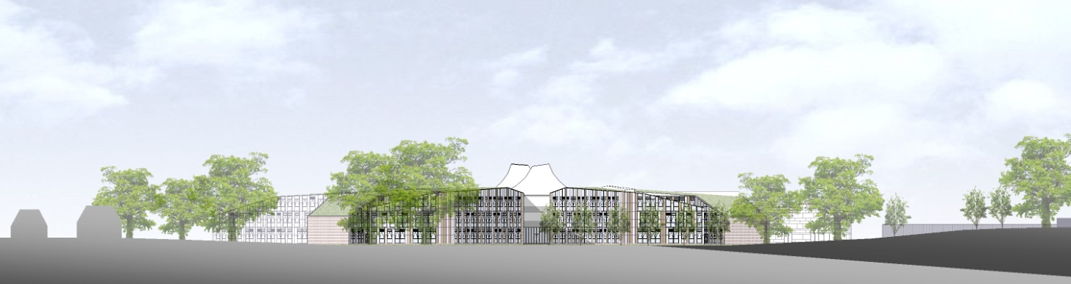

# ST. BARTHOLOMEW'S SCHOOL

MINIBUS DRIVER – CASUAL HOURS AS REQUIRED

# Required as soon as possible



**Andover Road**

**Newbury RG14 6JP**

**Tel: 01635 – 521255**

**Fax: 01635 576320**

**Email:** [**recruitment@stbarts.co.uk**](mailto:recruitment@stbarts.co.uk)

[**www.stbarts.co.uk**](http://www.stbarts.co.uk)

**THE FACULTY**

We wish to appoint a Minibus Driver with a public service vehicle licence to drive the school’s minibus. A full clean licence is essential.

The appointment involves driving as required, some of which will be outside normal school hours, plus regular cleaning and maintenance.

The preferred candidate will be required to undertake and pass a minibus test.

**THE POST & SALARY**

In view of the nature of the post, the hours will be flexible and paid on a timesheet basis.

Salary will be paid in accordance with the national APT&C point 12 (currently £17173 per annum full-time equivalent). Payment will be made at an enhanced rate of £10.15 per hour, which includes holiday pay.

**HOW TO APPLY**

Full post details, an application form and instructions on how to upload your completed application are available via the Jobs & Training / Job Opportunities section on the School’s website:

[**www.stbarts.co.uk**](http://www.stbarts.co.uk)

(Please note that curriculum vitae and covering letters cannot be accepted)

Successful candidates will be subject to a DBS enhanced check along with other relevant employment checks.

## Closing date: Sunday 3 June 2018

Thank you for considering St Bartholomew’s School.

Julia Mortimore

Headteacher