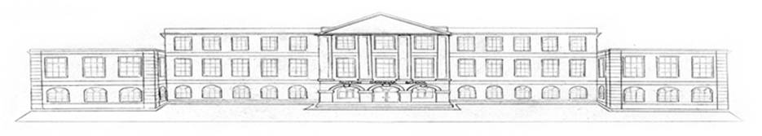Sutton Grammar School

Sutton Grammar School is an 11-18 selective convertor academy. The boys follow a predominantly academic curriculum leading to GCSE and A-level examinations. The last Ofsted inspection (December 2008) said the school was ‘outstanding’ overall and in every section. The report is available from the TES website or via the link from the school website.
Sutton Grammar School had a specialist science and mathematics designation and STEM subjects are an area of outstanding practice with national recognition for our work in this area. The 2018 UK Senior Scientist of the year and the 2017 UK Intermediate Engineer of the Year are both students from this school.

The School was founded in 1899 to meet the growing aspirations of the town and the surrounding country area. The School was grant maintained from April 1992, then was a foundation school and converted to academy status in 2011 and is a member of a collaborative partnership of all the secondary academies in Sutton.

The main school buildings on the current site date from 1928 and we have significantly improved the facilities in the last decade. A major £3m new building was opened in 2015 and includes two art teaching studios and an adjacent digital art suite. Other recent new buildings include teaching blocks for humanities, technology and IT, library, CCF building, and music centre. The sports hall and modern language building and the conversion of the old gym into a drama and music studio were followed by a new kitchen and canteen. In 2012 we opened a new £1.8m wing for mathematic. Two extra science laboratories have been created in the main building to keep up with the growth in demand for science at A-level, the latest in 2016 with grants from the Wolfson Foundation, the Garfield Weston Foundation and our own PTA.

The school now takes 135 boys into five forms in year 7 (so far into years 7-9) and there are multiple applications for each place. There are 289 in the sixth form. The total school roll is currently 934 and will reach about 960 in September 2019, which is small enough to provide a friendly, caring atmosphere, but large enough to support a successful sixth form with an appropriate choice of subjects at advanced level, providing an excellent basis for university entrance and professional careers. Although most of our sixth form come from our own year11 it is possible to join the school for A-levels and from September 2017 this option has been available for girls as well as boys, with the first 19 girls in their lower sixth year now. Despite this growth, our small size is overall a strength.

Management of teaching and learning is organised into seven faculties (English, Mathematics, Science, Humanities, Languages, Applied Studies, Performance) with the Heads of Faculty forming the core of the Academic Board. All of SLT except the bursar attend Academic Board meeting as does the Head of Academic Support and others as dictated by the agenda (e.g. Head of Sixth Form). There is a Pastoral Board, led by the Deputy Head, comprising the three Heads of School and their deputies, Special Educational Needs and Disability Co-ordinator, and the Head. The two boards act in an advisory capacity to the Senior Leadership Team. With a very supportive governing body the school has been able to make significant progress on its development plans.

Sutton Grammar boys are of a high academic potential: bright, articulate, open - they are demanding but very rewarding to teach. They are given every opportunity to develop their talents both in and out of the classroom. The curriculum is broadly based, all boys following a common course to the end of Year 9. There is some choice in Years 10 and 11 leading to GCSE (more than 70% of all results have been A* or A and we would like this figure to become higher still). We value breadth – virtually all boys in year 11 take 11 or 12 subjects. Most boys stay into the Sixth Form, where students are encouraged to take four subjects all the way through to A-level, and all students also take pre-U Global Perspectives at the end of year 12.

Examination results have been very good almost every year both in raw terms and on any measures of value added. In recent years an average of twelve boys a year have won places at Oxford and Cambridge colleges in a range of subjects, reflecting the high calibre of our best boys and the good quality of teaching in all faculties. Historically, the School has had a bias towards mathematics and science in the sixth form but, while these areas remain strong, there is a healthy balance of the strongest students across the whole range of the curriculum.

The core curriculum in the sixth form is enriched with schemes like Sports Leadership, Young Enterprise, and Pre-U Global Perspectives for all in the lower sixth. All students do extended projects at the end of the lower sixth. We also value the contribution of boys of all ages in sport, drama, music, Christian Union, Duke of Edinburgh, and other clubs and societies, and their success depends on the support of teaching staff to provide continuity and encouragement, although senior boys often take leading roles too. The school has a Combined Cadet Force unit that provides leadership and adventurous training opportunities (with some cadet places reserved for girls from our partner school, Nonsuch High School).

There are about sixty teachers at the School. The number of women teachers is growing including several in senior positions of responsibility, including the deputy headteacher and two of the seven heads of faculty. Staff turn-over is very low which is a good sign of a happy staffroom.

We take an interest in the training of new teachers and provide placements in several subjects for the Sutton Training School Partnership.

The School enjoys a central location in Sutton, convenient for many public transport routes, the High Street and Sutton Central Library. We also have an excellent games field in Cheam with 27 acres of pitches and a pavilion. Nearly half the boys represent the School in the many sports played against other schools and this provides another avenue for enthusiastic staff.

There is good collaboration with the other Sutton schools.

The school website gives a good impression of the school and can be viewed at: www.suttongrammar.sutton.sch.uk

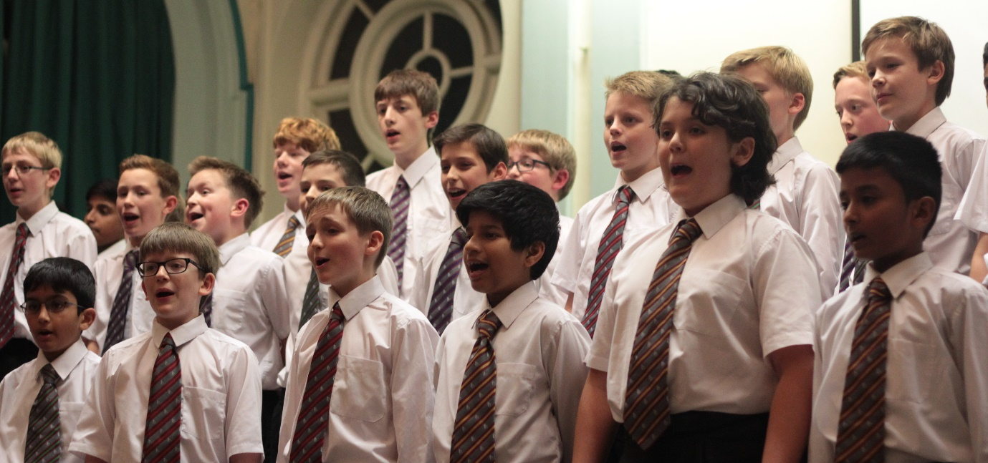

Salary and Conditions

Staff performance and salary are reviewed annually by the Remuneration Committee. Inflationary pay rises have always been applied in September each year. The school participates in the Teachers' Superannuation Scheme. Candidates should note that all appointments are subject to references, satisfactory medical checks and DBS clearance.

The school is a non-smoking establishment, and promotes healthy lifestyles amongst its staff and pupils. Staff make extensive use of the multi-gym equipment and sport for staff (e.g. badminton, spin class).

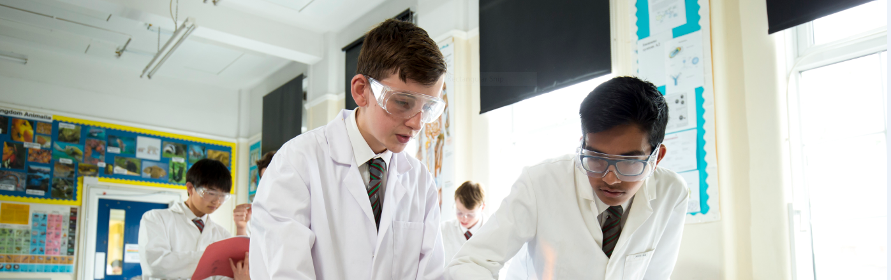

For an informal discussion with the Headmaster about any aspect of this post please contact Headmaster Gordon Ironside (E-mail: gironside@suttonmail.org) or telephone 0208 642 3821 X204

To apply use the TES application form by clicking on the apply here button on the advert on the TES.com website. Applications must be submitted by 5pm on Wednesday 18th April 2018.

Address: Mr G D Ironside, Headmaster, Sutton Grammar School, Manor Lane, Sutton, Surrey, SM1 4AS

tel: 020 8642 3821 fax: 020 8661 4500 E-mail: gironside@suttonmail.org

school website: www.suttongrammar.sutton.sch.uk

COME AND JOIN ONE OF THE BEST SCHOOLS IN THE COUNTRY!

