Davison CE High School for Girls  Selborne Road, Worthing, West Sussex, BN11 2JX  Telephone: 01903 233835 | 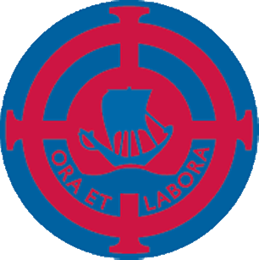

Davison Science is a successful Department in which students enjoy learning and teachers enjoy teaching. Students’ motivation, behaviour and achievement are excellent with extensive, extra academic and pastoral support for those who need it. The Department is fully-staffed with specialist Science teachers.
We are proud of our results, which have been consistently good for the last six years. All students take Double, Combined or Triple Science GCSEs. Last year’s Year 11 Double Scientists achieved 68% A*-C in Core Science and 67% in Additional Science. Triple Scientists achieved 98% A*-C in Physics, 98% in Chemistry and 98% in Biology.
Key Stage 3 are taught in five ability groups. In Year 10, there is one Triple Science class doing GCSE Biology, Chemistry and Physics and eight Combined Science classes, in four ability groups. In Year 11, there are two Triple Science classes doing GCSE Biology, Chemistry and Physics and eight Double Science classes in four ability groups, doing GCSE Core and Additional Science. Students in all year groups have the opportunity to take part in a wide variety of extra-curricular and enrichment activities and have won or done well in several competitive events involving other schools, both locally and nationally.
The Department has nine modern laboratories and a share of a new computer suite. All laboratories are well-resourced and we have a dedicated team of three specialist Science Technicians.
Please do not hesitate to contact me if you wish to know more about Science education at Davison.

Chris Hallworth (Subject Leader for Science)
March 2018

