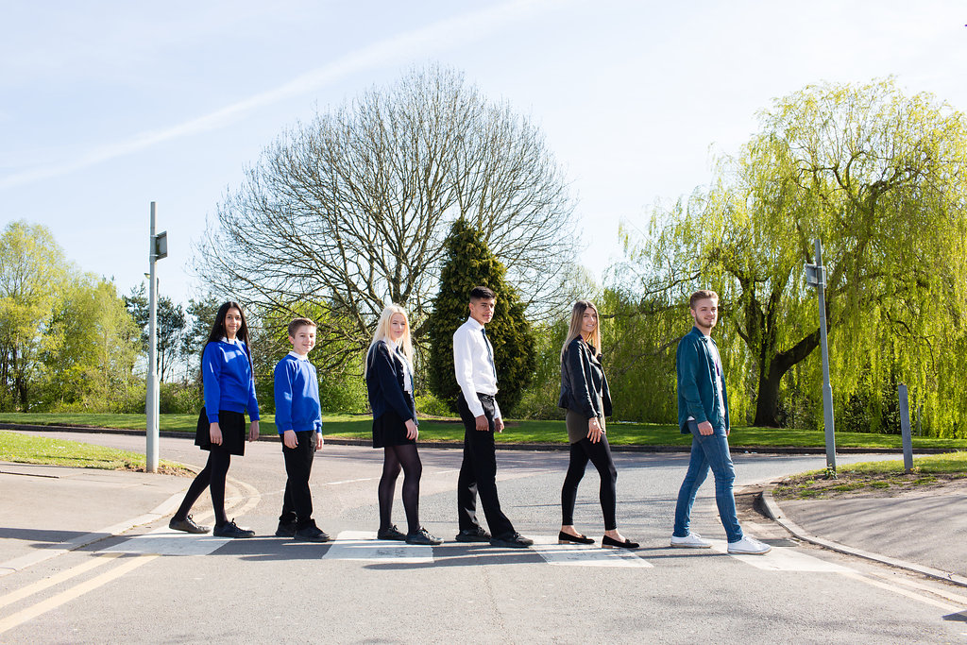

Teacher of English 11-19

Permanent
Full Time or Part Time
Newly Qualified Teachers, Main Pay Scale or Upper Pay Spine
Starting September 2018 or January 2019

Content

Vision, Values and Ethos |  | Page 3
Testimonials |  | Page 4
Faculty Information |  | Page 5
The Application Process |  | Page 6
Vacancy Advert |  | Page 7
Letter from the Headteachers |  | Page 8
Job Description |  | Page 9-10
Person Specification |  | Page 11-12

Vision, Values and Ethos
The shared vision and values of the Trust underpins all that we do, including the governance arrangements for the Trust.

Our Vision

Valuing Everyone, Achieving Excellence

Our Motto

Work Hard, Be Kind

Our goals
The goals of our trust:
- Outstanding levels of progress and achievement for all
- Outstanding levels of wellbeing for all
- Outstanding preparation for adult and working life
- Outstanding family and community engagement
- Outstanding levels of professional learning for all
Informed by “Schools of Tomorrow”

Testimonials

Extract taken from email correspondence, following a tour of the school by a prospective parent
(April 2016):
‘I would just like to say thank you for the time spent with me today on my tour of the campus, and state how impressed I was with the school. There seems to be a very calm, relaxed and organised approach to how the school operates, and I believe that obviously shows in the way your students behave’.

Written comments from parents following Year 9 Progress Evening (2017):
‘My child always talks positively about school to other children the same age, which I think is a good indicator that he is enjoying school’

‘Welcoming, approachable, friendly and knowledgeable staff’.

Written comments from parents following Year 11 Progress Evening (2017):
‘The teachers have pride in their teaching and in the pupils’ progress. They really care and are prepared to go the extra mile to support the students’.
‘My son seems to have progressed so well in most subjects. I feel this is due to good relationships he has been able to form with teachers and the standard of the lessons’.

Written comment from parent at the end of KS5 (2016):
‘This is my final parents evening after my youngest daughter is coming to the end of her years at GCE. Thank you for very happy years for my three daughters and for their excellent education!’

Thank you from parent of ex-student taking up a place at Cambridge University (2013):
‘To all the staff at Brookvale Groby Learning Campus.
My son has just started at Cambridge University studying Engineering. It was his ambition to go there and this summer, he achieved the grades he needed. We want to acknowledge the great teaching and support he received during his time with you. He progressed well academically, but also grew so much in maturity and confidence. With thanks to you all for your hard work and dedication.’

Extract of letter from staff member:
‘I have thoroughly enjoyed my time on campus. It has been a real pleasure working with staff who are always friendly, extremely supportive and willing to share ideas and knowledge. I have really appreciated having a senior leadership team which is so warm towards its staff and open to their comments and new ideas.
The children I have taught have made me smile, laugh and cry! I will miss my relationship with them and that buzz you get from seeing them progress. It does, however, give me great satisfaction to think that I have put into place schemes of work for pupils and created learning opportunities for them which should continue even after I have left.
I am sad to leave a post which I still love. Once more, thank you for all of your support and kindness.’

Comments from staff member leaving for promotion (June 2017):
It has been an honour to work at Groby and alongside such an amazing staff body. I have been supported at every turn and feel proud to have been a part of the change for the better that has taken place over the years. I wish the campus, staff and students continued success and recognition for their dedication.

English, Media & Literacy Faculty

‘Progress in English is Outstanding’ – Ofsted

The Brookvale Groby Learning Campus is a highly successful 11-19 educational organization created from the integration of two schools on the same site. Brookvale High School is an ‘outstanding’ 11-14 school and Groby Community College is a 14-19 upper school graded ‘good with outstanding features’ in its last Ofsted. Together, the campus meets the educational needs of 1600 students with nearly 400 at Post 16, and we became a Multi Academy Trust in April 2017.
We have a strong ethos of valuing everyone and achieving excellence for all. We set very high standards for our students and ourselves, we work hard, we look after each other, and we are committed to professional learning for all staff.
All staff are expected to commit to the continual improvement of practice, to focus on those things that make a difference to student outcomes, and to work collaboratively with colleagues to learn from and support others with regard to improving practice.
We have a spacious semi-rural campus location and most of our students live in the surrounding villages with some travelling from Leicester and its western suburbs.
Teamwork is one of our key strengths and we believe that this lays the foundations for successful learning within all of our subjects, both pre and post 16.

The team within the English Faculty works enthusiastically and energetically in a continual effort to get the best out of all students regardless of their abilities. We organise our classes predominantly by ability whilst retaining our focus on challenging and stretching all students: we continually reappraise practice, thinking creatively about new approaches. Most recently we have focused upon how to use questions in a continually challenging way, how to develop greater independence, and develop critical thinking. All approaches and resources are shared with each other and we have regular faculty meetings to share ideas and discuss teaching and learning strategies. Meeting with students outside of class is a natural extension of our work with them.

The team currently comprises fourteen English specialists and three dedicated teaching assistants. At GCSE we teach (AQA) Language and Literature as two separate qualifications to all students, offering GCSE Media as an option. At P16 we offer Language and Literature, Literature and Media. There is a broad range of teaching experience and expertise in the faculty; training and personal development of each teacher is of central importance to us. We work closely with graduate teacher and student teacher programmes.

The department has a long history of academic success at both GCSE and A level. We set ambitious targets for ourselves. Our students consistently achieve exam results which reflect their hard work and our dedication to ensuring that no child knowingly under-achieves.

The team teaches the majority of its classes in an English suite of eleven rooms sharing the use of the Faculty’s ICT suite. All rooms within the Faculty have data projectors, whiteboards and desk-top computers.

The Application Process

Complete application should be returned to tmalsbury@brookvalegroby.com

Or by post to

F.A.O. Tracey Malsbury

Brookvale Groby Learning Campus

Ratby Road

Groby

Leicester

LE6 0FP

A letter will be sent to shortlisted candidates with details of the interview process.

Queries

If you have any queries on any aspect of the application or need additional information please contact Tracey Malsbury, PA to Headteacher on the above email address.

Thank you.

The Role

Teacher of English 11-19
MPS from September 2018 or January 2019

Required for a September 2018 or January 2019 start, we are seeking to appoint an enthusiastic, committed, inspiring and well qualified teacher of English across the 11-19 age range. A willingness to teach Media Studies at GCSE and Level 3 will also be welcome.

The Brookvale Groby Learning Campus is a highly successful collaboration of two schools sharing the same site. Brookvale High School is an ‘outstanding’ 11-14 high school and Groby Community College is 14-19 upper school graded as ‘good with outstanding features’ in its last Ofsted. Together, the campus meets the educational needs of 1600 students with nearly 400 at Post 16.

The Brookvale Groby Learning Campus is undergoing an exciting period of change following becoming a Multi Academy Trust in April 2017. The schools have a strong ethos of valuing everyone and achieving excellence for all including the professional development of our staff.

The English, Media and Creative Writing faculty forms a central place on our campus. All students study English and English Literature to GCSE. The department also offers popular A Levels in English Literature, Language and Literature and Creative Writing as well as GCSE and Level 3 Media Studies.

Both newly qualified and experienced teachers are encouraged to apply.
We will consider both full time and part time applications.

Job Description and further information are available from Tracey Malsbury on 0116 2879921 or tmalsbury@brookvalegroby.com

Closing date: 9.00am, Monday 18th June 2018
Interviews to be held by Thursday 21st June 2018

The Brookvale Groby Learning Campus are committed to safeguarding and promoting the welfare of children and young people and expect all staff and volunteers to share this commitment. Applicants must be willing to undergo appropriate child protection screening, including checks with past employers and the Disclosure and Barring Service.

Dear Applicant

TEACHER OF ENGLISH 11-19

Thank you for your interest in the Teacher of English 11-19 vacancy with the Brookvale Groby Learning Campus.

We hope the documents provided help you to gain a feel for the school and if you would like to visit us as well, we would be delighted to show you round. Please contact Tracey Malsbury on 0116 2879921 or tmalsbury@brookvalegroby.com to make an appointment.

All the documents to support this application process are available on the website, www.brookvalegroby.com

To apply please complete the following:

- Application Form
- A letter of application, no more than two sides of A4, word processed using font size no smaller than 11

Your letter needs to be addressed to ourselves, and if you would like to e-mail your application then please send this to Tracey Malsbury on the email address above.

The closing time and date for this post is 9.00am, Monday 18th June 2018. The interviews will be held on Thursday 21st June. If you have not heard from us by then, please assume that your application has not been successful on this occasion. If this is the case, we would like to thank you for your interest and the time spent in applying.

This post will be subject to an enhanced level Disclosure & Barring Service check. All Brookvale Groby employees are expected to promote and safeguard the welfare of students at the school. Our Safeguarding Policy is made known to all and is designed to guide staff, students and parents/carers with regard to Safeguarding issues.

In line with best practice guidance re safeguarding we do not require an additional CV and any included with application forms sent to the school will not be taken forward to the short listing panel.

Yours sincerely
Katie Rush Robert Coles
Headteacher, Brookvale High School Headteacher, Groby Community College
Co-Director of BGLC Co-Director of BGLC

Job Profile
Post title | Teacher of English 11-19
Job purpose | - To provide the highest quality teaching and learning in order to raise standards of attainment and progress to meet campus targets.  - To implement and deliver an appropriately broad, balanced, relevant and differentiated curriculum for pupils and to support a designated curriculum area as appropriate.  - To facilitate learning experiences which provides pupils with the opportunity to achieve their individual potential.  - To enable each student to develop personally in line with the campus aims of Valuing Everyone, Achieving Excellence.
To whom the postholder reports | The postholder is accountable to:  - Headteacher for all matters  Responsible to:  Faculty Leader for all subject teacher matters
Duties and responsibilities specific to the post | Responsibilities: Teacher  - To undertake teaching commitments in accordance with curriculum and timetable requirements across the campus.  - To teach other subjects as and when required by the needs of the timetable and as directed by the Headteachers. This will be negotiated in accordance with the skills of the teacher.  - Prepare students effectively for qualifications and external examinations.  - To fulfil the roles and responsibilities of tutor to a group of students and support students on an individual basis through academic or personal difficulties. To act as a mentor to specific members of the tutor group in order to raise achievement.  - To take responsibility for personal CPD and to participate in campus and external CPD activities by negotiation.  - To undertake all of the requirements laid down by the campus Performance Management Policy.  - To participate in faculty/department and campus meetings.  - To participate in parental consultation/student progress evenings.  - To participate in the duty rota as instructed (two duties per week).  - To fulfil the “Professional Standards 2012” as laid down by the DfE:  - Set high expectations which inspire, motivate and challenge students – safe and stimulating environment. Set goals and challenge students of all abilities and backgrounds. Demonstrate positive attitudes, values and behaviours.  - Promote progress and outcomes by students - accountable for attainment, progress and outcomes.  - Demonstrate good subject and curriculum knowledge – including literacy and numeracy.  - Plan and teach well structured and engaging lessons – including setting regular homework as per the campus policy. Selecting and using a range of different learning resources and equipment, including ICT and where possible the use of interactive whiteboards.  - Adapt teaching to respond to the strengths and needs of all students – including differentiation / needs of SEND students.  - Make accurate and productive use of assessment – using data/marking accurately/ giving feedback to students on how to improve/maintaining records of students' progress and development  - Manage behaviour effectively – establish rules/routines. Promote positive behaviour. Have high expectations.  - Fulfill wider professional responsibilities – make a positive contribution to the ethos of the campus. Take responsibility for own professional learning.
UPS/Expert Professional Responsibilities (if applicable) | - Ensure own standards of teaching and learning are at least good or outstanding in order to be a leading professional in the campus.  - Contribute to the professional development of colleagues through coaching and mentoring, demonstrating effective practice, and providing advice and feedback.  - Other responsibilities to be determined by the Headteachers and Line Manager or as part of TLR responsibilities.
Generic duties and responsibilities | To work within the framework of national legislation and in accordance with the provisions of the School Teachers Pay and Conditions Document. In addition the post is subject to compliance with:  - School policies and guidelines on the curriculum and school organisation  - LA policies adopted by the campus  - The Conditions of Service for School Teachers in England and Wales and with locally agreed conditions of employment  - Common core of skills and knowledge for the children’s workforce.  - All teachers have a responsibility for safeguarding the welfare of children and young people he/she is responsible for or comes into contact with.  The duties and responsibilities detailed within this job description should be supplemented by those accountabilities, roles and responsibilities common to all classroom teachers, as set out within the School Teachers Pay and Conditions Document.
May 2018

Personnel Specification

ESSENTIAL | DESIRABLE | CRITERIA Assessed By
Qualifications  Degree in relevant subject.  Post Graduate Certificate of Education. |  | Application Form/CV  Application Form/CV
Training & Experience  Recent successful teaching experience at KS3 and KS4. For NQTs this includes teaching practice.  Proven commitment to own professional development. | Teaching experience at KS5. | Application Form/Letter/  Reference  Application Form/Letter/  Reference
Knowledge  Knowledge of current GCSE and A Level specifications  Understanding the role of assessment within the subject area. | Knowledge of teaching pedagogies. | Interview/Reference  Letter/Interview
Skills  Ability to work with students and staff in a supportive and challenging way.  Ability to use ICT both in the curriculum and as an administrative aid.  Ability to motivate and enthuse students, including disaffected and reluctant learners.  Ability and enthusiasm to work with students in mixed ability groups.  Effective inter-personal skills.  Good written and oral communication skills.  Effective organisational and administrative skills.  Ability to contribute to the strategic management of relevant teams through discussion and debate. |  | Reference/Letter (Observation of teaching at interview).  Letter/Interview (Observation of teaching at interview.)  Letter/Interview (Observation of teaching at interview).  Letter/Interview (Observation of teaching at interview).  Interview/Reference  Letter/Interview  Reference  Interview/Reference

Attitudes and attributes  Open-mindedness and commitment to co-operate with both students and staff.  Willing to work in an inclusive way to support all students to achieve their potential.  Able to create a positive working environment through display of students' work and celebration of students' achievements.  Able and willing to work with leaders and all colleagues in relevant teams in a co-operative, supportive and enthusiastic way.  Flexible, resilient and reliable.  Resourceful and innovative thinker.  Must contribute to the shared resource system.  In possession of a good attendance and punctuality record.  Willingness to dress as a professional in line with the ethos of the campus. |  | Reference/Interview  Letter/Interview  Reference/Interview  Reference/Interview  Reference  Letter  Reference/Letter  Reference  Interview/Reference

Jan 2018

