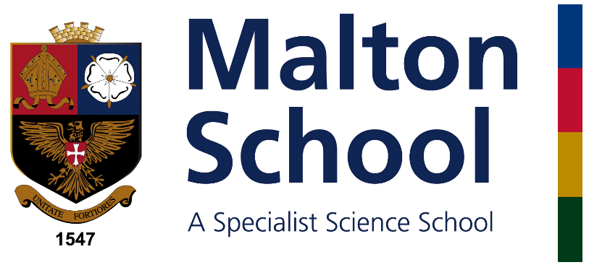
SUPPORT INSPIRE THRIVE

Faculty Leader
Humanities Faculty

(Geography, History, Citizenship, Religious Studies, Sociology and Psychology)

Information for Applicants

May 2018

Dear Applicant,

Thank you for your interest in the post of Faculty Leader of the Humanities Faculty at Malton School. This document aims to give you some information about the School and the application procedure.

Malton School serves a wide rural area of Central Ryedale, as well as the town of Malton itself. We currently have 783 students on roll, including 173 in the Sixth Form; there are 48 teaching staff and 49 support staff. We are fully comprehensive. Our staff student relationships are excellent. Behaviour is extremely good. Most of our students move on to university and many of them to Russell Group universities. We offer a very happy and supportive community in which colleagues can further develop their career. The school is over-subscribed. We currently have 4 forms in Years 8, 10 and 11 and 5 forms in Years 7, 9 and Sixth Form and are expanding to 5 forms across all year groups.

We are seeking to appoint an excellent teacher of Geography, History, Citizenship or Religious Studies to lead this successful faculty.

The school operates an iPad for Learning scheme. Every member of staff has an iPad as well as a laptop and all students have an iPad.

The school is a member of the Red Kite Teaching School Alliance, a group of high achieving Yorkshire schools (including Harrogate Grammar School, Prince Henry’s Grammar School, Ilkley Grammar School, Rossett School and Roundhay School). We share staff development programmes and opportunities within the alliance, including leadership development and support for newly qualified teachers.

I hope you will be interested in this post and I look forward to reading your application.

Yours sincerely,

Rob Williams
Headteacher

Benefits of working at Malton School
The school prides itself in being a supportive employer, offering favourable terms and conditions to facilitate outstanding teaching and learning. Some of the main additional benefits of working at Malton School include:

- PPA above the national expectation in response to staff delivery of a Personal Development Activity (PDA – see below).
- A strong bespoke staff development programme for all staff.
- A major investment in support staff roles (e.g. allowing the provision of “no cover”) so that teachers can focus on planning and delivering outstanding lessons.
- Membership of the Red Kite Teaching School Alliance.

Malton School is committed to safeguarding and promoting the welfare of students and young people and expects all staff to share this commitment.

The Humanities Faculty
The Faculty consists presently of seven specialist teachers who teach across Key Stage 3, 4 and 5. We work through consultation, collaboratively sharing ideas, approaches and resources. Whenever possible, faculty meetings will have a practical focus. Student progress and achievement have been strong in Humanities at both Key Stage 4 and 5. We are looking to appoint a leader who can help us develop into an outstanding faculty.

The school has seven designated humanities classrooms. All staff are given a laptop and iPad and every classroom is equipped with a data projector. iPads are used extensively in the faculty as a learning tool. The faculty has an exciting range of established extracurricular visits and guest speakers.

Geography
At KS5 level we currently offer Edexcel A Level and have enjoyed good academic results in the first AS exams. Each year a number of students continue their studies at university on a range of related courses. We have embraced the new curriculum and we offer Edexcel B Geography GCSE to allow progression through to the new A Level. The subject has increased its recruitment and for the last 4 years has had three GCSE classes. At KS3 we offer a full Geography curriculum in line with the National Curriculum changes introduced by the Government. The subject gained the Secondary Geography Quality Mark in 2014 and is in the process of reapplication this year.

History
At KS5 we currently offer AQA for A Level (Stuart Britain, the American Dream 1945-80 and France 1789-1914 for the NEA). This is delivered by two specialist teachers one of whom is a lead examiner for AQA. There are currently two classes in both Year 12 and Year 13 demonstrating the subjects’ strength in recruitment. At KS4 we deliver Edexcel for GCSE (Crime and Punishment, American West, Early Elizabethan England, Russia and the Soviet Union). Numbers opting for the subject at GCSE have increased to three classes this year demonstrating the strength of the subject specialist staff that deliver the curriculum. At KS3 we offer a full History curriculum in line with the National Curriculum changes introduced by the Government.
Religious Studies
This subject has not recruited to A level this year but in the past has been a popular choice achieving high academic results. This would be an area of focus for the new Head of Faculty. We currently offer GCSE Religious Studies A, each year recruiting a GCSE class. In the past the results have been the highest in the Red Kite School Alliance.

Psychology
We deliver the AQA Psychology A Level course which is a popular option choice at KS5 with two groups running in both Year 12 and Year 13.

Sociology
We currently offer the OCR Sociology A Level which is another popular A Level course led by a specialist Sociology teacher.

Citizenship
Citizenship is taught to all Years 7 to 11 for two hours per fortnight. This builds on a well-established programme of Personal & Social Education, complementing tutorial work and linking into the Careers programme. In Years 7 and 10 students are following the Archbishop of York Youth Award programme which involves completion of personal challenges as well as school based and community projects. The subject is currently taught by a range of staff none of whom are specialist in this field.

The School Curriculum
We operate a four-period day within a ten-day cycle. Each lesson is 75 minutes long. Students have 26 hours curriculum time each week.

Key Stage 3
Students are placed in mixed-ability form groups. In Years 8 and 9 setting is for Science, Maths and the group of subjects English, Geography, History, Modern Languages and Religious Education.

Key Stage 4
English (including Literature) Maths, Double Science, Religious Studies, Citizenship, and Physical Education are compulsory. Students then choose four further options subjects (10% of curriculum time each). GCSE General Studies is available as an additional entry in Y11.

Key Stage 5
Advanced Level courses are currently taught in Art, Biology, Business Studies, Chemistry, Computing, Design Technology, English Literature, French, General Studies, Geography, Food, Nutrition & Health, History, Maths, Maths (Further), Music, Philosophy and Belief, Physics, Physical Education, Psychology and Sociology.

Re-sit GCSE courses are also offered in English and Maths, together with an open access provision for IT skills acquisition.

Personal Development Activity
One hour per week is devoted to personal skills development. Staff offer nearly 40 different courses. Students choose a different course each term. The scheme is focused on Character education and the development of the whole child. New members of staff would be expected to contribute to this programme.

Academic Structure
The academic work of the School is structured in Faculties. Each Faculty is led by a Faculty Leader.

In-service training is managed in consultation with Faculty Leaders. Funding for books and equipment is derived from a formula which takes account of the numbers and ages of students as well as the nature of the subject. Faculties are also able to bid annually for additional funding from the School budget, the Endowment, and the PTA.

Pastoral Structure
Each Key Stage is led by a Head of School and an Assistant Head of School. There are currently four Form Tutors in Years 8, 10 and 11and five Form Tutors in Years 7, 9 and Sixth Form. The school is oversubscribed and moving to five forms across all year groups.

The School Site
We are fortunate to enjoy a large site on the edge of Malton with views of both the North York Moors and the Yorkshire Wolds. The sports field accommodates three hockey, four football, one rugby pitch, one cricket pitch and an athletics track as well as 7 hard court tennis courts / netball courts. Staff can use our sports facilities in the excellent sports centre. There is plenty of parking space for staff.

Malton School was founded in 1547, becoming a comprehensive school in 1971 with the merger of the original grammar school and the neighbouring county modern. The two buildings, known as East and West Wings, date from 1911 and 1958. As far as possible subject departments are housed in one wing. Most members of staff are based permanently in one room.

We opened a new Science block with four new laboratories in 2004 on becoming a specialist Science School, resulting in a total of eight laboratories and associated preparation rooms. Our Food Technology rooms were totally re-furbished in 2011. In February 2011 Archbishop Sentamu opened a community sports centre and full-sized, floodlit, astroturf pitch on the school site, providing us with the best P.E. facilities in the area. A new dance and drama studio was opened in September 2013. Fully refurbished DT rooms opened in September 2016.

School data

Address: Malton School
Middlecave Road
MALTON
North Yorkshire
YO17 7NH

Telephone: (01653) 692828

Email: admin@maltonschool.org
Website: www.maltonschool.org

Chair of Governors: Rachel Riddell
c/o Malton School

Clerk to the Governors: Nicola Wise
Malton School

Corporate Director of Education: Stuart Carlton
County Hall
NORTHALLERTON
North Yorkshire
DL7 8AE
Telephone: 0845 034 9494

Application
You are invited to submit an application for the post of Faculty Leader at Malton School and to support your application with a letter.

Completed application form and supporting letter should be submitted via TES or emailed to the Head’s PA, Nicola Wise njw@maltonschool.org by 9am, 22/05/2018. Your application will be acknowledged. Interviews are planned for 25/05/2018 so if you have not heard from us by then you should assume that your application has been unsuccessful on this occasion.

Thank you for your interest in the post of Faculty Leader. If you have any questions please do not hesitate to contact Nicola Wise on the email above or 01653 605302.

Malton School is committed to safeguarding and promoting the welfare of its students. All staff must have enhanced DBS Clearance and are expected to adhere to safe working practices.

