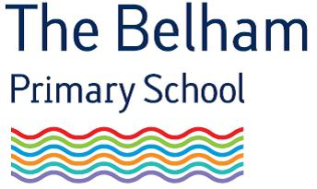
After School Club Co-Supervisor
Salary: Grade 4, Spine Point 13 - 20 (£11.16-£12.45 per hour) term-time only
Hours: 15:00-18.00 Monday to Thursday
Start date: September 2018

The Belham Primary School is a new and expanding school in Bellenden Road, Peckham. The Belham is part of Dulwich Hamlet Educational Trust, which also runs the nearby Dulwich Hamlet Junior School.
We are looking for an After School Club Co-supervisor to start in September and wish to appoint a reliable, friendly and enthusiastic person to fill the role.
You will be working in a supportive and friendly school that values its employees and supports their development. We occupy a brand new renovated building in a fantastic area of Peckham. And we have the loveliest children on the planet!
A full job pack including application form is available on our website, where you can also find out more about our school. For further information please call the School Business Manager on 020 8353 4290.
We will close applications when the position is filled.
Interviews will commence in September 2018.

Dulwich Hamlet Educational Trust | The Belham Primary School
165 Bellenden road, Peckham, London, SE15 4DG

www.thebelhamprimaryschool.org.uk

Dulwich Hamlet Educational Trust is committed to safeguarding and promoting the welfare of children. Appointments are subject to an enhanced DBS check and medical fitness to undertake the post.

The Dulwich Hamlet Educational Trust is committed to eliminating discrimination and advancing equality of opportunity. We welcome enquiries from everyone and value diversity in our workforce.

