Secondary Class Teacher
FOCUS SCHOOL

© 2015 Focus Learning Trust All Rights Reserved Published by Focus Learning Trust, January 2015

PURPOSE OF THE ROLE

The class teacher role is central to the delivery of excellent teaching and learning and is specifically required to:

- Continually raise student attainment and achievement through well planned, appropriately pitched and differentiated lessons
- Provide day-to-day classroom leadership, inspiration and management, and maintain excellent teaching practice
- Maintain an orderly and safe and classroom environment that is conducive to good learning
- Support the effective implementation of the agreed education programme including the overall development and well-being of individual learners of all abilities
- Support and implement the school’s student progress tracking arrangements at class level
- Ensure all teaching programmes and activities are carried out and documented to meet the relevant requirements of Examination Boards and other external bodies`
- Uphold and promulgate the Focus ethos within all areas of responsibility
- Maintain positive, appropriate and effective communications and relationships at all levels
- Work with other staff to promote relevant cross curricular activities in line with the school’s current policy
- Comply with and support the implementation of all school policies at all times

SAFEGUARDING

Focus Learning Trust and its affiliated schools are committed to safeguarding and promoting the welfare of children and young people and expect all staff and volunteers to share this commitment. The post is subject to a DBS Enhanced with Barred List Disclosure.

SUPPORT FOR THE ROLE

The role is supported by a Senior Teacher and a proactive board of trustees with a designated Campus Administrator to work with the Senior Teacher on a day to day basis. Focus Learning Trust provides a range of support services in areas such as IT, policies and resources.
School Development Advisors provide assistance in areas such as curriculum, SEND, performance management, CPD, data, pedagogy, and to support progress, promote consistency and share good practice between schools.

For further details email recruit.1@focus-school.com

DUTIES

In recognition of the importance of good classroom management combined with exemplary teaching practice for improved student learning outcomes, the key duties include but are not limited to the following:

- Report to and meet regularly with the Senior Teacher or such other line manager as directed by the Management Team
- Deliver lessons to timetable as directed by the Senior Teacher
- Ensure lessons are well planned, appropriately pitched and differentiated to meet the needs of all learners
- Set homework and mark work in line with the current
- school policies
- Attend and participate in staff meetings as requested by the Senior Teacher and Management Team
- Cooperate with the Senior Teacher on Management of Performance activities such as lesson observations and work scrutiny
- Provide reports and communicate regularly with parents
- Contribute to, share in and promote the wider and longer term vision of the school
- Within the areas of your responsibility, ensure the school
fulfils its obligations in regard of compliance with statutory and regulatory requirements
- Contribute to the recording of student performance data, tracking and target setting as directed by the Senior Teacher
- Maintain a high standard and equitable approach to student welfare and behaviour management in line with the current school policy
- Promote a classroom culture for learning in which everyone takes responsibility for a high standard of student behaviour.
- Consistently demonstrate a high standard of organisational skills in all areas of responsibility
- Establish & maintain effective working relationships at every level
- Respect and adhere to all Focus School policies & ethos
- Take advantage of professional development opportunities
- Undertake other reasonable duties as specified by the board of trustees

For further details email recruit.1@focus-school.com

PERSON SPECIFICATION

You will have passion, presence and personality, and a determination to lead continuous improvement in student learning outcomes.

ESSENTIAL CREDENTIALS
- Uncompromising approach to high standards.
- Qualified Teacher Status (QTS) with acceptable Enhanced DBS Disclosure
- Excellent classroom practitioner
- Demonstrable ability to maintain high standards of student management
- Organised, able to plan time effectively, prioritise and meet deadlines
- Empathy with children and young people
- Good interpersonal and communication skills
DESIRABLE CREDENTIALS
- Knowledge of and passion for Self Directed Learning principles
- Experience in the use of Video Conferencing and VLE
- Ability to teach in more than one subject area
- Experience in teaching across Key Stages

For further details email recruit.1@focus-school.com

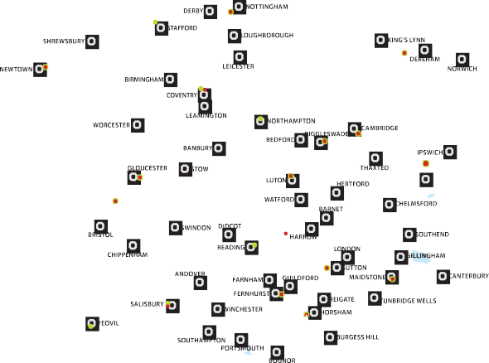

SCHOOL REGIONS

North | Primary | Secondary | TOTAL | East | Primary | Secondary | TOTAL | West | Primary | Secondary | TOTAL
Regional Total | 404 | 679 | 1083 |  | 629 | 824 | 1453 |  | 437 | 707 | 1144
Bramley Campus | 53 | 77 | 130 | Biggleswade Campus | 68 | 90 | 158 | Berkeley Campus | 65 | 121 | 186
Cottingham Campus | 42 | 70 | 112 | Cambridge Campus | 53 | 66 | 119 | Coventry Campus | 32 | 75 | 107
Crewe Primary Campus | 29 | 0 | 29 | Carshalton Campus | 85 | 42 | 127 | Gloucester Campus | 66 | 124 | 190
Hornby Campus | 36 | 51 | 87 | Dunstable Campus | 51 | 127 | 178 | Newtown Campus | 34 | 36 | 70
Knockloughrim Campus | 28 | 61 | 89 | Hindhead Campus | 76 | 110 | 186 | Plymouth Campus | 43 | 75 | 118
Long Eaton Campus | 29 | 63 | 92 | Linton Park Campus | 85 | 127 | 212 | Reading Primary Campus | 51 | 0 | 51
Millden Campus | 18 | 30 | 48 | Northampton Primary Campus | 53 | 0 | 53 | Stafford Primary Campus | 26 | 0 | 26
Newry Campus | 17 | 34 | 51 | Pulborough Campus | 46 | 73 | 119 | Stoke Poges Campus | 0 | 85 | 85
Ochil Campus | 60 | 101 | 161 | Stoke by Nayland Campus | 64 | 83 | 147 | Swansea Campus | 18 | 36 | 54
Stockport Campus | 26 | 101 | 127 | Swaffham Campus | 48 | 106 | 154 | Wilton Campus | 0 | 155 | 155
York Campus | 66 | 91 | 157 |  |  |  |  | Wilton Primary Campus | 77 | 0 | 77
 |  |  |  |  |  |  |  | Yeovil Primary Campus | 25 | 0 | 25

