|  |
| --- |
| **School Administrator & Reception Lead**  **Candidate briefing pack** |
|  |
| **Abdul** |
|  |

### 

Dear Candidate

Thank you for your interest in becoming our new School Administrator and Reception lead at The Children’s Trust.

The Children’s Trust is the UK’s leading charity for children with brain injury. We are unique, with an international reputation for the work we undertake to improve the lives of the children and families with whom we work. We provide information and support to thousands of children with brain injury and their families annually, through education, care, therapy and research. We provide expertise and experience in meeting the needs of children and young people with acquired brain injury, neuro-disabilities and complex health needs.

As a School Administrator and Reception lead, you will be reporting to your Line Manager. Your role will be to the first point of call for visitors to the school, parents, staff and children. As the ‘face’ of the school our receptionist will be welcoming, personable, helpful and able to represent the School in a professional and friendly manner.

You will be a natural and enthusiastic leader able to provide challenge and support to a high performing team.

This is a chance for an outstanding candidate to make a significant and lasting difference to the lives of thousands of children and families.

Kind regards



**Samantha Newton**

**Director of Education.**



The Charity

The Children’s Trust is the UK’s leading charity for children with brain injury and complex health needs.

The charity provides rehabilitation, medical care, special education, community services and expert information.

Our key services are:

* Rehabilitation for children with Acquired Brain Injury (ABI)
* A non-maintained special school for children with Profound and Multiple Learning Difficulties (PMLD)
* Support for children with ABI and their families in the communities across the UK, through our Brain Injury Community Services.
* Online information and support via our publications and braininjuryhub.co.uk

Our residential services based at our national specialist centre in Tadworth, Surrey, work in partnership with the NHS and local authorities to provide a step-down pathway of care between hospital and home. The centre is entirely child and family focused to ensure that their needs are appropriately supported.

In the community, we provide clinical support to complement local services and give children and young people with ABI the best chance of succeeding at home and in school.

We are the only paediatric centre with a national specialised commissioning contract (through NHS England) to provide brain injury rehabilitation for children with severe brain injury. Our other services are funded through local health commissioners (such as clinical commissioning groups), social care and education authorities, together with the millions raised through voluntary fundraising.

Thanks to the generosity of The Children’s Trust’s supporters, our 24 acre Tadworth site features a modern hydrotherapy pool, accommodation for parents, specially adapted equipment, soft play areas and a wheelchair-accessible treehouse.

We run a non-maintained special school for children with PMLD. The Children’s Trust School supports children and young people from 2 to 19 years old and is dual-registered with   
the Care Quality Commission (the school residential houses) and Ofsted.

The Children’s Trust is a charitable organisation with approximately 595 committed staff  
and 560 volunteers with a range of expertise across nursing and care, education, therapy, operations and centralised support functions such as finance, HR, fundraising  
and communications. A number of these staff are based off site around the UK as   
part of our community work or in our charity shop.

The Children’s Trust School

Children’s Trust School our aim is to provide **high quality education** and **expertise** to meet each pupil’s **individual special needs** and to **celebrate** all achievements in a happy environment.

As a non-maintained special school, we pride ourselves on seeing each individual as a **‘whole’** and delivering **integrated**, **holistic education**, therapy and care for pupils with profound and multiple learning difficulties. We provide **day** and **residential** education for pupils aged 2-19 years old. For children with disabilities aged 0-5 years we also offer **‘Taddies’,** a weekly run **parent** and **child** group that offers **support** and planned opportunities to learn through sensory **play** and **fun**!

We offer **individualised learning opportunities** relevant to each pupil to support the development of their **communication**, language and literacy skills, their cognitive development, **physical skills**, **environmental control** and **social**, **emotional and personal well-being**. We focus on developing pre-intentional learning to intentional and formal stages with an aim of supporting pupils to develop a **sense of agency** and understanding of the world around them.

Our services include **play therapy**, **music therapy**, **physiotherapy**, **occupational therapy**, **speech and language therapy**, **paediatric nursing** and access to **health services** including **GPs**, **consultants** and **clinics** such as orthotics. We aim to provide the best educational opportunities and unparalleled expertise in order to deliver significant outcomes.

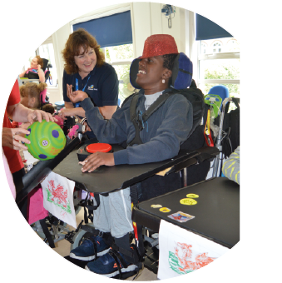

**Want to find out more?**

**Visit thechildrenstrust.org.uk/school**

The Children’s Trust School

Tadworth Court, Tadworth, Surrey

KT20 5RU

01737 365810

school@thechildrenstrust.org.uk

thechildrenstrust.org.uk

facebook.com/childrenstrust

twitter.com/childrens_trust

instagram.com/childrens_trust

Registered charity number 288018.



Job Description

|  |  |
| --- | --- |
| **Job Title** | School Administrator & Reception Lead |
| **Reports to** | The Headteacher |
| **Direct reports** | None |
| **Location** | The Children’s Trust School, Tadworth |
| **Working Hour** | 37 hours per week. Details of working week to be agreed with the Headteacher |
| **Salary** | £18,560 - £22,434 per annum |
| **Scale Range** | Equivalent to NJC Scale Range – points 19 – 25 |
| **Annual Leave** | Entitlement will be 35 days per annum, increasing to 36 after 5 years’ service. 4 weeks of annual leave will be taken during school closure. |
| **DBS** | Enhanced with Children’s Barred List |

### 

Job Purpose

You are the first point of call for visitors to the school, parents, staff and children. As the ‘face’ of the school our receptionist will be welcoming, personable, helpful and able to represent the School in a professional and friendly manner.



### Duties and Responsibilities

**WELCOME**

* To act as the first point of contact for the school in a professional manner.
* To welcome visitors and respond to telephone and email enquiries in a helpful and constructive manner ensuring that appropriate actions are taken in a timely manner.
* Ensure that the reception area is kept smart and tidy and that relevant noticeboards are kept up-to date.

**SAFEGUARDING**

* Ensure the safety and security of the school at all times, making sure that the front door is locked and entry to the premises controlled.
* Ensure that all visitors sign in and take a visitor badge where necessary.
* To professionally challenge any visitor who is not signed in.
* Ensure that copies of the Schools Safeguarding Policy and linked materials are available to visitors.
* Ensure that all visitors are provided with a safeguarding contact leaflet.

**ADMINISTRATION DUTIES AND RESPONSIBILITIES**

* Receive, sort and distribute all packages, deliveries and mail.
* Assisting with various administrative tasks and duties, utilising word, excel, outlook email and the school database updated. (Training will be provided)
* Carry out basic clerical duties (e.g., distribution of post/filing/taking meeting minutes/photocopying).
* Communicating with parents regarding all aspects of school life, receiving and passing on information,
* When required assist in the production of the weekly newsletter and other school notices, posters and school publications.

**OTHER RESPONSIBILITIES**

* To assist with the ordering of stationery, materials and resources and ensuring that stock levels are maintained.
* To act as one of the fire marshalls. Training will be given.
* S/he is required to support and encourage the school’s ethos and its objectives, policies and procedures as agreed by the governing body.
* S/he shall uphold the school’s policy in respect of child protection and safeguarding matters.
* S/he shall be subject to all relevant statutory and institutional requirements to take and hold post.
* S/he shall attend school events as required.
* S/he shall participate in school emergencies as required, including co-ordinating arrangements, locating students and staff, providing contact details and completing necessary documentation.
* All members of staff are required to participate in the school’s appraisal scheme

This job description describes the way the postholder is required to complete and perform the duties set out above.

These duties may be varied from time to time to meet the changing demands of the school at the discretion of the Headteacher and following consultation with you.

This job description does not form part of the Contract of Employment.

Signed . . . . . . . . . . . . . Date . . . . . . . . .



Organisation and Structure

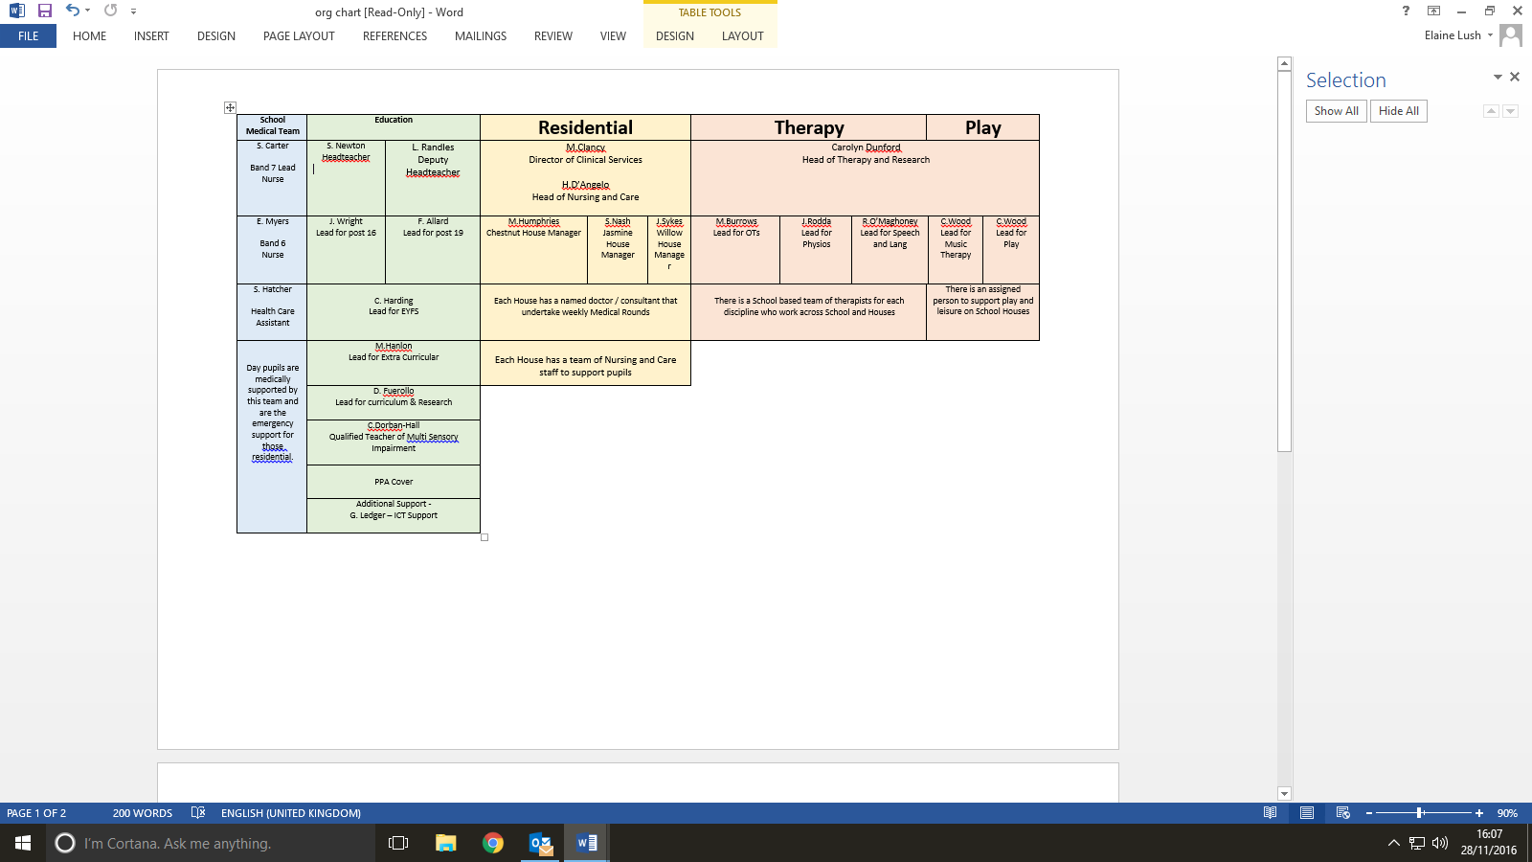



Person Specification

|  |  |
| --- | --- |
| **ESSENTIAL** | **DESIRABLE** |
| **Knowledge & Skills** | |
| Awareness of and enthusiasm for education and School life. |  |
| Knowledge and awareness of current customer service principles and practice. |  |
| **Qualifications** **and Skills** | |
| A good level of computer skills. Familiarity with Microsoft applications, including: word, excel, Outlook and have internet skills. | ECDL or equivalent level of IT skills. |
| Experience of using databases |  |
| Excellent organisational skills and ability to prioritise workload. |  |
| Excellent interpersonal and communication skills, in person, telephone and written. |  |
| Ability to work independently and as part of a team. |  |
| Excellent Customer Service Skills, with the ability to use discretion, patience, tact and respect for confidentiality. |  |
| **Experience** | |
| Of working in a busy environment. | Of working on a busy reception  Experience of working in a school |
| Of multitasking and working flexibly |  |
| Of team working |  |
| Experience of working with people | Experience of working with children with special educational needs |
| Demonstrable experience of working with systems and procedures |  |
| **Attributes** | |
| A love of working with people and children. |  |
| Willingness to develop self and skills |  |
| Willingness to work collaboratively and as part of a team |  |
| A sense of humour and a happy / positive persona |  |
| Ability to work under pressure |  |

­­



Safeguarding

The Children’s Trust is committed to safeguarding and promoting the welfare of children and young people. To achieve our commitment, we will ensure continuous development and improvement of robust safeguarding processes and procedures that promote a culture of safeguarding amongst our workforce.

The Children’s Trust has policies on safer recruitment, the recruitment of ex-offenders and criminal record checks, please refer to the Resource Team for further information.



Equality and Diversity

The Children’s Trust recognises the value of diversity and is committed to equality of opportunity. We expect staff to be treated with dignity and respect and solely on the basis of their merits, abilities and potential regardless of age, sex, sexual orientation, marital or civil partnership status, disability, race, nationality, ethnic origin, religion or belief as stated in the Equality Act 2010. We expect all staff to share this commitment and promote equality and diversity amongst their teams.



Values

Our ambition is to provide a professional service where the children and families are at the centre attention of what we do or us to be able to use this opportunity and to achieve this vision & ambition. We require all of our staff to be actively promoting and sharing our values that bring us closer to achieving our goal.

