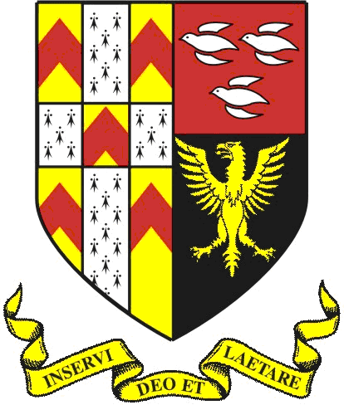

29th January 2018

Dear Applicant

Teacher of Music MPS/UPS

Thank you for your interest in the above vacancy. I hope that after reading the information about The Friary you will feel enthused by the prospect of working at the school and joining a dedicated team who are committed to achieving the best possible outcomes for our young people.

We would be pleased to receive your application, accompanied by a supporting letter of no more than two sides of A4 (font size 11 minimum) outlining your suitability for the post. The deadline for applications is 3.00pm on 14th February 2018. If you have not heard from us within two weeks of the closure date please assume your application has not been successful.

The school is committed to safeguarding and promoting the welfare of children and young people and expects all staff to share this commitment.

I look forward to hearing from you.

Yours faithfully,

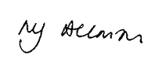

Matt Allman
Headteacher

