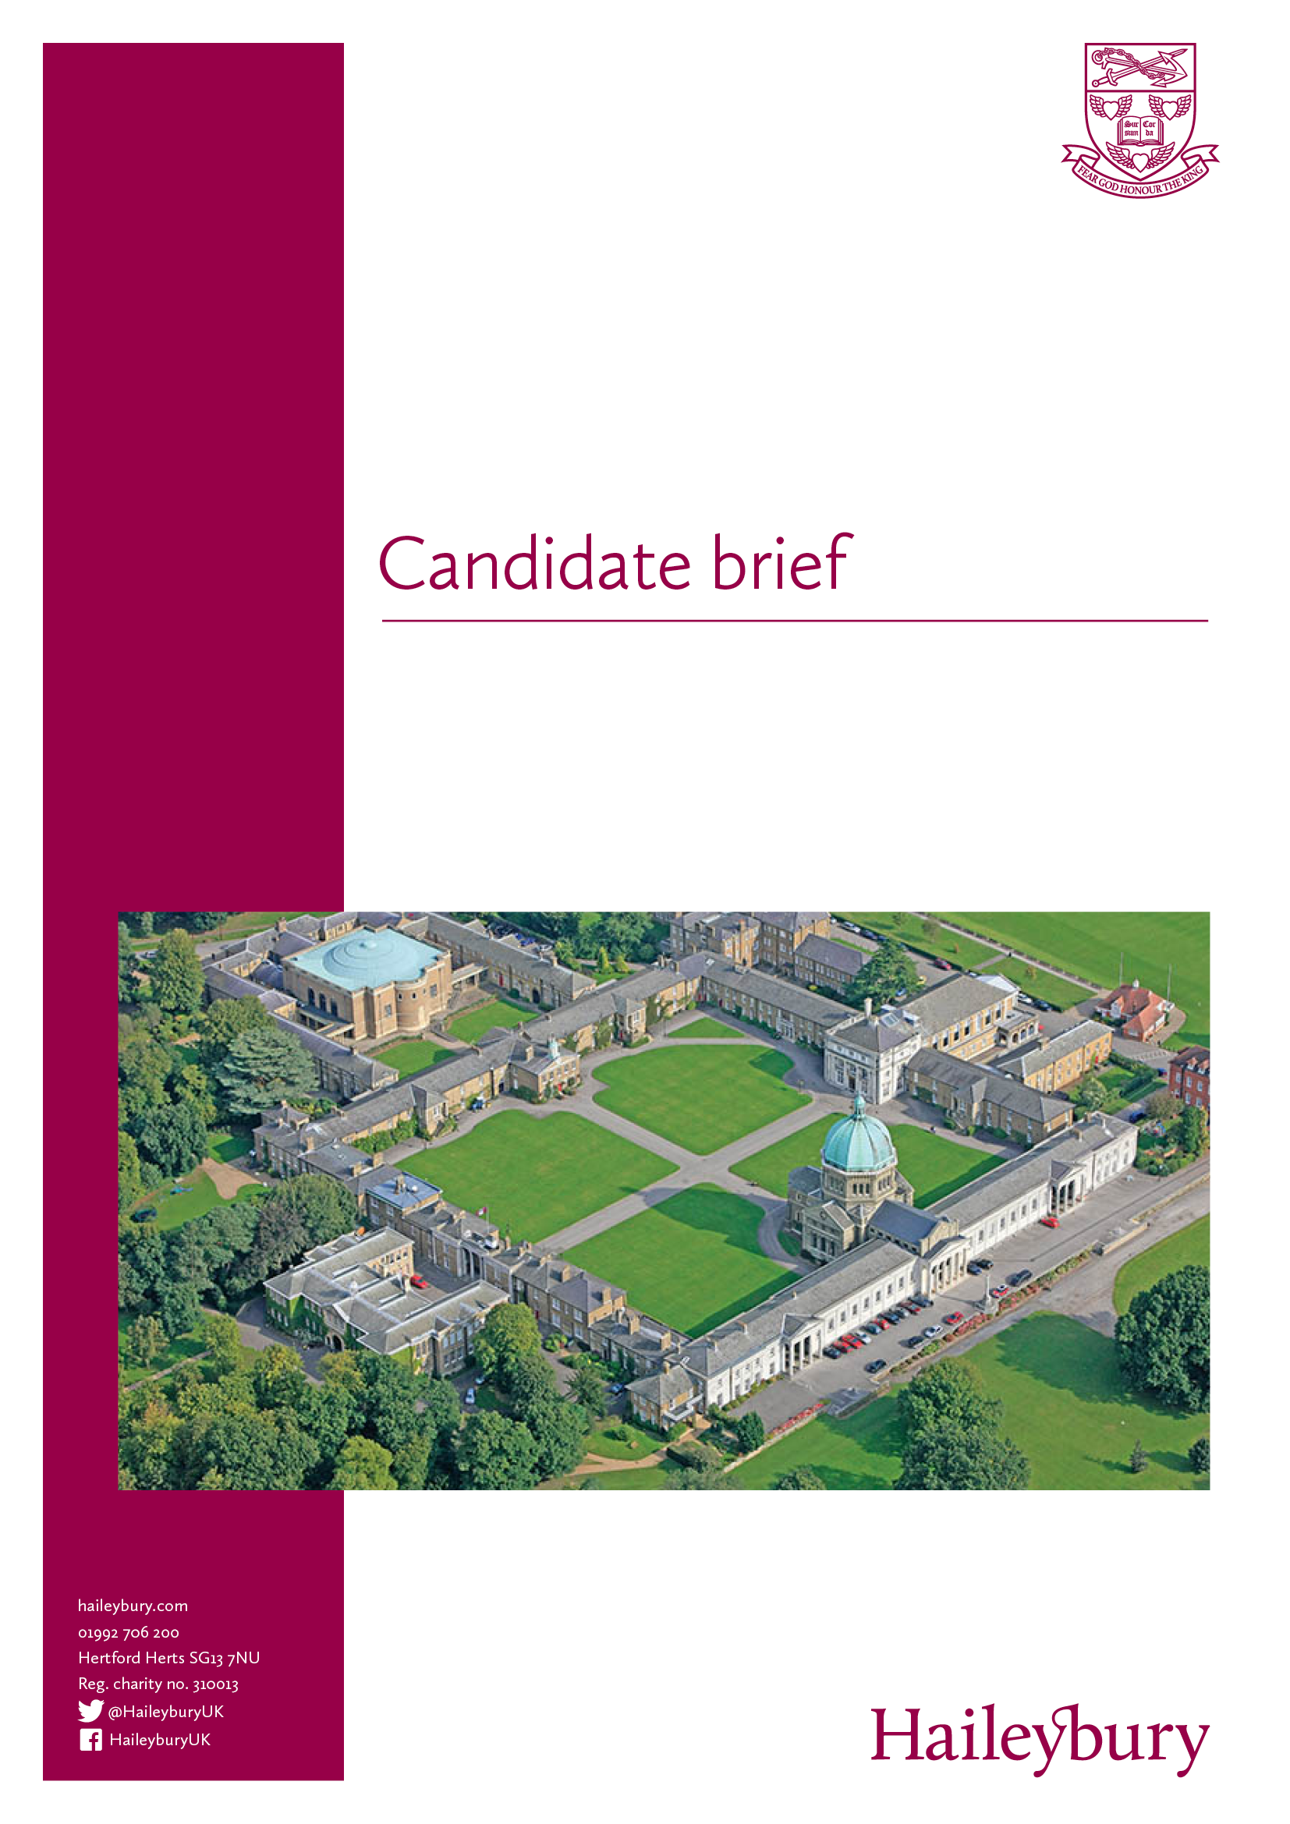

Published: 13 November 2017

Application deadline: 9 am, 20 November 2017

**Temporary Teacher of English**

(From January 2018, for two terms)

­

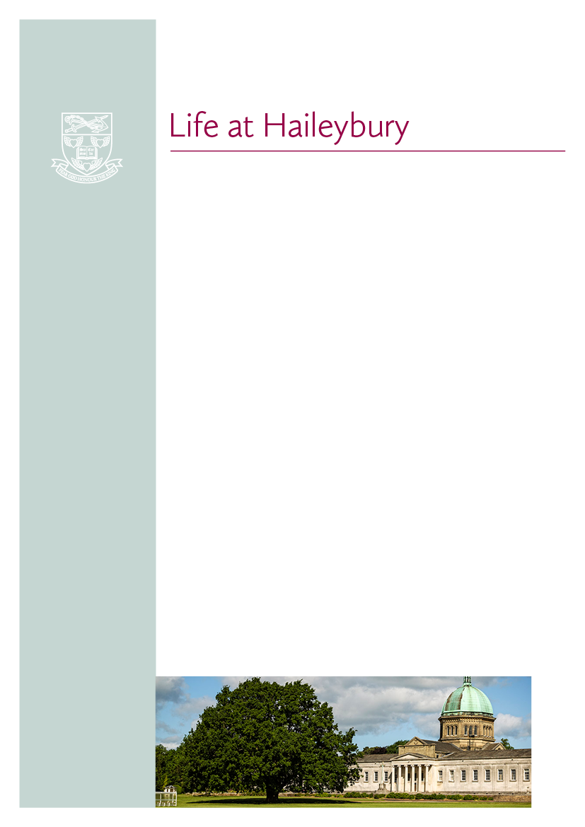

Haileybury is an outstanding British independent

co-educational boarding school. We offer modern boarding and day provision for eight hundred boys

and girls aged 11–18. Established in 1862, we are situated on a glorious, historic 500-acre campus in Hertfordshire, just 20 miles north of London and 35 miles south of Cambridge.

Ours is a happy, purposeful and tight-knit community where more than 90% of the teaching staff lives in College accommodation, either on campus or

within walking distance of our beautiful 500-acre site. This helps create a unique atmosphere in which to live and learn.

We focus on creating a warm, nurturing environment which is particularly evident in

the Lower School, a “school within a school” for Years 7 and 8, which includes its own Boarding House, Highfield. Boarders and day pupils join one of 12 houses when they enter Main School (Years 9-13). This creates strong “family” groups of about 55 pupils per House.

An appreciation of the wider life of a seven-day-week boarding school would be valued but is not essential for this temporary role. This could include a willingness to involve oneself in the boarding and co-curricular programme. Teaching staff are also expected to attend Chapel services.

* A welcoming, vibrant community - whether you are a young, single NQT or more established professional with or without a family, you will find your niche
* Excellent CPD and career development opportunities with regular internal training, and opportunities to pursue further training outside of the school
* A vibrant sporting community with opportunities to join staff sports teams and use our world class facilities
* Great music making for musicians of all abilities and opportunities to be included in concerts
* Living on site and avoiding commuting
* Being part of the Haileybury family which comprises our sister schools in Kazakhstan, our alumni organisation and Haileybury Turnford, a local state maintained academy sponsored by Haileybury
* Easy access to all the cultural, social, sporting and retail facilities on offer in London.

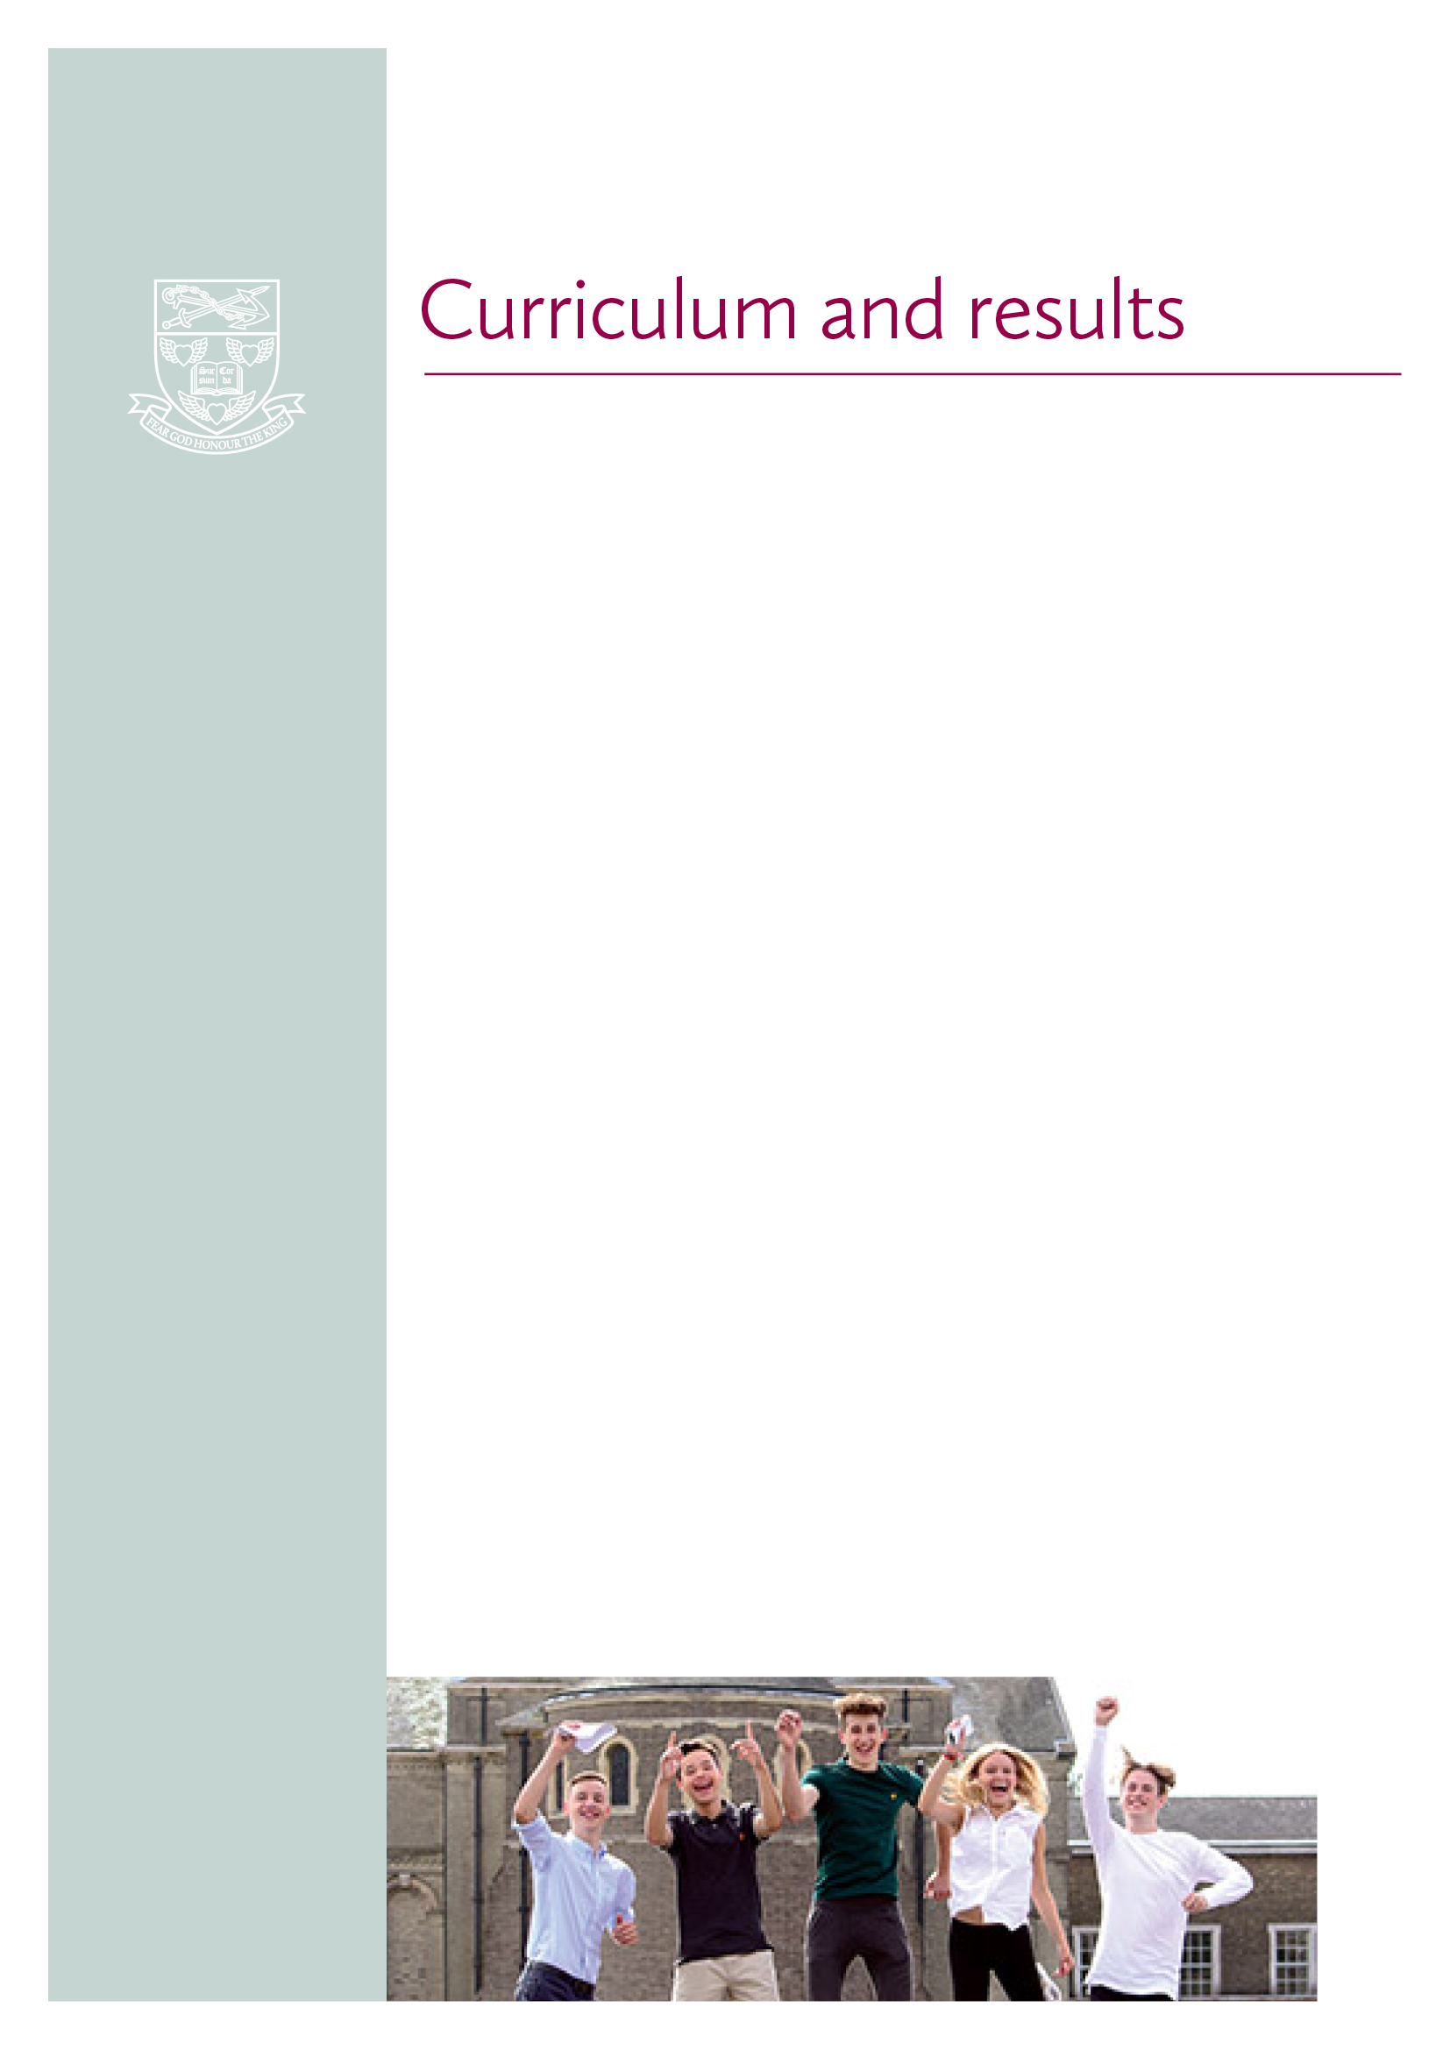

At Haileybury, we encourage academic excellence and promote intellectual curiosity. Our teachers are highly committed and enjoy extensive resources to deliver inspirational teaching that motivates and challenges our pupils.

We are an academically selective school, providing a wide range of (I)GCSEs and in the Sixth Form a choice of A Level or the International Baccalaureate (IB) Diploma. Our all-round pastoral care extends to pupils and staff alike and is underpinned by our open, embracing Christian ethos that welcomes equally those of faith and no faith. This nurturing environment, together with extensive co-curricular activities, creates confident individuals, with leadership, team and social skills. We deliver what many schools only promise – a truly holistic education in which our pupils are prepared for university and life beyond as global citizens.

Haileybury combines excellent scholarship with forward-looking teaching. In pupils and teachers alike, our aim is to nurture a love of learning and a desire to explore new ideas. In so doing we prepare pupils to develop academically and to achieve at their highest level. Their endeavours are supported by outstanding facilities, study resources and enrichment opportunities.

We offer a broad curriculum where pupils study for (I)GCSEs, and either A Level or the International Baccalaureate Diploma. We also provide a dedicated Lower School for Years 7 and 8 and our innovative curriculum includes subjects such as Positive Psychology for year 7.

In summer 2017 Haileybury pupils excelled in their (I)GCSE results, achieving 63.7% at A*–A, with 35% of all grades awarded at A*. For the third year running, a top set of Year 10 pupils sat their Maths (I)GCSE exam a year early and all obtained an A*. IB Diploma results in 2017 were once again strong with our IB graduates achieving a collective provisional average score of 36.35 points out of a possible 45 (the global average score is 29.95 points). A Level results for 2017 were also excellent with 67.3% of all grades awarded at A*–B, while 12.6% of A Level pupils across all subjects achieved A*s.

Our pupils traditionally gain places at Oxbridge, Russell Group universities and leading international universities in Europe, the Far East and the USA.

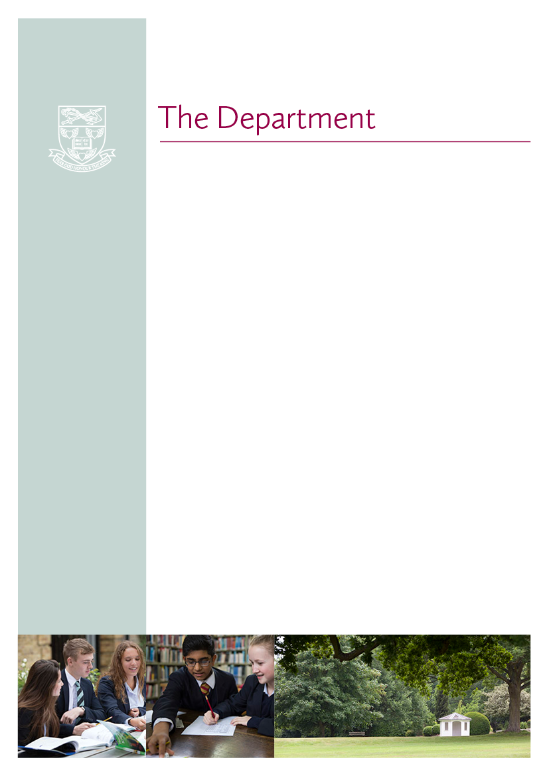

The English Department currently consists of seven full-time and four part-time teachers. The Head of Department is assisted by a Second in Department and a Key stage 3 Co-ordinator. Teachers are strongly encouraged to draw on their own enthusiasms within the subject to create interesting and challenging lessons. We collaborate closely with our colleagues in Drama (one of whom also teaches English), as well as our SEN Department.

The Department is housed in dedicated suite of classrooms, each of which is equipped with a desktop PC and projector; several also have an interactive whiteboard. At the heart of the Department is a large Common Room which makes for a sociable atmosphere, conducive to the informal exchange of ideas.

In Lower School and Removes (Years 7-9) we follow our own schemes of work which broadly shadow the National Curriculum. In Middles and Fifths (Years 10 and 11) all pupils study English Language and English Literature for IGCSE (Edexcel). In the Sixth Form pupils study English Literature at A Level (OCR) and as part of the IB Diploma (we offer the Literature, Language and Literature and Literature and Performance courses at Standard and Higher Level). Intensive preparation for Oxbridge candidates begins in their Lower Sixth year.

The Department has a good record of pupils gaining places to read English at leading universities, and we are looking to build on our past successes.

We have a thriving Sixth Form English Society, Green Room, in which members of the Department speak on literary-related topics ranging from James Bond to Geoffrey Hill. External speakers are also regularly invited: Professor Robert Eaglestone (Royal Holloway), Dr Daniel Swift (New College of the Humanities) and Simon Armitage have recently addressed our Sixth Formers.

We encourage participation in extra-curricular creative writing: pupils have the opportunity to publish their work in a creative writing magazine, *Littererchewer*, and to write articles for *The Haileyburian*. Each year the Department puts on an array of enrichment trips which complement the curriculum.



Haileybury wishes to appoint a well-qualified and suitably experienced teacher of English, for two terms, from January 2018

**Purpose of the position**

To fulfil the teaching requirements as directed by the Head of Department, according to the overall aims of the school. The teacher must be able to teach English in the Sixth Form (to IB Diploma and A Level), and can expect to teach classes ranging from Year 7 to Year 13.

*If appropriate: to offer support to the learning, pastoral and co-curricular needs of the individual students through the house system as a tutor and the co-curricular programme. These duties should be carried out to a high standard to ensure the all-round quality of education for pupils at Haileybury.*

The teaching fortnight currently consists of 60 periods of 55 minute lessons from Monday to Saturday lunchtime, *together with games on Tuesday, Thursday and Saturday afternoons and activities including CCF on a Wednesday afternoon (involvement in these co-curricular areas to be discussed)*. A normal teaching load for a teacher is around 42 periods per fortnight.

All professional duties are outlined in the Contract of Employment, the associated Employment Manual and the Staff Handbook. Here is an extract of the key responsibilities and tasks:

**Key responsibilities**

* ensuring the best possible academic outcomes for pupils through planning, preparing and delivering courses and lessons to a high standard
* assessing, marking, recording and reporting on the development, progress and attainment of pupils in line with College and Departmental policy
* providing timely and supportive feedback to pupils on their work
* following the agreed policies in the Staff and Departmental Handbooks with regard to such matters as programmes of study, teaching methods, supporting pupils with Learning Support needs and homework (prep)
* maintaining a stimulating teaching environment and exercising proper care of teaching materials, equipment and rooms
* advising on and co-operating in the preparation and development of courses of study, teaching materials, teaching programmes, methods of teaching and assessment
* promoting the general progress and well-being of individual pupils and groups of pupils
* participating in arrangements for further external training and professional development as a teacher
* *if appropriate: to be a house tutor, and to work with and inspire a tutor group of young people, as part of a wider team of year group and boarding house tutors following the expectations set out in the Staff Handbook.*
* *if appropriate: to supervise pupils as part of a boarding house tutor team, this will include carrying out an evening boarding house duty, and occasional Saturday evening and Sunday commitments.*
* to share responsibility for all pupils within the College (especially those in individual’s teaching or tutor groups) in liaison with appropriate Heads of Department, Housemasters and Housemistresses and senior managers
* maintaining good order and discipline among the pupils and safeguarding their health and safety both when they are on the College premises and when they are engaged in College activities elsewhere



Accepting an offer of employment at Haileybury is as much about a lifestyle choice as it is about pursuing a satisfying career path. The College has high expectations of its staff and therefore looks to reward them with an attractive benefits package, which includes:

* Attractive salary
* College accommodation on campus or close by for most full-time staff (this is subject to availability). Accommodation is provided rent and Council Tax free. Overall we estimate the benefits of College housing to be worth in the region of £18,000 p.a. to a standard rate taxpayer
* Fee concessions of 75% for the children of any member of the full-time Teaching Staff who meet the College’s entry requirements
* Membership of the Teachers’ Pension Scheme
* Longer holidays than the maintained sector
* Residential Doctor and full-time Health Centre
* Access to a private healthcare scheme
* Typically generous sickness and maternity arrangements
* Childcare voucher scheme
* Residential Church of England Chaplain
* Free lunch is provided when on duty (Haileybury is known for its high quality catering)
* Free tea and coffee are available throughout the working day
* A welcoming Common Room
* Use of the College’s world class sporting and leisure facilities
* Fabulous location:
  + Central London – 25 minutes (by train)
  + London Heathrow Airport – 50 minutes
  + London Stansted Airport – 30 minutes
  + London Luton Airport – 40 minutes
  + A1 and M25 – 20 minutes

**Statutory Requirements & Equal Opportunities**

**Safeguarding & Child Protection**

For this post must be willing to undergo child protection screening, including, but not limited to, reference checks with previous employers, prohibition checks and a criminal record check via the Applicants Disclosure and Barring Service (including Barred List Check). All offers of employment are conditional upon the satisfactory outcome of child protection screening checks.

**Disclosures**

We will appoint, train, develop and promote on the basis of merit and ability alone. It is a stipulation of the Governors and a statutory requirement that members of staff appointed to Haileybury should be shown not to have any criminal record which might prevent them accepting a post at the College. Accordingly, Haileybury requires permission from all members of staff to make an appropriate investigation. Offers of employment are subject to a satisfactory outcome of this enquiry.

**Equal Opportunities**

Haileybury is an equal opportunities employer and is committed to a policy of treating all our employees and job applicants equally. It is our policy to take all reasonable steps to employ and promote employees on the basis of their abilities and qualifications without regard to age, disability, sex, gender reassignment, pregnancy, maternity, marital or civil partnership status, race (which includes colour, nationality and ethnic or national origins), sexual orientation, trade union membership, religion or belief.



**Working hours:** This is a role requiring a commitment to work some evenings and weekends during term time, and also some periods of time in formal school holidays in relation to public exam results days and co-curricular trips, for example. The boarding aspect of the College also requires commitment from staff covering pastoral and co-curricular activities during the evenings and at the weekends.

**Salary:** will be discussed at interview and will be determined by experience and qualifications.

**References:** The appointment is subject to the receipt of satisfactory references

**Commencement:** January 2018 **Duration:** Two terms

**Applications** should be made on the staff application form and include a covering letter, outlining the reasons why you are interested in the role and any additional information you would like to add. CVs are not accepted. Please address to: Ms Denise Matthews, *The Master’s PA,*Haileybury, Hertford SG13 7NU. Or please send a scanned copy to d.matthews@haileybury.com

**Closing date and selection process:** Completed applications must be received by 9 am, Monday 20th November; Interviews will take place in the week commencing 27 November 2017.

**Documents required at interview:** As an educational establishment Haileybury requires that all employees be subject to a check with the Disclosure and Barring Service. The successful applicant will be required to complete an Enhanced Disclosure form with a Barred List check and any offer of employment will be dependent on the satisfactory outcome of such enquiries. All such checks must be completed prior to the employee starting work at Haileybury. Therefore, in order to facilitate this process all candidates are required to bring the following documents to the interview:

* valid passport
* UK driving licence (both parts if applicable)
* UK birth or marriage certificate
* two documents as proof of address e.g. a utility bill and a bank statement
* proof of your National Insurance Number e.g. National Insurance Card or a previous P45 or P60

In addition to the above, please bring to the interview all proof of relevant qualifications and courses undertaken. Originals only will be accepted, do not bring photocopies.

**What to expect at interview** (example interview schedule):

8.50 – 9.10 am Interview with The Master and Deputy Head (Academic)

9.10 – 9.30 am Interview with The Deputy Master and Deputy Head (Co-curricular)

9.50 – 10.45 am Teach an observed lesson

10.45 – 11.15 am Tour of the campus

11.15 – 11.45 am Visit to the Department with the Head of Department

11.45 am – 12.15 pm Meeting with a member of the HR team

**Overseas applicants:** Applications are welcomed from applicants not currently resident in the UK and these applicants may at the College’s discretion be interviewed by Skype.

If you have any questions regarding the interview process please contact the Master’s PA, Denise Matthews in the first instance on 01992 706 482 or email d.matthews@haileybury.com

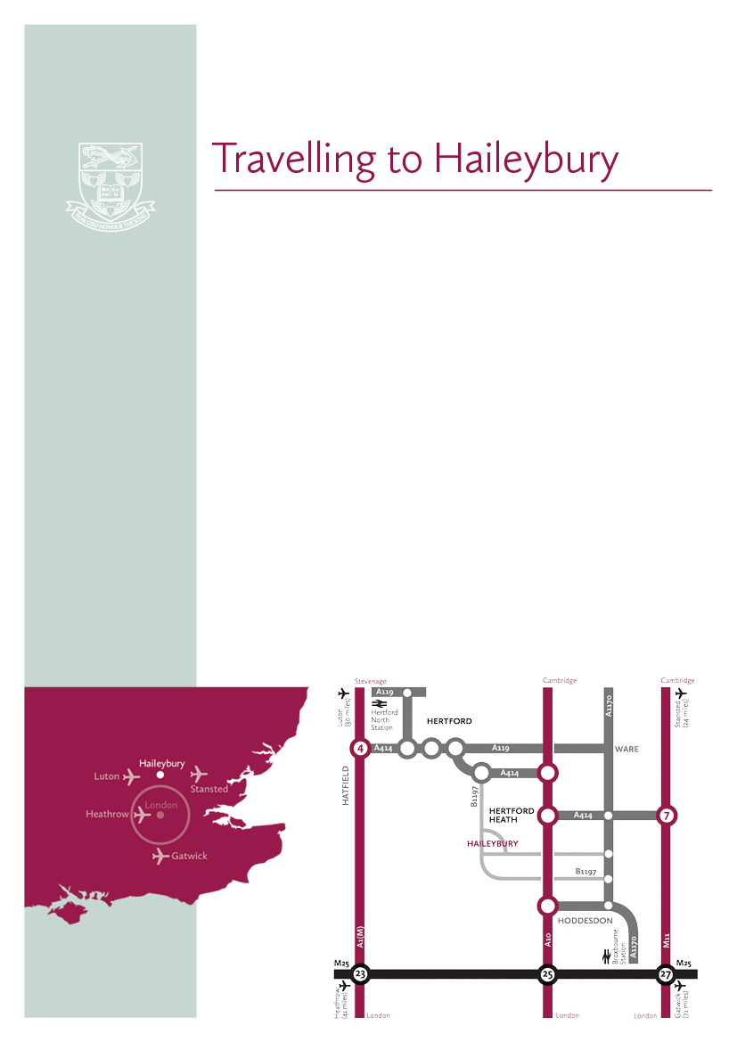

Haileybury is located in rural Hertfordshire

between Hertford and Hoddesdon about 20 miles north of central London

Air travel

London Heathrow (50 minutes by car), London Stansted (30 minutes by car) and London Luton (40 minutes by car) airports are within easy reach of Haileybury. London Gatwick Airport (75 minutes by car) is only slightly further away. All are served by rail links to central London.

By rail

There are two main line railway stations close to Haileybury. Hertford North to London (Moorgate or King’s Cross) is a 40-minute journey. Broxbourne to London (Liverpool Street) is 35 minutes. Hertford North is a five minute car ride from Haileybury and Broxbourne is 10 minutes away.

By road

Haileybury is conveniently located close to the A10 and easily accessible via the M25, A1(M), M11 and A414.

From the South East  Leave the M25 at junction 25 to join the A10 north (Cambridge), exiting the A10 at Hoddesdon.

From the South West  Leave the M25 at junction 21a to join the A405, then the A414 to Hatfield and on to Hertford. The B1197 leads to Hertford Heath village.

From the North  Leave the A1(M) at junction 4 for the A414 to Hertford, or leave the M1 at junction 7 (St Albans) for the A414 to Hertford.

From the East  Via the M11 leave at junction 7 (Harlow) for the A414 to Hertford.