INFORMATION FOR APPLICANTS

Welcome to Rutland

Thank you for your interest in our vacancies, and in joining us at Rutland County Council. We have put together some information that we hope will help you to make the most of your application, and explain in advance what you can expect from the recruitment process. You will also find the answers to some of our more frequently asked questions.

We have also included some information about who we are, what our values are and what we can offer you as an employer.

In addition to this document, you should also have received the following:

- Job description and job requirements
- Application form
- Personal Details form

If there is anything further you would like to know about the role you are considering before you return your completed application form to us, please make contact with the manager leading on the recruitment for this role – their contact details will have been given in the advert.

If your question is more general, please contact us at recruitment@rutland.gov.uk

We look forward to receiving your application.

The Rutland Team

Completing your application form

Our application form has been designed to ensure we capture all of the information we will need to make a decision on how closely your skills, knowledge and experience meet the requirements of the role you are applying for.

To help you get started, we have put together some hints and tips to help you make the most of this opportunity:

- Give yourself enough time before the closing date to complete your application form thoroughly
- We don’t accept CVs, so make sure your application covers everything we will need to know about your skills, knowledge and previous experience
- We cannot take into consideration any personal knowledge we may have of you, or any previous applications you may have made to work for us
- Think about how you structure the information you provide – use the job requirements as a list to ensure you cover all of the elements of the role when completing section 5 of the form. This is what managers use to determine who to invite to an interview so give details of how and when you have demonstrated these
- Remember, we are looking to see if you can undertake the role; talk about what you were responsible for, rather than what the team did
- Complete the whole form, and explain any gaps in your work history
- Ask someone you trust to read it over before you submit it to us
- Make sure you return your completed application form and personal details form to us before the closing date and time.
- Submit this by post to Human Resources, Catmose, Oakham, Rutland LE15 6HP
- If you are completing a paper copy, please use black ink and you may find it helpful to keep a copy.
- If you would prefer to complete electronic versions of the form, these can be downloaded from our website. Submit your completed application to recruitment@rutland.gov.uk and you will receive a message confirming we have it
- If you are a candidate with a disability, please advise us of any adjustments that you would need if offered an interview to enable us to consider these. Please put these on your Personal Details form.

Attending interviews

We generally send interview invites out by email, so please check your inbox if you have given us your email address. This will include details of where your interview will be, the time and who to ask for on arrival. If you do not have access to email, we will confirm the details by letter. If it is less than 5 days before the interview date, we will call you to invite you and then confirm the arrangements by email.

If you need to rearrange, please contact HR in the first instance and we will discuss this with the interview panel. Where we are told either on the application form, or once you have been invited, of dates/times you are unavailable, we will do our best to rearrange your interview – this will not always be possible however.

We will let you know in the invite email if you need to prepare anything in advance, such as a presentation, or whether there will be any exercises for you to complete on the day. These will be used along with the responses to your interview questions when the panel make the final selection decision. During your interview you will be asked to provide concrete examples to support your answers to questions based on the job requirements.

You will need to bring to your interview:

- Proof of eligibility to work in the UK (a full list will be included with your invite)
- All original qualification certificates relevant to this post, as listed in the job requirements
- Any relevant identification documents for checking and recording for a Disclosure and Barring Service/Disclosure Scotland check, should this be required for the role
We are a Disability Confident employer. We are committed to interviewing all applicants with a disability who meet the minimum criteria of the job requirements. If any alternative arrangements are required, please let us know so that these can be considered.

What happens next?
One of the interview panel will call you to let you know if you have been successful. We will then send you a conditional offer letter for the role within one week. If you are not successful, we will let you know either by phone or letter, and give you the option to get some feedback which will help with future interviews.

Frequently asked questions

Can I apply for a job on the closing date?
Yes, you can still apply as long as your application form reaches us before the time given in the advert on the closing date.

What happens to my application form after the closing date?
Shortly after the closing date all of the application forms received for the role are passed to the interview panel. They then shortlist these using the job requirements to select who to invite for interview.

The post I applied for closed 4 weeks ago and I’ve not heard anything. Should I assume I’ve not been successful?
Unfortunately we get a large number of applications for our roles and so it is not possible to go back to everyone individually. If you would like some feedback on your application to help for future roles, please contact HR and we will ask the recruiting manager to contact you.

The post I have applied for is referred to as a ‘Safer Recruitment’ post. What does this mean?
In a ‘Safer Recruitment’ post you would be working with children or vulnerable adults, and so would need to hold a Disclosure and Barring Service (DBS) check for the post. We also request references before the interview for these posts.

Why do I need to have a DBS check?
The DBS enables employers to check the criminal records of employees and potential employees, in order to ascertain whether or not they are suitable to work with vulnerable adults and children. For individuals working in certain positions, a valid DBS disclosure is a legislative requirement.
Depending on the role, this check will be made at either Standard or Enhanced levels. If you subscribe to the DBS update Service, please indicate this on your Personal Details form to help us speed up this check.
Further information can be found on the DBS website
I have an unspent criminal conviction. Will this stop me from getting a job with you?
We will look at any unspent criminal convictions in relation to the job you are applying for. We will take into consideration the nature of the job, and the circumstances and background to the offence(s) when making a decision.

How do I know if my criminal conviction is ‘spent’ or not?
Under the Rehabilitation of Offenders Act 1974, some criminal convictions become ‘spent’ after a rehabilitation period. The length of this period depends on the sentence and the age of the person at the time of the conviction. With certain exceptions, following this period an applicant is not normally obliged to mention it on an application form.

Further information can be found on the gov.uk website.

When do you request references for other posts?
For all other posts, references are requested after you have verbally accepted our conditional offer of employment. If you have put on your application form you are happy for us to approach your referees, we will go ahead and do this. If this is not the case, we will contact you first.

Who should I put as my referees?
We will need the details of two referees. Please make sure your most recent experience is covered, providing your current line manager’s details, or most recent manager’s if you are not currently working. If you have not been employed then please give your lecturer or Head Teacher’s details. Friends and relatives are not acceptable referees.

Why is it only a ‘conditional’ offer?
All offers of employment at RCC are conditional subject to the confirmation of pre-employment checks, including:

- A satisfactory medical assessment
- Proof of eligibility to work in the UK
- Proof of relevant qualifications and professional registration to undertake the role
- Receipt of two satisfactory references
- Disclosure and Barring Service (DBS) / Disclosure Scotland check (for certain roles only – we will need sight of the original certificate when this is received)

We will keep you up to date with the progress of these checks, but would advise you not to resign from your current position until we have confirmed these are all satisfactory and a start date has been agreed.

When will I be able to start work?
Once all of the pre-employment checks have been completed your new line manager will contact you to arrange a start date and time.

The post I am interested in is described as ‘politically restricted’. What does this mean?
The Local Government and Housing Act 1989 places certain restrictions on some Local Government employees, preventing them from taking part in political activities. We will tell you if this applies to the job and what this means in practice.

Why do you want to know my religion and ethnic background?
The information provided on the Personal Details form is used for monitoring purposes only. We want to ensure that our process is free from any form of discrimination and this information allows this to be regularly reviewed. This form is kept by the Human Resources team - no line managers have access to this information.

I don’t believe that my application and/or interview was handled fairly. How do I make a complaint?
We would suggest that you ask for some verbal feedback from the chair of the interview panel in the first instance if you have not been successful. If you are not satisfied with the reasons given, please write to Human Resources within 14 days. Please include the reasons for your dissatisfaction, the post you applied for and the interview date so that we can thoroughly investigate this. If you feel that you have been unfairly treated at any other stage of the process, please contact Human Resources.

About us

We’re Rutland, England’s smallest County Council. We’re committed and responsive in a way that many other authorities can only dream of. As a unitary authority, we provide a diverse range of services and are able to get closer to the things that really matter to the community.

Rutland is an idyllic, rural county rated the best for quality of life in Halifax’s 2015 survey. With watersports, golf courses, wildlife, great schools, Michelin-starred eateries, and beautiful views that make for a unique commute, it’s all here.

But there’s more to Rutland than the unspoilt villages and picturesque market towns would let on. We’re proud of our past, but not stuck in it with initiatives such as the rollout of super-fast broadband continuing to ensure we are a great place to live and work.

We’re succeeding because we know how to turn being small to our advantage. We keep things simple and democratic, with a management structure that enables our staff to experience a great deal of breadth and scope in their roles. We may have three directorates, but working as One Council ensures our customers remain at the heart of every decision and action agreed. We bring together our strengths, share our challenges and successes, and keep each other informed to ensure we work effectively to deliver quality services time and time again. Our Values bind us together, whatever our role and wherever we work.

We focus our resources on the things that make the most tangible difference to the community. In order to do this, we listen to those who have contact with our services, pool resources and knowledge with partners and use this to inform service design. Ready to embrace change, we work closely with our partners to break down organisational barriers, challenge our working practices and are not afraid to try new ways of working.

Just as importantly, we look after each other. Support is there for aspiring managers and leaders to develop into senior roles and progress their careers. Our teams are made up of people with a huge range of skills from all kinds of business and local authority backgrounds. We embrace the ideas of everyone who works here, no matter what their level or role, and encourage every individual to seize new opportunities whether for personal growth or for the benefit of our services. We want to attract the best people who will build their career with us, helping to shape services long into the future.
For more information on the Council’s structure, Members and our Corporate plan visit www.rutland.gov.uk
One Council – Our Values

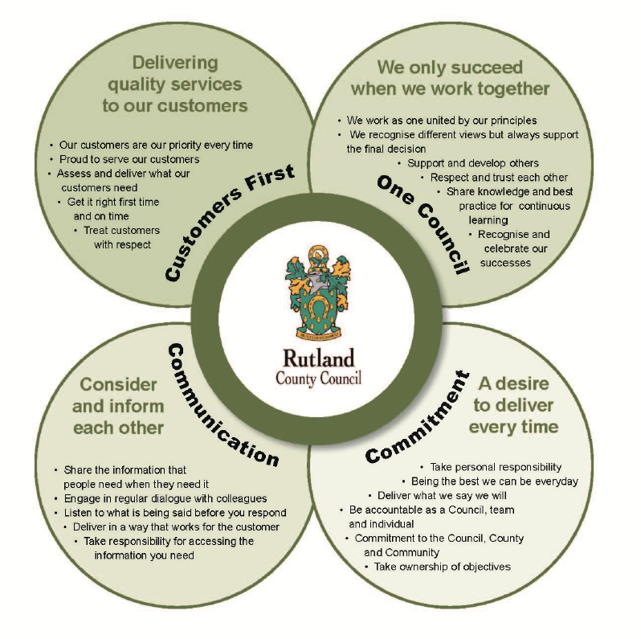

Our benefits

Our vision is to ensure Rutland is a great place to live, learn, work, play and visit.

To achieve this we want our staff to feel enabled to be the best they can be every day, with opportunities to provide and continuously develop excellent services, in a supportive and professional environment.

That is why we reward the effort and dedication shown by every member of staff with a comprehensive benefits package, commitment to their personal and professional development and the flexibility to manage work and home commitments.

Pay and benefits:
- A minimum of 24 days annual leave (pro-rata), with a further 5 days added after 5 years’ continuous service. Plus 8 days paid bank holidays
- A competitive salary in line with nationally agreed pay scales
- A 37 hour working week (standard hours are 8.30am – 5pm Monday to Thursday; 8.30am – 4.30pm on Fridays, although this may vary due to the requirements of the post)
- Relocation policy (where applicable)
- A defined benefits pension scheme with the LGPS, including the option to make additional voluntary contributions
- Access to pool cars when travelling on Council business
- Choice of 3 levels of parking permits for car parks across Oakham – payment can be deducted monthly from your salary
- Career breaks and extended periods of leave
- Payment of fees for membership to one professional body where this is a requirement of your role (eg. HCPC, CIPD, AAT)

Personal development:
- Regular 1-2-1 meetings with your manager to review progress, acknowledge and celebrate success, identify and support your needs
- A probationary period of 6 months to ensure you have the support you need to succeed in your new role
- An annual Performance Development Review to set targets, review progress and identify your development needs to support your career development
- Financial support and time off for study to achieve additional qualifications needed for your role
- Easy access to a variety of internal and external training courses, as well as a range of e-learning modules through our Learning Management System
- Regular policy and organisational update sessions for managers and those aspiring to a management position in future
- Regular staff communications with briefing, newsletters and team meetings

Family friendly
- Enhanced maternity, paternity and adoption pay
- Special and family leave provisions
- Flexible working policies to enable you to balance work and home commitments
- Employer Assisted Volunteering scheme
- Childcare vouchers enabling you to benefit from reduced childcare costs

Health and wellbeing
- 24/7 advice, support and counselling for you and your immediate family via our employee assistance programme, via phone or online
- Cycle to work scheme
- Occupational health service
- Lunchtime yoga, circuits and cycle rides, as well as discounted swimming sessions
- No smoking policy applies in all Council buildings and grounds

Other benefits
- Discounted membership at CostCo Wholesale
- Reduced rate Enterprise car hire

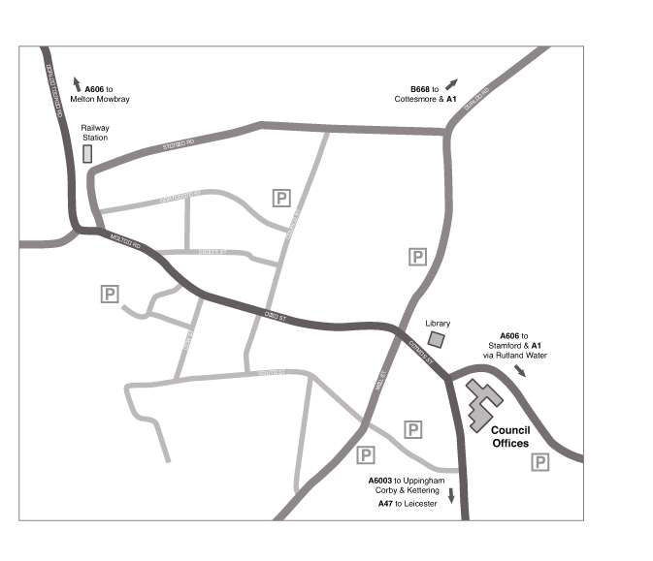

RUTLAND COUNTY COUNCIL
Catmose, Oakham, Rutland LE15 6HP
Telephone (01572) 722577 Fax (01572) 758307 DX 28340 Oakham
E-mail: recruitment@rutland.gov.uk

