JOB DESCRIPTION

Position Title: Head of Virtual School

Grade: P02

Directorate: People

Department: Learning & Skills

Responsible to: Head of School Improvement

Purpose of the Job:

Support and challenge governing bodies, head teachers, designated teachers and other personnel to secure the best possible educational provision and outcomes for children and young people in the care of the Council.

Set the strategic direction and policy to raise the educational attainment and achievement of Children Looked After across all educational settings in Rutland and ensure all Children Looked After participate in education and make positive transitions at key educational milestones.

Ensure all Children Looked After have equal access to education, training and employment opportunities and to ensure all services are responsive to and informed by their needs.

Main Responsibilities:

- To act as Head of the Virtual School to make sure that the Local Authority’s duty to promote the educational achievement of its Children Looked After is properly discharged. Produce an annual Virtual Head report; self-evaluation and development plan for the virtual school, setting out an assessment of its impact, the progress of all children in care in the area, and proposed actions to achieve future targets

- To ensure the Pupil Premium is allocated efficiently and that schools are held to account by monitoring and evaluating the effectiveness of the use of the Pupil Premium for those children and young people in the care of the Council

- To ensure up to date information is maintained and monitored on educational provision and admissions for all school age Children Looked After, to ensure they have school and other placements which best meet their needs and have an up to date and appropriate Personal Education Plan (PEP or EPEP). Act as Virtual Head lead on quality of personal education plans (PEPs and e PEPS) and work closely with relevant colleagues to ensure the availability of robust data which can be used effectively to track the educational progress of children and young people in care

- To monitor school admissions to ensure that children are placed in the school/ setting which best meets their need.

- To report regularly on the achievement of Children Looked After through the Authority’s Corporate Parenting Structures and work with senior colleagues and carers to ensure that Rutland County Council is an excellent Corporate Parent.

- To champion the needs of Children Looked After, promoting their continued attendance in schools and education and training and ensure that effective systems are in place to support a successful transition to adulthood. Ensure the views of children and young people are fully considered in decision making and developments relating to service provision.

- To work directly with schools/settings, designated teachers, parents and carers and other personnel within the Council in order to drive forward and implement strategic plans and policies to drive up standards of education and achievement for children and young people in care.

- To lead on the analysis of children’s achievement data in the full range of educational settings, including those with special educational needs and disabilities, who are in the care of the Council and those being educated in the Council but in the care of another as though they attended single virtual school.

- To work with wider LA teams, including social care, to ensure the educational needs of Children Looked After are adequately considered when making decisions about moving placements and to promote the importance of stability in schooling. Raise awareness about the importance of education for children in care and ensure they treat it as a high priority

- To work with appropriate colleagues and carers to ensure that children in care gain the right support from all statutory agencies, and from the voluntary sector, including support for their health, avoidance of crime and anti-social behaviour and being encouraged to take part in positive activities

- To proactively disseminate good practice on working with schools which have Children Looked After on roll, especially in relation to supporting schools and social workers to have high aspirations of them during their school career and in progression to further and higher education

- To ensure that effective support and challenge are provided to professional staff in schools/ settings, and governing bodies, so that all children in care make good progress and achieve

- Be proactive in making effective links and in engaging in collaboration with virtual school head teachers and others in authorities where the authority’s children are being educated

- Ensure that the local authority fully considers any appeal against a school exclusion of any child in the care of the council and supports the social workers through this process and, when an exclusion takes place, to ensure a prompt alternative placement.

- To manage delegated budgets against projects – ensure budgets and expenditure are effectively monitored and reported in accordance with Finance Procedure rules.

- To act in accordance with the principles set out in the Employee Code of Conduct and the Council’s Values, recognising the duty of all public sector employees to discharge public functions reasonably and according to the law.

Dimensions
The post holder will have responsibility for cost centres/budgets including allocation of Pupil Premium Plus and a further Council fund for allocation dependent on service user need eg. Extra tuition, personal education. Total budgets vary dependent on the number of Children Looked After – c. up to £100k.

STANDARD CLAUSES

1. Training

You will keep under review your own training and developmental needs and keep yourself informed of current issues and be alert to Rutland County Council‘s and other relevant bodies training programmes and policies.

2. Health and Safety

You will take reasonable care for your health and safety and have regard to other persons who may be affected by the performance of your duties, in accordance with the provisions of Health and Safety legislation and Rutland County Council’s and Departmental codes of practice and procedures. You will exercise proper care in handling, operating and safeguarding any equipment, vehicle or appliance provided, used or issued by the Council or provided or issued by a third party for individual or collective use in the performance of your duties.

3. Equal Opportunities

You will uphold Rutland County Council’s Equal Opportunities practices in accordance with the Council’s Equality and Diversity Policy, to ensure the promotion of fair and high quality services to all.

4. Customer Care

You will promote and deliver fair and high quality customer care services that are sensitive and responsive to customers and in accordance with Rutland County Council’s Customer Care Policies.

5. Financial Management

To be aware of your responsibilities under the constitution of the Council relating to financial and contract procedural rules.

6. Technology

Where appropriate you will work with computer and other new technology and associated systems as required and support staff in its use.

7. Risk Management Responsibility

You will take reasonable steps to ensure your awareness of any issues identified in strategic or operational Risk Registers that impact on, or might be impacted on by the performance of your duties. You will exercise the proper care in carrying out actions to mitigate such risks as directed by your line manager or by corporate or departmental statements of policy.

8. Environment

You will familiarise yourself and work in accordance with the County Council’s environmental policies and established office and work practices, including, but not limited to, those contained on the Environmental Policies webpage on the Staff Intranet available via the Climate Change intranet pages.

9. Other duties

This job description indicates the main areas of activity of this post. From time to time, however, other tasks/duties may be required but these will fall within the general areas of responsibility and grade of the post. Any changes which are of a permanent nature will, following consultation with you, be included in the job description in specific terms and will be formally issued to you.

JOB REQUIREMENTS

QUALIFICATIONS/TRAINING/EDUCATION
Essential | Method of Assessment *
Degree and/or equivalent Professional Qualification  Qualified teacher or equivalent qualification | A/D  A/D

Desirable | Method of Assessment *
Leadership or Management Qualification | A/D

EXPERIENCE/KNOWLEDGE
Essential | Method of Assessment *
Knowledge of legislation applied to schools and local authorities in respect of children looked after and the virtual school  (including that pertaining to safeguarding)  Knowledge of research and evidence based best practice in improving outcomes for looked after children.  Knowledge of the requirements of the current Ofsted evaluation practice, and experience of supporting schools or other educational settings through Ofsted inspections or other external moderation  Knowledge of key national policy drivers, legislation and broader influences related to the role  A demonstrable knowledge of safeguarding processes, particularly in regard to Children Looked After  Successful teaching experience in a number of schools or other educational settings and/or significant experience in a local authority or other organisation concerned with Education  Improvement  Track record of improving outcomes for Children Looked After  Experience of informing classroom practice across a number of schools or significant experience in a local authority or other organisation concerned with education improvement | A/I  A/I  A/I/T  A/T  A  A/I  A/I  A/I

Desirable | Method of Assessment *
Experience of working in a political environment | A

SKILLS
Essential | Method of Assessment *
Ability to work constructively and professionally with senior school staff, governors, colleagues and external agencies in bringing about improvement  Ability to construct, implement and evaluate plans to promote improvement within the LA or its schools and settings  Highly effective presentation, communication and interpersonal skills, engaging with a wide range of internal and external bodies, building partnerships and productive working relationships in order to positively promote organisational reputation and interests; produces formal specifications such as Education Plans  Able to be creative and think through issues and problems through the use of theoretical, conceptual and technical knowledge to find practical solutions  Able to be innovative, creative and deliver effective solutions to complex situations.  Successful negotiator and influencer in order to gain acceptance and buy in from key partners and stakeholders eg. Schools | A / I  A / I  A / I  A / I  A / I  A/I

Desirable | Method of Assessment *
Able to utilise technology and software programmes in improving services and ensure working processes are current | A / I

EQUALITY AND DIVERSITY
Essential | Method of Assessment *
Able to recognise discrimination and be proactive in ensuring the Council’s policy is put into practice. | A

OTHER
Essential | Method of Assessment *
Demonstrate a commitment to safeguard and promote the welfare of children and young people  Flexible in working patterns to fulfil commitments often outside the working day.  Highly motivated and robust under pressure. Able to bring energy, vitality and challenge to the team. | A  A  A/I

Desirable | Method of Assessment *
A clear understanding and knowledge of the workings of local government including its legal, financial, social and political context, political processes | A

* A = Application Form D = Documentary evidence I = Interview T = Test

STRUCTURE
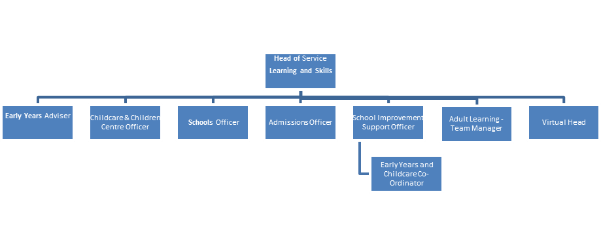
NOTE: These requirements must be reviewed each time this post becomes vacant. The reviewing manager must sign below. If changed, please submit both the original job description and amended job description to the Human Resources Department.

DATE | CHANGE - YES/NO | PREPARED BY  (Name & Position Title)
September 2017 | Yes | Gill Curtis

