Bishop Ramsey CE School

Teacher of Mathematics

The Mathematics Faculty

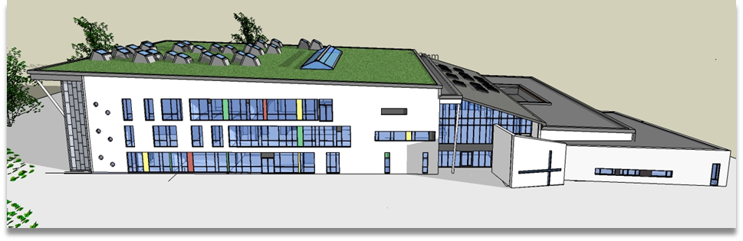

Mathematics is delivered by a team of 11 specialists. We also have a dedicated Higher Level Teaching Assistant (HLTA) who works with Special Needs students, teaches and completes administration for the Department.
In Year 7, students are grouped within three ability bands from as early as possible in the school year and this is reviewed on a regular basis. The curriculum for Years 7 and 8 builds the foundation for the start of the three year Key Stage 4 curriculum. We are currently working on embedding a new assessment and tracking scheme in Key Stage 3 and using ICT to enhance student understanding, including the use of Graphical Calculators in the Sixth Form.
The students follow the Edexcel syllabus at GCSE. The Mathematics Department is one of the highest achieving in the school, with 85% of pupils achieving Level 4+ at GCSE in 2017. Students also have the opportunity to take FSMQ Additional Mathematics as part of their Key Stage 4 options, with at least one group in each of Years 9, 10 and 11 following the course.
Mathematics is a thriving subject in the Sixth Form. We currently offer the Edexcel syllabus with a flexible approach that enables us to set the students and give them the opportunity to study combinations of Mathematics and Further Mathematics at AS and A2 level. Each year we have a number of students who achieve at the highest level in Mathematics and Further Mathematics.
We have a suite of 7 recently refurbished classrooms. Each one has its own Prowise interactive whiteboard and we have a set of 16 laptop computers sited in the Department. Each teacher has their own personal laptop. The Mathematics Faculty has its own office and stockrooms, with a wide variety of resources.
The Department makes a large contribution to the life of the school. Students take part in the UKMT Challenges and a few progress to the Kangaroo and Olympiad stages. Students also have the opportunity to attend Maths Club and enter other local and national competitions.
We hope this brief synopsis will have given you something of the flavour of Mathematics at Bishop Ramsey. We extend a warm welcome to new members of a friendly, lively and hardworking Department.

