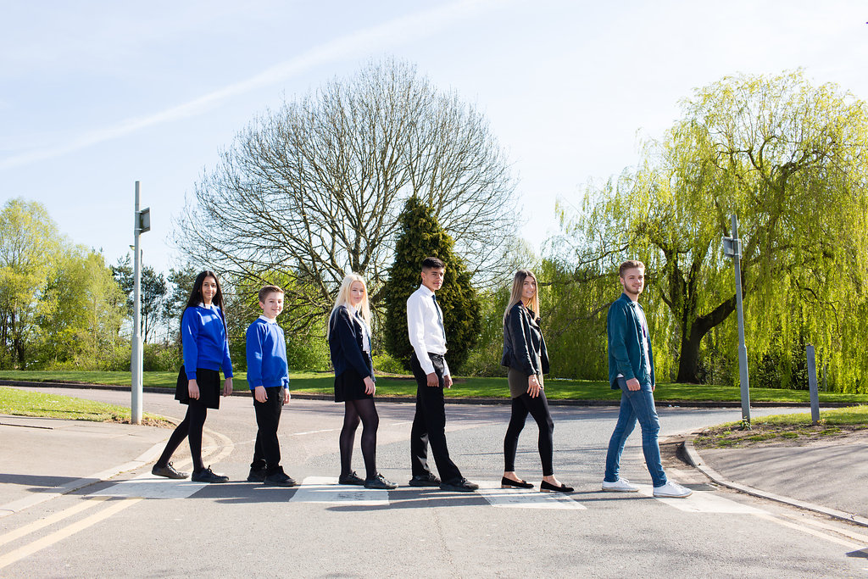

Teacher of Science 11-19

Permanent
Full Time
Newly Qualified Teachers, Main Pay Scale or Upper Pay Spine
Starting September 2018
Content

Vision, Values and Ethos |  | Page 3
Testimonials |  | Page 4
Department Profile |  | Page 5
The Application Process |  | Page 6
Vacancy Advert |  | Page 7
Letter from the Headteachers |  | Page 8
Job Description |  | Page 9-10
Person Specification |  | Page 11-12

Vision, Values and Ethos
The shared vision and values of the Trust underpins all that we do, including the governance arrangements for the Trust.

Our Vision
Valuing Everyone, Achieving Excellence

Our Motto
Work Hard, Be Kind

Our goals
The goals of our trust:
- Outstanding levels of progress and achievement for all
- Outstanding levels of wellbeing for all
- Outstanding preparation for adult and working life
- Outstanding family and community engagement
- Outstanding levels of professional learning for all
Informed by “Schools of Tomorrow”

Testimonials
Extract taken from email correspondence, following a tour of the school by a prospective parent
(April 2016):
‘I would just like to say thank you for the time spent with me today on my tour of the campus, and state how impressed I was with the school. There seems to be a very calm, relaxed and organised approach to how the school operates, and I believe that obviously shows in the way your students behave’.
Written comments from parents following Year 9 Progress Evening (2017):
‘My child always talks positively about school to other children the same age, which I think is a good indicator that he is enjoying school’
‘Welcoming, approachable, friendly and knowledgeable staff’.
Written comments from parents following Year 11 Progress Evening (2017):
‘The teachers have pride in their teaching and in the pupils’ progress. They really care and are prepared to go the extra mile to support the students’.
‘My son seems to have progressed so well in most subjects. I feel this is due to good relationships he has been able to form with teachers and the standard of the lessons’.
Written comment from parent at the end of KS5 (2016):
‘This is my final parents evening after my youngest daughter is coming to the end of her years at GCE. Thank you for very happy years for my three daughters and for their excellent education!’
Thank you from parent of ex-student taking up a place at Cambridge University (2013):
‘To all the staff at Brookvale Groby Learning Campus.
My son has just started at Cambridge University studying Engineering. It was his ambition to go there and this summer, he achieved the grades he needed. We want to acknowledge the great teaching and support he received during his time with you. He progressed well academically, but also grew so much in maturity and confidence. With thanks to you all for your hard work and dedication.’
Extract of letter from staff member:
‘I have thoroughly enjoyed my time on campus. It has been a real pleasure working with staff who are always friendly, extremely supportive and willing to share ideas and knowledge. I have really appreciated having a senior leadership team which is so warm towards its staff and open to their comments and new ideas.
The children I have taught have made me smile, laugh and cry! I will miss my relationship with them and that buzz you get from seeing them progress. It does, however, give me great satisfaction to think that I have put into place schemes of work for pupils and created learning opportunities for them which should continue even after I have left.
I am sad to leave a post which I still love. Once more, thank you for all of your support and kindness.’

Comments from staff member leaving for promotion (June 2017):
It has been an honour to work at Groby and alongside such an amazing staff body. I have been supported at every turn and feel proud to have been a part of the change for the better that has taken place over the years. I wish the campus, staff and students continued success and recognition for their dedication.
Science Faculty

The Brookvale Groby Learning Campus is made up of two schools (Brookvale High School 11-14 and Groby Community College 14-19) working together as one organisation, and we are looking for a science teacher who wants to teach 11-19. We have a spacious green campus on the edge of the village of Groby, with both school buildings close together, and students accessing the staff and facilities across both buildings.

The Science Department is housed within 4 specialist labs in the Brookvale building and 6 specialist labs in the Groby building, supported by 4 technicians. There is also access to computer suites in both buildings.

We place great emphasis on supporting all our staff to be the best we can be. For our teachers this means the professional support to be good or outstanding. All colleagues are expected to share good and outstanding practice and we have a strong team of outstanding teachers who coach and support others. This is a great place to work if you want to develop your teaching and learning expertise within a positive, friendly, caring environment.

Our students make excellent progress in science, but we are not complacent. We are always looking to improve student progress and enhance subject enthusiasm.

The Application Process

Complete applications should be returned to tmalsbury@brookvalegroby.com

Or by post to

F.A.O. Tracey Malsbury
Brookvale Groby Learning Campus
Ratby Road
Groby
Leicester
LE6 0FP

Shortlisted candidates will be contacted with details of the interview process.

Queries

If you have any queries on any aspect of the application or need additional information please contact Tracey Malsbury, PA to the Headteacher on 0116 2879921.

Thank you.

The Role

Teacher of Science 11-19
Full Time Permanent
MPS from September 2018

Required from September 2018, we are seeking to appoint an enthusiastic, committed, inspiring and well qualified teacher of Science across the 11-19 age range.

The Brookvale Groby Learning Campus is a highly successful collaboration of two schools sharing the same site. Brookvale High School is an ‘outstanding’ 11-14 high school and Groby Community College is 14-19 upper school graded as ‘good with outstanding features’ in its last Ofsted. Together, the campus meets the educational needs of 1600 students with nearly 400 at Post 16.

The Brookvale Groby Learning Campus is undergoing an exciting period of change, and became a Multi Academy Trust on 1 April 2017. The schools have a strong ethos of valuing everyone and achieving excellence for all including the professional development of our staff.

Science forms a central place on our campus. Our students make excellent progress in science, but we not complacent. We are always looking to improve student progress and enhance subject enthusiasm.

Both newly qualified and experienced teachers are encouraged to apply.

Visits to the campus are very welcome.
Job Descriptions and further information are available on our website –
www.brookvalegroby.com

For further information or to arrange an informal discussion/tour of the campus please contact Tracey Malsbury on 0116 2879921 or tmalsbury@brookvalegroby.com

Closing date: 9.00am, Tuesday 20 February 2018
Interviews: Monday 26 February 2018

The Brookvale Groby Learning Campus is committed to safeguarding and promoting the welfare of children and young people and expect all staff and volunteers to share this commitment. Applicants must be willing to undergo appropriate child protection screening, including checks with past employers and the Disclosure and Barring Service.

Dear Applicant

TEACHER OF SCIENCE 11-19

Thank you for your interest in the Teacher of Science vacancy within the Brookvale Groby Learning Campus.

We hope the documents provided help you to gain a feel for the school and if you would like to visit us as well, we would be delighted to show you round. Please contact Tracey Malsbury on 0116 2879921 or tmalsbury@brookvalegroby.com to make an appointment.

All the documents to support this application process are available on the website, www.brookvalegroby.com

To apply please complete the following:

- Application Form
- A letter of application, no more than two sides of A4, word processed using font size no smaller than 11

Your letter needs to be addressed to ourselves, and if you would like to e-mail your application then please send this to Elaine Freeman on the email address above.

The closing time and date for this post is 9.00am, Tuesday 20 February 2018. The interviews will be held within 2 weeks from that date. If you have not heard from us by then, please assume that your application has not been successful on this occasion. If this is the case, we would like to thank you for your interest and the time spent in applying.

This post will be subject to an enhanced level Disclosure & Barring Service check. All Brookvale Groby employees are expected to promote and safeguard the welfare of students at the school. Our Safeguarding Policy is made known to all and is designed to guide staff, students and parents/carers with regard to Safeguarding issues.

In line with best practice guidance re safeguarding we do not require an additional CV and any included with application forms sent to the school will not be taken forward to the short listing panel.

Yours sincerely
Katie Rush Robert Coles
Headteacher, Brookvale High School Headteacher, Groby Community College
Co-Director of BGLC Co-Director of BGLC

Job Profile
Post title | Teacher of Science 11-19
Job purpose | - To provide the highest quality teaching and learning in order to raise standards of attainment and progress to meet campus targets.  - To implement and deliver an appropriately broad, balanced, relevant and differentiated curriculum for pupils and to support a designated curriculum area as appropriate.  - To facilitate learning experiences which provides pupils with the opportunity to achieve their individual potential.  - To enable each student to develop personally in line with the campus aims of Valuing Everyone, Achieving Excellence.
To whom the postholder reports | The postholder is accountable to:  - Brookvale Headteacher for KS3  GCC Headteacher for KS4 & 5  Responsible to:  Faculty Leader for all subject teacher matters
Duties and responsibilities specific to the post | Responsibilities: Teacher  - To undertake teaching commitments in accordance with curriculum and timetable requirements across the campus.  - To teach other subjects as and when required by the needs of the timetable and as directed by the Headteachers. This will be negotiated in accordance with the skills of the teacher.  - Prepare students effectively for qualifications and external examinations.  - To fulfil the roles and responsibilities of tutor to a group of students and support students on an individual basis through academic or personal difficulties. To act as a mentor to specific members of the tutor group in order to raise achievement.  - To take responsibility for personal CPD and to participate in campus and external CPD activities by negotiation.  - To undertake all of the requirements laid down by the campus Performance Management Policy.  - To participate in faculty/department and campus meetings.  - To participate in parental consultation/student progress evenings.  - To participate in the duty rota as instructed (two duties per week).  - To fulfil the “Professional Standards 2012” as laid down by the DfE:  - Set high expectations which inspire, motivate and challenge students – safe and stimulating environment. Set goals and challenge students of all abilities and backgrounds. Demonstrate positive attitudes, values and behaviours.  - Promote progress and outcomes by students - accountable for attainment, progress and outcomes.  - Demonstrate good subject and curriculum knowledge – including literacy and numeracy.  - Plan and teach well structured and engaging lessons – including setting regular homework as per the campus policy. Selecting and using a range of different learning resources and equipment, including ICT and where possible the use of interactive whiteboards.  - Adapt teaching to respond to the strengths and needs of all students – including differentiation / needs of SEND students.  - Make accurate and productive use of assessment – using data/marking accurately/ giving feedback to students on how to improve/maintaining records of students' progress and development  - Manage behaviour effectively – establish rules/routines. Promote positive behaviour. Have high expectations.  - Fulfill wider professional responsibilities – make a positive contribution to the ethos of the campus. Take responsibility for own professional learning.
UPS/Expert Professional Responsibilities (if applicable) | - Ensure own standards of teaching and learning are at least good or outstanding in order to be a leading professional in the campus.  - Contribute to the professional development of colleagues through coaching and mentoring, demonstrating effective practice, and providing advice and feedback.  - Other responsibilities to be determined by the Headteachers and Line Manager or as part of TLR responsibilities.
Generic duties and responsibilities | To work within the framework of national legislation and in accordance with the provisions of the School Teachers Pay and Conditions Document. In addition the post is subject to compliance with:  - School policies and guidelines on the curriculum and school organisation  - LA policies adopted by the campus  - The Conditions of Service for School Teachers in England and Wales and with locally agreed conditions of employment  - Common core of skills and knowledge for the children’s workforce.  - All teachers have a responsibility for safeguarding the welfare of children and young people he/she is responsible for or comes into contact with.  The duties and responsibilities detailed within this job description should be supplemented by those accountabilities, roles and responsibilities common to all classroom teachers, as set out within the School Teachers Pay and Conditions Document.

Personnel Specification

ESSENTIAL | DESIRABLE | ESSENTIAL CRITERIA Assessed By
Qualifications  Degree in relevant subject.  Post Graduate Certificate of Education or equivalent. |  | Application Form/CV  Application Form/CV
Training & Experience  Recent successful classroom experience at KS3 and 4. For NQTs this includes teaching practice. | Classroom experience at KS5. | Application Form/Letter/  Reference
Proven commitment to own professional development. |  | Application Form/Letter/  Reference

Knowledge
Knowledge of current GCSE and AS/A2 specifications  Knowledge of recent inspection evidence and classroom research and ability to use it to inform and improve teaching and learning.  Knowledge of assessment procedures at all levels of examination. | Knowledge of progression routes beyond KS5. | Interview/Reference  Letter/Interview  Letter
Skills  Ability to work with students and staff in a supportive and challenging way.  Ability to motivate and enthuse students, including disaffected and reluctant learners.  Ability and enthusiasm to work with students in mixed ability groups.  Effective inter-personal skills.  Good written and oral communication skills.  Effective organisational and administrative skills. | Ability to use ICT both in the curriculum and as an administrative aid. | Reference/Letter (Observation of teaching at interview).  Letter/Interview  (Observation of teaching at interview.)  Letter/Interview  (Observation of teaching at interview).  Interview/Reference  Letter/Interview  Reference
Ability to contribute to the strategic management of the Faculty/Base Team/campus through discussion and debate. |  | Interview/Reference

Attitudes and attributes  Open-mindedness and commitment to co-operate with both students and staff.  Willing to work in an inclusive way to support all students to achieve their potential.  Able and willing to work with science leaders on campus in a cooperative, supportive and enthusiastic way.  Excited by the developing subject content both at GCSE and AS/A2 levels.  Flexible, resilient and reliable.  Resourceful and innovative thinker.  Must contribute to the shared resource system.  In possession of a good attendance record and punctual.  A willingness to dress in a professional manner in accordance with the ethos of the campus. | Able to create a positive working environment through display of students' work and celebration of students' achievements.  Able to contribute actively to the extra-curricular of the campus be that through lunchtime, after school or projects week provision. | Reference/Interview  Letter/Interview  Letter/Interview  Letter/Interview  Reference  Letter  Reference/Letter  Reference  Interview

