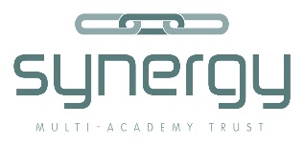

Corpusty Primary School is a popular, established school which has recently joined the Synergy MAT. Following the last Ofsted in February 2017, we are in exciting times, with a change in leadership and new staff joining the team which is developing new ideas for the future. The school works closely with the community and strongly values a broad curriculum which ensures children are confident and enthused to learn.

At Corpusty, we believe everyone should:

- Be happy and enjoy and be enthusiastic about learning.
- Have their innate abilities developed and encouraged.
- Be encouraged to enquire, question and investigate.
- Feel safe and supported.
- Be encouraged to be a fully participating and responsible member of their community and the wider world.
- Be recognised, valued and respected.

The school is a small village primary situated in beautiful rural surroundings and enjoys lots of support from the community, governors and our Friends of Corpusty committee. It is a lively and engaging learning environment supported by a passionate and dedicated team of staff.

