October 2018

A rare and remarkable opportunity that will change your career.

Dear Colleague

We are delighted that you are considering applying for the position of Assistant Leader of IT, Business Studies and Computer Science at The Ruth Gorse Academy. This is an exciting opportunity for a candidate who is keen to be at the forefront of our organisational change. The GORSE Academies Trust continues to demonstrate exceptional opportunities for the students within the Trust. In July 2017, The Ruth Gorse Academy joined Hillcrest Academy, The Morley Academy and The Farnley Academy in being rated as Outstanding in all categories in their OFSTED inspections.

As a city, Leeds continues to struggle regarding the educational achievement of communities in areas of greatest socio-economic challenge. It is our determination to use the free schools initiative to change this unacceptable situation and to ensure that we establish in an area of extreme poverty an exceptionally effective 11-16 academy.

Our mission statement sums up the aspiration of our academy: ‘Dare to achieve beyond what you are today’. The Ruth Gorse Academy ensures that students receive an outstanding education that focuses on aspiration, high expectations and personalisation. Together these non-negotiable values instil in young people a self-belief that enables students to access the highest standard of further educational provision and employment. We believe that every child is unique; through retaining this focus in all aspects of our work we ensure that all young people receive an exceptional educational experience that is personalised to them.

Above all else, along with the Governing Body, we are looking for a colleague who is passionate about working with young people of all abilities and has the talent and drive required to deliver an outstanding provision in English. Should you be successful in this application, you will find yourself joining a department and an institution that is unashamedly ambitious, proud of its many achievements and single minded in its determination to be a truly brilliant school.

Clearly, working in our academy will be demanding as well as very rewarding. We assure you that as our colleague you will be of great value and importance, an importance reflected in the quality of our induction and professional development programmes.

Should you choose to apply please ensure that the application form is completed fully. A CV is not required. Supporting statements should be no longer than 2 sides of standard font and should address how you will promote the highest standards of achievement for all young people.

We look forward to hearing from you.

Yours sincerely
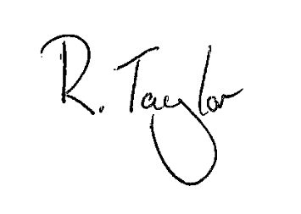

Rebekah Taylor
Principal

