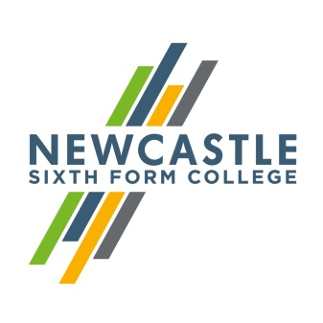
Gerard Garvey

Dear applicant,
Counsellor (Maternity Cover)
Thank you for your interest in Newcastle Sixth Form College. I am delighted that you are considering becoming part of our team. As the largest provider of A Levels in the Newcastle area, we are always keen to add new talent. I hope that the information below proves useful as you put your application together.
Expert and enthusiastic staff are fundamental to our success. As an inclusive sixth form we attract students from the full range of ability and we only offer academic qualifications (GCSE and A Levels). This means that we rely upon staff who are ambitious for their students and willing to go the extra mile in supporting them to realise their potential. Our students come from across the region and bring a variety of different social and cultural experiences. We are keen to celebrate this; in recent years we moved to rainbow lanyards and have developed a culture of inclusivity, with events promoting equality and diversity at every opportunity.
Our team is relatively small; there are 100 staff who teach and support about 100 students on our Access to Level 3 (GCSE) and approximately 1200 students on an A Level programme. As a sixth form college, we work exclusively with school leavers to support them in their progression to university or into work. This post is for an experienced counsellor who is passionate about working with young people, who cares about their progress and who wants to make a real difference to their future. You will be have experience of working with young people aged 16 – 19 in an educational setting and be passionate about providing holistic support to enable them to achieve academic success.
I hope that you will visit our website to find out more about the College, and if you wish to visit us to look around informally we would welcome that. If you would like to arrange a visit, please contact the Head of Learning Support, Jen Burlton, on 0191 226 6275.
Yours faithfully,

Gerard Garvey
Principal
Newcastle Sixth Form College, Westmorland Road, Newcastle upon Tyne, NE4 7SA
T: 0191 272 1001 E: enquiries@newcastlesixthformcollege.ac.uk
www.newcastlesixthformcollege.ac.uk

