Information for applicants  The Role | 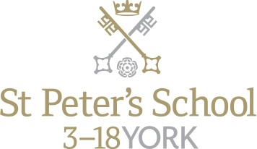

Post: | Chef (Clifton)
Department: | Catering
Responsible to: | Catering Manager/Head Chef
Hours of work: | Minimum of 37.5 hours per week (this may include shifts between the hours of 6.30am – 7.00pm and other evening and weekend working)
Salary: | £23,179 per annum rising to £24,163 on successful completion of six months probabtion.

Overall Purpose of the Post:

- To be a part of the team in the catering department.
- To take responsibility for the ordering, preparation, presentation, dietary requirements and serving of all meals to an exceptional standard within budget.
- To provide advice to, and supervision of catering staff in regard to special diets, allergens and intolerances
- Catering for functions and events.

Main Tasks:

- To prepare, cook and appropriately present meals and buffets for pupils, staff and special functions as required.
- To ensure routine day to day as well as specialised cleaning of kitchen equipment, work surfaces, kitchen floors and storage areas, as directed by the Catering Manager.
- To ensure waste is controlled with regard to preparation and cooking.
- To supervise staff to ensure that they are effectively employed during their shifts.
- To maintain the highest standards of health, hygiene, safety and supervision of staff to ensure that personal and practical hygiene standards are maintained and that staff are working safely in safe conditions.
- To ensure all dietary requirements are met and all allergen controls are strictly kept to, providing support to, and supervision of catering staff.
- To manage the ordering and control of all food, to include; receiving and checking stock, checking equipment and materials are used correctly, closely monitoring portion control.
- To ensure that routine data is collected as required and that all daily checks, including temperature control during production, preparation, service and storage are carried out properly.
- To continuously monitor and evaluate all services, including preparation and cooking processes, in order to suggest and make improvements in these areas within the budget.
- To immediately report all accidents, near misses, damage or breakages to the Catering Manager.
- To actively assist in ensuring a five star food hygiene rating.
- To ensure that the Catering Department is opening and closed at the required times and secured when not in use.

All staff at St Peter’s School are required to observe all relevant Health and Safety, Equality and Data Protection legislation and procedures.
The School is committed to safeguarding and promoting the welfare of children and young people and expects all staff and volunteers to share this commitment. The successful applicant will be required to undergo checks with the Disclosure and Barring Service. The post holder will be required to take care to safeguard their own safety and that of others with whom they work and to cooperate with those designated with responsibility for health and safety.
Note: This job description is not a comprehensive definition of the post and the post holder will be expected to undertake any other tasks commensurate with the duties and responsibilities of the post. The job description will be reviewed as part of the cycle of appraisal, and it may be subject to modification or amendment at any time after consultation with the post holder.

Job Specification

Criteria | Essential | Desirable | Assessment
Experience | Substantial experience in the provision of meals within catering establishments  Producing special meals for those with allergies and intolerances. | Experience of supervising staff  Chef experience within an educational establishment | Interview
Qualifications | NVQ Level 2 or City & Guilds 706/1 706/2  Level 3 Award in Supervising Food Safety in Catering  Driving Licence |  | Application Form
Specialist Knowledge | Relevant health and safety legislation  Excellent levels of food preparation and cooking skills  Record keeping for all elements of the service  Menu planning  Catering for functions/events  Allergen and tolerance awareness |  | Application Form / Interview
Skills / Abilities | Polite and approachable  Clean and tidy appearance  Efficient service delivery including good portion control and minimal waste |  | Interview / References
Personal Attributes/Competencies | A commitment to safeguarding and protecting children and young people.  Able to work flexibly to meet the requirements of the post, including evening and weekend work |  | Interview / References

How to Apply

For an informal discussion, please contact Keith Stimpson, Catering Manager on 01904 527364.
Please note that applications must be made on the School’s application form and accompanied by a covering letter. Please do not send CVs, either in place of or as an attachment to the application.
The closing date for all applications is Monday 19th November 2018 at 10.00am.
About St Peter’s
Background

St Peter’s School, York comprises three schools: St Peter’s School (pupils aged 13 – 18), St Olave’s School (pupils aged 8 – 13) and Clifton School and Nursery (pupils aged 3 – 8 years). The school is fully co-educational with 1,100 pupils, of whom 158 are full time boarders and 231 are in the Sixth Form. There are over 300 teaching and support staff. It is one of very few schools in the North of England to offer three distinct phases of education, each sharply identified and focused towards the needs of its pupils at each age group and set within an overall context of trust, confidence-building, inspiration and opportunity.

St Peter’s is the fourth oldest school in the world, founded in 627AD, and is ranked in the top 100 schools in the country for its academic results. The school is located within a short walk of York city centre, with its thriving cultural, educational and commercial life. Many of St Peter’s facilities are modern and spacious, with playing fields adjacent to the main building that stretch down to the River Ouse.

An Independent Schools Inspectorate Report in 2017 found the school to be ‘excellent’ in all areas.

Clifton School and Nursery

Clifton School and Nursery, for day girls and boys aged rising 3 to 8 years, has its own building with use of extensive play areas, sports hall and swimming pool. Under the leadership of the Head, teachers use the attractive buildings and play areas to maximum advantage, teaching a broad and balanced curriculum which gives a wide variety of experiences, and emphasises the importance of basic skills. The curriculum is based on the National Curriculum and Primary Strategy, but goes far beyond this, both within the school day and during the wide range of co-curricular activities and visits outside of School.

Clifton enjoys separateness, a clear identity and its own House system. It allows smooth academic progression and provides tailor-made approaches and facilities for each age group.

Clifton School and Nursery was named by the TES Awards as the Prep/Pre-Prep School of the Year in February 2018.
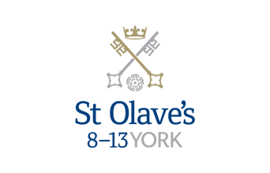

St Olave’s School

St Olave’s School (pronounced ‘olives’), for girls and boys aged 8 to 13 years, is adjacent to the main campus of St Peter’s and introduces boarding as an element of the School. Under the leadership of the Master, the teaching staff provide expertise in the 8 to 13 range, guaranteeing subject specialism to challenge and support every pupil.

The curriculum is wide and challenging with expert teaching from the earliest age. There are many opportunities for recreational and competitive sport with girls’ and boys’ teams enjoying success both regionally and nationally. There are numerous co-curricular activities to choose from on a weekly basis. Music plays a central role in school life, involving the full range of orchestral instruments.

Boarding is an integral element of the School and is accommodated in Wentworth, a boarding house on the main school campus.

St Olave’s has retained its own identity – a school within a school – giving all pupils a sense of pride and identity. It is recognised as a school in its own right, playing a vital role in the success of Clifton and St Peter’s.
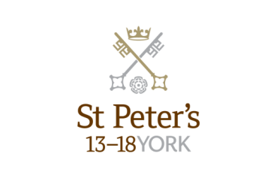

St Peter’s School

St Peter’s School, for children aged 13 to 18 years, is underpinned by academic rigour and challenge. Through outstanding teaching, first rate facilities, high expectations and pupils’ hard work and enthusiasm, St Peter’s achieves considerable success across a broad curriculum.

The four vibrant and successful boarding houses for boys and girls lend vitality to the pastoral life of the School. Inspiration from living in close proximity to a cultured and historic city adds further richness to the pupils’ lives. The Ofsted inspection of Boarding in December 2010 found the School’s provision to be Outstanding.

The School Chapel stands at the centre of the campus and regular services (three mornings a week) give pupils and staff the opportunity to reflect together on the spiritual values of the community and on the meaning and significance of what is happening locally, nationally and globally.

Music, Art and Drama are central to the cultural and academic depth of the School. The Sports programme is extensive, providing a wide range of choice for both girls and boys. Results are excellent, and St Peter’s pupils’ co-curricular achievements are considerable. The excellence of the teaching and facilities allows pupils to thrive.

The school’s website can be visited at www.stpetersyork.org.uk. The most recent inspection report is available on the ISI website.

About York

St Peter’s School is situated five minutes’ walk away from York’s compact city centre. York is one of the oldest and most beautiful cities in Europe, famous for its gothic Minster and winding medieval streets. York has won a number of tourist awards and further details are available on the Visit York website. York is regularly voted as one of the best places to live in the UK. Such is the size and layout of York, walking and cycling are ideal ways to get around, including taking in the famous sights of this historic city; an ancient Roman and Viking capital.

York is a central rail hub between Edinburgh, London and Manchester. The main railway station is only a 15 minute walk from the School. In addition it has a large variety of restaurants, pubs, theatres, cinemas, parks, museums and galleries, and life in York is always interesting, by day or by night.

Finding somewhere to live is also comparatively easy. York’s rental sector is in good health, though demand remains high. If you are trying to buy you will find York prices are around the national average.

York is a family friendly city. Attractions such as the Jorvik Viking Centre, the Barley Hall, the York Dungeons, the National Railway Museum and the York Chocolate Story are immensely popular with people of all ages.

The city lies in the Vale of York, a valley that runs north to south between the heathery North Yorkshire Moors to the east and the famous Yorkshire Dales to the west. Both areas offer an excellent escape for walkers, cyclists, climbers – indeed anyone with a love of fresh air and rolling countryside.

A guide to the City of York can be found at http://www.visityork.org/
Employee benefits

Our vision is to be a happy, thriving 3-18 co-educational day and boarding school community that combines a classical, high quality, all-round education with a forward-looking and exciting approach to learning.

Our staff are the key to our success. It is their expertise, enthusiasm and commitment that is reflected in our high standards and continued success. In return, we offer all our colleagues a competitive total reward package from day one of their employment with us.

Annual Leave

Employees on all-year round contracts are entitled to a basic entitlement of 25 days paid annual leave each year plus public holidays (public holidays occurring when the School is in session are working days). Part-time or term time employees receive a pro-rata allowance of annual leave. This rises to 27 days after 5 years of service.

Cycle to Work Scheme

Eligible employees can join our Cycle to Work Scheme (also a salary sacrifice arrangement) that allows tax and National Insurance savings on the purchase of a bicycle (and related equipment).

Free School Lunches

Staff can enjoy a free meal during the lunch period in the School Dining Room. Lunch is provided on normal working days during term time. A selection of hot and cold food, beverages and sandwiches are available.

Parking
There is extensive free parking available to staff on the school site.

Pension

Eligible support staff are automatically enrolled into the St Peter’s School Pension Scheme. Those who do not meet the government criteria for eligibility will be given the option to join/opt in. The School pays a contribution of 12% of the monthly salary and the employee is required to pay 6%.

School Chapel

School Chapel is available to former pupils, staff and people connected the school for weddings, christenings and other appropriate events. Extensive grounds and gentle green lawns provide an excellent location for a marquee or champagne reception. The School is licensed for regulated entertainment and the Memorial Hall is ideal for evening functions.
Sick Pay

Where employees are unable to attend work due to sickness, there is a provision for contractual sick pay. The amount of sick pay increases according to the employee’s length of service and current contract.
Enhanced Maternity Pay
After one year’s continuous service with the School by the 11th week before the EWC, you will be entitled to receive enhanced maternity benefits as well as Statutory Maternity Pay (SMP).
Sports Facilities

All staff can use the school sports facilities free of charge when they are not in use by the pupils. This includes a modern gym and swimming pool.

Training and Development

Our employees are encouraged to continually develop their skills and knowledge. Training and development opportunities may include gaining a professional qualification and other learning opportunities.

How to find us

You can find St Peter’s School, York, at YO30 6AB. The School is less than fifteen minutes on foot from York Railway Station.

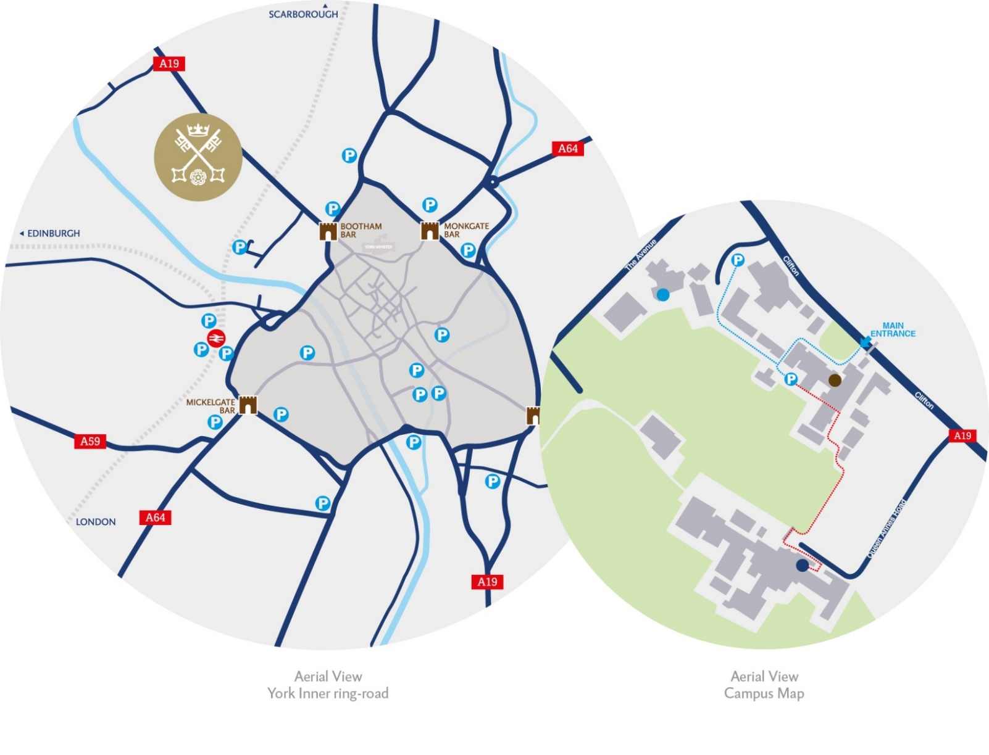
By car:

From York City Centre: Take the Thirsk Road (A19) at the Bootham Bar traffic lights. The school is 700m on the left, immediately after the footbridge.

From the A64: Take the Northern Ring Road (A1237). At the A19 roundabout turn towards the city centre. The school is two miles on the right, 300m after Clifton Green. Turn right into the school immediately before the footbridge that crosses the road.

Parking is available on site.

