St John’s Catholic Primary School
St Elmo’s Road, Rotherhithe, London, SE16 6SD.

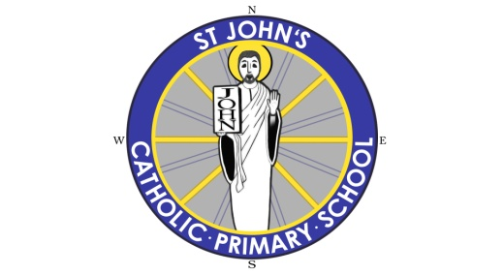

"To Love and Serve One Another"

Class Teachers - Key Stage 1, Key Stage 2 or EYFS
MPS/UPS/NQT welcome to apply
September 2017 or sooner

St John’s is an inclusive, thriving and popular school that has lots of strengths and, just as importantly, the capacity to get even better. We are part of a hard federation with another school in our Local Authority, and together we are working towards becoming outstanding. The School would like to appoint committed teachers, ideally practising Catholics, to join our team as we help and support our pupils to fulfil their potential.

We can offer you a School, which has:
Children that are happy, well behaved, enthusiastic and eager to learn.
Friendly, supportive and committed of teaching and support staff colleagues, who readily embrace new ideas and are committed to learning and achieving together.
A caring and supportive learning community, strong links with parents, the Parish and the local community.
On-going CPD with regular release time to reflect and improve on your practice beyond PPA time.
A collaborative and supportive Governing Body.
Great transport links by bus, train and tube to Canada Water.

What our students say about their School:
It is welcoming with kind pupils.
There are lots of different trips and activities.
The children’s work is displayed all over the school.
It has teachers who challenge us.
We come together to enjoy assemblies.

The Governors are looking for talented and enthusiastic teachers who have a passion for making a difference to the learning and life chances for children.

To do this, you will be:
A successful practitioner who can demonstrate excellent practice and provide exciting learning experiences for the children in your class.
Committed and enthusiastic about each individual child’s learning and determined to see that each child maximises their full potential.
Creative and imaginative, having the ability to enthuse children, inspire and motivate.
Able to work as a team member.

If you interested in joining the staff team at St John’s, you are welcome to come and visit us to see what a great place this is to work. Please contact the school office to arrange a tour, we would be delighted to hear from you.

To request a School tour please contact Tracy Ribbens, on 020 7252 1859, or by email at office@st-john.southwark.sch.uk.

The School is committed to safeguarding and promoting the welfare of children and the successful applicant will be subject to an enhanced disclosure through the Disclosure and Barring Service.

Closing date for return of completed application forms: Noon, Monday 9th May 2017.
Short listing Tuesday 10th May 2017 with interviews Friday 12th May 2017.

