Working at the Prince of Wales Island International Primary School

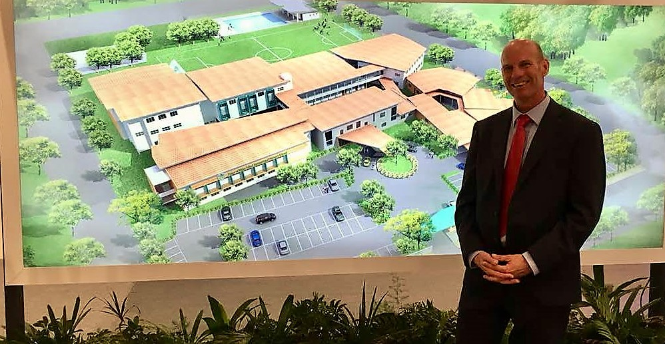

The School
The school was created within the MTT Group of companies under a new division called the MTT Learning Academy. The group remains in family ownership, having been founded in 1963 by the current Executive Chairman’s father. The family have a passionate interest in education; the Chairman’s children were educated in the UK, and hence the ambition to provide a school for local children in Malaysia that mirrored the ethos and methods of the UK schools. The family retain a close and supportive interest in the success of the school and continue to invest strongly in it. In contrast to many International Schools in Malaysia which are part of large educational groups, POWIIS is truly independent. Both MTT and the school promote a sense of ‘family’, and value long term relationships.
The launch of the primary school in September 2019 builds on the ever- growing reputation of POWIIS. The majority of the school’s students are from Penang, with others coming from across South East Asia and beyond. The school has wide range of nationalities and is truly multi-cultural. We stress the importance of the holistic development of our students, with an ambitious and diverse co-curricular programme.
The school is situated in one of the island’s most popular residential areas, Tanjung Bungah, positioned on the Northern coast in between Georgetown and Batu Ferringhi. The school is an English medium international school and the curriculum is based on the English National Curriculum, though content is context relevant to meet the needs of the school’s student body.
The teaching staff is predominantly European, who share with high quality Malaysian colleagues, outstanding facilities and good resourcing. There is an emphasis on staff development.
Applicants are encouraged to explore the school’s website: ​www.powiisprimary.edu.my

Living in Penang
Penang is both an island, and State extending to the mainland. Pulau Pinang (Penang Island) is connected to the mainland by two impressive road bridges, and also ferry services. It has an international airport. Regular short services connect to the major hubs of Kuala Lumpur and Singapore, and onwards to global destinations.
The centre of the island is often described as ‘old Malaysia’ a charming rustic mix of jungle, plantations and traditional villages, fast disappearing in some areas with new up-market residential developments. Picturesque fishing villages line the coast which also features attractive sandy beaches.
The island’s main town is Georgetown; this UNESCO World Heritage site draws visitors from all over the world to its multicultural atmosphere and architecture. Temples, markets, artists’ studios, and traditional craft workshops mix with bustling commercial enterprises - not to mention innumerable cafes, wine bars and restaurants of all types. Penang is known as the street food centre of southeast Asia. From expensive fine dining in glorious historic surroundings, to simple hawker stalls at the roadside, Penang has it all. Such is the range a full meal can cost anything between RM 5.00 at a local hawker stall to RM250 at one of Penang’s finest restaurants.
Many people enjoy resort style living in the numerous stylish developments on the northern shores - again from simple traditional homes to exclusive high-rise condominiums, Penang offers something for every taste - and budget!

Salaries, benefits, cost of living - and lifestyle
Salaries and benefits will be shared with all shortlisted candidates.

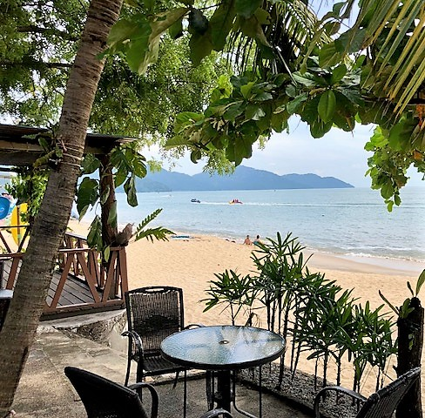
Depending on their off-shore commitments, most staff working at POWIIS Primary will enjoy the relatively inexpensive lifestyle, supportive environment and easy access to some of the most exciting locations in the world. Many take regular trips back to their home countries and when returning enjoy the wonderful contrasts Malaysia provides.
To assist with settling in, overseas hired teachers are ‘placed’ into appropriate rental accommodation by the school for the first year. Domestic bills are relatively inexpensive however, the purchase of a car can be pricy depending on the model and year of the car. With low fuel, maintenance and running costs, many staff opt to lease a car. Grab- a taxi hailing service- is affordable and generally very reliable.
One of the greatest benefits relates to the Malaysian Pension fund known as EPF. The Employees’ Provident Fund (EPF) is a fantastic savings plan to which teachers contribute 11% of their monthly salary. Employers are required to contribute an additional 13% to this monthly, meaning teachers are saving nearly 25% of their annual gross salary a year. With an annual interest rate of 3%-6%, it provides a very useful end of contract lump sum.
In international schools, contracts are typically two or three years, low turnover and staff stability is highly valued by school leaders and parents. We work very hard to create a life/work balance for our staff, and many report being able to enjoy their chosen profession in an area conducive to a healthy and balanced lifestyle. All value the private health care provided, and, of course, the jungle, beaches and weather….

