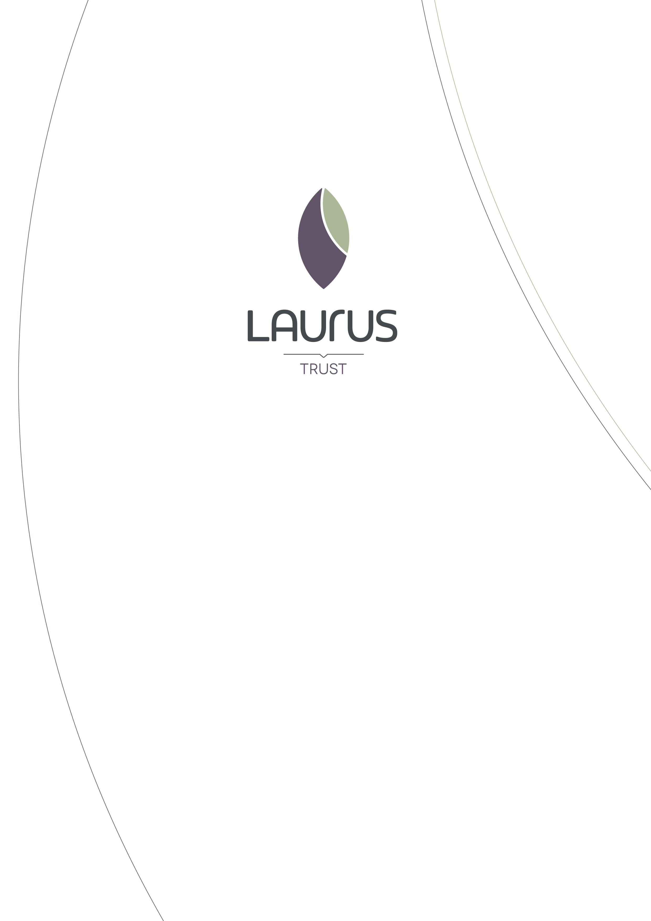

Candidate Information Pack

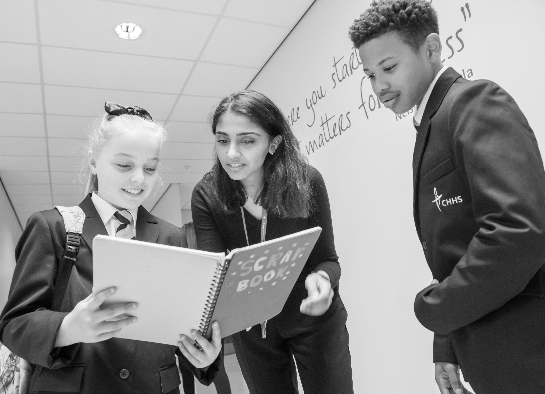
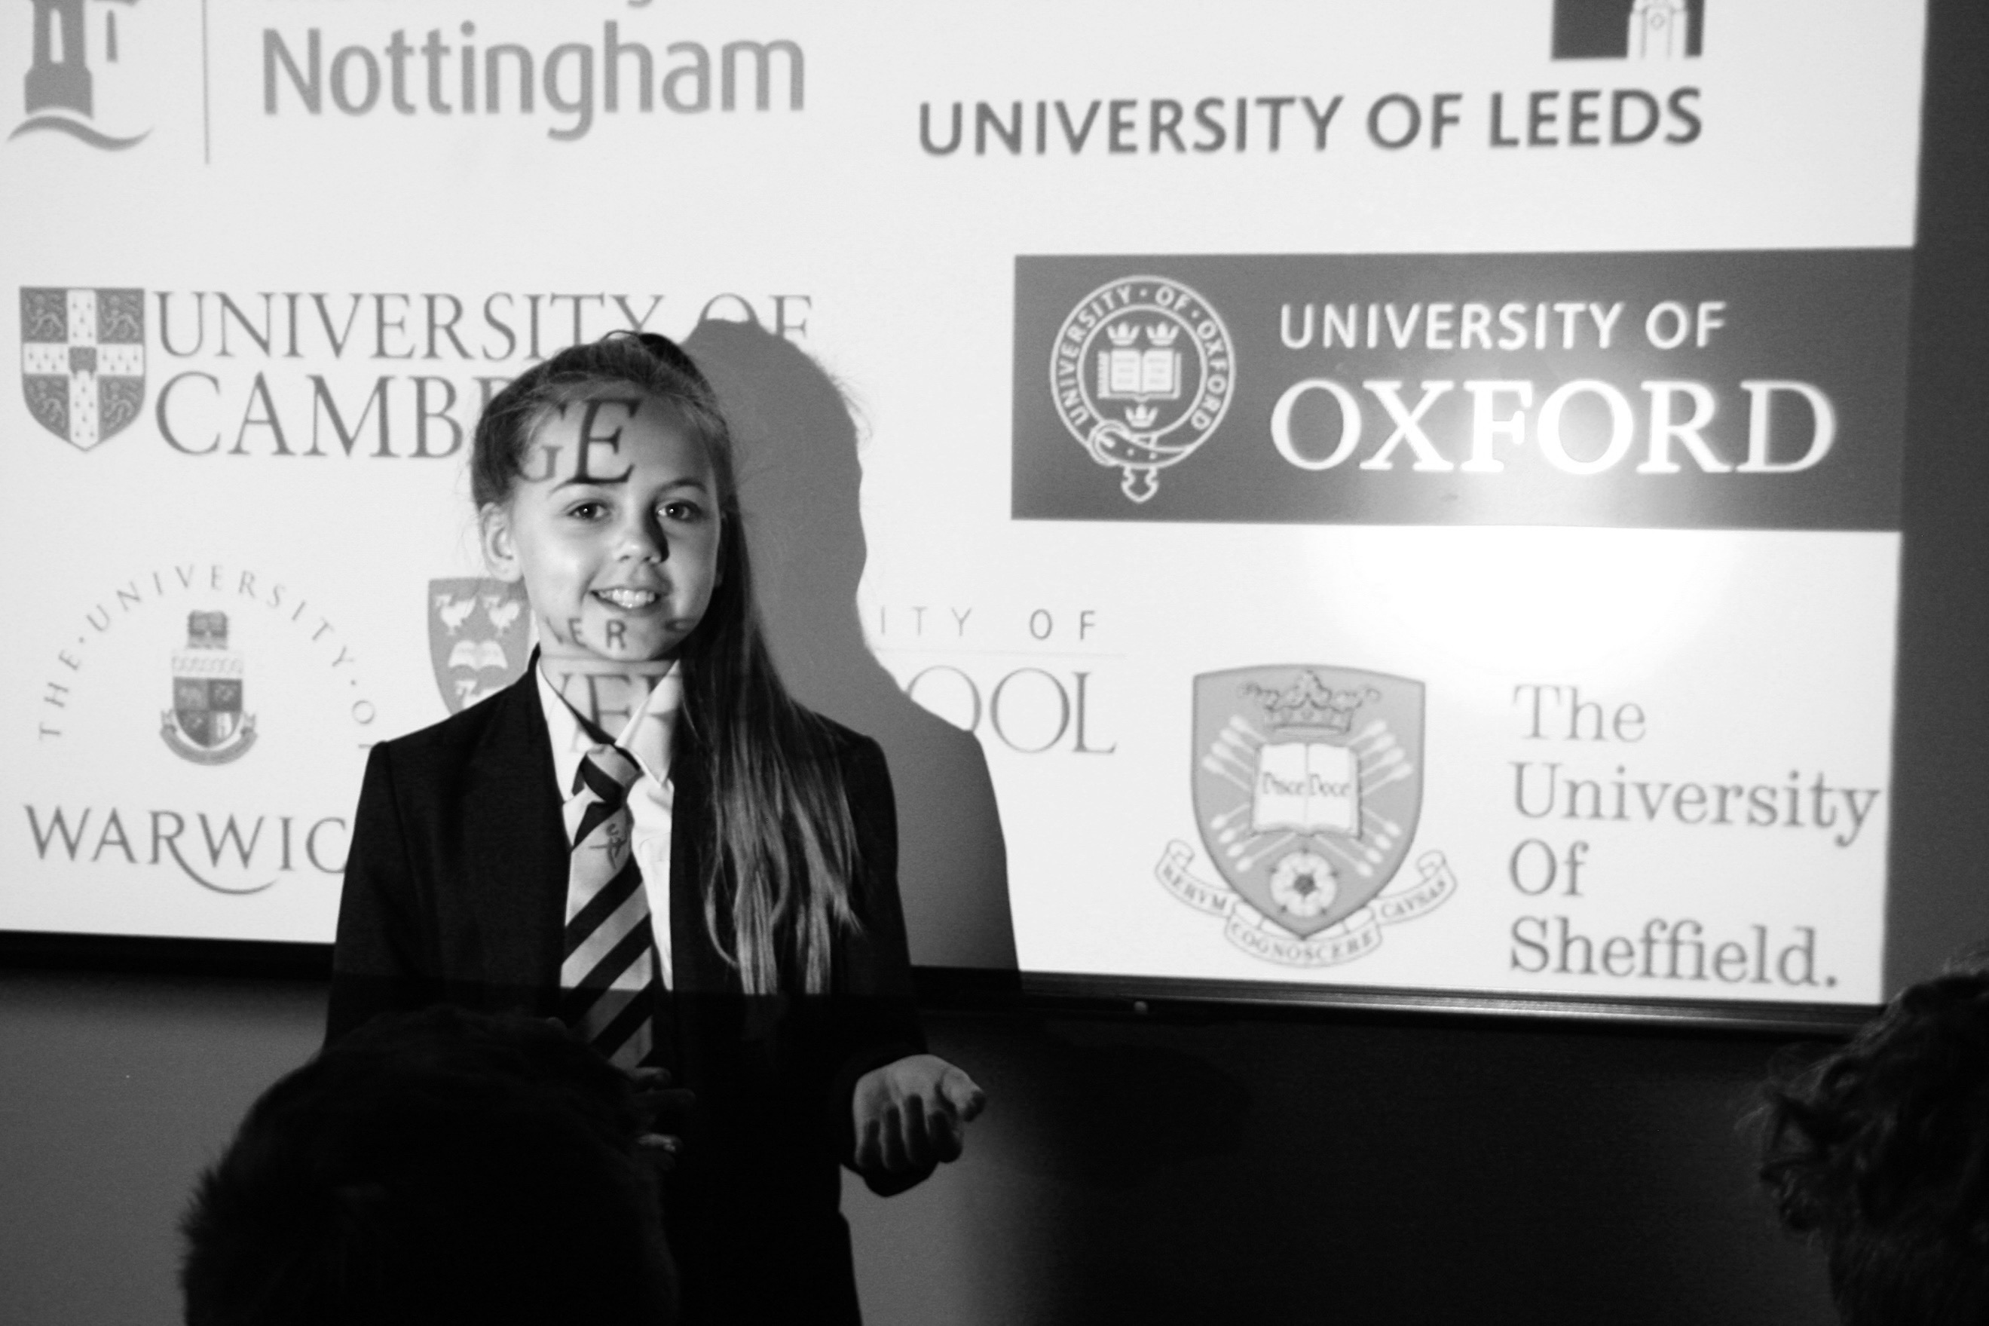
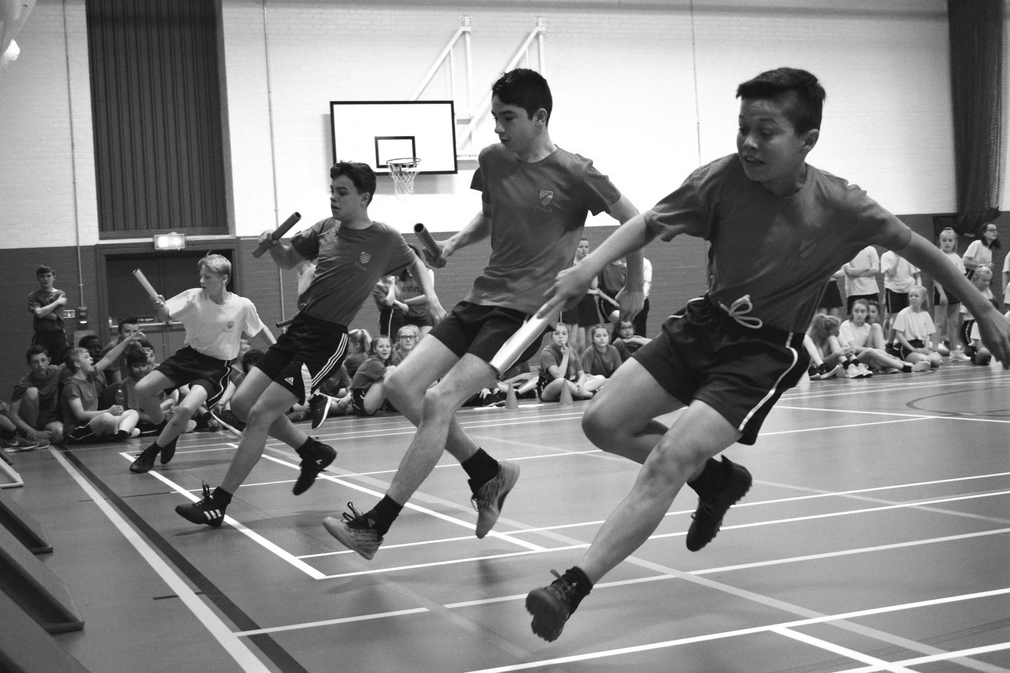
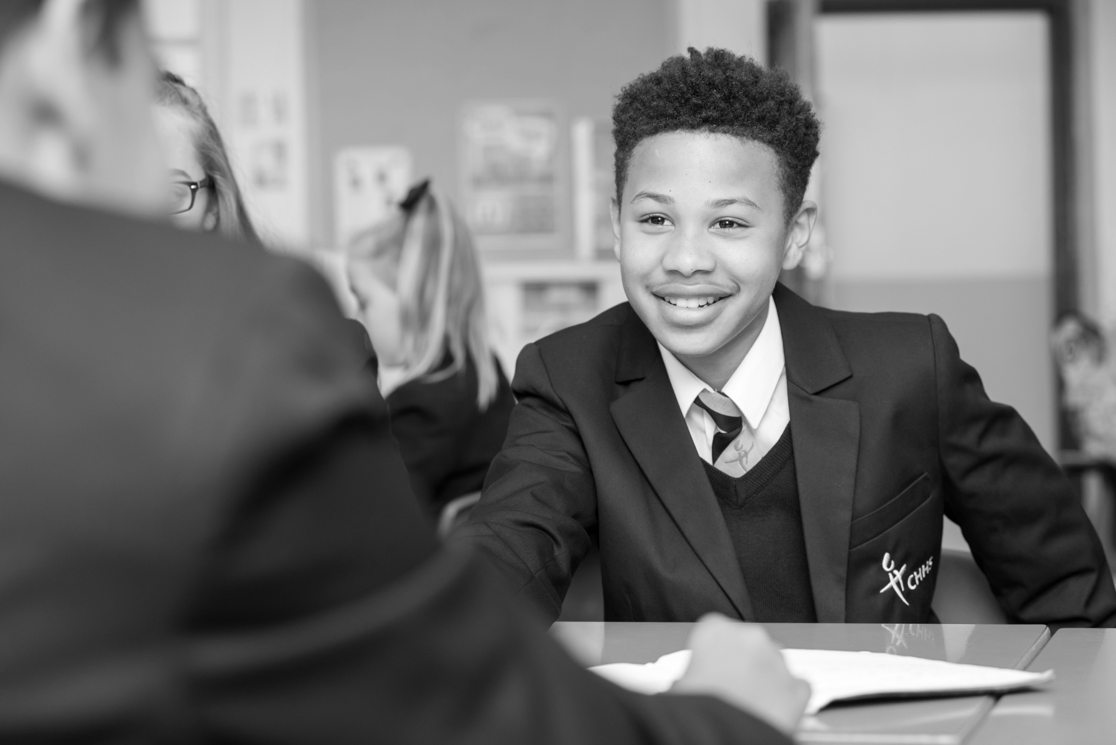
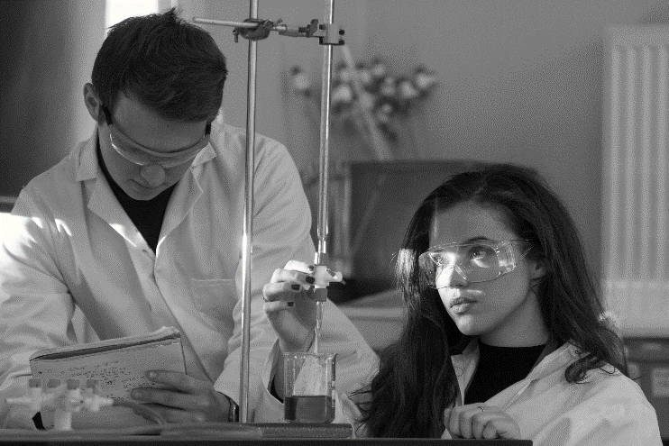
Laurus Trust overview

Context
The Laurus Trust is a newly formed Trust with Cheadle Hulme High School, the founder school, at its centre.

In the 2017 Progress 8 Headline measure CHHS came in the top 3% of schools nationally and also ranked as the 25th comprehensive school nationwide in the annual Times Parent Power Survey. This year CHHS is ranked in the top ten most sought after schools in Greater Manchester. Gorsey Bank, a high performing local Primary School joined Laurus in 2016.

The Trust currently has five Free Schools in the pre-opening phase. Three are due to open in September 2018:

- Cheadle Hulme Primary School in Stockport, a 4-11 Primary School
- Laurus Cheadle Hulme in Stockport, an 11-16 Secondary School
- Laurus Ryecroft in Tameside, an 11-18 Secondary School

In addition, we have an 11-18 Secondary School in Didsbury (Manchester) opening in September 2019. We have also been approved to open an 80 place Alternative Provision School in Stockport – Laurus AP. The Pendlebury Centre, an Outstanding PRU, is currently in the process of joining the Laurus Trust.

Laurus Vision
‘For everyone regardless of background or circumstance to be inspired, to thrive in all environments, to recognise what it takes to succeed, to set aspirational goals and work hard to achieve them.’

The key belief of Laurus is that the all-round educational attainment of individual students is substantially promoted by their participation in a whole range of activities, not just classroom based academic ones. Inspiring students through these activities will enable them to become better motivated, as well as being more respected by their peers.

The access to funding from the Law Family Charitable Foundation will empower The Law Family Education Trust (LFET) to effectively enable all students within the Laurus Trust to have the same access to high quality enrichment as those students who attend private schools.

Training in the use of voice, and performing arts generally, will inspire confidence and enhance the presentation skills of the pupils. Other extra-curricular activities, together with regular sport and exercise, and a sense of competitive spirit, will increase personal well-being, health and concentration levels. The Trust will also promote team building skills, leadership, and a passion to perform to the best of one’s ability in all disciplines. These higher levels of individual betterment will be achieved across all ability levels through a wide scope of activities. Leadership is a skill to be learned and cultivated. Students will learn about the importance of success, and how to cope with setbacks, not as failure but as a springboard to better achievement. There will be a focus on developing presentation skills and self-confidence in general. Inspiring students to broaden their horizons and believe that ‘anything is possible’, is absolutely key to post-education success.

Education starts no later than primary school entry. Delivering better developed cohorts of pupils into secondary schools will foster a much stronger springboard for further success, and help to ensure that no child gets left behind as a consequence of background or other difficulty.

From nursery through to sixth form we will strive to provide the best all-round educational experience.

Culture
Achieving self-worth for every child by being unashamedly academic, unapologetically aspirational and by having uncompromising standards.

All strategy decisions in each Laurus school will be carefully considered with reference to a continued move towards agreed cultural norms. All Laurus schools will develop a culture of:

- Valuing hard work – we do whatever it takes for as long as it takes.
- Continuous improvement
- Respect & trust
- High expectations & ambition
- High autonomy, high accountability
- Praise and reward - celebrate success & learn from failure

Drivers
These are the core principles that drive the culture in order for the vision to be fulfilled:

- Cornerstones
- Qualities, attitudes and habits
- Leadership guiding principles
- Professional learning

Leadership Guiding Principles
The leadership guiding principles outline how we expect our schools to be led and managed.

Laurus leaders believe that every child, regardless of background or circumstance, will achieve self-worth and success through recognising what it takes to achieve and working hard to attain it. They set aspirational goals within a robust framework of academic excellence and uncompromising standards that inspire children to thrive in all environments.

Laurus recognises and rewards potential in the pursuit of excellence.

Laurus leads in education, building educational communities and securing successful futures for all.

Qualities, attitudes & habits
Laurus schools will develop the following qualities, attitudes and habits:

Courage Not running from or avoiding challenge; speaking up for what’s right

Vitality Approaching life with excitement and energy; feeling alive and activated

Self-control Regulating what one feels and how one behaves; being self-disciplined

Social intelligence Being aware of motives and feelings of other people and oneself

Optimism Expecting the best in the future and working to achieve it

Perseverance Finishing what one starts; completing something despite obstacles; a combination of persistence and resilience.

Curiosity Taking an interest in experience for its own sake; finding things fascinating

Integrity Speaking the truth and presenting oneself sincerely and genuinely

Gratitude Being aware of and thankful for the good things that happen

(Peterson and Seligman, 2004)

These qualities, attitudes and habits will be embedded within systems and practice and combine with the cornerstones to ensure that students develop the human capital needed for success.

Cornerstones
Our academic curriculum is knowledge led and ensures that the needs and talents of all students are recognised and developed.

We do not just wish for our students to be successful whilst they are with us. We wish to develop the Knowledge, Attitudes, Skills and Habits (KASH) that will allow them to continue to be successful in whatever route they choose.

Our ethos is built on four Cornerstones:

- Academic Aspiration
- Culture, Creativity & Rhetoric
- Competition and Physical Endeavour
- Leadership and Service

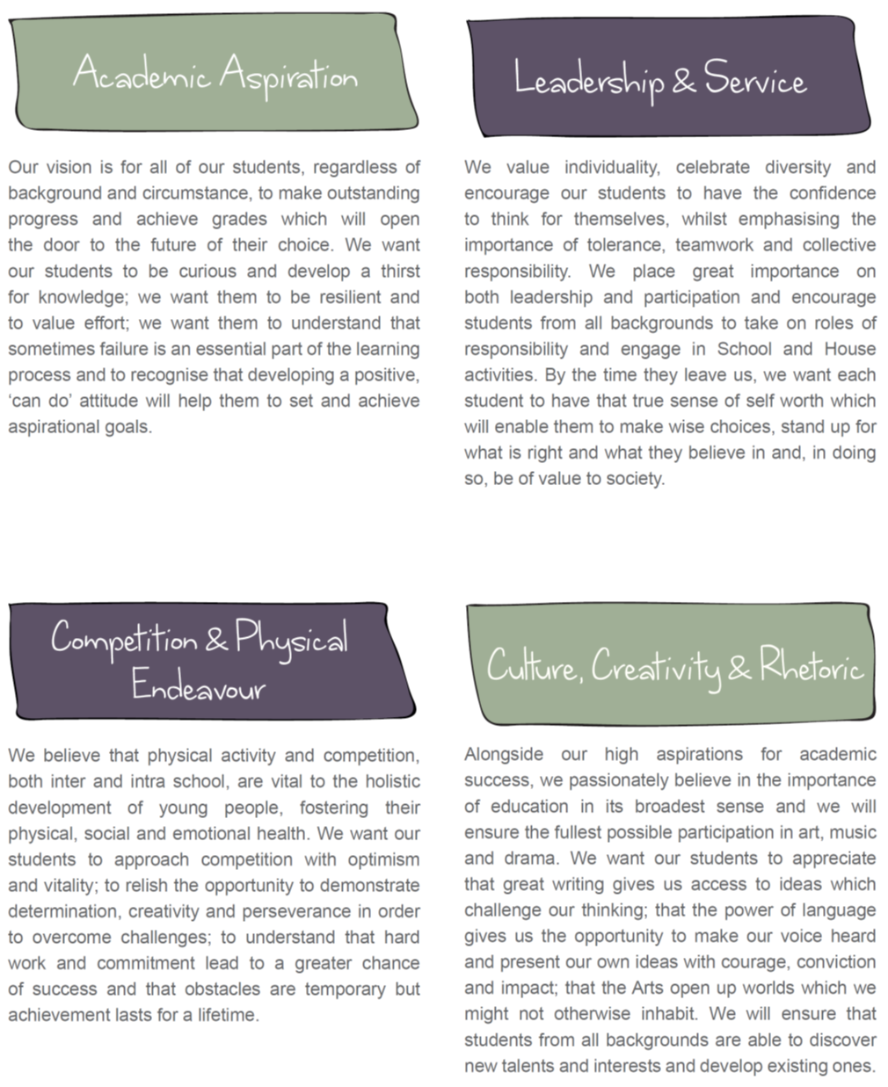

Teaching School at Cheadle Hulme High School
The vision for the school-centred initial teaching training (SCITT) is to be the engine room to provide teachers for the Laurus Schools and beyond. Our SCITT has been awarded Outstanding in all areas by OFSTED in November 2017.

Cheadle Hulme High School (CHHS) leads the Altius Alliance, which was designed as a SCITT for the age range 11-16 from September 2015.

Our intention is to further grow our provision over the next 5 years with the ultimate aim of recruiting and training the majority of the Laurus Trust’s teachers within our own SCITT, thus ensuring the very highest calibre of teachers with the very best training.

In addition to our work with Initial Teacher Training we also provide high quality support for a number of schools in the North West. The Teaching School currently has 49 Specialist Leaders of Education who support colleagues in other schools and deliver Continuing Professional Development & Pedagogy to our Associate Teachers.

Our aim is to ensure that all of our teachers are research literate and as such we offer an in-house Masters degree in education which is subsidised through the Trust.

Pastoral System
We believe the care and guidance of our students via our Pastoral System to be a real strength of the school.

Students are placed in mixed ability forms and allocated a form tutor who usually stays with them for the full five years. Our students and form tutors are led by a non-teaching Head of Year who also moves up through the school with the year group developing outstanding relationships with both the students and their parents/carers. A member of the Senior Leadership Group is also attached to each year team to ensure academic progress, as well as a Head of House.

We have a well-established behaviour policy and our rewards system is fully embedded in the school.

Timetable
CHHS operates a twenty-five period week of one hour units operates. The formal start of the day for staff begins at 8.20am with briefings held three days a week. We have unit 6 lessons from 3 - 4pm in our Sixth Form. Lessons in years 7-11 end at 3pm.

In the new Laurus Schools a 28 period week of one hour units operates. We have 6 units each day apart from Wednesdays when electives take place in units 4 and 5. Electives will also be operating at 3:45 – 4:45pm Mondays, Tuesday and Thursdays.

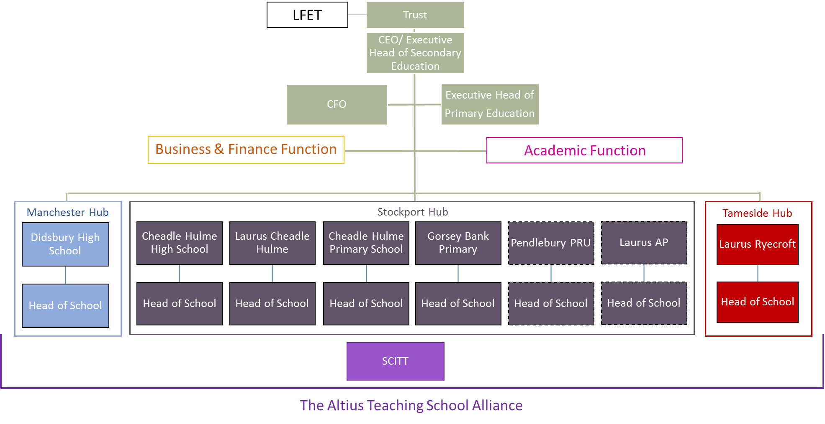
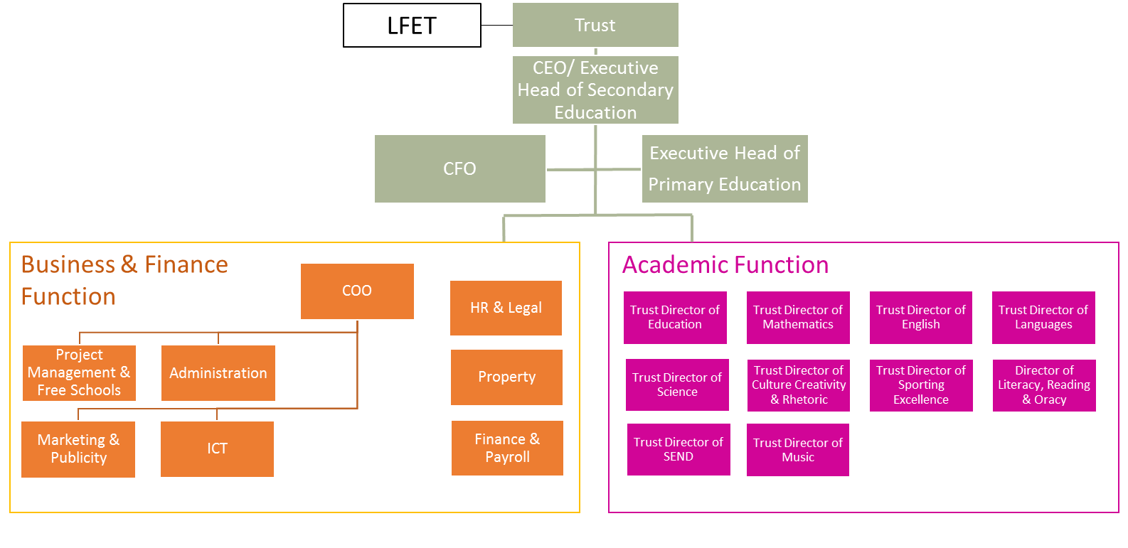

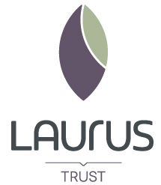
Laurus Trust
Cheadle Hulme High School
Woods Lane, Cheadle Hulme
Cheadle, SK8 7JY

laurustrust.co.uk

