.
Parklands High School

Teacher of
Humanities

Application Pack

Learn, Respect,
Aspire, Achieve

-

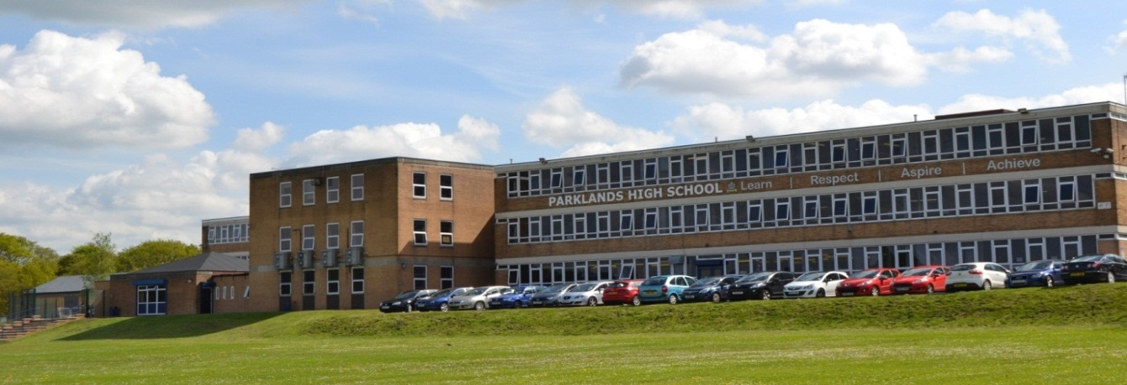

‘The good achievement of different groups of students shows the school’s dedication to ensuring that all students have an equal chance to achieve well’
(Ofsted November 2014)

March 2017

Dear Candidate

May I take this opportunity to introduce you to Parklands High School, an over-subscribed, successful, supportive and high achieving academy with 1062 pupils on roll. The school plays an active role in teacher training and in collaborating with other schools. It is also one of only 8 schools in the country to have been awarded the SSAT Leading Edge Framework For Exceptional Education in recognition of its innovative work in transforming learning behaviours.

At Parklands we aim to deliver an outstanding and exceptional educational experience to our student community. We are proud of our reputation as a forward thinking school which invests in the latest teaching and learning technologies and resources. Combined with an extensive network of pastoral support, we foster leadership skills and develop the attributes, personal qualities and social skills that will be essential to our students as they become adults in an ever changing world. Indeed, in 2014, Ofsted commented ‘The opportunities students have to enhance their spiritual, moral, social and cultural development are exemplary’.

The core values of Learn, Respect, Aspire and Achieve underpin the Parklands’ ethos and we believe that everyone, both students and staff, should strive to be the best that they can be. No matter what changes are ahead in terms of national policy, we maintain focus on offering a curriculum that stretches and challenges our students, preparing them for future careers and adult working life.

Parklands High School is a ‘Good’ school and was graded at its last inspection as Outstanding for behaviour and safety of pupils. The best schools are underpinned by strong foundations of basic discipline and respect and we have high expectations. “Students attitudes to learning in all key stages are positive…they make good progress across all subjects in all year groups” (Ofsted November 2014).

The Geography and History departments work closely together under the umbrella of Humanities, supporting one another, and constantly reflecting on their own practice. They are forward thinking, creative, innovative and supportive of change and new approaches. We are looking for a teacher who is inspired by the opportunity to work with colleagues who genuinely want to improve the experiences and outcomes for all students in their care and create a curriculum which inspires and enables students to perform at their best.

Please take time to look at our website, www.parklandsacademy.co.uk and this application summary. They can only give you a glimpse into life at our school, but I hope it will inspire you to apply for this excellent career opportunity in a school community where you can make a significant impact and where we will welcome you warmly and support you professionally.

Yours faithfully,

Mrs Claire Hollister
Headteacher

The Post

Salary Main/Upper Pay Scale (subject to experience)
TLR N/A
Contract type and term Full time, permanent
Start date September 2017

We are seeking a colleague with excellent qualifications, who is enthusiastic and dynamic with a strong ambition to build on our success to date. A colleague who will work collaboratively with the team, is receptive to innovative practices and is an inspirational and motivational practitioner. You will also be expected to take an active role in all aspects of the work of the Geography and History departments and the school which is at an exciting stage in its improvement journey.

The ethos of both departments is one of engagement, enjoyment, excellent teacher/pupil relationships and expectations of high standards for all pupils. We seek someone who will impart a love of Humanities to pupils. Ideas and new initiatives are warmly welcomed. A sense of humour and the ability to be a team player are vital.

The successful candidate will:

- be an excellent teacher

- be a strategic and innovative thinker

- be committed to raising achievement and levels of progress for all learners

- be focused on improving teaching and learning

- be able to inspire and motivate students and colleagues

- be a team player with excellent interpersonal and communication skills
- have excellent subject knowledge

Examination Results Summary

Geography | 2015 | 2016
% A* - C | 71 | 70
% A/A* | 33 | 23

History | 2015 | 2016
% A* - C | 86 | 89
% A/A* | 50 | 49

Closing date 12.00 noon Wednesday 22nd March 2017
Proposed interview date Week commencing Monday 27th March 2017

The application form can be downloaded from the website www.parklandsacademy.co.uk Please complete this and return it to the school. In addition, please submit an accompanying statement to outline to what Key Stage you are able to teach each subject and how your experiences demonstrate that you meet the person specification.
Maximum 3 sides of A4, size 12 Arial font.

Please return applications by email, marked ‘Teacher of Humanities application’ to admin@parklandsacademy.co.uk

For an informal discussion, please contact Mr S Mitchell, Deputy Headteacher, either by telephone or email to smitchell@parklandsacademy.co.uk

Parklands High School is committed to safeguarding and the process of safer recruitment. As a result, this post is subject to an enhanced Disclosure and Barring Service check, and all shortlisted candidates will be expected to prove their identity at interview. The successful candidate will be expected to show original copies of qualifications and further proof of their identity.

Parklands High School
Teacher of
Humanities

Job Description & Person Specification
Learn, Respect,
Aspire, Achieve.

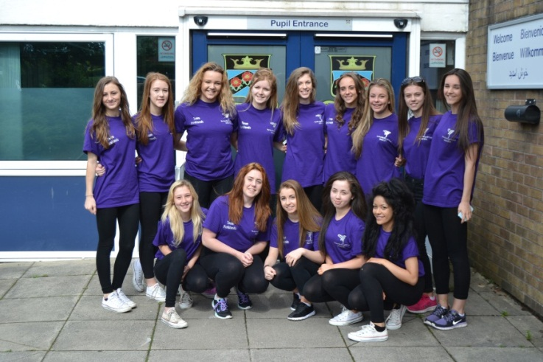

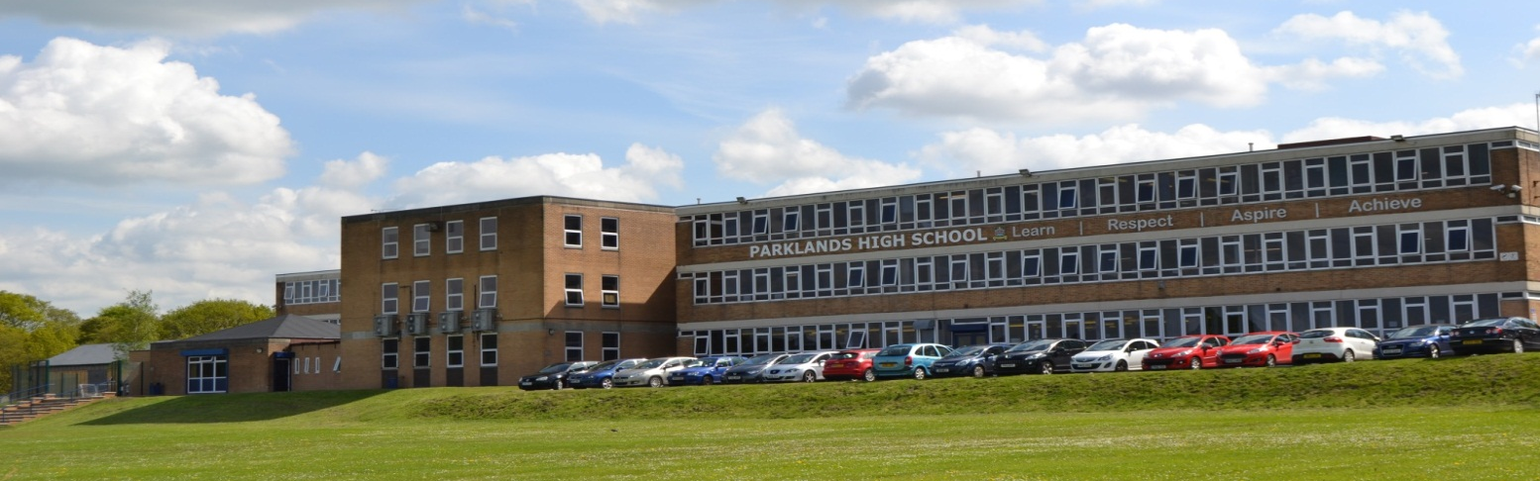

Students have good attitudes to learning….there is a calm and purposeful atmosphere …. many students are involved in extra-curricular activities and in leadership roles’
(Ofsted November 2014)

Job Title | Teacher of Humanities (Geography and History)
Department/Area | Geography and History
Responsible to | Headteacher, SLT Curriculum Manager, Curriculum Leader Geography, Curriculum Leader History.

Working Time
a. 190 days (or part time equivalent) of teaching a designated timetable plus 5 days (or
equivalent) in which the teacher may only be required to perform other duties.
b. Any other session as directed by the Headteacher

Prompt attendance and leadership/participation as appropriate in:
c. Staff Briefing - 8.30am and any other designated meetings.
d. Agreed pre-school, break, lunch time and post school duties

Calendar:
g. Full participation at directed time events on the annually published calendar.
h. Attendance at calendar sessions, meetings and INSET will be agreed at the start of the academic year.
i. Attendance at optional CPD opportunities.
Safeguarding | To report all information and concerns to the Designated Senior Leader.  This should be completed promptly, factually, and in line with the school’s confidentiality requirements.
Health and Safety | To comply with the school’s Health and Safety Policy and report all information and concerns to the designated representative. This should be completed promptly.

Main Duties

- Principal responsibilities:
Under the direction of the Curriculum Leaders for Geography and History,
• To contribute to teaching and learning in both subjects including production of shared resources.
• To participate in the development and implementation of appropriate syllabi, materials and schemes of work reflecting the school’s published aims, policies and procedures. This includes the School SEF and development plan, teaching and learning policy and behaviour policy.
• To maintain accurate and complete assessment records and use them constructively to inform learning and to report to parents as required.
• To participate in the process of student target-setting, developing and implementing schemes of work and maintaining progressive learning outcomes in lessons.
• To attend and contribute to department meetings, TLC sessions and INSET training as required.

- Additional specific responsibilities:
• To be the form teacher of an assigned form.
• To undertake the pastoral care and guidance of each individual in the form and monitor their academic progress.
• To deal with and administer all routine business connected with the form, including returns as required.
• To take responsibility for the conduct of Form time.
• To provide or contribute to reports and keep records as appropriate.
• To check and comment on reports to parents as needed.
• To keep a general eye on the personal appearance and behaviour of the form and insist on a high standard.
• To attend and contribute to assemblies when required and actively supervise the form's movement both to the place of assembly and whilst it is in progress.
• To attend House meetings.

- General duties:
• To have responsibility for safeguarding and promoting the welfare of the young people for whom you are responsible and all those you may come into contact with.
• To mark the register of all groups in accordance with the procedures determined by the attendance policies.
• To carry out a share of supervisory duties in accordance with published schedules.
• To share responsibility for good order and discipline in the school.
• To participate in appropriate meetings with colleagues and parents or carers.
• To participate in Appraisal and School Self Evaluation arrangements.
• To adhere to published school policies.

- Be courteous to colleagues, students and parents and provide a welcoming environment to guests.
- Discharge your duty of care for your own and others’ health and safety.

- Please note:
• The above responsibilities are subject to the general duties and responsibilities contained in the "School Teachers' Pay and Conditions Document".
• This job description does not direct the particular amount of time to be spent on carrying out any of your duties and no part of it may be so construed.

Other duties will be required as and when necessary to the post from time to time. The job description is current at the date shown but, in conjunction with the post-holder, may be revised by the Headteacher to reflect and anticipate changes in the job. These would be commensurate with the grade and job title. Such variations that are made to the duties and responsibilities will not change the general character of the post.

All aspects of the post will be evaluated by appropriate means including discussions with those staff the holder is responsible to, including the Headteacher and members of the SLT.

Please advise the school of any disability you may have or develop so that the school may
endeavor to make any necessary reasonable adjustments to the job and the working
environment.

Person Specification-Teacher
Humanities Department
(Geography and History)
 | Essential | Desirable | How Assessed
QUALIFICATIONS
Qualified teacher status |  |  | A/C
A recognised degree or equivalent |  |  | A/C
EXPERIENCE OF TEACHING
Successful Geography KS3/KS4 level in an 11-16 school- either in placement or employment |  |  | A/R
Successful History teaching to KS3/KS4 level in an 11-16 school- either in placement or employment |  |  | A/I/R
PROFESSIONAL UNDERSTANDING
Assessment for learning |  |  | A/ I/R
Planning |  |  | A/ I/R
Differentiation / personalisation to include the needs of SEND pupils |  |  | A/ I/R
Behaviour management strategies |  |  | A/ I/R
ICT literacy |  |  | A/ I/R
Awareness of health and safety issues in the teaching of Geography and History |  |  | A/ I/R
APPLICATION FORM AND LETTER
Letter should be clear, concise, accurately written and presented in an organised way: |  |  | A
Letter should outline a clear educational philosophy and relate directly to the requirements of the post and the school as outlined in the Job Description, this Person Specification and other documentation |  |  | A
Application form should be fully completed, accurate and legible |  |  | A
Candidates will have to demonstrate their suitability to work with children |  |  | A/I/R
KNOWLEDGE, SKILLS AND ATTRIBUTES
Candidates should be able to show that they have:
Excellent subject knowledge and effective classroom practice |  |  | A/I/R
knowledge and understanding of current educational issues, including national policies, priorities and legislation |  |  | A/I/R
knowledge and understanding of current curricular, teaching and learning issues relevant to the needs of the school |  |  | A/I/R
understanding of strategies for school improvement |  |  | A/I/R
ability to use ICT to enhance learning and to administer professional duties |  |  | A/I/R
self-confidence, self-motivation, personal impact and presence |  |  | A/I/R
the ability to relate well to pupils, parents and staff |  |  | A/I/R
effective communication and exceptional interpersonal skills |  |  | A/I/R
high levels of commitment, enthusiasm and motivation |  |  | A/I/R
a clear understanding of the needs, values and aspirations of all pupils being educated in this school |  |  | A/I/R
A good sense of humour |  |  | A/I
Willingness to make a substantial contribution to the school’s vision and future development |  |  | A/I R

Note: We will always consider your references before confirming a job offer in writing.

Key: A = Application (including letter) C = Certificate I = Interview R = Reference

