TEACHER OF ICT/COMPUTING
MPS

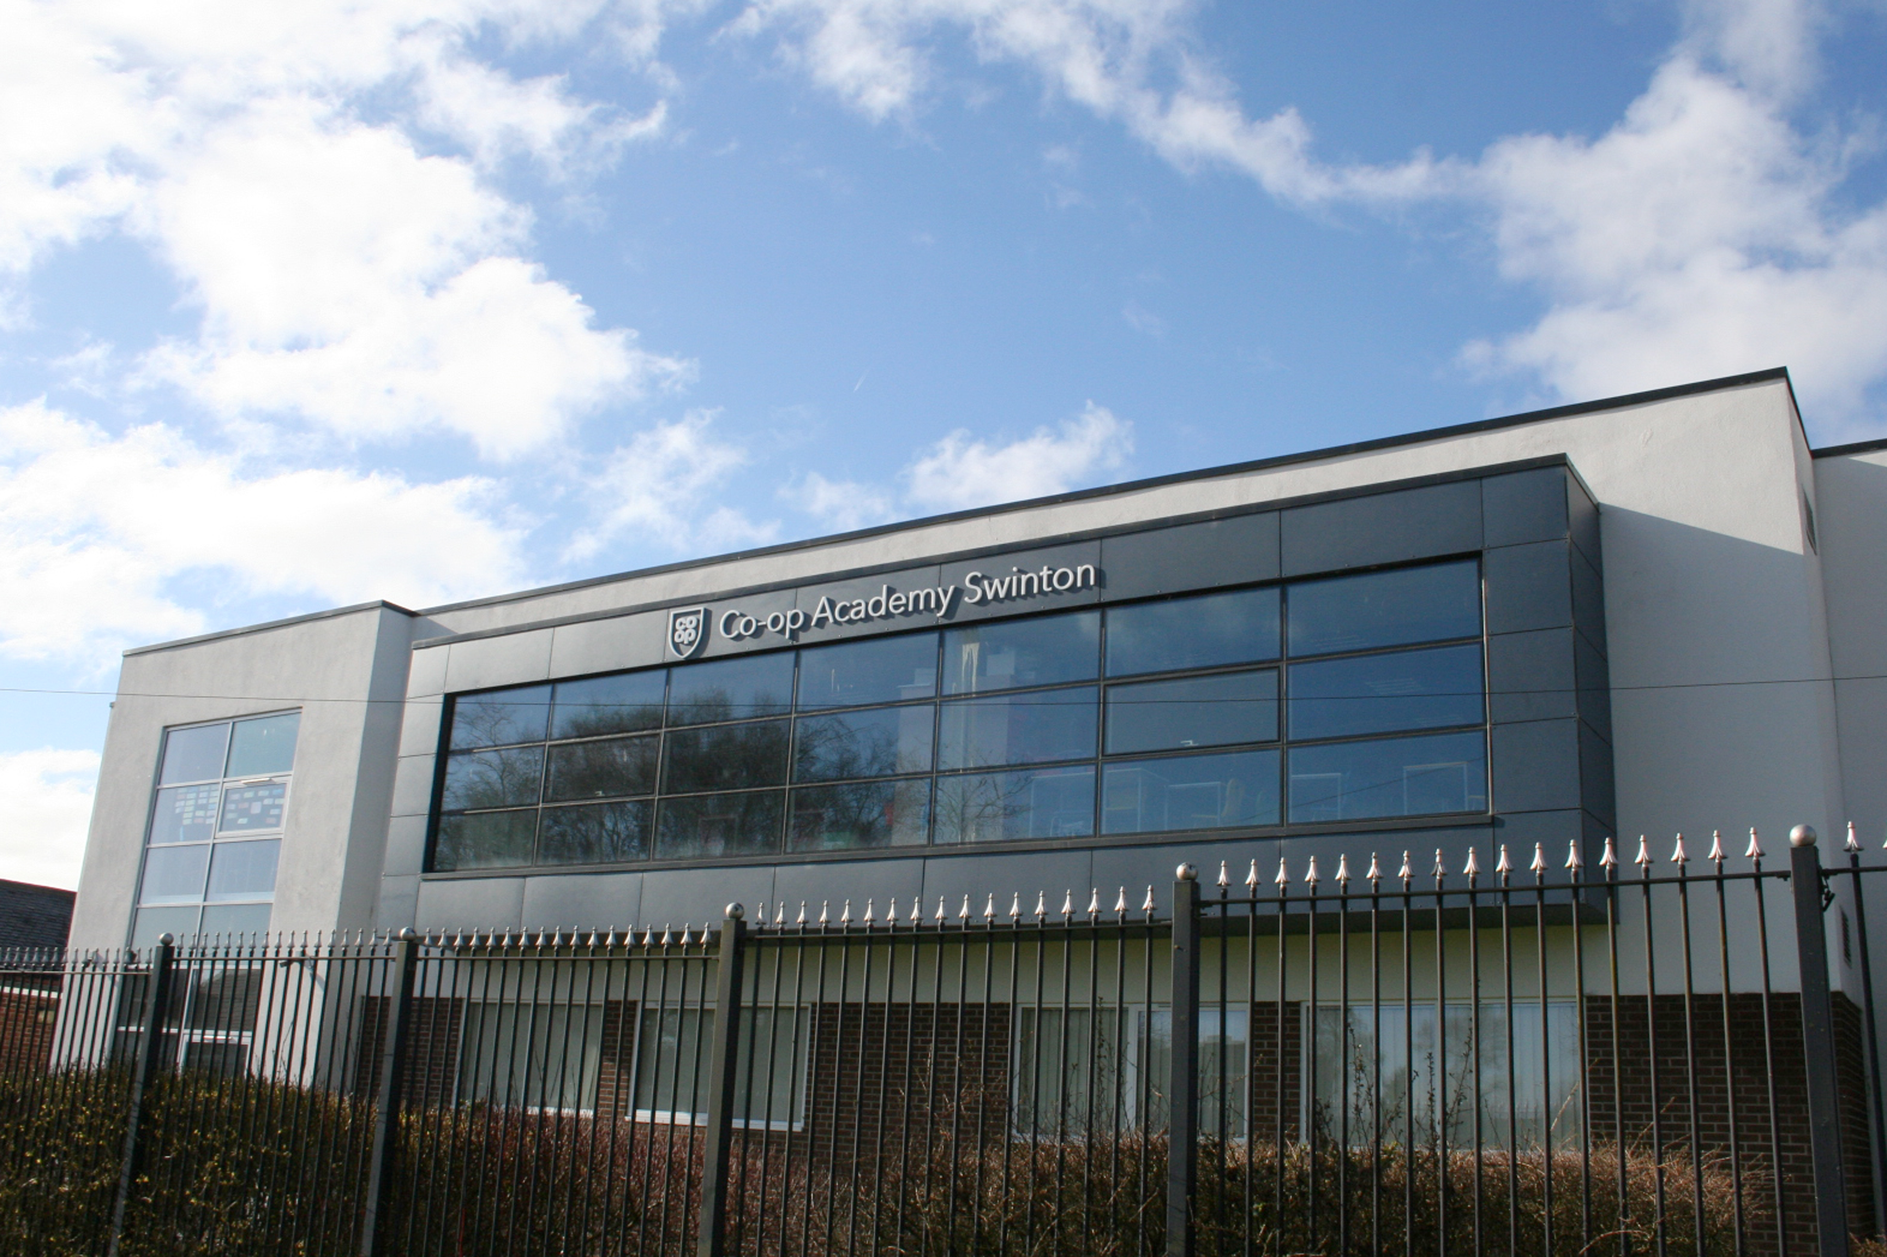
Application Information Pack
February 2018

Contents…
Page 3 | Welcome from our Headteacher
Page 4 | Job Advert
Page 5 | SECTION 1 : Co-op Academy Swinton  Current  The Future  School Location
Page 11 | SECTION 2  The Post  Person Specification  Job Description
Page 16 | SECTION 3  Arrangements for the application  Enhanced Disclosure

Welcome from our Headteacher…

Thank you for considering this post at
Co-op Academy Swinton. We hope you will find
all you need to help you consider our school for your next career move. Due to a doubling of first choice preferences we are increasing the number of teaching positions which has led to the creation of this new post.

You find us at an exciting time! Our school has recently joined the Co-op Academies Trust, which has a fantastic record of improving the life chances of the children it serves whilst challenging and supporting its staff.

On arriving at Co-op Academy Swinton, you immediately notice the excellent relationships evident between students and staff and the purposeful environment evident in lessons. With this foundation, our students' journey to being confident, happy and able to achieve their aspiration has already started.

Co-op Academy Swinton provides an outstanding setting for our childrens’ education. We are ambitious to give our children every advantage, and following our previous full refurbishment and extension of our facilities, we have recently completed work on our new catering classrooms and a community cafe.

This development is an example of our constant drive to provide our students with the best possible opportunities. It is a great privilege to be the Headteacher of such a thriving school. We believe all children can be successful and it is our mission to teach them that effort and determination will help them achieve this. Our students are taught to be independent and versatile so that they can be successful in an ever-changing, competitive world.

The statement ‘Strive to Achieve’ underpins all our work and reflects the beliefs of the students, staff and Governors here at Co-op Academy Swinton. Collectively we must build our students’ aspirations, give them the skills and opportunities to achieve them and create leaders in the community.

If you share our vision for Co-op Academy Swinton and are determined to help our students strive to achieve their best then I look forward to reading your application.

Mr M. Harrison

Headteacher, Co-op Academy Swinton
Co-op Academy Swinton
Headteacher: Mr M. Harrison BSc (Hons) PGCE
Sefton Road, Pendlebury, Manchester, M27 6JU
Tel : 0161 794 6215 Email: enquiries@tshs.co.uk
NOR 723 11 – 16 years

Teacher of ICT/Computing - MPS
We require an enthusiastic and inspirational teacher of ICT/Computing to join our Computer Science/Business Studies & ICT department for the 1st September 2018. The successful candidate must be able to: establish good relationships with students to inspire learning; promote interest in the subjects and ensure high achievement; be able to work well with colleagues in the department and across the school; have commitment and initiative and a ‘can do’ approach, willing to make a contribution to the life of the school and to ensuring that all our students achieve the best possible outcomes. Applicants must be outstanding and motivated teachers with the drive to deliver results at KS4.
An excellent career and professional development offer is also at the heart of the academy’s commitment to you. In addition you will have the opportunity to link with other Cooperative Academies across the North West.
Our core co-operative values define us. Every member of staff in our academy follows our ‘Ways of Being’;
- Do what matters most
- Be yourself, always
- Show you care
- Succeed together
Co-op Academy Swinton is popular and one of the most improved schools in the country. We are part of the Co-op Academies Trust. Inspected under the new Ofsted inspection framework, we are delighted to have achieved a good judgement in every category and an overall judgement of good in November 2015. We are well on the way to becoming the Outstanding school that the community deserves. After recently joining the Trust we continue our drive for excellence, in everything we do, to better our students’ life chances.

Application forms are available from our school website www.theswintonhigh.co.uk and returned via email to Carol Robinson at Co-op Academy Swinton crobinson1@swinton.coop

The Coop Academy Swinton is committed to safeguarding and promoting the welfare of children and young people and expects all staff and volunteers to share this commitment. Any offer of employment is subject to a satisfactory enhanced DBS check.

Closing date: Monday 21st May 2018

Interview date: To be arranged

SECTION 1
Co-op Academy Swinton

Context
Swinton is situated on the outskirts of Salford, bordering Bolton, Bury and Trafford. It is well served by the motorway networks, M6, M60 and M62 giving access to the surrounding countryside of Cheshire, Lancashire, The Lake District and Derbyshire national parks. The school is within easy reach of the rail network into Manchester City Centre. Swinton rail station is two minutes’ walk from the school and serves the Southport, Wigan, Bolton, Manchester lines. The regeneration of Manchester city centre, Salford Quays and the Trafford Centre gives a wide diversity of theatres, clubs, cinemas, restaurant and shopping opportunities within a few miles of our school. LS Lowry, the famous artist, lived within a few hundred yards of our school where he painted some of his most famous works.

Co-op Academy Swinton, an 11-16 comprehensive is one of 14 high schools and academies in the Salford Local Authority. On the 1st August 2011 our school converted to an Academy and on 1st March 2018 we joined the Co-op Academies Trust.

Accommodation
Our school originally came into existence in September 1988 when Wardley High School and Pendlebury High School merged to form a single 11-16 comprehensive school on one site, located half a mile from the Swinton town centre. Whilst the buildings vary considerably in age and appearance, internal refurbishment of existing facilities has provided a pleasant working environment. A new maths suite, totally refurbished science laboratories, an ICT resource area comprising five computer rooms, a technology block and refurbished art and library facilities have improved the teaching environment. Improvements to the school environment have been substantial over the last few years and are continuing. We regard the environment as an important factor in encouraging students to learn and every effort is made to maintain high standards. Despite all of these developments we acknowledge the need for continued refurbishment for our school so we may continue to serve our community in the best possible environment.

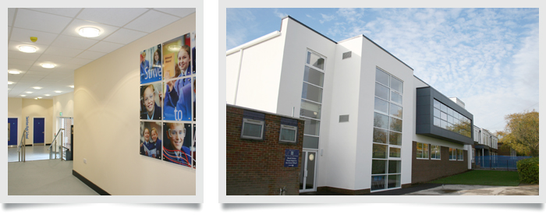

ICT
In September 2015 we launched the innovative E2BN ICT Solution, being the first school in England to do so. This will put us at the cutting edge of cloud based learning. We have almost one laptop or tablet PC per student in the school. Every teacher currently has their own laptop computer and all staff who wish to have an interactive whiteboard and visualiser in their classrooms do so. Lesson observations show that ICT for learning is a strength across all areas of the curriculum.

Students
We attract students across the full ability range, and have at present 723 and increasing year on year, students between the ages of 11 and 16 years on roll. Our students are drawn mainly from the Swinton, Clifton, Pendlebury and Wardley areas of Salford. However, it is worth noting that 1:5 of our students are from out of the immediate catchment area. This is a phenomenon which reflects our increasing popularity and is directed related to our growing reputation and improving exam results. 20% of our students are eligible for Free School Meals and there are 7 students with Educational Health Care Plans and 9 Looked After Children.

There is a substantial upsurge in student numbers currently in our local feeder primary schools and the expectation is that by 2018 Co-op Academy Swinton, along with many local secondary schools, will be full to capacity.

Care, Guidance and Support (CGS)
We believe that the success of our students is founded on high expectations, on good teaching and a solid partnership between school and home. ‘Respect’ and ‘Strive to Achieve’ underpin everything we do and drive our school to challenge ourselves and each other. The system of care, guidance and support underpins the ethos of the school. It is based on the Year Group principle led by a Pupil Progress Coordinator (a qualified teacher) with a full time Year Manager in assistance. The Pupil Progress Coordinator reports to the line manager Assistant or Deputy Headteacher. Three Year Managers and two social inclusion officers support learning for children by providing a complementary service to existing staff, external agencies working with the school and links with parents, with an aim to assist in improving attendance and academic attainment of targeted children. Our Year Managers also provide post-school study support. All our staff are committed to this system, both as form tutors and in their working relationship with the students. All staff are expected to support the maintenance of high standards of behaviour, discipline, appearance and uniform, upon which the school places a high priority. There is a Student Council with representatives from each year group, including the Head Boy, Head Girl and Senior Prefects. They meet to discuss issues raised by students at form and year level. There is a planned form tutor programme every morning, organised by the Pupil Progress Coordinator.

Academic Organisation
We have a staffing complement of some 70 full and part-time members, including teachers, support assistants, site, administrative/reprographic staff, technicians, cleaners and kitchen staff. Since September 2012 we now manage our own catering and cleaning, and those staff are directly employed by the school.

The academic structure of the school is based on a system of four Faculty Leaders: Communications (English, French and Spanish), Mathematics, Science and Humanities are each led by a Director of Learning. There are six head of departments: Technology, Computer Science, Business Studies & ICT, Arts & Textiles, PE, Music & Drama and Special Educational Needs. All reporting to their respective Deputy Head or Assistant Head Line Manager. The extended leadership team consists of core senior leaders and four directors of learning.

There is a fully calendared programme of weekly directed time meetings including: regular Curriculum, ICT for learning, Care, guidance and support, and Senior Leadership Team Meetings. We place high emphasis on staff development both for school improvement and personal professional development. There is a successful Induction programme for new staff, which has been praised by Ofsted.

Extra-Curricular Activities
As an example of our ‘Respect’ and ‘Strive to Achieve’ agenda we provide a wide range of extra-curricular activities, which are well supported by students and all staff. These provide opportunities for students to follow their interests and talents in drama, sport, music and dance. Our school’s musical activities have an excellent reputation and the Steel Pans have performed in a wide variety of locations.

All staff are actively involved in a comprehensive range of extra-curricular activities including an extensive programme of after-school lessons, clubs and activities.

Community Links
Recognised in our Ofsted inspections of 2007, 2012 and 2015 Co-op Academy Swinton has developed outstanding links with the local community through community placements including local nurseries and old people’s homes and the local Salford Business Education Partnership. We are one of only 21 Manchester United Foundation Schools in the country and work closely with Salford Red Devils and Swinton Lions Rugby teams. Termly concerts are a regular feature of the school calendar, which are well supported by staff, parents, governors and students.

Primary School Links
All faculties have developed links with feeder Primary Schools. We have a Deputy Headteacher responsible for transition between Key Stage 2 and Key Stage 3 and all staff participate in primary liaison activities at some point during the year, usually but not exclusively, in June and July. This is an extremely successful programme, recognised as such in our 2007 and 2012 Ofsted inspection reports. At Key Stage 4 we provide careers advice and guidance to all students and currently hold the gold CEIAG award. In addition to this, local and national charities are well supported by our school community.
Attendance
We take attendance very seriously and see good staff and student attendance as a key factor in sustaining school improvement. For the last five years our student attendance has risen annually and for the last four years it has been significantly above the national average for all secondary schools. Raiseonline consistently shows this element of our work to be outstanding.

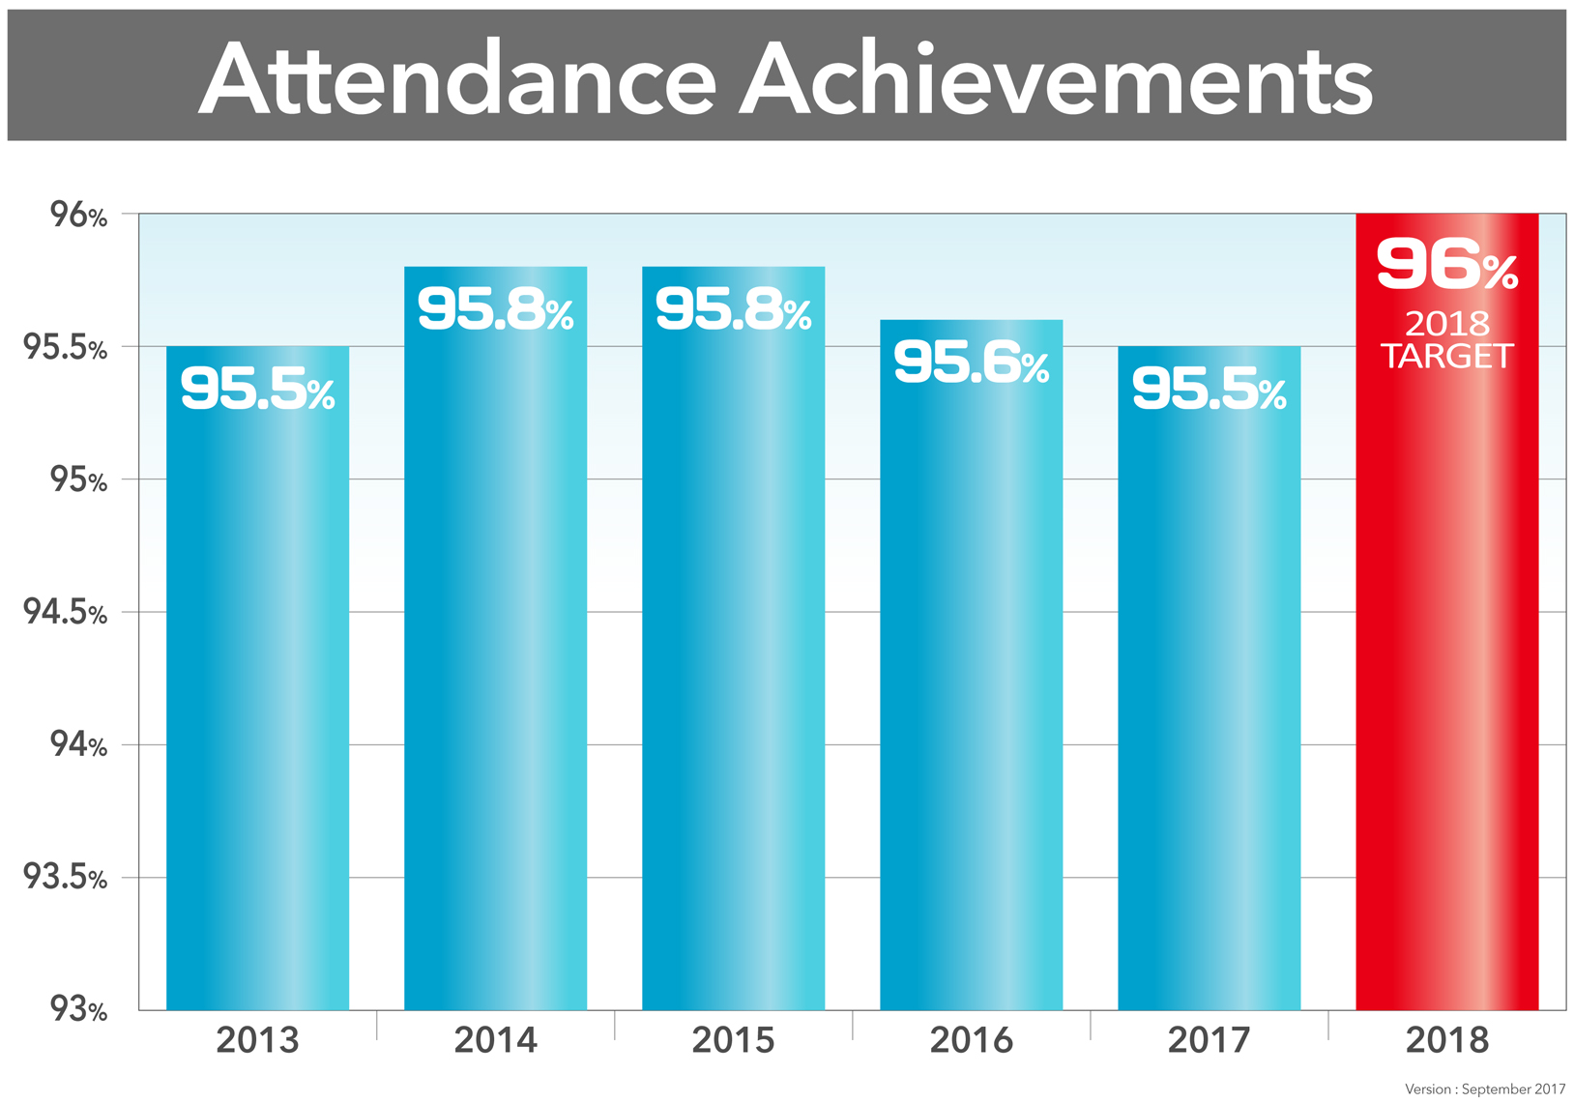

Monitoring and Evaluation
We have a detailed development planning cycle aimed at fostering a shared determination to develop an already good school into an outstanding one. Monitoring and evaluation of teaching is incorporated into the school calendar and Performance Management is thriving. We operate a range of monitoring and evaluation processes such as formal lesson observations, learning walks, work samples and our Directors of Learning regularly monitor staff planners.

Homework
There is a homework timetable which we expect all staff and students to adhere to. This is monitored for the frequency and quality of homework and appropriate action taken to acknowledge good practice or address underperformance.

Teaching and Learning
We are committed to giving our students the best possible learning opportunities. In addition to our substantial investment to support ICT for learning we are continuously developing collaborative staff approaches to learning for example by thriving coaching sets, Kagan Structures, use of lesson objectives and assessment for learning techniques. The importance of teaching and learning permeates through all of our work. It is a first agenda item on almost all of our meetings.
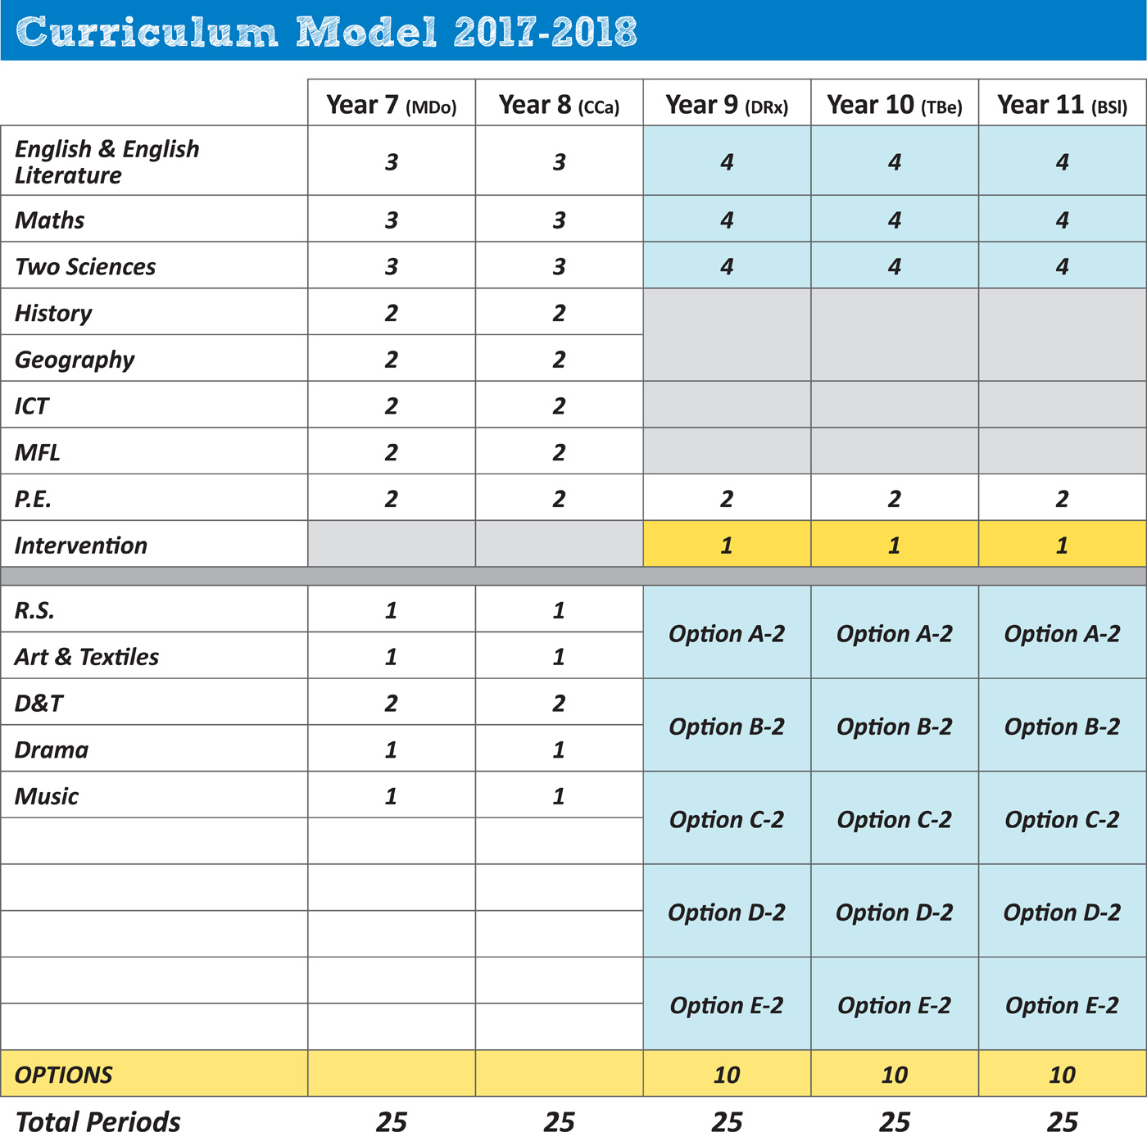
Curriculum Plan
We believe that the breadth and quality of the Curriculum is central to the ongoing achievement, progress and motivation of our students. We adopt a rigorous programme of literacy intervention to support our academy pledge that every child has a reading age of 10.5 or more by the end of Year 7. This ensures that our students can all access the opportunities that our modern curriculum presents to them. Our school operates a two year Key Stage 3 in

Years 7 and 8 followed by a three year Key Stage 4 in Years 9, 10 and 11. Guided option choices are made in Year 8. Students will be given every support and encouragement to pursue subjects aligned to their abilities and interests.

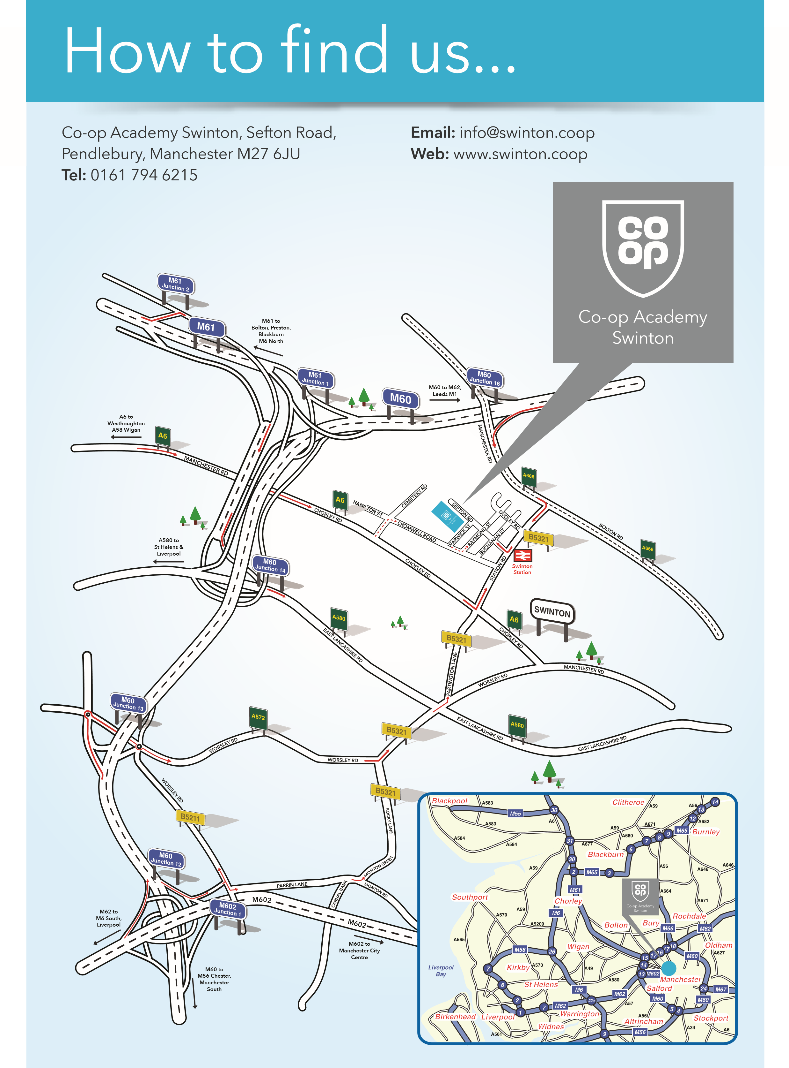
SECTION 2

The Post, Person Specification and Job Description
The Post
Job Title: | Teacher of ICT/Computing
Salary: | MPS
Start Date: | 1st September 2018
Tenure of Post: | Permanent

Person Specification
Experience: | - Experience of successfully teaching ICT/Computing in one or more UK secondary schools at both Key Stage 3 and 4 (can be evidenced through placements).  - Good record of attendance and punctuality.
Qualifications: | - Qualified teacher of ICT  - Degree in ICT or equivalent qualification.
Knowledge/Skills: | - Evidence of personal professional development relevant to this post.
This is a real opportunity to develop your career alongside like-minded, skilled professionals, in a dynamic and supportive team.

The Computer Science, Business Studies & ICT Department

The department is staffed by three specialist qualified full time teachers. The staffing structure gives a wealth of experience and expertise. The teachers work as a team, sharing expertise and ideas. At present each teacher is based in their own classrooms.

The department is improving resources through the purchase of new learning material, differentiated to suit different pupil abilities, and the development of in-house resources to meet the needs of pupils in both key stages.

The team are committed to the development of ICT and students are encouraged to access the network to use software and the internet which supports pupil learning. Pupils are encouraged to show an interest in ICT as a subject, to show initiative and take responsibility for their own learning. All staff in the department have their own school laptops and whiteboards.

Key Stage 3
Pupils are placed into ability sets on entry using Key Stage 2 results. In Year 7, pupils sit the Cognitive Ability Tests and these, together with internal assessments and monitoring allow pupil progress to be measured. Ability is tested termly in Year 7, pupil progress is celebrated in a year assembly through the award of ‘Progress Certificates’ and letters to parents. KS3 computing, full suite of Microsoft Office, Serif Creative Suite, Macromedia Studio, Scratch, Python Programming.

Key Stage 4
The department teaches OCR GCSE Computer Science (Python Programming up to GCSE minimum). Edexcel CiDA (additional Software: Adobe Premium Suite e.g. photoshop & sketch up).

The department meets regularly and there is an on-going programme of developmental work and training to keep abreast of current requirements.

The department works hard to improve teaching and learning. All staff are encouraged to develop their range of skills and all main scale teachers are encouraged to take responsibility for some aspect of the department’s work. This may be varied to enhance professional development. The successful candidate will have the opportunity to gain a range of experience while contributing creatively to the challenges of providing the best in ICT teaching and learning for our students.

This is a fabulous opportunity to join a well-established and experienced faculty.

JOB DESCRIPTION

POST TITLE: Teacher of ICT/Computing

Responsible to: Head of department

Salary Scale: Main teacher scale

Responsible for:

Main Purpose: Ensure the highest possible standards are achieved in the faculty and in the teaching of ICT/Computing and other subjects.

Contract: Permanent

Hours of duty: In accordance with school teachers’ pay & conditions

Main Purpose
To carry out the standard duties and responsibilities of any teacher in the Co-op Academy Swinton.

To work as a member of a departmental team in a curriculum area within school.

To share in the corporate responsibility for the education and well-being of all students in accordance with the school policies.

To develop effective relationships with students, parents, staff, governors and other members of the school community.

To assist in the provision of support/revision/ booster classes for students taking external examinations, module tests, controlled tests and course work.

To assist with the transition of students from Year 6 to 7, participating in primary liaison activities and to help ensure a smooth and effective transition occurs for all new intake students, for example target setting, transition visits etc.

To contribute to the development of whole school strategies to develop literacy across the curriculum.

Attend Parents’ Evening as required.

Keep up-to-date with new developments and initiatives in teaching.

Incorporate and promote the use of literacy in the delivery of teaching.

To be a form tutor and ensure that students have high standards of uniform, punctuality and attendance.
Planning, teaching and class management

To develop, along with appropriate colleagues, syllabuses and programmes of work, designed to meet the needs of all students, with particular reference to the National Curriculum and developments in literacy and numeracy.

Teach allocated students through appropriate planning to achieve progression of learning by:

- Identifying clear teaching objectives and specifying how they will be taught and assessed.
- Setting tasks which challenge students and ensure high levels of interest.
- Setting appropriate and demanding expectations.
- Setting clear targets, building on prior attainment.
- Identifying SEND or very able students and make appropriate provision.

Provide clear structures for lessons maintaining pace, motivation and challenge

Make effective use of assessment and ensure coverage of programmes of study.

Ensure effective teaching and best use of available time.

Monitor and intervene to ensure sound learning and discipline.

Use a variety of teaching methods to:
- Match approach to content, structure information, present a set of key ideas and use appropriate vocabulary
- Use effective questioning, listen carefully to students, give attention to errors and misconceptions
- Select appropriate learning resources and develop study skills through library and other sources.

Ensure students acquire and consolidate knowledge skills and understanding appropriate to the subject taught.

Evaluate own teaching critically, to improve effectiveness.

To have corporate responsibility for the behavior of students in accordance with the school’s Behaviour Policy and procedures.

To manage classroom and teaching equipment to create a positive, stimulating and safe learning environment which makes full use of all available resources.

Implement the departmental policy regarding homework in conformity with the school’s policy and informing parents as appropriate.

To work closely with the head of department in the implementation and development of new curriculum initiatives.
To attend and participate in meetings and training sessions and contribute to school decision making and consultation procedures as required.
Monitoring, assessment, recording, reporting

To follow the school and the departments Assessment Policy.

Assess how well learning objectives have been achieved and use them to improve specific aspects of teaching.

Mark and monitor students’ work as per school policy and set targets for progress.
Assess and record students’ progress systematically and keep records to check work is understood and completed, monitor strengths and weaknesses, inform planning and recognise the level at which the student is achieving.
Prepare and present informative reports to parents.

General
Adhere to Teachers’ Standards at all times.
Be aware of and comply with policies and procedures relating to Safeguarding, Child Protection, health, safety and security, confidentiality and data protection, reporting all concerns to an appropriate person.
Contribute to the overall ethos/work/aims of the school.
Contribute to the corporate life of the school through appropriate participation in meetings and management systems necessary to coordinate the management of the school.
Take responsibility for their own professional development and duties in relation to school policies and practices.
Establish effective relationships and communicate with other staff to support achievement and progress of students and other staff and set a good example through their presentation and professional conduct.
Endeavour to give every child the opportunity to reach their potential and meet high expectations.
Carry out duties with full regard to Co-op Academy Swinton policies and procedures.
Be aware of and support difference and ensure equal opportunities for all.
To safeguard and promote the welfare of students

This job description is not a definitive list of responsibilities but identifies the key components of the role. The post holder will, therefore, be required to undertake any other reasonable duties commensurate with the level of responsibility/salary of this post.

SECTION 3

Arrangements for the Application

Application Details:
Please apply by submitting to the school:
- A completed application form.

Closing date: Monday 21st May 2018
Interview Date: To be arranged

* Candidates called for interview may be contacted by telephone or in writing.

ENHANCED DISCLOSURE

Thank you for your interest in this position at Co-op Academy Swinton.

The post you are applying for involves working with young people. It is therefore exempt from the Rehabilitation of Offenders Act and any offer of employment will be subject to an Enhanced Disclosure.

Rehabilitation of Offenders Disclosure – All posts within CAT’s academies are exempt from the Rehabilitation of Offenders Act 1974 (Exceptions) order 1975 (new guidance 2014). This means that you must disclose any unspent cautions, convictions or bind-overs, any offences that would not be filtered, during the application stage.

Further details will be sought prior to appointment.

An enhanced disclosure is carried out by Disclosure and Barring Service and will check criminal records for information on any convictions, cautions, reprimands and warnings held on the Police National Computer and on Local Police Records.

All information on criminal records provided by both you and within the Enhanced Disclosure will be used, stored and disposed of in confidence and in line with the Disclosure and Barring Service Code of Practice of Disclosure Information.

If your application is successful you will receive further information on how to complete the Enhanced Disclosure.

Please note, it is school policy that all newly appointed staff must have full enhanced DBS clearance and two satisfactory references before they begin work at Co-op Academy Swinton.

