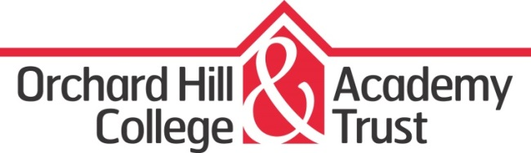
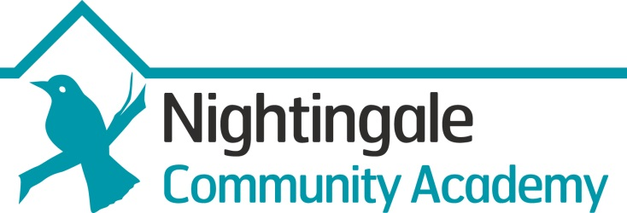

Class Teachers

Main Pay Scale/Upper Pay Scale + SEN dependant on experience and qualifications

Full Time

Do you believe that Teachers have a critical role in transforming learning and enriching the lives of young people? Would you like to be part of something energetic, innovative and empowering? If so, we want to hear from you.

We are currently recruiting for Teachers of:

- Science Teacher
- Design and Technology Teacher
- Mechanical Teacher
- Humanities

The Orchard Hill College Academy Trust (OHCAT) is a multi-academy trust which became the sponsor of Nightingale Community Academy on 1st September 2016. The Trust is a specialist provider with a strong track record in contributing to improving the education offer for young learners with Special Educational Needs (SEN).

Nightingale Community Academy caters for learners aged 5-19 who have Social, Emotional and Mental Health as their primary SEN need. Some learners also have Autistic Spectrum Disorder, ADHD, or other learning difficulties. At Nightingale Community Academy we are committed to raising the expectations of our learner group, removing barriers to learning and delivering attainment at the highest level.

We are looking for someone with drive, creativity and a passion for teaching to join our team and contribute to our fast improving school. Academy Status brings new opportunities and we are looking for new team members who can add value by delivering ‘quality first’ learning experiences that challenge and engage. Experience of working with learners with SEN in either a mainstream or special setting is desirable but not essential. What is imperative is that you have high expectations, a love of challenge and a determination to make a difference to the lives of our learners.

Nightingale Community Academy is committed to a multi-disciplinary approach to meeting learners’ needs, and promotes high quality professional development for all staff.

It is strongly advised that you contact the school to arrange a visit. To arrange, or to discuss the post further with the Principal or Assistant Head please email info@nightingaleca.org or phone to make an appointment. To apply for the role please send through your application to jobs@orchardhill.ac.uk

Nightingale Community Academy is committed to safeguarding and promoting the welfare of children and young people and expects all staff and volunteers to share this commitment.

Closing Date: 25th June 2017
Interview Date: 3rd July 2017

