Shavington Academy
‘Together we enjoy, create, aspire and achieve’

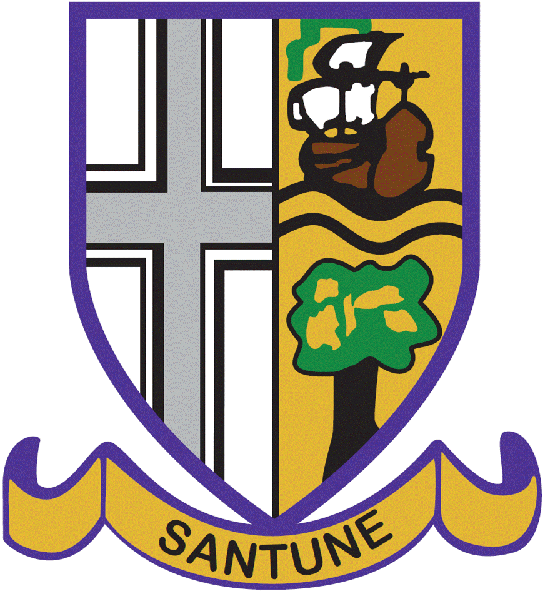

Applications are invited for the full- time permanent post of
Curriculum Leader of Modern Foreign Languages

Background Information

Shavington Academy has been a Multi Academy Trust, operating initially as a single school, since 1st September 2015. We educate pupils aged 11-16, serving the villages and conurbation to the South of Crewe. Our catchment includes Wistaston Church Lane, The Berkeley, Shavington, Weston and Wybunbury Delves Primary Schools, though we draw pupils from across Crewe and South Cheshire.

In 2012 we became one of fourteen high schools in Cheshire East to form the Chimney House Teaching School Alliance. Being a member of a teaching school has many benefits for teachers across the Teaching School; we both deliver and receive high quality training to support professional development at all levels, within the partnership. The academy has been inspected within three Initial teacher Training inspections in the last eighteen months, and has been commended in all three for the importance we place on developing teachers, at all levels.

Teaching and Support Staff across the school are professional and committed to the school and the pupils’ success. Together with the high standards that our pupils meet, our reputation as a school is very positive.

We feel that we are a school with high aspirations and this judgement was validated by a full OfSTED inspection in May 2014 when we were graded ‘Good’ in all areas. A copy of the Ofsted report is accessible from our school website. We now consider ourselves to be on a journey to outstanding, and are optimistic about appointing a Curriculum Leader of Modern Foreign Languages who is committed to joining us on this journey.

Results in 2017 were good and outstanding in some areas. Our overall Progress 8 score was +.1, which places us in the top ten most successful schools of Cheshire East. I am also pleased to say that we were able to narrow our PP/ non PP gap and continue to focus on this important aim. Our 2017 results for GCSE French were 88% A* to C and for GCSE German were 100% A* to C, however, these were relatively small cohorts, as MFL is optional at KS4.

Over the past three years, MFL uptake has increased year on year and we offer, French, German and Spanish to GCSE level. We follow the AQA specifications. This post represents a fantastic opportunity to lead the MFL Department through its next phase of development. The ability to teach GCSE Spanish is essential and the offer of an additional language i.e. French or German would be desirable. We are looking to appoint a Curriculum Leader who is committed to engaging pupils in MFL through innovation and strong pedagogy and you will receive full support from our team of enthusiastic and highly-skilled MFL teachers.

We seek a dynamic and inspirational Curriculum Leader of MFL who is looking to develop professionally with us and we offer excellent CPD opportunities. You will need to consistently model engaging teaching that captures the interest of pupils, have a commitment to widening pupils’ experiences of the world around them and have the organisational skills and capacity to lead and develop the improvements and developments that have taken place thus far within the department. The successful candidate will need to understand the value of team work and professional dialogue.

Informal inquiries prior to application should be made to, Mr Reno Chell, Assistant Headteacher: rchell@shavington.academy . Tours of the academy are welcomed, so that you can gain a sense of the education that we provide.

Application should be made to halton@shavington.academy . To apply for this post, please complete the enclosed application form, and provide a supporting statement of no more than two sides of A4 on your suitability for the post and the academy. The closing date for applications is Monday 16th April, 2018 at 9.00am. Interviews will take place on Thursday 19th April, 2018. The post becomes available from 1st September, 2018. All applications should be returned by email to halton@shavington.academy . Curriculum Vitae cannot be accepted.

Many thanks for your interest in Shavington Academy.
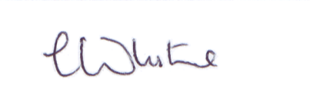

Mrs C White
Head Teacher

