

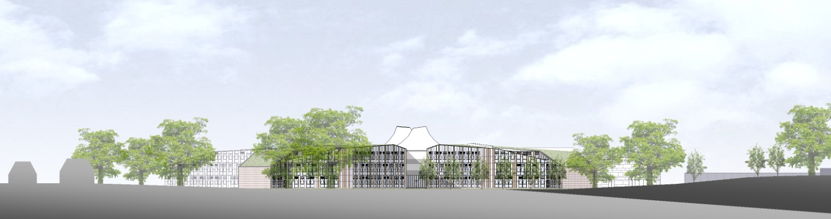

# ST. BARTHOLOMEW'S SCHOOL

SITE SUPERVISOR (CARETAKER) – CASUAL HOURS AS REQUIRED

# Required as soon as possible



**Andover Road**

**Newbury RG14 6JP**

**Tel: 01635 – 521255**

**Fax: 01635 576320**

**Email:** [**recruitment@stbarts.co.uk**](mailto:recruitment@stbarts.co.uk)

[**www.stbarts.co.uk**](http://www.stbarts.co.uk)

**THE FACULTY**

Become a member of our Facilities team, assisting in the day to day smooth running of the School. You will be involved in a wide range of activities which ensure the site is a safe environment for our School community.

We are looking for a flexible team member who is a good communicator, helpful, well organised and able to work on their own with minimal supervision.

Hours of work will be casual and agreed in advance with the Facilities Manager, based on the lettings planned in the school buildings.

**THE POST & SALARY**

In view of the nature of the post, the hours will be flexible and paid on a timesheet basis.

Salary will be paid in accordance with the national APT&C point 14 (currently £17681 per annum full-time equivalent). Payment will be made at an enhanced rate of £10.45 per hour, which includes holiday pay.

**HOW TO APPLY**

Full post details, an application form and instructions on how to upload your completed application are available via the Jobs & Training / Job Opportunities section on the School’s website:

[**www.stbarts.co.uk**](http://www.stbarts.co.uk)

(Please note that curriculum vitae and covering letters cannot be accepted)

Successful candidates will be subject to a DBS enhanced check along with other relevant employment checks.

## Closing date: Sunday 16 September 2018

Thank you for considering St Bartholomew’s School.

Julia Mortimore

Headteacher