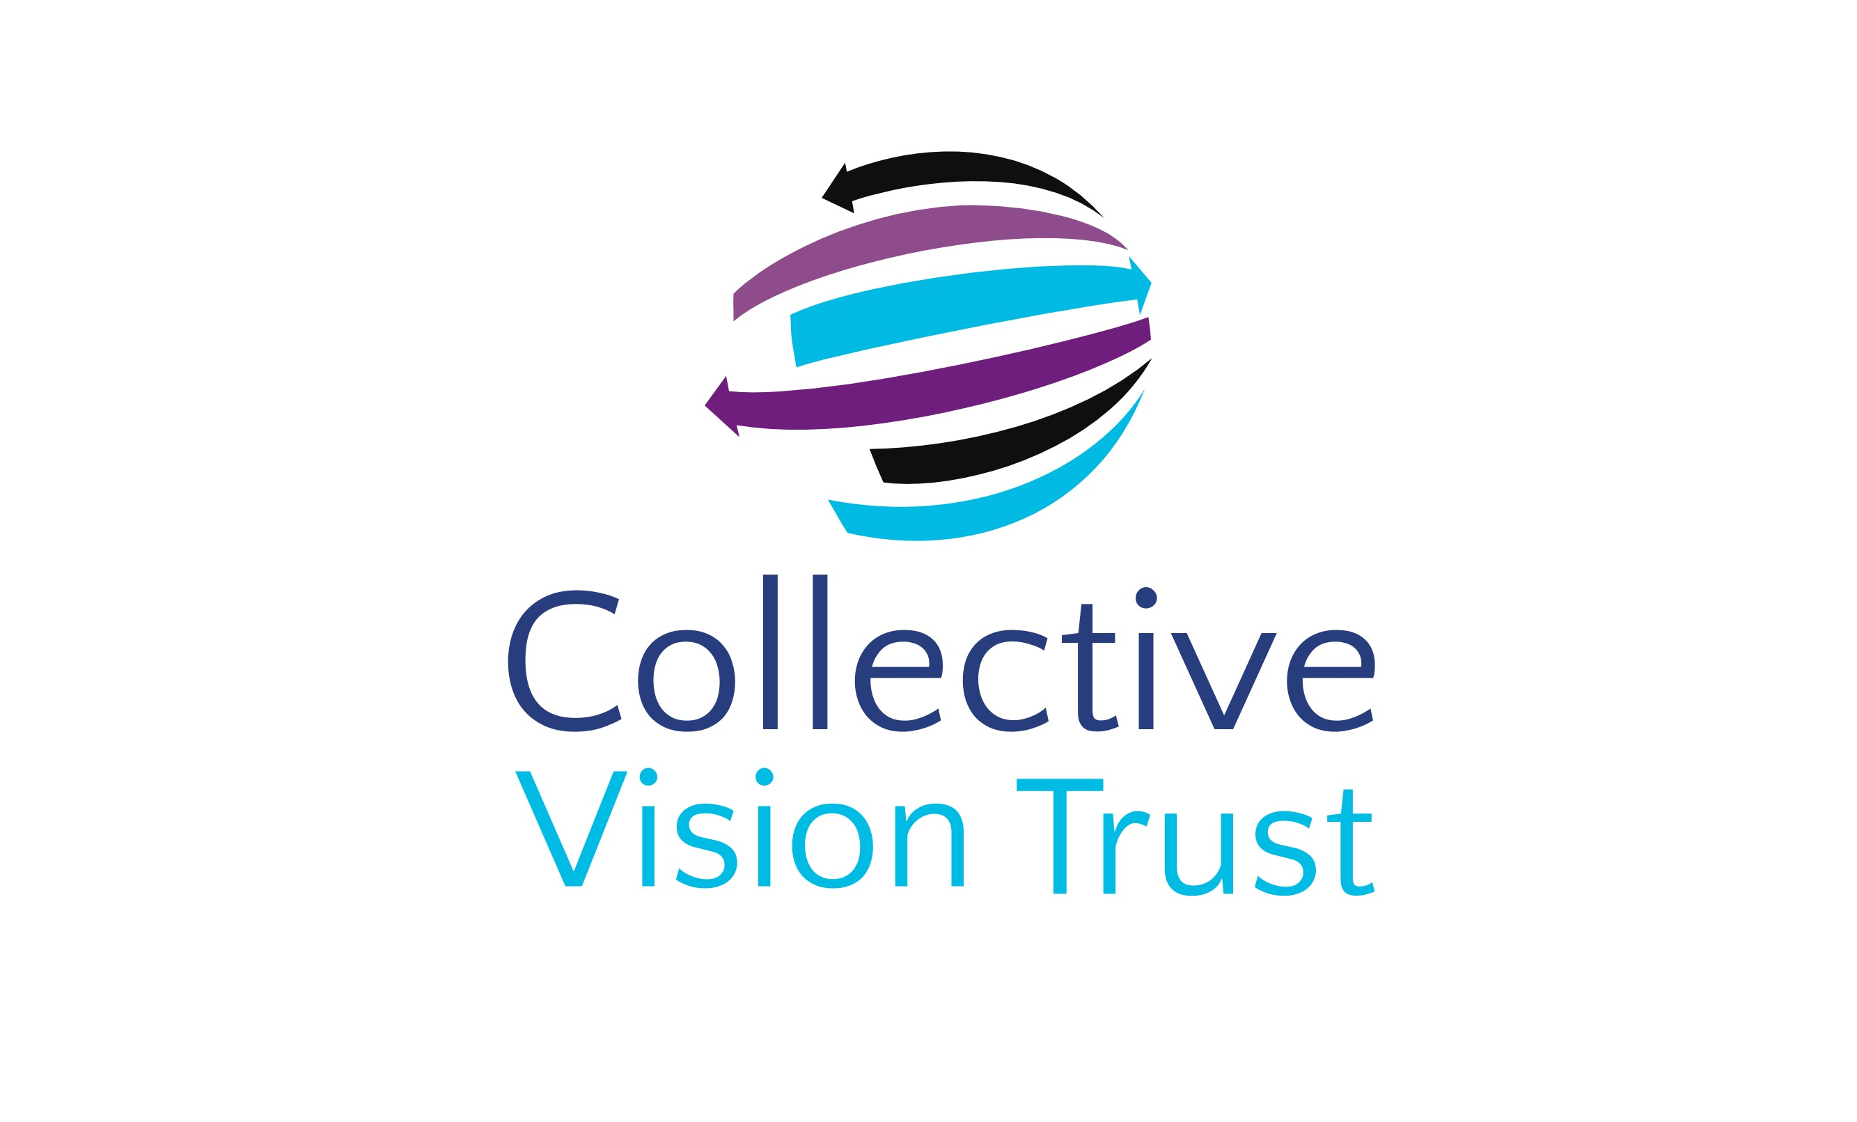
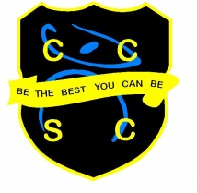
Science Department

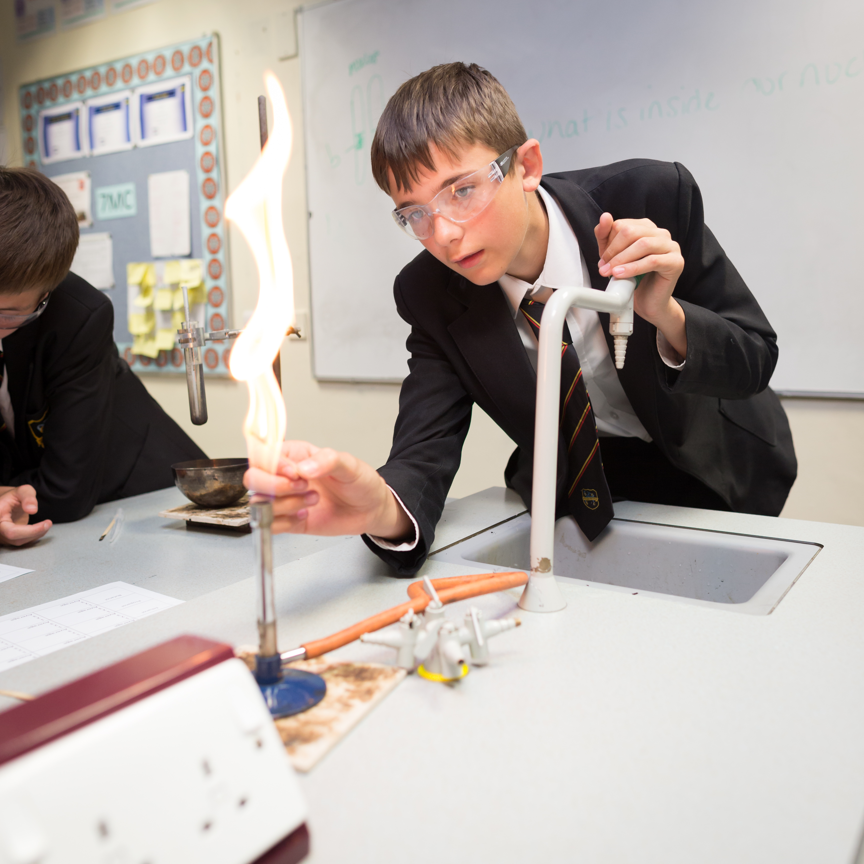
The Science Department at CCSC is one of the leading and largest department in the school, with 5 full time teaching staff and 2 technicians. We are driven by the desire to ensure every child achieves their full potential and we are passionate in making ‘Scientists of the Future.’ For this reason, we set very high standards for staff to ensure that all pupils are making expected progress and above.

The department has five large Science labs that are fully equipped to carry out practical lessons effectively and safely. Each lab has an interactive whiteboard, WiFi connection and the latest Apple Mac technology including Apple TV. All staff at CCSC have their very own personal Mac Book Air and iPad: these are essential tools in the development of modern education. Combined with this, all KS4 pupil have personal iPads that can be used in lessons to facilitate and engage learning further.

In line with the school’s innovative curriculum, the Science Department run a two-year KS3 programme. At KS3 we follow the New Exploring Science Specification, which provides a thorough foundation of content and skills in readiness for KS4. Students start KS4 in Year 9 and embark on the GCSE 9-1 Science programme following the Edexcel Specification. We deliver separate science to upper band classes and combined science to the higher specification to all other pupils. Staff and pupils have access to all online ActiveTeach and ActiveLearn resources to complement our existing resources and to promote learning beyond the classroom.

The GCSE Science results have been consistently in line with or above national average for many years and we strive to continue with this high standard. We had fantastic success with Triple Science pupils in 2016 achieving 100% A*-C and over 50% achieving A-A*. This success continued into 2017 with a positive progress measure across all science GCSEs; namely +0.98 Core & +0.89 Additional. Once again 50% of Triple Science pupils achieved A/A* in all three separate sciences.

