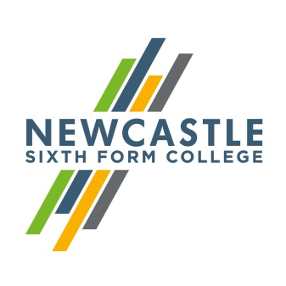
Gerard Garvey
Principal

Dear applicant,
Teacher of Drama (Fixed term to 20 December 2018)
Thank you for showing an interest in our College. I hope you find the information about this post exciting and that it encourages you to apply.
We are absolutely committed to our vision, and determined to create an outstanding College through all members of our College community working hard to achieve it. With an ethos based on aspiration and achievement, Newcastle Sixth Form College will provide the first choice for academic sixth form education in the region. Through high quality teaching and learning in an exciting, dynamic and supportive environment, we will enable our students to realise their potential. If you share this vision, and believe that you share our commitment to making this College a great place to work and learn, I look forward to receiving your application.
As a Sixth Form College, we work exclusively with school leavers to support them in their progression to university or into work. This post is for a teacher of Drama who is confident in teaching both practical and theoretical elements. We have 3 classes of students involved in the study of Drama (Edexcel specification). Students bring a wide range of experience to Drama and many wish to pursue it at University or as a career. An ability to teach or support in an additional A level subject would be an advantage, although not essential. We are also keen for all our teachers to be involved in our wider enrichment programme, and we look forward to hearing how you would be able to contribute to this.
I hope that you will visit our website to find out more about the College, and if you wish to visit us to look around informally we would welcome that. If you would like to arrange a visit, please contact my PA on 0191 226 6225.
Yours faithfully,

Gerard Garvey
Principal
Newcastle Sixth Form College, Westmorland Road, Newcastle upon Tyne, NE4 7SA
T: 0191 272 1001 E: enquiries@newcastlesixthformcollege.ac.uk
www.newcastlesixthformcollege.ac.uk

