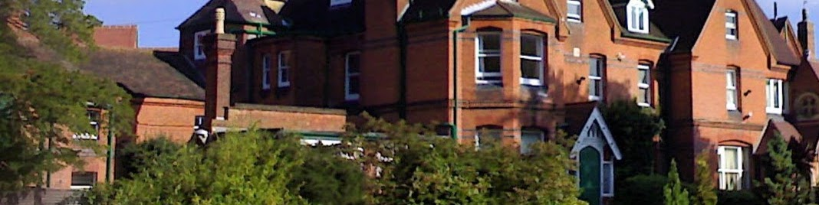

Appointment of

Teacher of PE and Girls’ Games

Applicant Pack

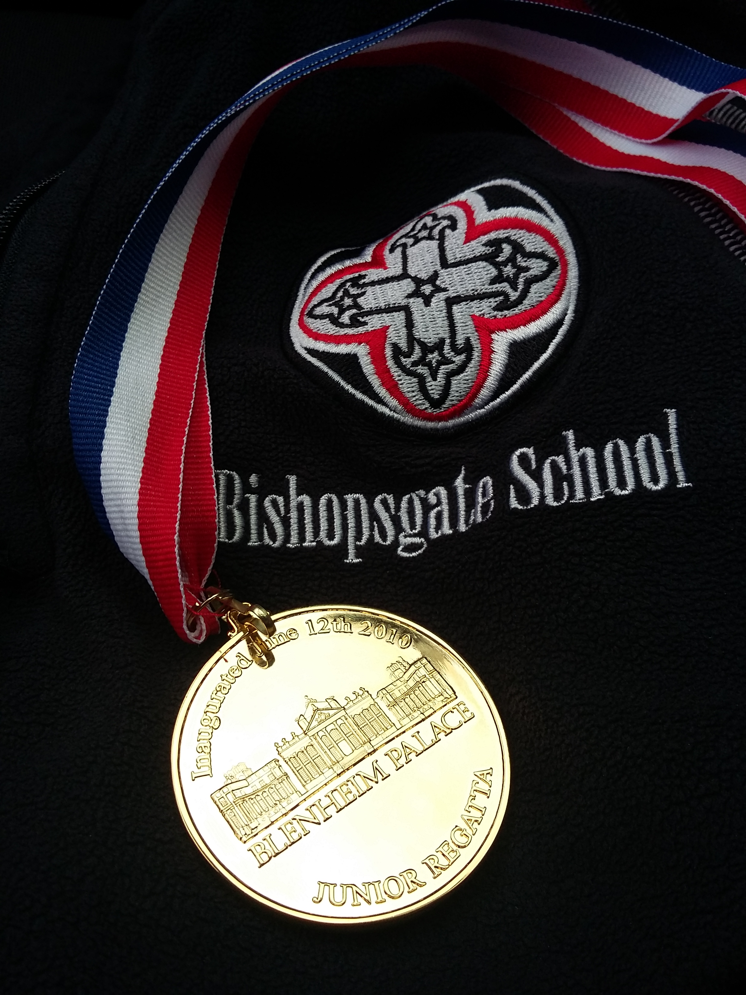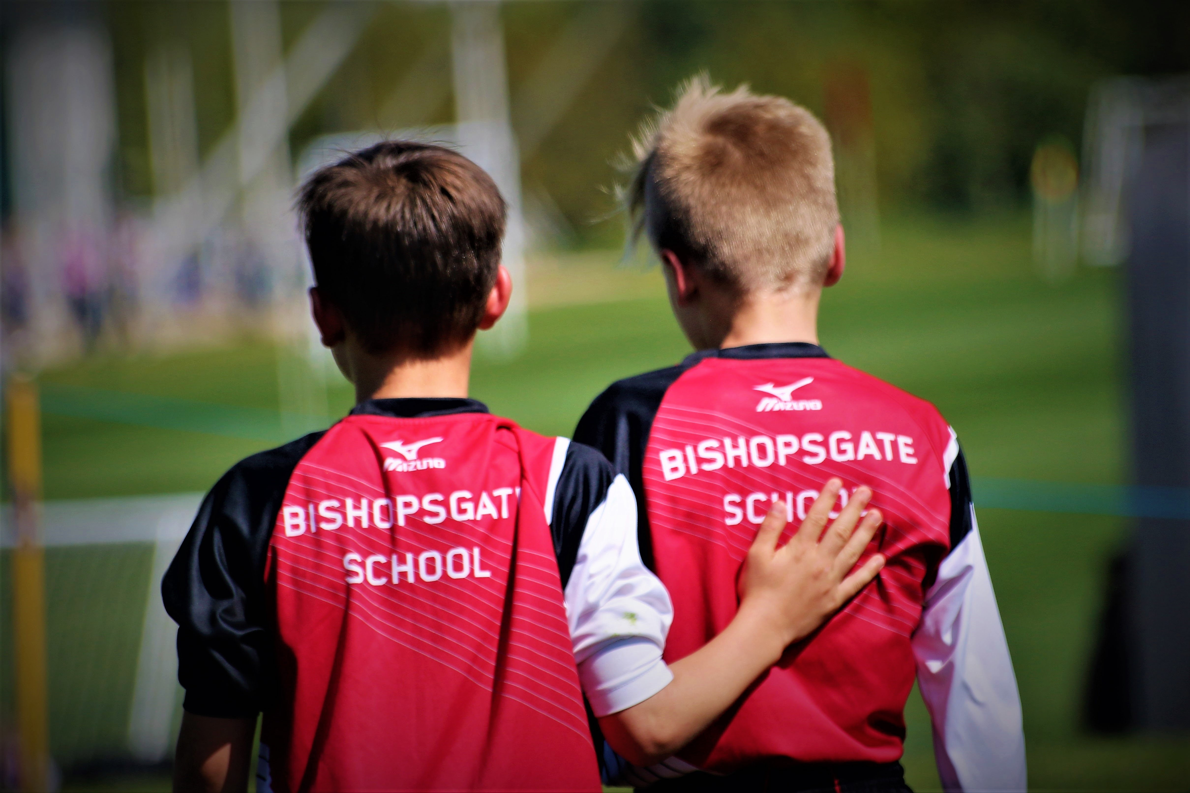

Introduction – Bishopsgate School

Bishopsgate School is a vibrant and happy community in which all members of staff do their utmost to ensure that the children in their care enjoy their childhoods and develop a lifelong love of learning. Prep School years are precious and staff at Bishopsgate strive for the highest standards of teaching and learning and of pastoral care. A member of the Prep School Baccalaureate (PSB) programme, the school places the skills it believes are required for a happy and successful life at the very heart of its curriculum and everyday life.

The real test of any successful school is the quality of relationships within it. Staff can never spend too long creating and nurturing healthy relationships with colleagues, pupils and with parents. If we are to ensure that each and every child has the opportunity to shine at something and develop the self- confidence to prosper at Bishopsgate, it is vital that we work closely with parents and are sensitive to the disparate needs of the children in our care.

Very simple things can make all the difference to a child's perception of school - always acknowledging a child in the corridor, smiling, meeting and greeting at the classroom door, offering children specific and formative feedback - can all go a long way towards helping a child feel as though he/she is an integral part of our school community.

The Background

Bishopsgate School is the successful outcome of a merger in September 1996 between Scaitcliffe and Virginia Water Prep Schools - combined the schools had over 160 year’s involvement in prep school education. Scaitcliffe, based at the present school site, was a traditional boys-only prep school with a long and distinguished history - founded by the Vickers family at the end of the 19th century. Indeed, as the scholarship boards testify, it had an extremely solid and successful academic record. Virginia Water Prep School was a 3 to 11 Girl’s school with boys to aged seven, many of whom moved on to Scaitcliffe afterwards. It was based on a small site in a residential road in Virginia Water and maintained healthy numbers and a good academic standard. The Virginia Water site was sold and the proceeds secured a new 99 year lease on the Scaitcliffe site.

The New Era

The new school was known for its first year as Scaitcliffe and Virginia Water Prep and then, in September 1997, it was renamed Bishopsgate School - to reflect both its changed role as a co-ed prep school and its proximity to the Bishop's Gate into Windsor Great Park.

The first impression of Bishopsgate School, gained by those who visit is:

- A large green campus in a beautiful part of the country, situated within extremely pleasant grounds which are conducive to the teaching of children.

- A friendly, comfortable Edwardian country house feel, but with a modern, forward looking element.

- A reassuring environment, slightly distant from the rush of everyday life.

This remains the case, but Bishopsgate School has changed significantly in recent years, with pupil numbers rising steadily to a school roll of around 360 at the commencement of the Lent Term in 2017. Throughout this period of pupil expansion, there has been continuous and significant development of the school’s infrastructure. This commenced in the 1990s with the development of the Vickers Hall, followed in 2004 by the Jubilee and Windsor Buildings, all of which significantly improved the facilities available for the education of children at Bishopsgate School. During the same period, the refurbishment of the Library and the Music School took place, and the creation of the Performing Arts Studio further enhanced the school facilities. Other enhancements since this time have included the addition of new classrooms on the top Floor of the Jubilee Building, and the creation of an outstanding first floor extension of the Windsor Building that has allowed the creation of four new teaching classrooms and a Design and Technology Studio. In 2013, the School completed the development of a four-lane 25 metre swimming pool to enhance existing sports and educational facilities at the school. During the same year, the School also created a new and additional classroom for use by Year 3 and 4 pupils in the Windsor Building, and there was major investment in a significant upgrade of the IT Suite, as well as the procurement of trolleys of laptops and iPads for use by the pupils. In 2014, the School completed an extension to the Dining Room which significantly enhanced the facilities for the children and, in April 2015, a major refurbishment of the Science Classroom was completed. The most recent projects have included the further upgrade of IT facilities at the school, and the redevelopment of the current all-weather surface. In 2016, the School completed an extension to the Music House, and in the same year there was refurbishment and additional accommodation added to the Windsor Building, resulting in outstanding new facilities for Years 3 and 4 pupils, as well as a move to new accommodation in the same building of the Learning Support Department.

These major advances have transformed the facilities of the school, but do not mean that there is nothing left to be done. The educational needs of children constantly change. The older buildings and facilities continue to need regular refurbishment, and changes in curriculum and inspection regulations necessitate the constant monitoring, review and development of all aspects of the school’s operation.

Governors and the School Leadership Team continually strive to ensure that the facilities available to children attending Bishopsgate School are of the highest possible quality.

Mission Statement
NIL NISI OPTIMUM

Bishopsgate School exists to provide a first class education through a broad and balanced curriculum, preparing its children for life in the 21st century.

To fulfil its mission the school aims:
To prepare its pupils for life beyond school, fostering the qualities of industry, tolerance and honesty among all members of the school community, and helping them build up the mental, emotional, social and strategic resources to enjoy challenge and cope with uncertainty and complexity.
To discover the things they would love to be good at while strengthening their will and skill to pursue them.
To ensure the school fulfils these aims, we promote and develop in our children four key aptitudes: resilience, curiosity, reflection and collaboration

Safeguarding and Safer Recruitment Statement

Bishopsgate is committed to safeguarding and promoting the welfare of children and young people and expects all staff and volunteers to share this commitment. Applicants will be required to undergo child protection screening appropriate to the post, including checks with past employers and the Disclosure and Barring Service.

Applicants should read the school’s policies on ‘Child Protection Safeguarding’ and, ‘Safer Recruitment’ which are available on the school’s website.

Data Protection

Bishopsgate School processes information about its current, past or prospective employees, and applicants who are defined as data subjects under the Data Protection Act 1998. We process personal information for a variety of reasons such as administering the admissions process, administering the employment process, recording payroll information, recording academic progress, monitoring attendance, and enabling references to be provided. The School may also be required by law to collect and use certain types of personal information to comply with the requirements of government departments to provide data. The Data Protection Act 1998 applies to all personal information about living individuals held either electronically or in a manual filing system.

Personal data shall be: processed fairly and lawfully; obtained only for one or more specified and lawful purposes, and shall not be further processed in any manner incompatible with that purpose or purposes; adequate, relevant and not excessive in relation to the purpose for which it is processed; accurate and, where necessary, kept up to date; not kept for longer than is necessary for that purpose; processed in accordance with the rights of data subjects under the Data Protection Act; kept secure; not transferred to a country or territory outside the UK unless that country or territory ensures an adequate level of protection for the rights and freedoms of data subjects in relation to the processing of personal data.
A Privacy Notice will be provided to the successful candidate with their contract of employment.

Recruitment and Selection Procedure

If it is decided to make an offer of employment following a formal interview, any such offer will be conditional on the following:
- the agreement of a mutually acceptable start date and the signing of a contract incorporating the School's standard terms and conditions of employment;
- verification of the applicant's identity (where that has not previously been verified);
- the receipt of two references (one of which must be from the applicant's most recent employer) which the School considers to be satisfactory;
- information about whether the applicant has ever been referred to, or is the subject of a sanction, restriction or prohibition issued by, the National College for Teaching and Leadership (NCTL) which renders them unable or unsuitable to work at the School;
- for applicants who have carried out teaching work outside the UK, information about whether the applicant has ever been referred to, or is the subject of a sanction issued by, a regulator of the teaching profession in any other country which renders them unable or unsuitable to work at the School;
- confirmation from the National College for Teaching and Leadership that the applicant is not subject to a prohibition order;
- the receipt of an enhanced disclosure from the DBS which the School considers to be satisfactory;
- confirmation that the applicant is not named on the Children's Barred List;
- information about whether the applicant is/has ever been subject to a direction under section 142 of the Education Act 2002 which prohibits, disqualifies or restricts them from providing education at a school, taking part in the management of an independent school or working in a position which involves regular contact with children which renders them unable or unsuitable to work at the School;
- confirmation that the applicant is not disqualified from working in connection with early or later years provision;
- verification of the applicant's medical fitness for the role;
- verification of the applicant's right to work in the UK;
- any further checks which the School decides are necessary as a result of the applicant having lived or worked outside of the UK which may include; an overseas criminal records check, certificate of good conduct or professional references; and
- verification of professional qualifications which the School deems a requirement for the post, or which the applicant otherwise cites in support of their application (where they have not been previously verified).

All positions within the School are exempt from the provisions of the Rehabilitation of Offenders Act 1974. All applicants must therefore declare all previous convictions and cautions, including those which would normally be considered "spent" except those received for an offence committed in the United Kingdom if it has been filtered in accordance with the DBS filtering rules.
A failure to disclose a previous conviction (which should be declared) may lead to an application being rejected or, if the failure to disclose is discovered after employment has started, may lead to summary dismissal on the grounds of gross misconduct. A failure to disclose a previous conviction may also amount to a criminal offence.

Application Procedure

To apply for the position, please complete the application form in full. This is available from the school’s website in the ‘Careers’ section under ‘Current Vacancies’. CVs cannot be accepted without the completed application form. The application form should be sent, together with a covering letter to the Recruitment Administrator, Mrs Sarah Allmond, either:

• By email to sallmond@bishopsgatesch.uk
or
• By post to Bishopsgate School, Bishopsgate Road, Englefield Green TW20 0YJ.

Closing Date: 09.00 Monday 25th May 2018.

Interviews will be held week commencing 4th June 2018.

We may see some candidates prior to the closing date due to the limitations of term time.

Please note that references will be sought prior to interview.

Candidates who have a disability or any other special requirements should let the school know if there are any reasonable adjustments they would like the school to make as part of this recruitment process.

