**Trinity All Through School, Lewisham**

**Application Pack**

|  |  |  |
| --- | --- | --- |
| C:\Users\dlucas12.209.TRS\OneDrive\Trinity\marketing\photographs\DSC_0034.jpg | C:\Users\dlucas12.209.TRS\OneDrive\Trinity\marketing\photographs\DSC_9742.jpg | C:\Users\dlucas12.209.TRS\OneDrive\Trinity\marketing\photographs\DSC_9448.jpg |
| C:\Users\dlucas12.209.TRS\OneDrive\Trinity\marketing\photographs\DSC_9090.jpg | **Learning Loving Living** | C:\Users\dlucas12.209.TRS\OneDrive\Trinity\marketing\photographs\DSC_9959.jpg |
| C:\Users\dlucas12.209.TRS\OneDrive\Trinity\marketing\photographs\DSC_0196.jpg |  |  |

Welcome to Trinity all through school.

Thank you for your enquiry about the Key Stage Two class teacher post at Trinity all through School, Lewisham. I hope this pack gives you all the information you need at this stage, and that we can look forward to your application. If you require any additional information or have any questions please do not hesitate to contact us straight away.

Trinity all through school is a thriving community, where our staff and pupils are enthusiastic, conscientious, talented and caring. We take appointing new staff very seriously and seek other professionals who are committed to young people and supporting Trinity to continue to move forward. We are very proud of our school and are seeking likeminded people to join us with our vision and ethos of making all pupils succeed in a happy and caring environment. The successful candidate will help support our inclusive vision in providing the very best education for all children and help us to achieve the next level of success. We are a 2 form intake primary school at one site (Leahurst Road, London, SE13 5HZ) and a 4 form intake secondary school down the road (Taunton Road, Lee, London SE12 8PD). The primary phase is in a renovated Victorian building that has a vast amount of space and facilities. We have a dedicated music room, food technology room and a large computer room alongside our library. We have 2 indoor spaces to use for PE / Whole School Worship and other events. We are lucky to have a large outdoor space as well. The secondary site is a modern purpose built building that has all the latest facilities. The building has a sense of space for all the school community. The primary and secondary phase operate closely enough to be able to gain all the benefits from the through school ethos. Transition, curriculum and assessment is shared across the phases, as well as staff expertise. Students from both phases benefit from being part of a through school as well as our staff. The two sites are geographically apart, however the school works together but each phase has its own distinctive characteristics. We have a strong Character Education that ties us together from early years through to year 11. This way we are developing from the start young people who are skilled, nurtured and supported through a family structure.

cid:image002.png@01D3889F.9FF111B0Our aim is to be a strong Christian community in which children and adults can flourish. A community where pupils fulfil their potential and achieve the very best educational outcomes, enabling them to make good life choices, to uphold British Values, and to take their place as citizens of the wider world. Our ethos says:

* We are a Learning Community
* We are a Loving family
* We are Living good lives

To find out more about our school please do visit our website, where you can look at the through-school elements or the distinctiveness of each of the two phases as well. [www.trinitylewisham.org](http://www.trinitylewisham.org) If you are interested please do complete the application form. The details of the deadline can be found in the job advert attached here, as well as on our website.

Thank you

 David Lucas BSc (hons) MA NPQH, Executive Headteacher

**Lead Practitioner for Inclusion or Teaching and Learning across the Curriculum in the Primary Phase (Pay scale L1 – L4)**

It is an incredibly exciting time to join the Primary phase of Trinity all through school. We are currently a two form entry school, offering classes from reception to year four. September 2018 will see us grow to year five and the following year our site will house the full primary age range - up to year six.

We have a young, supportive leadership team, which we are seeking to expand as the school grows. The introduction of a Lead Practitioner forms part of this strategic expansion. A Lead Practitioner at Trinity will work closely with the Head of School and Deputy Head to continue to drive improvement in their area of responsibility through modelling excellent teaching, coaching and co-teaching with peers, as well as introducing and monitoring excellent systems and processes to ensure our high standards are maintained and self-improving. As a through school, we also offer excellent opportunities for leadership development, at all levels - including cross phase.

Our staff team are vibrant, fun, hardworking and have the highest expectations for our children.

To get a feel for our wonderful, unique school please visit our website [here](https://www.trinitylewisham.org/page/?title=Trinity+Primary+School&pid=2). To see some of the creative learning which takes place, please visit our new curriculum blog [here](https://trinityprimarylewisham.blogspot.co.uk/).

We look forward to your application.



Come and join our amazing school.

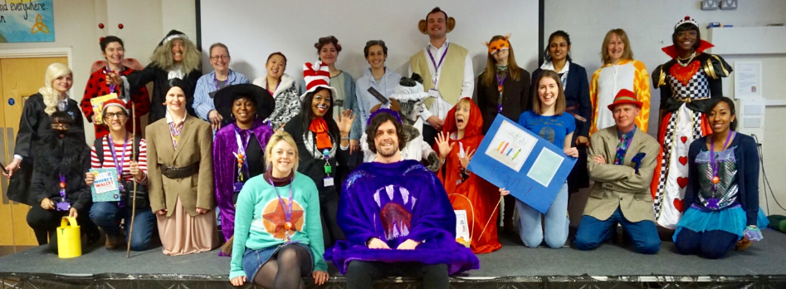



Darren Janes

**Head of School**

**Primary Phase**

**Trinity All Through School, Lewisham**

cid:image002.png@01D3889F.9FF111B0

