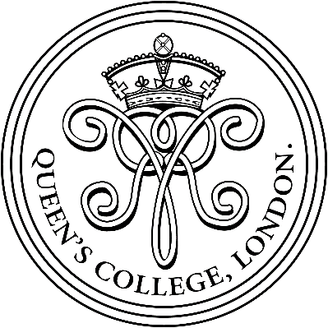

QUEEN’S COLLEGE, LONDON
43–49 Harley Street, London W1G 8BT
www.qcl.org.uk

Founded 1848
GSA school of 370 girls aged 11-18

Science Technician
(Term time only position)
Part-time or full-time (3, 4 or 5 days per week)
September 2018

Queen’s College is a wonderful place to work. We are a high-performing smaller school, which enjoys excellent laboratory facilities and a unique central London location.

We are seeking to appoint a reliable and enthusiastic Science Technician to join our Science Team. The role, mainly focused on supporting teaching in Biology, would either suit someone with experience or someone new to working in the school laboratory environment, as training would be provided. This is an exciting opportunity for someone interested in both science and working with young people.

Salary range: £26,000-£32,000 per annum (FTE) dependent on qualifications, experience and number of working days per week.

Applications should be made on the Queen’s College application form and sent to the Assistant Bursar by post or e-mail (rhall@qcl.org.uk) and accompanied by a supporting covering letter, indicating your preferred number of working days per week. Applications will be considered as they are received by the College. Submission of the equal opportunities monitoring form is optional.

Queen’s College is committed to safeguarding and promoting the welfare of children, and applicants must be willing to undergo child protection screening, including checks with past employers and the Disclosure and Barring Service.

