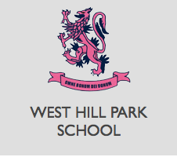

Welcome
A message from our Headmaster
When you start working at West Hill Park, you will be welcomed into a warm and supportive community in which everyone is valued and where we show respect and care for one another
We believe that schools days should be among the most rewarding days of a child’s life and within our stimulating and secure environment we provide a rich experience, academically, culturally and spiritually.
We think the experience of a day spent teaching should be equally rewarding, and the role of Head of English and Drama at West Hill is an opportunity for an inspirational and ambitious professional to really make a difference.
We were rated excellent in all categories of our recent ISI inspection, so are looking for an outstanding and dedicated individual to lead our highly successful English and Drama department. The successful candidate will have excellent teaching ability, strong leadership qualities and be able to communicate effectively with pupils and staff at all levels.
I am excited to have the chance to recruit a new and influential leader to my team. You will be working closely with our Senior Management and we welcome an experienced Head of Department or equally someone looking to develop their career in their first role leading a department. We really do have a thriving and vibrant community and being part of our team gives the successful applicant the chance to develop their experience, through the academic curriculum, and also drama, music, games, our boarding house and extra activities
If you would like to talk to me personally about this opportunity and why West Hill Park might be the right job for you, please feel free to call me on 01329 842356.
Alastair Ramsay
Headmaster

