

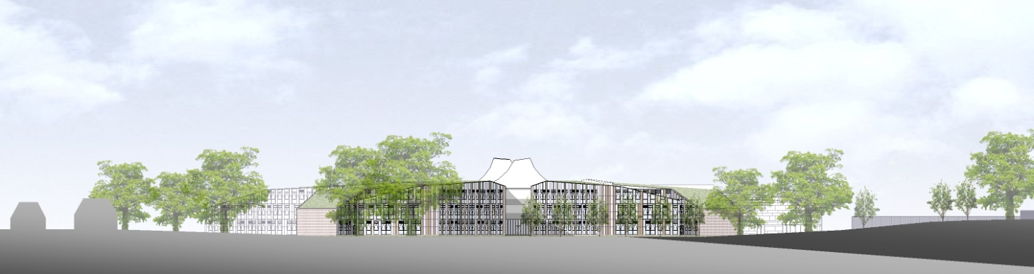

# ST. BARTHOLOMEW'S SCHOOL

TECHNICIAN: SCIENCE

Part-time, permanent

# Required as soon as possible

**Andover Road**

**Newbury RG14 6JP**

**Tel: 01635 – 521255**

**Fax: 01635 576320**

**Email:** [**recruitment@stbarts.co.uk**](mailto:recruitment@stbarts.co.uk)

[**www.stbarts.co.uk**](http://www.stbarts.co.uk)

**THE FACULTY**

The Science faculty has a policy of providing stimulating, relevant, balanced and high quality Science courses which fulfil the National Curriculum, provide valuable qualifications, encourage a responsibility for the environment in a technological world and give each pupil knowledge, understanding and skills which enable them to lead satisfying and useful lives.

The faculty is based in a suite of 13 ICT-rich and fully equipped laboratories, a psychology classroom, an ICT room and two well stocked prep rooms. The faculty is well resourced and 7 technicians provide support.

At KS3 we have a scheme of work that uses a practical investigative approach to teach both knowledge content and scientific skills. KS3 at St Bart’s is completed in Year 8 and we begin KS4 teaching in Year 9. At the end of Year 9 the most able students are invited to complete the course for separate Science whilst the majority of students continue to study for and certificate in AQA Science Combined Science.

Teaching of all the courses at KS3 and 4 is shared between the Biology, Chemistry and Physics department.

In 2017-2018 there are a large number of students in the Sixth Form studying Science based A-levels:

Biology (AQA) 8 sets

Chemistry (AQA) 5 sets

Physics (OCR Advancing Physics) 6 sets

Psychology (AQA) 8 sets

The average set size is approximately 15 – 20.

There is also a small group of sixth form students studying towards BTEC level 3 Science.

All members of the department teach at all levels in the school and are involved with the development of courses throughout the age range.

**THE POST**

* We are seeking to appoint a Technician: Science to join the Science faculty as soon as possible on a permanent basis.
* The position is part-time, term time only plus 5 training days pro rata.
* You will be required to work 15 hours and 30 minutes per week as follows:

Monday 12.00pm to 4.00pm

Tuesday 12.30pm to 4.00pm

Wednesday 12.00pm to 4.00pm

Thursday 8.00am to 12.00pm

When you work 5 hours or more in a day you are entitled to a 30 minute break which is unpaid.

###### THE SALARY

* The successful candidate will be paid in accordance with the national APT&C scale, point 11-13 (currently £15,807.00 to £16,491.00 per annum full-time equivalent). This equates to a starting salary of £5,651.24 gross per annum or £8.19 per hour. Staff will be appointed to the start point of the advertised scale unless there is a specific experience reason for the Headteacher to agree an alternative point within the range.
* All leave must be taken during school holidays. Your annual salary will be calculated to include payment for your leave entitlement. Your annual salary will therefore be 44.5 weeks pay, to be paid in 12 equal monthly amounts.

**HOW TO APPLY**

Full post details, an application form and instructions on how to upload your completed application are available via the Contact & Apply / Job Opportunities section on the School’s website:

[**www.stbarts.co.uk**](http://www.stbarts.co.uk)

(Please note that curriculum vitae and covering letters cannot be accepted)

Successful candidates will be subject to a DBS enhanced check along with other relevant employment checks.

## Closing date: Sunday 29 April 2018

Thank you for considering St Bartholomew’s School.

Julia Mortimore

Headteacher