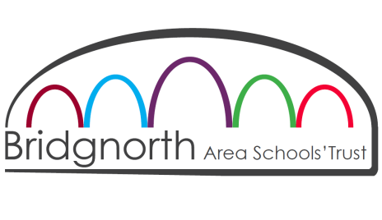

OLDBURY WELLS
BRIDGNORTH Shropshire WV16 5JD

Teacher of Computer Studies

Job details
Salary: MPS / UPS

Contract Type: full time

Contract Term: permanent

Closing date: 9am on Friday, 8 December 2017

Start date: April 2018 (if available) or September 2018
---------------------------------------------------------------------------------------------------------------------------------------
We are an oversubscribed, expanding school, rated ‘Good’ by Ofsted and ranked second in the 2016 Shropshire League Tables. We are seeking to employ an inspiring and enthusiastic Teacher of Computer Studies. Computer Studies is included within our Applied Studies faculty (together with Music, Media, Business Studies, Psychology and vocational studies), so applications from teachers able to offer a second area are especially welcomed.

This post will be ideal for a NQT or an established teacher looking for a new post. They will join a strong faculty with a supportive head of department. NQTs will have a carefully managed training and support package.

Oldbury Wells is a flourishing academy, the founding school of the Bridgnorth Area Schools’ Trust. At present our Trust comprises a family of four schools (Oldbury Wells plus three feeder primary schools) which are local to each other. Our Trust is committed to supporting local education and enjoys strong partnership arrangements with all local primary schools. We are a comprehensive school with students across the whole ability range.

We have a very good track record in terms of examination results with excellent Progress 8, Attainment 8 and VA scores. We are in a position of strength as a school, with our students successful across the range of groups and across the full range of subjects. Oldbury Wells School also has an established and flourishing Sixth Form.

We are located just 20 minutes from the West Midlands conurbation where we enjoy a small town location in Bridgnorth within easy reach of the Birmingham and Telford areas.

Oldbury Wells School is committed to safeguarding and protecting the welfare of children and young people and therefore expects all staff to share this commitment. All appointments are subject to a satisfactory DBS check.

Further details of this vacancy can be downloaded from our website, www.oldburywells.co.uk/page/266/vacancies.
Alternatively please telephone 01746 760509 or e-mail Mrs Frances Sherrington, PA to the Headteacher, at frances.sherrington@oldburywells.com. The closing date is 9am on Friday, 8 December 2017.

Visits to the school may be arranged through Mrs Rachel Chapman, Director of Learning for Applied Studies, at rachel.chapman@oldburywells.com

