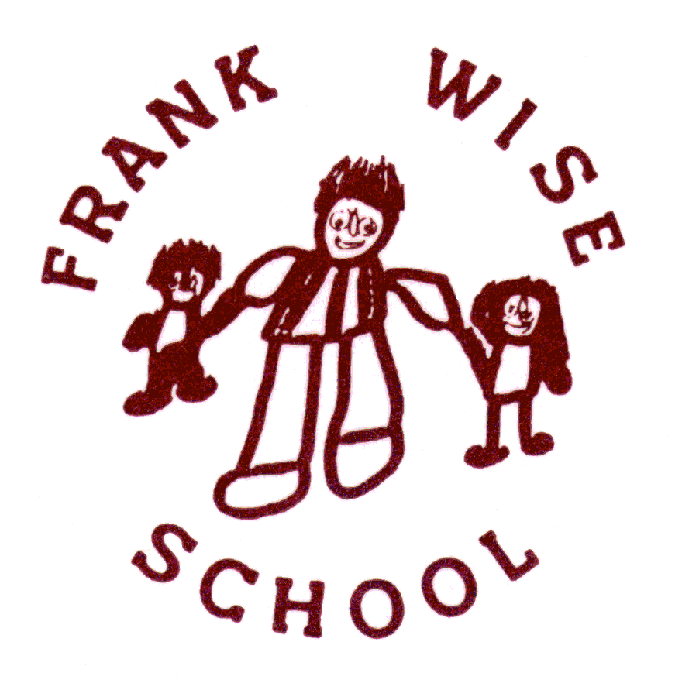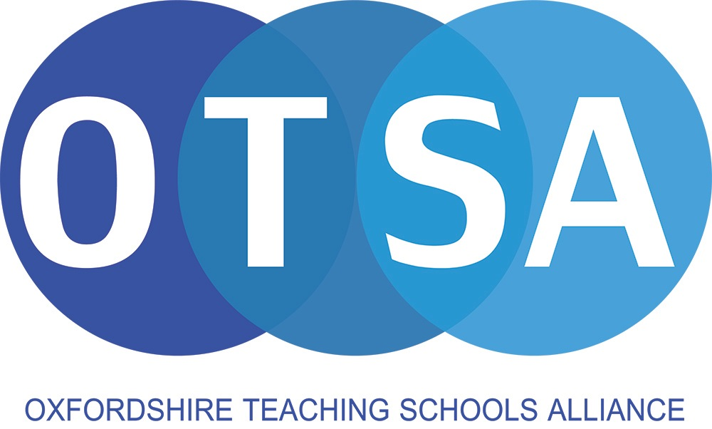

**FRANK WISE SCHOOL**

**General Information**

Frank Wise School caters for 106 children aged between 2-19 years with severe and complex learning disabilities. The school’s catchment area is the major centres of Banbury, Chipping Norton and the villages around them.

**Organisation**

The school has 11 broad chronologically based classes including a nursery. Pupils are grouped by age, but with careful consideration of individual and group needs.

Our Assessment Nursery caters for children who, through early identification, display developmental difficulties. Children start on a part-time basis and sessions are either mornings or afternoons. Within our nursery class children have opportunities to develop positive learning attitudes, as well as acquiring basic skills.

There is a tangible division between the primary age and senior age teaching areas of the school. This is important as it parallels the move from primary to secondary which is made by children in most schools and enables the pupil to develop an awareness of moving from childhood to adolescence. The resources available in the senior section of the school, together with the physical layout of the classrooms, give opportunities for the extended curricular activities necessary for older aged pupils. Our post-16 unit, the Griffiths Centre, provides a further distinct development for students aged between 16 and 19, with a strong emphasis on the functional use of skills across a wide range of community settings.

**Curriculum**

Within the school’s curriculum framework, which incorporates relevant aspects of the National Curriculum, all pupils are taught through the use of structured individual and small group learning programmes. This approach enables teachers to design and implement teaching programmes to meet the very specific needs of every child in their class.

**Links with Other Schools**

The school’s policy of developing strong links with mainstream schools manifests itself at present by all our pupils spending at least half a day per week in local primary and secondary schools for joint curricular activities. Therefore, inclusion is an educational opportunity for all our pupils.

As a community focussed school we have direct partnerships with many local schools, colleges and organisations, providing advice, guidance and support. Our work has led to us taking on the role of Advocacy School with the National Education Trust.

**Oxfordshire Teaching Schools Alliance**

The school is one of three Teaching Schools working together across Oxfordshire with a range of strategic partners to support school improvement and leadership development throughout the county.

| **Address** | Hornbeam Close  Banbury  Oxon  OX16 9RL |
| --- | --- |
| **Headteacher** | Sean O’Sullivan |
| **Email** | [office@frankwise.oxon.sch.uk](mailto:office@frankwise.oxon.sch.uk) |
| **Website** | [www.frankwise.oxon.sch.uk](http://www.frankwise.oxon.sch.uk) |
| **Phone** | 01295 263520 |
| **Fax** | 01295 273141 |